Supplemental Digital Content
This supplement has been provided by the authors to give readers additional information about their work.

Supplement to:

Prevalence and Course of Frailty in Survivors of Critical Illness

Nathan E. Brummel MD MSCI FCCM, Timothy D. Girard MD MSCI, Pratik P. Pandharipande MD MSCI FCCM, Jennifer L. Thompson MPH, Ryan Jarrett BA, Rameela Chandrasekhar PhD, Christopher G. Hughes, MD FCCM, Mayur B. Patel, MD MPH FCCM, Alessandro Morandi MD MPH, Thomas M. Gill, MD, E. Wesley Ely MD MPH FCCM

Table of Contents:
- Methods
  - Detailed inclusion and exclusion criteria
  - Detailed BRAIN-ICU and MIND-ICU study Protocol
  - Table S1. Canadian Study of Health and Aging Clinical Frailty Scale
  - Descriptions of Katz Index of Independence of Activities of Daily Living and Repeatable Battery for the Assessment of Neuropsychological Status.
  - Definitions of selected baseline and critical illness-related factors
- Results
  - Table S2. Demographic and Clinical Characteristics of Patients According to Frailty State at 3-month follow-up.
  - Table S3. Demographic and Clinical Characteristics of Patients According to Frailty State at 12-month follow-up.
  - Figure S1. Factors Associated with Severity of Frailty at 3-Month and 12-Month Follow-Up.

1. Methods

- Inclusion and exclusion criteria
Inclusion Criteria
We enrolled adult patients in a medical or surgical intensive care unit (ICU) receiving treatment respiratory failure or shock (cardiogenic or septic). We considered a patient to be in respiratory failure if they were receiving any of the following treatments at the time of enrollment: invasive mechanical ventilation, noninvasive positive pressure ventilation, continuous positive airway pressure, supplemental oxygen via a nonrebreather mask, or nasal cannula delivering heated high-flow oxygen. We considered a patient to be in cardiogenic shock if they were being treated at the time of enrollment with an intra-aortic balloon pump or any of the following medications administered for acute cardiac dysfunction: dopamine ≥ 7.5mcg/kg/min, dobutamine ≥ 5 mcg/kg/min, norepinephrine ≥ 5 mcg/min, phenylephrine ≥ 75 mcg/min, epinephrine at any dose, milrinone at any dose (if used with another vasopressor), or vasopressin ≥ 0.03 units/min (if used with another vasopressor). We considered a patient to be in septic shock when suspected or proven infection was documented in the setting of hypotension being treated with any of the previously listed medications. Patients who were on long-term ventilatory support prior to their acute illness that resulted in the hospitalization qualified for enrollment in this study if they met criteria for shock (as defined above) or they had a new onset of respiratory failure, defined as either an increase of pressure support of 5 cms H₂O or positive end expiratory pressure of 2 cms H₂O from the patient’s baseline ventilatory settings.
Exclusion Criteria
Patients who met inclusion criteria were excluded if they met any of the following criteria:
(1) Cumulative ICU time > 5 days in the past 30 days, not including the current ICU stay
(2) Severe cognitive or neurodegenerative diseases that prevent a patient from living independently at baseline, including mental illness requiring institutionalization, acquired or congenital mental retardation, known brain lesions, traumatic brain injury, cerebrovascular accidents with resultant moderate to severe cognitive deficits or ADL disability, Parkinson’s disease, Huntington’s disease, severe Alzheimer’s disease or dementia of any etiology
(3) ICU admission post cardiopulmonary resuscitation with suspected anoxic injury
(4) An active substance abuse or psychotic disorder, or a recent (within the past 6 months) serious suicidal gesture necessitating hospitalization.
(5) Blind, deaf, or unable to speak English
(6) Moribund and not expected to survive for an additional 24 hours and/or withdrawing life support to focus on comfort measures only.
(7) Prisoners
(8) Patients who live further than 200 miles from the enrolling center and who do not regularly visit the area.
(9) Patients who are homeless and have no secondary contact person available.
(10) The onset of the current episode of respiratory failure, cardiogenic shock, or septic shock was > 72 hours ago.
(11) Patients who have had cardiac bypass surgery within the past 3 months (including the current hospitalization)

- Summary of the BRAIN-ICU and MIND-ICU study protocols
The (BRAIN-ICU) study was conducted at Vanderbilt University Medical Center and Saint Thomas Hospital (both Nashville, TN, USA) and the MIND-ICU Study was conducted at the Tennessee Valley Healthcare System (Nashville, TN, USA), George E. Wahlen Department of VA Medical Center in VA Salt Lake City Health Care System (Salt Lake City, UT, USA), and Seattle Division of the VA Puget Sound Health Care System (Seattle, WA, USA).
Each day, study personnel screened the census of the medical and surgical ICUs at each enrolling site. At enrollment, study personnel collected baseline information including sociodemographics, comorbid medical conditions, disability in basic and instrumental activities of daily living, and baseline cognitive function, and baseline frailty as detailed below. Enrolled patients were followed daily in the hospital until they were discharged (or for up to 30 days). Each day, study personnel collected detailed physiologic and pharmacologic data used to calculate the covariates described below including daily severity of illness scores, duration of delirium, duration of coma, duration of severe sepsis, duration of mechanical ventilation and mean daily doses of sedatives and opiates. Patients then underwent follow-up assessments 3 and 12 months after discharge as detailed in the main manuscript.

- Table S1. Canadian Study of Health and Aging (CSHA) Clinical Frailty Scale.
The CSHA Clinical Frailty Scale (CFS) is a 7-point scale that assesses patients along the continuum from fitness to frailty. The CFS is a clinical judgment-based scale created from the 70-point, mathematically derived, Frailty Index. The CFS strongly correlates with the Frailty Index and is predictive of both mortality and institutionalization in population-based cohort studies¹ and in studies of patients with frailty who become critically ill.²⁻⁴
Table S1. Canadian Study of Health and Aging (CSHA) Clinical Frailty Scale.
Score | Category | Description
1 | Very Fit | Robust, active, energetic, well motivated and fit; these people commonly exercise regularly and are in the most fit group for their age
2 | Well | Without active disease, but less fit than people in category 1
3 | Well, with treated comorbid disease | Disease symptoms are well controlled compared with those in category 4
4 | Apparently vulnerable | Although not frankly dependent these people commonly complain of being “slowed up” or have disease symptoms
5 | Mildly Frail | With limited dependence on others for activities of daily living
6 | Moderately Frail | Help is needed with both instrumental and non-instrumental activities of daily living
7 | Severely Frail | Completely dependent on others for activities of daily living, or terminally ill

- Descriptions of Katz Index of Independence of Activities of Daily Living and Repeatable Battery for the Assessment of Neuropsychological Status.
Katz Index of Independence in Activities of Daily Living (Katz ADL).⁵ The Katz ADL assesses the need for assistance in six basic activities of daily living (bathing, dressing, toileting, transferring out of bed or chair, bowel and bladder continence, and feeding) in the two weeks prior to the onset of illness. Scores for each activity range from 0 (completely independent) to 2 (complete dependence) and are summed to generate the Katz ADL score.
Repeatable Battery for the Assessment of Neuropsychological Status (RBANS).⁶ The RBANS assesses global cognition, including individual domains of immediate and delayed memory, attention, visuospatial construction, and language. The age-adjusted mean score on the RBANS is 100, with a standard deviation of 15; lower scores indicate worse cognition. We defined cognitive impairment as an RBANS score 78 or less (i.e., a conservative definition representing 1.5 standard deviations below the age-adjusted mean)
- Definitions of selected baseline and critical illness-related factors
Comorbid medical conditions were recorded using the Charlson Comorbidity Index.⁷ The Charlson Comorbidity Index is a score that predicts the 10-year mortality for a patient with a range of co-morbid medical conditions. Scores for specific medical conditions are summed to provide a total score with a range of 0 to 33 points (since some of the categories are mutually exclusive). Higher scores indicate greater risk of mortality.

Baseline disability in basic activities of daily living were determined using the Katz Index of Independence in Activities of Daily Living (Katz ADL).⁵ The Katz ADL assesses the need for assistance in six basic activities of daily living (bathing, dressing, toileting, transferring out of bed or chair, bowel and bladder continence, and feeding) in the two weeks prior to the onset of illness. Scores for each activity range from 0 (completely independent) to 2 (complete dependence) and are summed to generate the Katz ADL score.

Baseline disability in instrumental activities of daily living were determined using the Functional Activities Questionnaire (FAQ).⁸ The FAQ assesses need for assistance in 10 activities (1. writing checks, paying bills, balancing a checkbook; 2. assembling tax records, business affairs, or papers; 3. shopping alone for clothes, household necessities or groceries; 4. playing a game of skill, working on a hobby; 5. heating water, making a cup of coffee, turning off stove after use; 6. preparing a balanced meal; 7. keeping track of current events; 8. paying attention to, understanding, discussing TV, book, magazine; 9. remembering appointments, family occasions, holidays, medications; 10. traveling out of neighborhood, driving, arranging to take buses). Each activity is scored from 0 (normal) to 3 (dependent). Thus, scores range from 0 (no disability) to 30 (complete disability).

Duration of delirium was calculated as the number of days where the Confusion Assessment Method for the ICU (CAM-ICU)^{9,10} was positive.

Duration of coma was calculated as the number of days where the patient’s level of consciousness was a -4 or -5 on the Richmond Agitation-Sedation Scale (RASS).^{11,12}

Duration of severe sepsis was calculated as the number of days where severe sepsis was present. Sepsis was defined as infection plus at least 2 systemic inflammatory response syndrome (SIRS) criteria.¹³ The presence of sepsis was determined using prospectively collected data that was adjudicated following the ICU stay by a panel of 3 intensivists [PPP, TDG and EWE]. Severe sepsis was defined as the presence of sepsis in conjunction with any signs of organ failure such as mechanical ventilation, cardiovascular or renal SOFA score ≥ 2, delirium or coma.

Duration of mechanical ventilation was calculated as the number of days (or portion thereof) where the patient was treated with mechanical ventilation.

Mean daily severity of illness score was calculated using a modified version of the sequential organ failure assessment (SOFA) score. The SOFA score is a validated organ dysfunction scoring system that measures severity of illness over time.¹⁴ The score is calculated for the respiratory, cardiovascular, hepatic, coagulation, renal and neurologic systems. Individual organ system scores range from 0 (no dysfunction) to 4 (organ system failure) and are summed to create an overall severity of illness score ranging from 0 to 24, where higher scores indicate worse organ dysfunction. We modified the SOFA score to exclude the neurologic component since we specifically adjusted for the duration of coma in our models.

2. Results
a. Table S2. Demographic and Clinical Characteristics of Patients According to Frailty Status at 3-month follow-up.

Characteristic | Non-Frail  (CFS 1-3)  N=152 | Vulnerable  (CFS 4)  N=139 | Frail  (CFS 5-7)  N=239
Age, years | 60 (48 to 69) | 60 (60 to 70) | 63 (55 to 72)
Female sex, n (%) | 57 (37%) | 52 (37%) | 102 (43%)
CFS Score at baseline, n (%)
1-Very Fit | 13 (9%) | 2 (1%) | 5 (2%)
2-Well | 36 (24%) | 27 (19%) | 23 (10%)
3-Well with treated comorbid disease | 54 (36%) | 67 (48%) | 61 (26%)
4-Apparently vulnerable | 34 (22%) | 25 (18%) | 57 (24%)
5-Mildly frail | 13 (9%) | 8 (6%) | 41 (17%)
6-Moderately frail | 2 (1%) | 8 (6%) | 42 (18%)
7-Severely frail | 0 (0%) | 2 (1%) | 10 (4%)
Charleson Comorbidity Index score at baseline | 1 (0 to 3) | 2 (1 to 4) | 3 (1 to 4)
Katz ADL score at baseline | 0 (0 to 0) | 0 (0 to 0) | 0 (0 to 1)
FAQ score at baseline | 0 (0 to 1) | 0 (0 to 1) | 1 (0 to 6)
IQCODE score | 3.0 (3.0 to 3.1) | 3.0 (3.0 to 3.1) | 3.0 (3.0 to 3.2)
APACHE II score at ICU admission | 24 (18 to 29) | 22 (16 to 29) | 23 (17 to 28)
Mean daily SOFA score in the ICU | 7 (6 to 9) | 7 (6 to 9) | 6 (5 to 8)
Delirious^{c}, n (%) | 104 (68%) | 92 (66%) | 169 (71%)
Duration of deliriumª, days | 3 (2 to 5) | 3 (2 to 7) | 4 (2 to 8)
Comatose^{d}, n (%) | 76 (50%) | 75 (54%) | 120 (50%)
Duration of comaª, days | 2 (1 to 5) | 2 (1 to 4) | 3 (1 to 5)
Septic^{b}, n (%) | 87 (58%) | 88 (64%) | 161 (68%)
Duration of sepsisª, days | 3 (2 to 8) | 4 (2 to 7) | 4 (2 to 8)
Mechanically ventilated, n (%) | 136 (89%) | 122 (88%) | 208 (87%)
Duration of mechanical ventilationª, days | 2 (1 to 5) | 3 (1 to 5) | 3 (1 to 8)
ICU length of stay, days | 4 (2 to 8) | 5 (2 to 10) | 5 (3 to 12)
Hospital length of stay, days | 9 (6 to 16) | 10 (6 to 17) | 11 (7 to 19)
Data are median (interquartile range) unless otherwise indicated.
CFS= clinical frailty scale; ADL= activities of daily living; FAQ= functional activities questionnaire of instrumental ADLs; IQCODE= informant questionnaire on cognitive decline in the elderly; APACHE II= acute physiologic and chronic health evaluation, version II; SOFA= sequential organ failure assessment
ªAmong those with the clinical condition; ^{b}Defined according to Sepsis-2 definition for severe sepsis; ^{c}Defined as the number of days the Confusion Assessment Method for the ICU was positive; ^{d}Defined at the number of days the Richmond Agitation-Sedation Scale was -4 or -5.

b. Table S3. Demographic and Clinical Characteristics According to Frailty Status at 12 months

Characteristic | Non-Frail  (CFS 1-3)  N=150 | Vulnerable  (CFS 4)  N=132 | Frail  (CFS 5-7)  N=162
Age, years | 60 (49 to 67) | 60 (50 to 70) | 63 (55 to 73)
Female sex, n (%) | 53 (35%) | 57 (43%) | 72 (44%)
CFS Score at baseline, n (%)
1-Very Fit | 12 (8%) | 4 (3%) | 3 (2%)
2-Well | 37 (25%) | 23 (17%) | 16 (10%)
3-Well with treated comorbid disease | 63 (42%) | 53 (40%) | 40 (25%)
4-Apparently vulnerable | 25 (17%) | 27 (20%) | 39 (24%)
5-Mildly frail | 9 (6%) | 16 (12%) | 27 (17%)
6-Moderately frail | 3 (2%) | 7 (5%) | 31 (19%)
7-Severely frail | 3 (1%) | 2 (2%) | 6 (4%)
CFS Score at 3 months, n (%)
1-Very Fit | 6 (4%) | 0 (0%) | 0 (0%)
2-Well | 26 (19%) | 10 (8%) | 3 (2%)
3-Well with treated comorbid disease | 46 (33%) | 28 (23%) | 8 (5%)
4-Apparently vulnerable | 38 (27%) | 45 (38%) | 31 (21%)
5-Mildly frail | 21 (15%) | 26 (22%) | 46 (33%)
6-Moderately frail | 2 (1%) | 10 (8%) | 50 (34%)
7-Severely frail | 0 (0%) | 0 (0%) | 8 (5%)
Charleson Comorbidity Index score at enrollment | 1 (0 to 3) | 2 (1 to 3) | 2 (1 to 4)
Katz ADL score at enrollment | 0 (0 to 0) | 0 (0 to 0) | 0 (0 to 1)
FAQ score at enrollment | 0 (0 to 0) | 0 (0 to 1) | 0 (0 to 7)
IQCODE score | 3.0 (3.0 to 3.0) | 3.0 (3.0 to 3.1) | 3.0 (3.0 to 3.3)
APACHE II score at ICU admission | 23 (18 to 29) | 23 (16 to 29) | 22 (16 to 29)
Mean daily SOFA score in the ICU | 7 (5 to 9) | 6 (5 to 9) | 6 (5 to 8)
Delirious^{c}, n (%) | 104 (69%) | 87 (66%) | 115 (71%)
Duration of deliriumª, days | 3 (1 to 5) | 3 (2 to 5) | 5 (2 to 8)
Comatose^{d}, n (%) | 73 (49%) | 70 (53%) | 88 (54%)
Duration of comaª, days | 2 (1 to 5) | 2 (1 to 4) | 3 (2 to 5)
Septic^{b}, n (%) | 93 (62%) | 76 (58%) | 117 (73%)
Duration of sepsisª, days | 3 (2 to 8) | 4 (2 to 7) | 4 (2 to 7)
Mechanically ventilated, n (%) | 136 (91%) | 115 (87%) | 144 (89%)
Duration of mechanical ventilationª, days | 2 (1 to 5) | 2 (1 to 5) | 2 (1 to 8)
ICU length of stay, days | 4 (3 to 10) | 5 (2 to 8) | 5 (3 to 11)
Hospital length of stay, days | 9 (6 to 18) | 9 (6 to 15) | 11 (6 to 17)
Data are median (interquartile range) unless otherwise indicated. CFS= clinical frailty scale; ADL= activities of daily living; FAQ= functional activities questionnaire of instrumental ADLs; IQCODE= informant questionnaire on cognitive decline in the elderly; APACHE II= acute physiologic and chronic health evaluation, version II; SOFA= sequential organ failure assessment
ªAmong those with the clinical condition; ^{b}Defined according to Sepsis-2 definition for severe sepsis; ^{c}Defined as the number of days the Confusion Assessment Method for the ICU was positive; ^{d}Defined at the number of days the Richmond Agitation-Sedation Scale was -4 or -5.

c. Figure S1. Factors Associated with Severity of Frailty at 3-Month and 12-Month Follow-Up.
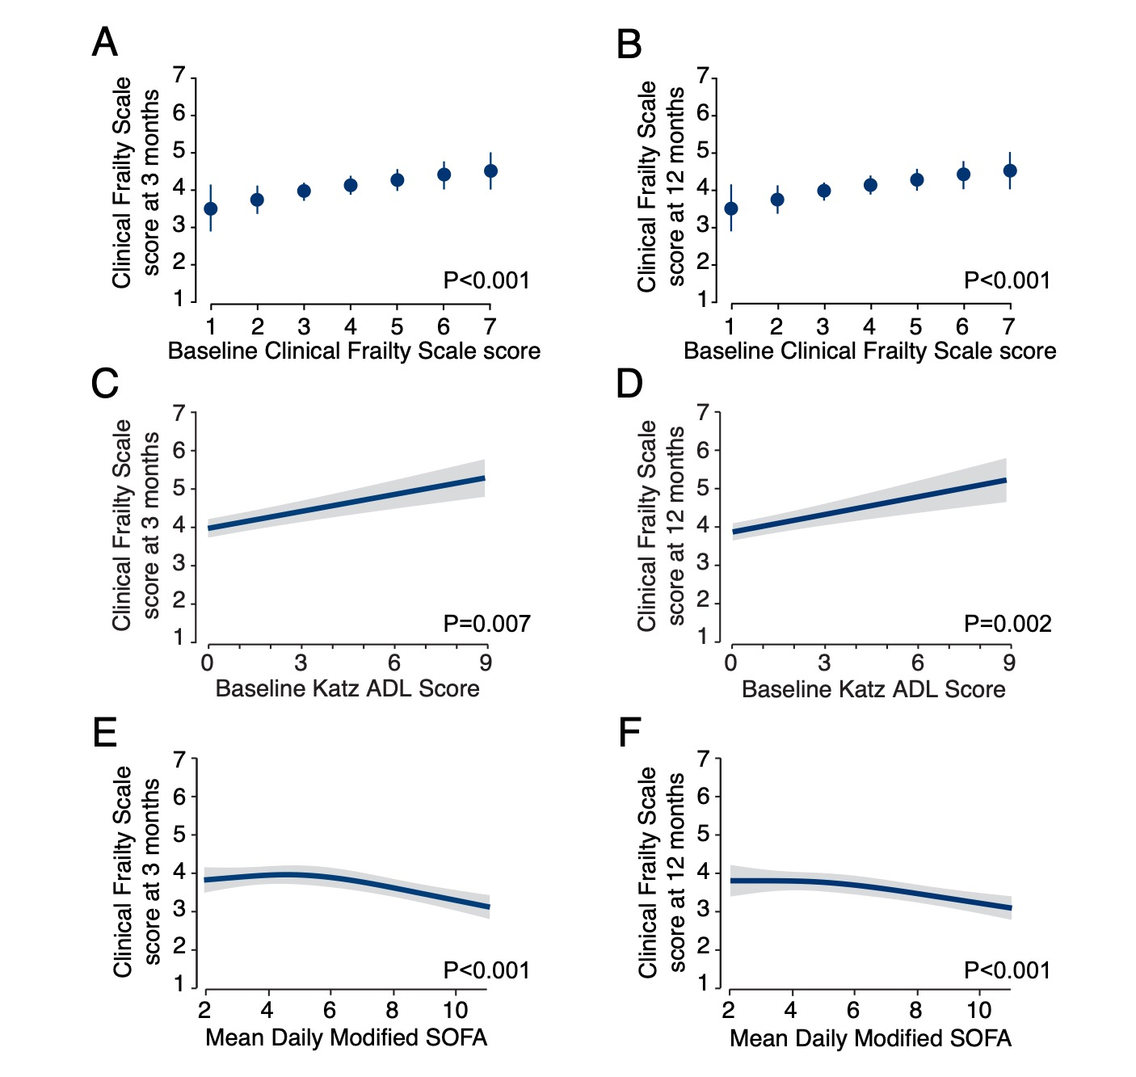
Figure S1 illustrates the adjusted associations between factors with Clinical Frailty Scale scores at 3 and 12 months. For panels A and B, blue dots represent the point estimate and vertical lines represent the 95% confidence intervals. For panels C, D, E, and F, the blue line represents the association and the grey shaded area represents the 95% confidence interval. Panels A and B demonstrate the positive association between baseline (i.e., in the 2 months prior to critical illness) with greater Clinical Frailty Scale scores at 3 (Panel A) and 12 months (Panel B). Panels C and D demonstrate the positive association between baseline Katz ADL scores (x-axis) with higher Clinical Frailty Scale scores at 3 (Panel C) and 12 months (Panel D). Panels E and F demonstrate the negative association between mean daily modified sequential organ failure score (x-axis) with lower Clinical Frailty Scale scores at 3 (Panel E) and 12 months (Panel F).

References:
1. Rockwood K, Song X, MacKnight C, et al. A global clinical measure of fitness and frailty in elderly people. CMAJ. 2005;173(5):489-495.
2. Bagshaw SM, Stelfox HT, McDermid RC, et al. Association between frailty and short- and long-term outcomes among critically ill patients: a multicentre prospective cohort study. CMAJ. 2014;186(2):E95-102.
3. Le Maguet P, Roquilly A, Lasocki S, et al. Prevalence and impact of frailty on mortality in elderly ICU patients: a prospective, multicenter, observational study. Intensive Care Med. 2014;40(5):674-682.
4. Brummel NE, Bell SP, Girard TD, et al. Frailty and Subsequent Disability and Mortality among Patients with Critical Illness. Am J Respir Crit Care Med. 2017;196(1):64-72.
5. Katz S, Ford AB, Moskowitz RW, Jackson BA, Jaffe MW. Studies of illness in the aged. The index of ADL: a standardized measure of biological and psychological function. JAMA. 1963;185:914-919.
6. Randolph C, Tierney MC, Mohr E, Chase TN. The Repeatable Battery for the Assessment of Neuropsychological Status (RBANS): preliminary clinical validity. J Clin Exp Neuropsychol. 1998;20(3):310-319.
7. Charlson ME, Pompei P, Ales KL, MacKenzie CR. A new method of classifying prognostic comorbidity in longitudinal studies: development and validation. J Chronic Dis. 1987;40(5):373-383.
8. Pfeffer RI, Kurosaki TT, Harrah CH, Jr., Chance JM, Filos S. Measurement of functional activities in older adults in the community. J Gerontol. 1982;37(3):323-329.
9. Ely EW, Inouye SK, Bernard GR, et al. Delirium in mechanically ventilated patients: validity and reliability of the confusion assessment method for the intensive care unit (CAM-ICU). JAMA. 2001;286(21):2703-2710.
10. Ely EW, Margolin R, Francis J, et al. Evaluation of delirium in critically ill patients: validation of the Confusion Assessment Method for the Intensive Care Unit (CAM-ICU). Crit Care Med. 2001;29(7):1370-1379.
11. Ely EW, Truman B, Shintani A, et al. Monitoring sedation status over time in ICU patients: reliability and validity of the Richmond Agitation-Sedation Scale (RASS). JAMA. 2003;289(22):2983-2991.
12. Sessler CN, Gosnell MS, Grap MJ, et al. The Richmond Agitation-Sedation Scale: validity and reliability in adult intensive care unit patients. Am J Respir Crit Care Med. 2002;166(10):1338-1344.
13. Levy MM, Fink MP, Marshall JC, et al. 2001 SCCM/ESICM/ACCP/ATS/SIS International Sepsis Definitions Conference. Crit Care Med. 2003;31(4):1250-1256.
14. Ferreira FL, Bota DP, Bross A, Melot C, Vincent JL. Serial evaluation of the SOFA score to predict outcome in critically ill patients. JAMA. 2001;286(14):1754-1758.

