Supplemental Figures and Tables

Supplemental Figure 1. Critical care settings among included studies

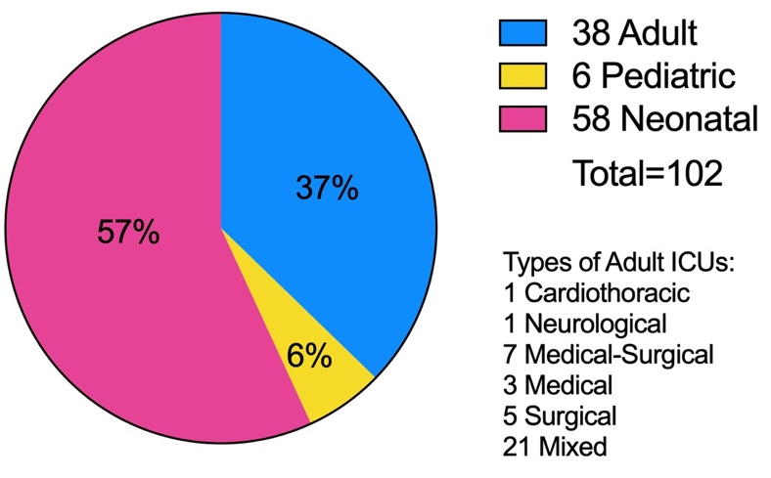

Supplemental Figure 2. Classification of (a) intervention stage, (b) critical care setting, (c) enrolled caregivers, (d) duration of intervention¹, (e) last time point of follow-up, and (f) attrition of enrolled caregivers²

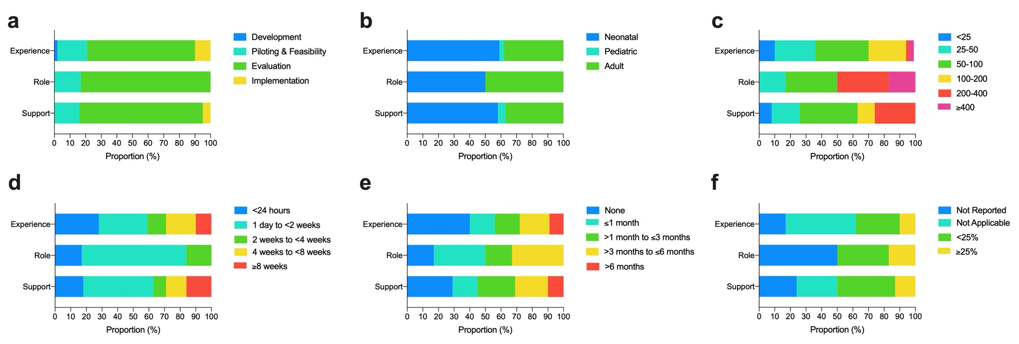

¹Total duration of intervention; studies where duration depended on length of stay were categorized according to median length of stay
²Percent of enrolled caregivers lost to last time point of study (i.e., last day of intervention duration or last point of follow-up)

Supplemental Figure 3. Meta-analysis of caregiver (a) PTSD and (b) distress. Parentheses following study reference denote intervention type: (E), caregiver experience; (R), caregiver role; (S), caregiver support. Asterisk indicates adult ICU.

(a) PTSD
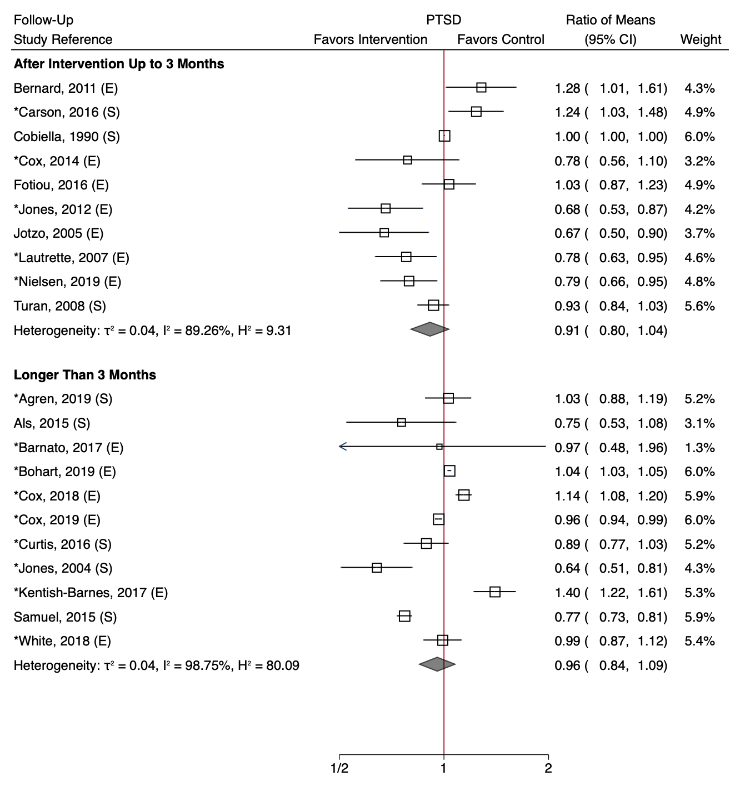

(b) distress
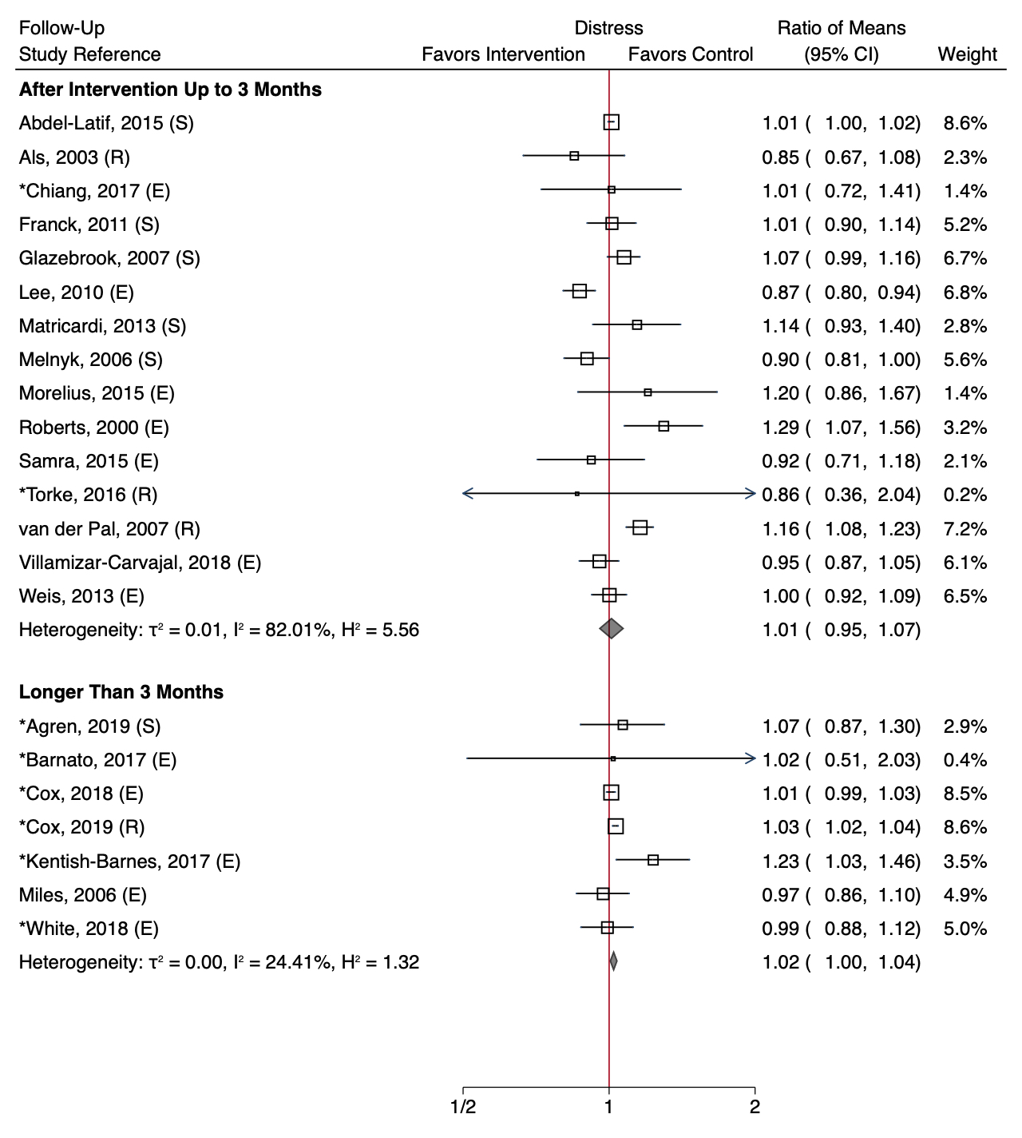

Supplemental Figure 4. Meta-analysis of caregiver courage, Parentheses following study reference denote intervention type: (E), caregiver experience; (R), caregiver role; (S), caregiver support. Asterisk indicates adult ICU.

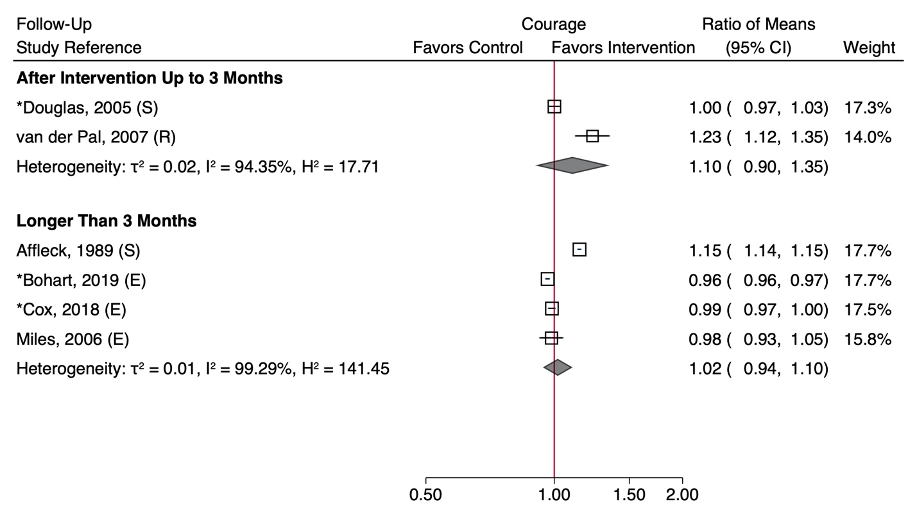

Supplemental Figure 5. Heat map characterizing intervention type and significant effects on (a) negative and (b) positive psychological outcomes among quasi-experimental and uncontrolled studies not amenable to meta-analysis

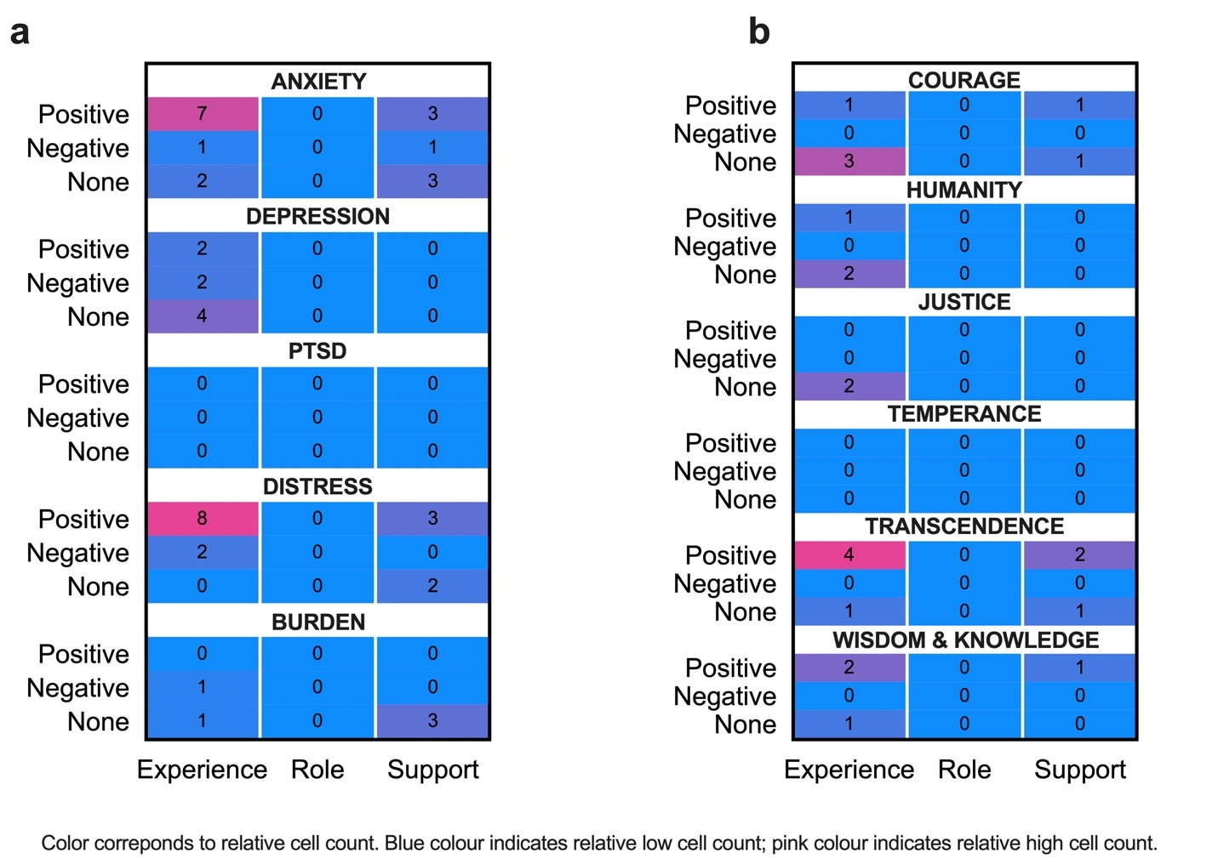

Supplemental Table 1. Preferred Reporting Items for Systematic review and Meta-Analyses (PRISMA) Checklist
Section/topic | # | Checklist item | Reported on page #
TITLE
Title | 1 | Identify the report as a systematic review, meta-analysis, or both. | 1
ABSTRACT
Structured summary | 2 | Provide a structured summary including, as applicable: background; objectives; data sources; study eligibility criteria, participants, and interventions; study appraisal and synthesis methods; results; limitations; conclusions and implications of key findings; systematic review registration number. | 4
INTRODUCTION
Rationale | 3 | Describe the rationale for the review in the context of what is already known. | 5
Objectives | 4 | Provide an explicit statement of questions being addressed with reference to participants, interventions, comparisons, outcomes, and study design (PICOS). | 5
METHODS
Protocol and registration | 5 | Indicate if a review protocol exists, if and where it can be accessed (e.g., Web address), and, if available, provide registration information including registration number. | 5
Eligibility criteria | 6 | Specify study characteristics (e.g., PICOS, length of follow-up) and report characteristics (e.g., years considered, language, publication status) used as criteria for eligibility, giving rationale. | 6
Information sources | 7 | Describe all information sources (e.g., databases with dates of coverage, contact with study authors to identify additional studies) in the search and date last searched. | 6-7
Search | 8 | Present full electronic search strategy for at least one database, including any limits used, such that it could be repeated. | S. Table 3
Study selection | 9 | State the process for selecting studies (i.e., screening, eligibility, included in systematic review, and, if applicable, included in the meta-analysis). | 7
Data collection process | 10 | Describe method of data extraction from reports (e.g., piloted forms, independently, in duplicate) and any processes for obtaining and confirming data from investigators. | 7-8
Data items | 11 | List and define all variables for which data were sought (e.g., PICOS, funding sources) and any assumptions and simplifications made. | 8-9  S. Table 1
Risk of bias in individual studies | 12 | Describe methods used for assessing risk of bias of individual studies (including specification of whether this was done at the study or outcome level), and how this information is to be used in any data synthesis. | 8-9
Summary measures | 13 | State the principal summary measures (e.g., risk ratio, difference in means). | 9
Synthesis of results | 14 | Describe the methods of handling data and combining results of studies, if done, including measures of consistency (e.g., I²) for each meta-analysis. | 9

Section/topic | # | Checklist item | Reported on page #
Risk of bias across studies | 15 | Specify any assessment of risk of bias that may affect the cumulative evidence (e.g., publication bias, selective reporting within studies). | 9
Additional analyses | 16 | Describe methods of additional analyses (e.g., sensitivity or subgroup analyses, meta-regression), if done, indicating which were pre-specified. | 9
RESULTS
Study selection | 17 | Give numbers of studies screened, assessed for eligibility, and included in the review, with reasons for exclusions at each stage, ideally with a flow diagram. | 9  Figure 1
Study characteristics | 18 | For each study, present characteristics for which data were extracted (e.g., study size, PICOS, follow-up period) and provide the citations. | 10-13  S. Table 3
Risk of bias within studies | 19 | Present data on risk of bias of each study and, if available, any outcome level assessment (see item 12). | 14  S. Results  S. Table 10  S. Table 11
Results of individual studies | 20 | For all outcomes considered (benefits or harms), present, for each study: (a) simple summary data for each intervention group (b) effect estimates and confidence intervals, ideally with a forest plot. | 10-13  Figure 4  Figure 5  Figure 6  Figure 7  Figure 8  S. Figure 3  S. Figure 4
Synthesis of results | 21 | Present results of each meta-analysis done, including confidence intervals and measures of consistency. | 10-14  Figure 2  Figure 3  S. Table 7
Risk of bias across studies | 22 | Present results of any assessment of risk of bias across studies (see Item 15). | 14  S. Results  S. Table 12
Additional analysis | 23 | Give results of additional analyses, if done (e.g., sensitivity or subgroup analyses, meta-regression [see Item 16]). | 14  S. Table 5  S. Table 6  S. Table 8  S. Table 9
DISCUSSION
Summary of evidence | 24 | Summarize the main findings including the strength of evidence for each main outcome; consider their relevance to key groups (e.g., healthcare providers, users, and policy makers). | 14-18
Limitations | 25 | Discuss limitations at study and outcome level (e.g., risk of bias), and at review-level (e.g., incomplete retrieval of identified research, reporting bias). | 18
Conclusions | 26 | Provide a general interpretation of the results in the context of other evidence, and implications for future research. | 18
FUNDING
Funding | 27 | Describe sources of funding for the systematic review and other support (e.g., supply of data); role of funders for the systematic review. | 3

From: Moher D, Liberati A, Tetzlaff J, Altman DG, The PRISMA Group (2009). Preferred Reporting Items for Systematic Reviews and Meta-Analyses: The PRISMA Statement. PLoS Med 6(7): e1000097. doi:10.1371/journal.pmed1000097
Supplemental Table 2. Classification framework for intervention type, stage of intervention, and caregiver psychological outcomes

Intervention type¹ | Operational Definition
Caregiver experience | Interventions aimed at caregiver distress and negative emotions, difficulty or deteriorating relationships, balancing the need to relieve suffering with the desire to communicate, or helplessness versus control.
Caregiver role | Interventions aimed at caregiver detection and prevention of patient delirium, monitoring patient symptoms, or advocating for the patient.
Caregiver support | Interventions aimed at caregiver knowledge on delirium, advice on how to respond to the patient, caregiver support systems, or patient outcomes.
Stage of Intervention⁶ | Operational Definition
Development | Identifying the evidence base; identifying/developing theory; modelling process and outcomes.
Piloting & Feasibility | Testing procedures; estimating recruitment/retention; determining sample size.
Evaluation | Assessing effectiveness; understanding change process; assessing cost-effectiveness.
Implementation | Dissemination; surveillance and monitoring; long-term follow up.
Negative Psychological Outcome | Operational Definition
Anxiety² | An emotion characterized by feelings of tension, worried thoughts, physical changes like increased blood pressure. People with anxiety disorders usually have recurring intrusive thoughts or concerns; avoid certain situations out of worry; have physical symptoms such as sweating, trembling, dizziness, or a rapid heartbeat.
Depression² | People with depression may experience a lack of interest and pleasure in daily activities; significant weight loss or gain; insomnia or excessive sleeping; lack of energy; inability to concentrate; feelings of worthlessness or excessive guilt; and recurrent thoughts of death or suicide.
PTSD² | An anxiety problem that develops after extremely traumatic events. People with PTSD may relive the event via intrusive memories, flashbacks and nightmares; avoid anything that reminds them of the trauma; and have anxious feelings they didn’t have before that are so intense their lives are disrupted.
Psychological distress³ | The unique discomforting, emotional state experienced by an individual in response to a specific stressor or demand, that results in temporary or permanent harm to the person. People who experience psychological distress may be unable to effectively cope; rapidly change emotional status; have difficulty communicating; experience feelings of discomfort or harm.
Psychological burden⁴ | Emotions such as concern or uneasiness due to a person’s worry about the success or failure of their role, which are affected by the workload and work conditions of their role. People who experience psychological burden often feel the need to do more.
Positive Psychological Outcome⁵ | Operational Definition
Courage | Bravery, coping, resilience, persistence, integrity, vitality, or zest.
Humanity | Love, kindness, or social intelligence.
Justice | Citizenship, fairness, or leadership.
Temperance | Forgiveness and mercy, humility, prudence, or self-control.
Transcendence | Appreciation of beauty and excellence, gratitude, hope, humor, spirituality, or satisfaction.
Wisdom & Knowledge | Creativity, curiosity, open-mindedness, love of learning, perspective, or innovation.

¹Adapted from Finucane et al., 2017
²As defined by American Psychological Association
³As defined by Ridner et al., 2003
⁴As defined by Kim et al., 2018
⁵Adapted from the Character Strengths and Virtues by Peterson and Seligman et al., 2004
⁶Adapted from the Medical Research Council and National Institutes of Health Research 2019 joint publication on "Developing and Evaluating Complex Interventions to Improve Health"

Supplemental Table 3. Complete MEDLINE search strategy
Population  (Informal or Family Caregivers) | Setting  (Critically Ill) | Interventions  (Psychological) | All
1. Exp Caregivers/  2. Exp Family/  3. Family.mp  4. Families.mp.  5. Caregiv*.mp.  6. “care giv*”.mp.  7. Carer*.mp.  8. Spouse.mp.  9. “next of kin".mp.  10. Support person.mp.  11. “loved one*”.mp.  12. “Significant other*”.mp.  13. Partner.mp.  14. Relative.mp.  15. Proxy.mp.  16. Surrogate.mp.  17. Friend.mp.  18. Or/1-17 | 19. Exp Intensive Care Unit/  20. “intensive care”.mp.  21. ICU.mp.  22. Critical* ill.mp.  23. “critical care”.mp.  24. Or/19-23 | 25. exp Psychological Tests/  26. exp Resilience, Psychological/  27. exp Stress, Psychological/  28. Psychol*.mp  29. Or/25-28  30. “postintensive care syndrome-family”.mp.  31. “postintensive care syndrome family”.mp.  32. Or/30-31  33. “psychological distress”.mp.  34. “psychological stress”.mp.  35. Or/33-34  36. exp Depressive Disorder/  37. Depressive disorder*.mp.  38. Depress*.mp  39. Major depressive disorder.mp.  40. MDD.mp.  41. Or/36-40  42. Exp Posttraumatic stress disorder/  43. (Post adj2 traumatic stress).mp.  44. (Post adj2 traumatic syndrome).mp.  45. Posttraumatic stress.mp.  46. PTSD.mp.  47. Or/42-46  48. Exp Anxiety disorders/  49. Anxiety disorder*.mp.  50. Anxiety*.mp.  51. Generalized anxiety.mp.  52. Generalized anxiety disorder*.mp.  53. GAD.mp.  54. Or/48-53  55. “positive aspects of care”.mp.  56. “positive appraisal”.mp.  57. “positive experienc*”.mp.  58. “positive perception*”.mp  59. “positive impact*”.mp.  60. “personal growth”.mp.  61. Enjoyment.mp.  62. Satisfaction*.mp.  63. Benefit*.mp.  64. Hope.mp.  65. Gratification.mp.  66. Pleasure*.mp  67. Gain*.mp.  68. Uplift*.mp.  69. Strength.mp.  70. Reward*.mp.  71. Or/55-70  72. 29 or 32 or 35 or 41 or 47 or 54 or 71 | 73. 18 and 24 and 72  74. Exp animals/ not humans.sh  75. 73 not 74

mp=title, abstract, original title, name of substance word, subject hearing word, keyword heading word, protocol supplementary concept word, rare disease supplementary concept word, unique identifier
Supplemental Table 4. Characteristics of included studies according to intervention type

Caregiver Experience
Source | Design¹ | Sites (N) | Setting | Intervention | Stage | Duration² | Follow-Up | Caregivers³ (N) | Attrition⁴ (%)
Agren, 2015(1) | RCT | 1 | Surgical | Patient-Partner Psychoeducational Support | Piloting & Feasibility | 6 months | 3 months, 12 months | 42 | 23.81
Barnato, 2017(2) | RCT | 3 | Mixed | Storytelling | Piloting & Feasibility | 2 hours | 3 months, 6 months | 32 | 12.50
Bernard, 2011(3) | RCT | 1 | Neonatal | Brief Cognitive-Behavioral Therapy | Piloting & Feasibility | 2 weeks | 1 month | 56 | 3.57
Bohart, 2019(4) | RCT | 10 | Mixed | Recovery Programme | Evaluation | 3 months | 3 months, 12 months | 181 | 38.67
Cano Gimenez, 2015(5) | RCT | 1 | Neonatal | Five-Step Individualized Psychology Program | Evaluation | 4 weeks | None | 134 | N/A
Carvalho, 2009(6) | RCT | 1 | Neonatal | Psychological Support with Education | Evaluation | NICU stay | First Preterm Infant Appointment | 59 | N/A
Chiang, 2016(7) | Quasi-experimental | 1 | Mixed | Brief Cognitive-Behavioral Therapy | Evaluation | 2 hours | 5 days | 45 | 0.00
Chiang, 2017(8) | RCT | 1 | Mixed | Family Education | Evaluation | 2 hours | None | 74 | N/A
Clarke-Pounder, 2015(9) | RCT | 1 | Neonatal | Decision-Making Tool | Piloting & Feasibility | 3 days | 2 weeks | 20 | 0.00
Colville, 2010(10) | RCT | 1 | Pediatric | Pediatric Follow-Up Clinic | Evaluation | Single visit | 2 months, 5 months | 154 | 31.82
Combe, 2005(11) | Uncontrolled | 1 | Not reported | Patient and Family Diaries | Implementation | Up to 12 months | 2 months, 6 months, 12 months | 35 | 0.00
Cox, 2014(12) | RCT | 1 | Medical-surgical | Mindfulness Training Intervention | Evaluation | 6 weeks | None | 2 | N/A
Cox, 2018(13) | RCT | 5 | Medical-surgical | Coping Skills Training | Evaluation | 6 weeks | 3 months, 6 months | 86 | 23.26
de Bernardo, 2017(14) | Uncontrolled | 1 | Neonatal | Family Centred Care | Piloting & Feasibility | NICU stay | 60 days | 126 | 12.70
Ettenberger, 2017(15) | RCT | 1 | Neonatal | Music Therapy | Evaluation | NICU stay | None | 36 | N/A
Feeley, 2008(16) | Uncontrolled | 1 | Neonatal | Promoting Mothers Ability to Communicate | Piloting & Feasibility | NICU stay | 1.5 months, 6 months | 33 | N/A
Fotiou, 2016(17) | RCT | 1 | Neonatal | Relaxation Techniques | Evaluation | NICU stay | 10-15 days, 3 months | 59 | N/A
John, 2018(18) | Quasi-experimental | 1 | Neonatal | Activity Based Group Therapy | Evaluation | 4 weeks | None | 39 | N/A
Johnson, 2007(19) | Uncontrolled | 1 | Neonatal | Kangaroo Care | Implementation | 60 minutes | None | 18 | N/A
Jones, 2012(20) | RCT | 2 | Mixed | Family Diaries | Piloting & Feasibility | 2 months | 3 months | 36 | 16.67
Jotzo, 2005(21) | RCT | 1 | Neonatal | Trauma-Preventive Psychology | Evaluation | NICU stay | None | 50 | N/A
Kadivar, 2015(22) | Quasi-experimental | 2 | Neonatal | Narrative Writing | Evaluation | 10 days | None | 70 | N/A
Kaufer, 2008(23) | Uncontrolled | 1 | Medical | Psychosocial Palliative Care | Evaluation | Unclear | 2 to 16 months | 98 | 0.00
Kentish-Barnes, 2017(24) | RCT | 22 | Mixed | Condolence Letter | Evaluation | Within 3 days of death | 30 days, 6 months | 242 | 21.49
Kloos, 2008(25) | RCT | 1 | Surgical | Progress Diary | Evaluation | ICU stay | 3 days, 1 week | 91 | 0.00
Knapp, 2013(26) | Uncontrolled | 1 | Surgical | EPICS Family Bundle | Evaluation | ICU stay | 8 weeks | 84 | N/A
Koh, 2007(27) | RCT | 1 | Neonatal | Taped Conversations with Neonatologist | Evaluation | 10 days | 4 months, 12 months | 200 | N/A
Kucuk Alemdar, 2018(28) | Uncontrolled | 1 | Neonatal | Spiritual Care | Evaluation | 30-60 minutes | None | 62 | N/A
Lautrette, 2007(29) | RCT | 22 | Mixed | Communication Strategy and Brochure | Evaluation | Undefined single conference | 90 day | 126 | 0.00
Lee, 2010(30) | RCT | 3 | Neonatal | Bright Light Therapy | Piloting & Feasibility | 3 weeks | 3 weeks | 30 | 0.00
Lee, 2013(31) | Uncontrolled | 1 | Neonatal | Booklet & Nursing Guide | Evaluation | 2 weeks | 2 weeks | 69 | 0.00
Micik, 2002(32) | Quasi-experimental | 1 | Surgical | Nurse Information Sessions | Implementation | ICU stay | 5 days, 5 months | 40 | 2.50
Miles, 2006(33) | RCT | 2 | Neonatal | Skin-To-Skin Contact | Evaluation | 4 weeks | 4 months, 12 months | 78 | 30.77
Morelius, 2015(34) | RCT | 2 | Neonatal | Skin-To-Skin Contact | Evaluation | 12 days | 1 month, 4 months | 37 | 13.51
Mouradian, 2013(35) | Uncontrolled | 1 | Neonatal | Art-Based Occupation Group | Evaluation | 2 hours | None | 40 | N/A
Nielsen, 2019(36) | RCT | 4 | Medical-surgical | Family Diaries | Evaluation | ICU stay | 3 months | 106 | 14.15
Noergaard, 2018(37) | Quasi-experimental | 1 | Neonatal | "More Father-Friendly NICU" | Evaluation | NICU stay | None | 109 | N/A
Pagnementa, 2016(38) | Uncontrolled | 4 | Mixed | Family Communication | Evaluation | ICU stay | Discharge | 163 | 27.61
Pineda, 2012(39) | Quasi-experimental | 1 | Neonatal | Single-Patient Room | Implementation | NICU stay | 5 weeks/term equivalence | 81 | 0.00
Preyde, 2003(40) | Quasi-experimental | 2 | Neonatal | Parent Buddy Program | Evaluation | NICU stay | 16 weeks | 60 | 18.33
Prichard, 2015(41) | Quasi-experimental | 1 | Mixed | Hand Massaging | Piloting & Feasibility | 3 days | None | 30 | N/A
Rennick, 2011(42) | RCT | 3 | Pediatric | Touch and Talk | Piloting & Feasibility | Unclear | None | 65 | N/A
Ribeiro, 2018(43) | RCT | 1 | Neonatal | Music Therapy | Evaluation | NICU stay | None | 21 | N/A
Roa, 2018(44) | Uncontrolled | 1 | Neonatal | Music Therapy | Implementation | NICU stay | None | 122 | N/A
Roberts, 2000(45) | RCT | 2 | Neonatal | Kangaroo Care | Evaluation | NICU stay | None | 30 | N/A
Rosa, 2018(46) | RCT | 36 | Mixed | Flexible Family Visitation | Evaluation | ICU stay | 30 days | 1685 | 86.05
Rosenbaum, 2015(47) | RCT | 1 | Neonatal | Neonatal Bereavement Support | Evaluation | At caregiver discretion | 3 months, 12 months | 75 | 30.67
Saenz, 2009(48) | RCT | 1 | Neonatal | Early Discharge | Evaluation | At discharge | 3 months | 171 | 18.13
Samra, 2015(49) | RCT | 2 | Neonatal | Skin-To-Skin Contact | Implementation | 3 hours | 24 hours before discharge | 40 | 15.00
Segre, 2013(50) | Uncontrolled | 1 | Neonatal | Listening Visits | Piloting & Feasibility | 1 month | None | 23 | N/A
Shaw, 2013(51) | RCT | 4 | Neonatal | Parental Trauma Prevention | Evaluation | 3 weeks or 4 weeks | 5 weeks | 103 | 4.85
Shaw, 2014(52) | RCT | 4 | Neonatal | Parental Trauma Prevention | Evaluation | 3 weeks or 4 weeks | 6 months | 103 | 7.77
Villamizar-Carvajal, 2018(53) | RCT | 3 | Neonatal | Creating Opportunities for Parent Engagement (COPE) | Evaluation | 2 weeks | None | 60 | N/A
Weis, 2013(54) | RCT | 1 | Neonatal | Guided Family-Centred Care | Evaluation | NICU stay | None | 134 | N/A
Welch, 2016(55) | RCT | 1 | Neonatal | Family Support | Evaluation | NICU stay | 4 months | 80 | 0.00
White, 2018(56) | RCT | 5 | Mixed | Family Support | Evaluation | ICU stay | 6 months | 1006 | 19.58
Wong, 2019(57) | Uncontrolled | 1 | Mixed | Social Support Network | Evaluation | ICU stay | None | 25 | N/A
Yun, 2017(58) | Uncontrolled | 1 | Neurological | Transition Nursing Program | Development | Pre-transfer | None | 94 | N/A
Caregiver Role
Source | Design¹ | Sites | Setting | Intervention | Stage | Duration² | Follow-Up | Caregivers³ | Attrition⁴
Als, 2003(59) | RCT | 3 | Neonatal | Newborn Individualized Developmental Care and Assessment Program | Evaluation | NICU stay | 2 weeks | 92 | 0.00
Azoulay, 2018(60) | RCT | 7 | Mixed | Family-Staff Communication Questions | Evaluation | 5 days | None | 302 | 52.65
Browne, 2005(61) | RCT | 1 | Neonatal | Family-Based Infant Intervention | Evaluation | 30-45 minutes | 1 month | 84 | 5.95
Cox, 2019(62) | RCT | 5 | Medical-surgical | Personalized Web-Based Decision Aid | Evaluation | 3 days | 3 months, 6 months | 416 | 21.63
Torke, 2016(63) | RCT | 1 | Mixed | Family Navigator | Piloting & Feasibility | 90% ICU stay | 8 weeks | 26 | 0.00
van der Pal, 2007(64) | RCT | 2 | Neonatal | Newborn Individualized Developmental Care and Assessment Program | Evaluation | NICU stay | 2 weeks | 360 | 0.00
Caregiver Support
Source | Design¹ | Sites | Setting | Intervention | Stage | Duration² | Follow-Up | Caregivers³ | Attrition⁴
Abdel-Latif, 2015(65) | RCT | 1 | Neonatal | Caregiver Bedside Presence | Evaluation | NICU stay | None | 72 | 25.40
Affleck, 1989(66) | RCT | 1 | Neonatal | Transitional Consultation Program | Evaluation | 15 weeks | 6 months | 94 | 0.00
Agren, 2019(67) | RCT | 2 | Mixed | Health Promoting Conversations | Piloting & Feasibility | 2 weeks | 3 months, 12 months | 17 | 41.18
Als, 2015(68) | RCT | 1 | Pediatric | Psychoeducational Tool | Piloting & Feasibility | 2 weeks | 6 months | 31 | 19.35
Breisinger, 2018(69) | Quasi-experimental | 1 | Cardiothoracic | Postcardiac Surgery Family Tool Kit | Implementation | At admission | None | 83 | N/A
Carson, 2016(70) | RCT | 4 | Medical | Family Emotional Support Meetings | Evaluation | 10 days | 3 months | 365 | 14.52
Chaboyer, 2007(71) | RCT | 1 | Medical-surgical | Liaison Nurse | Evaluation | 4 weeks "on call" | None | 100 | N/A
Chien, 2005(72) | Uncontrolled | 1 | Medical | Needs-Based Education Program | Evaluation | 3 days | None | 66 | N/A
Chourasia, 2013(73) | Uncontrolled | 1 | Neonatal | Counselling | Evaluation | 45 minutes | 48 hours | 100 | 0.00
Cobiella, 1990(74) | RCT | 1 | Neonatal | Prenatal Adaptation | Evaluation | 13 minutes | 1 week, 2 weeks | 30 | 30.00
Curtis, 2016(75) | RCT | 2 | Mixed | Communication Facilitator | Evaluation | 2 days | 3 months, 6 months | 268 | 54.48
Daly, 1994(76) | RCT | 1 | Surgical | Family Information Pack | Evaluation | ICU stay | None | 60 | N/A
de Alencar, 2009(77) | Uncontrolled | 1 | Neonatal | Kangaroo Care | Evaluation | NICU stay | 50 days | 177 | 2.26
Douglas, 2005(78) | RCT | 1 | Mixed | Family Diaries | Evaluation | At discharge | 2 months | 290 | 26.90
Egerod, 2011(79) | Uncontrolled | 2 | Medical-surgical | Family Diaries | Evaluation | Reading diary at leisure | 3 months, 12 months | 13 | 0.00
Franck, 2011(80) | RCT | 4 | Neonatal | Pain Management | Evaluation | NICU stay | 3 months | 213 | 20.66
Glazebrook, 2007(81) | RCT | 6 | Neonatal | Parenting Baby Interaction | Evaluation | 6 weeks | 3 months | 233 | 14.59
Hane, 2015(82) | RCT | 1 | Neonatal | Family Nurture Intervention | Evaluation | NICU stay | None | 65 | N/A
Holditch-Davis, 2013(83) | Quasi-experimental | 4 | Neonatal | Preterm Infant Interventions | Evaluation | NICU stay | 2 months | 208 | 0.00
Ingram, 2017(84) | Quasi-experimental | Multiple | Neonatal | Train-to-Home | Implementation | At discharge | Unclear | 245 | N/A
Jang, 2005(85) | Uncontrolled | 1 | Neonatal | Workbook | Evaluation | 3 days | 1 week | 32 | 0.00
Jones, 2004(86) | RCT | 2 | Mixed | Self-Help Manual | Evaluation | 6 weeks | 2 months, 6 months | 104 | 16.35
Matricardi, 2013(87) | RCT | 1 | Neonatal | Parental Specific NICU Intervention | Evaluation | 5 weeks | None | 42 | N/A
Melnyk, 1997(88) | Quasi-experimental | 1 | Pediatric | Creating Opportunities for Parent Engagement (COPE) | Evaluation | 2-16 hours after admission to 24-36 hours after transfer | 4 weeks | 30 | 13.33
Melnyk, 2001(89) | Quasi-experimental | 1 | Neonatal | Creating Opportunities for Parent Engagement (COPE) | Piloting & Feasibility | 2-4 days after admission until 1 week after discharge | 3 months, 6 months | 42 | 0.00
Melnyk, 2004(90) | RCT | 2 | Neonatal | Creating Opportunities for Parent Engagement (COPE) | Evaluation | 2-4 days after admission until 1 week after discharge | 3 months | 143 | 0.00
Melnyk, 2006(91) | RCT | 2 | Neonatal | Creating Opportunities for Parent Engagement (COPE) | Evaluation | 2-4 days after admission until 1 week after discharge | 1 week, 2 months | 260 | 5.00
Meyer, 1994(92) | RCT | 1 | Neonatal | Family-Based | Evaluation | At discharge | None | 34 dyads | N/A
Mitchell, 2004(93) | Uncontrolled | 1 | Mixed | Structured Individualize Transfer Method | Evaluation | 2 weeks | None | 162 | N/A
O'Brien, 2013(94) | Quasi-experimental | 1 | Neonatal | Family Integrated Care | Piloting & Feasibility | NICU stay | None | 93 | N/A
Ong, 2019(95) | Uncontrolled | 1 | Neonatal | Structured Nursing | Evaluation | 10 days | 2 weeks | 216 | 0.00
Preyde, 2007(96) | Quasi-experimental | 2 | Neonatal | Peer Support | Evaluation | Unclear | 4 months | 59 | 16.95
Rodriguez Martinez, 2003(97) | RCT | 1 | Mixed | Family Participation | Evaluation | 3 days | 12 months | 60 | 18.33
Roman, 1995(98) | Quasi-experimental | 1 | Neonatal | Parent-to-Parent Support | Piloting & Feasibility | 4 months | 4 months, 12 months | 58 | 18.97
Samuel, 2015(99) | RCT | 1 | Pediatric | Follow-Up Clinic | Piloting & Feasibility | 2 months | 6 months | 209 | 24.89
Shaw, 2014(100) | Uncontrolled | 3 | Medical-surgical | Family Communication | Evaluation | Unclear | 8 weeks | 67 | 19.40
Turan, 2008(101) | RCT | 1 | Neonatal | Stress Reduction | Evaluation | 10 days | None | 76 | N/A
Turner, 2009(102) | Uncontrolled | 1 | Neonatal | Neonatal Discharge Support Group | Evaluation | Open attendance without limit | 6 months | 9 | 0.00

¹RCT, randomized controlled trial; Quasi-experimental, non-randomized controlled trial; Uncontrolled, non-randomized uncontrolled trial
²Total duration of intervention
³Number of caregivers enrolled
⁴Percent of enrolled caregivers lost at last time point of study (i.e., last day of intervention duration or last point of follow-up)

Supplemental Table 5. Included studies with notable subgroups determined from study eligibility criteria

Source | Setting | Notable Subgroup
Browne, 2005 | Neonatal | Actual LOS >2 weeks
Matricardi, 2013 | Neonatal | Actual LOS >3 weeks
Lee, 2010 | Neonatal | Anticipated LOS >2 weeks
Lee, 2013 | Neonatal | Anticipated LOS >3 weeks
Cano Gimenez, 2015 | Neonatal | Anticipated LOS >4 weeks
Ribeiro, 2018 | Neonatal | Anticipated LOS >4 weeks
John, 2018 | Neonatal | Anticipated LOS >4 weeks
Clarke-Pounder, 2015 | Neonatal | Anticipated LOS >2 weeks
Segre, 2013 | Neonatal | Clinically depressed mothers only
Barnato, 2017 | Mixed | End of Life
Carson, 2016 | Medical | End of Life
Kaufer, 2008 | Medical | End of Life
Kentish-Barnes, 2017 | Mixed | End of Life
Lautrette, 2007 | Mixed | End of Life
Rosenbaum, 2015 | Neonatal | End of Life
White, 2018 | Mixed | End of Life
Combe, 2005 | Not reported | End of Life
Curtis, 2016 | Mixed | End of Life
Affleck, 1989 | Neonatal | ICU Transition
Chaboyer, 2007 | Medical-surgical | ICU Transition
Fotiou, 2016 | Neonatal | ICU Transition
Ingram, 2017 | Neonatal | ICU Transition
Jang, 2005 | Neonatal | ICU Transition
Melnyk, 1997 | Pediatric | ICU Transition
Melnyk, 2001 | Neonatal | ICU Transition
Melnyk, 2004 | Pediatric | ICU Transition
Melnyk, 2006 | Neonatal | ICU Transition
Mitchell, 2004 | Mixed | ICU Transition
Roman, 1995 | Neonatal | ICU Transition
Saenz, 2009 | Neonatal | ICU Transition
Turner, 2009 | Neonatal | ICU Transition
Yun, 2017 | Neurological | ICU Transition

Sorted first by subgroup then by source alphabetically

Supplemental Table 6. Summary of findings from long-term follow-up of interventions

Follow-Up of One Month or Less
Source | Intervention | Last Point of Follow-Up | Psychological Outcomes | Significant Effect of  Intervention¹
Als, 2003 | Newborn Individualized Developmental Care and Assessment Program | 6 months | Distress | Decreased distress
Bernard, 2011 | Brief Cognitive-Behavioral Therapy | 1 month | Depression, PTSD | None
Browne, 2005 | Family-Based Infant Intervention | 1 month | Distress, Wisdom & Knowledge | Decreased distress, Increased wisdom & knowledge
Chiang, 2017 | Family Education | 5 days | Anxiety, Depression, Distress, Courage, Humanity, Justice, Transcendence, Wisdom & Knowledge | None
Chourasia, 2013 | Counselling | 48 hours | Distress | Decreased distress
Clarke-Pounder, 2015 | Decision-Making Tool | 2 weeks | Anxiety, Transcendence | None
Cobiella, 1990 | Prenatal Adaptation | 2 weeks | Anxiety, Depression, PTSD | Decreased anxiety
Jang, 2005 | Workbook | 1 week | Distress, Courage | None
Kloos, 2008 | Progress Diary | 1 week | Anxiety | None
Lee, 2010 | Bright Light Therapy | 3 weeks | Depression | None
Lee, 2013 | Booklet & Nursing Guide | 2 weeks | Distress, Burden | Decreased distress
Melnyk, 1997 | Creating Opportunities for Parent Engagement (COPE) | 4 weeks | Anxiety, Depression, PTSD, Distress | Decreased PTSD
Ong, 2019 | Structured Nursing | 2 weeks | Distress | Decreased distress
Rosa, 2018 | Flexible Family Visitation | 30 days | Anxiety, Depression, Temperance | Decreased anxiety, Decreased depression, Increased Temperance
van der Pal, 2007 | Newborn Individualized Developmental Care and Assessment Program | 2 weeks | Distress, Courage | Decreased distress
Follow-Up Longer Than One Month to Three Months
Source | Intervention | Last Point of Follow-Up | Psychological Outcomes | Significant Effect of Intervention¹
Carson, 2016 | Family Emotional Support Meetings | 3 months | Anxiety, Depression, PTSD | Increased PTSD
de Alencar, 2009 | Kangaroo Care | 50 days | Depression | Decreased depression
de Bernardo, 2017 | Family Centred Care | 60 days | Distress, Courage, Humanity, Wisdom & Knowledge
Douglas, 2005 | Family Diaries | 2 months | Depression, Burden, Courage | None
Fotiou, 2016 | Relaxation Techniques | 3 months | Anxiety, PTSD | None
Franck, 2011 | Pain Management | 3 months | Anxiety, Depression, Distress, Burden | None
Glazebrook, 2007 | Parenting Baby Interaction | 3 months | Distress, Humanity | None
Holditch-Davis, 2013 | Preterm Infant Interventions | 2 months | Anxiety, Depression, PTSD, Distress | None
Jones, 2012 | Family Diaries | 3 months | PTSD | Decreased PTSD
Knapp, 2013 | EPICS Family Bundle | 8 weeks | Courage, Humanity, Justice | None
Lautrette, 2007 | Communication Strategy and Brochure | 90 day | Anxiety, Depression, PTSD | Decreased anxiety, Decreased depression, Decreased PTSD
Melnyk, 2004 | Creating Opportunities for Parent Engagement (COPE) | 3 months | Anxiety, Depression | None
Melnyk, 2006 | Creating Opportunities for Parent Engagement (COPE) | 2 months | Anxiety, Depression, Distress, Burden, Transcendence | Decreased anxiety, Decreased depression, Decreased distress, Increased transcendence
Nielsen, 2019 | Family Diaries | 3 months | Anxiety, Depression, Distress | None
Pineda, 2012 | Single-Patient Room | 5 weeks | Anxiety, Depression, Distress, Courage | Increased distress
Saenz, 2009 | Early Discharge | 3 months | Anxiety, Depression, Courage | Decreased depression
Shaw, 2013 | Family Communication | 8 weeks | Temperance, Transcendence | Increased temperance
Shaw, 2013 | Parental Trauma Prevention | 5 weeks | Anxiety, Depression, PTSD | Decreased depression, Decreased PTSD
Torke, 2016 | Family Navigator | 8 weeks | Anxiety, Depression, Distress, Burden | None
Follow-Up Longer Than Three Months to Six Months
Source | Intervention | Last Point of Follow-Up | Psychological Outcomes | Significant Effect of Intervention¹
Affleck, 1989 | Transitional Consultation Program | 6 months | Anxiety, Depression, Burden, Courage | Increased courage
Als, 2015 | Psychoeducational Tool | 6 months | Anxiety, Depression, PTSD | None
Barnato, 2017 | Storytelling | 6 months | Anxiety, Depression, PTSD, Distress, Burden | None
Colville, 2010 | Pediatric Follow-Up Clinic | 5 months | Anxiety, Depression, PTSD | None
Cox, 2018 | Coping Skills Training | 6 months | Anxiety, Depression, PTSD, Distress, Courage, Temperance, Transcendence | None
Cox, 2019 | Personalized Web-Based Decision Aid | 6 months | Anxiety, Depression, PTSD, Distress, Transcendence, Wisdom & Knowledge | None
Curtis, 2016 | Communication Facilitator | 6 months | Anxiety, Depression, PTSD | Decreased depression
Feeley, 2008 | Promoting Mothers Ability to Communicate | 6 months | Anxiety, PTSD, Distress | None
Jones, 2004 | Self-Help Manual | 6 months | Anxiety, Depression, PTSD | None
Kentish-Barnes, 2017 | Condolence Letter | 6 months | PTSD, Distress | None
Melnyk, 2001 | Creating Opportunities for Parent Engagement (COPE) | 6 months | Anxiety, Depression, Distress, Burden | None
Micik, 2002 | Nurse Information Sessions | 5 months | Distress | Decreased distress
Morelius, 2015 | Skin-To-Skin Contact | 4 months | Depression, Distress | None
Preyde, 2003 | Parent Buddy Program | 16 weeks | Anxiety, Depression, Distress | Decreased anxiety, Decreased depression, Decreased distress
Preyde, 2007 | Peer Support | 4 months | Courage, Transcendence, Wisdom & Knowledge | Increased courage, Increased transcendence, Increased wisdom & knowledge
Samuel, 2015 | Follow-Up Clinic | 6 months | Anxiety, Depression, PTSD | Decreased anxiety, Decreased depression, Decreased PTSD
Shaw, 2014 | Parental Trauma Prevention | 6 months | Anxiety, Depression, PTSD | Decreased anxiety, Decreased depression, Decreased PTSD
Welch, 2016 | Family Support | 4 months | Anxiety, Depression | Decreased anxiety, Decreased depression
White, 2018 | Family Support | 6 months | Depression, Distress, Transcendence | Increased transcendence
Follow-Up Longer Than Six Months
Source | Intervention | Last Point of Follow-Up | Psychological Outcomes | Significant Effect of Intervention¹
Agren, 2015 | Patient-Partner Psychoeducational Support | 12 months | Depression | None
Agren, 2019 | Health Promoting Conversations | 12 months | PTSD, Distress, Burden, Transcendence | Decreased PTSD, Decreased distress, Decreased burden
Bohart, 2019 | Recovery Programme | 12 months | Anxiety, Depression, PTSD, Courage | None
Kaufer, 2008 | Psychosocial Palliative Care | 16 months | Anxiety, Transcendence, Wisdom & Knowledge | Decreased anxiety, Increased Transcendence, Increased Wisdom & Knowledge
Koh, 2007 | Taped Conversations with Neonatologist | 12 months | Anxiety, Depression, PTSD, Transcendence | Increased transcendence
Miles, 2006 | Skin-To-Skin Contact | 12 months | Anxiety, Depression, Distress, Burden, Transcendence | None
Robinson, 1998 | Witnessed Resuscitation | 9 months | Anxiety, Depression, Distress | None
Rodriguez Martinez, 2003 | Family Participation | 12 months | Anxiety | Decreased anxiety
Roman, 1995 | Parent-to-Parent Support | 12 months | Anxiety, Depression, Burden | Decreased anxiety
Rosenbaum, 2015 | Neonatal Bereavement Support | 12 months | Depression, Burden, Transcendence | Increased depression, Increased burden, Decreased transcendence
Agren, 2015 | Patient-Partner Psychoeducational Support | 12 months | Depression | None

¹Effect deemed significant when at least p<0.05

Supplemental Table 7. Estimates for ratio of means for each type of psychological outcome
Psychological Outcome | Corresponding Figure | Subgroup | No. Included Estimates | Estimate (95% CI) | Interpretation of Estimate
Anxiety |  | After Intervention | 7 | 0.92 (0.84-1.01) | No statistical difference
 |  | At 1 Month or Less | 4 | 0.89 (0.80-1.00) | No statistical difference
 |  | Longer Than 1 Month Up to 3 Months | 8 | 0.92 (0.85-1.01) | No statistical difference
 |  | Longer Than 3 Months Up to 6 Months | 10 | 0.94 (0.89-0.99) | Favours intervention
 |  | Longer Than 6 Months | 4 | 1.00 (0.87-1.15) | No statistical difference
 |  | After Intervention Up to 3 Months | 19 | 0.92 (0.87-0.97) | Favours intervention
 |  | Longer Than 3 Months | 14 | 0.96 (0.91-1.02) | No statistical difference
 |  | Adult ICU | 16 | 0.92 (0.86-0.99) | Favours intervention
 |  | Neonatal or Pediatric ICU | 17 | 0.94 (0.90-0.98) | Favours intervention
 |  | Caregiver Experience | 18 | 0.92 (0.87-0.99) | Favours intervention
 |  | Caregiver Role | 2 | 0.99 (0.96-1.01) | No statistical difference
 |  | Caregiver Support | 13 | 0.94 (0.90-0.99) | Favours intervention
Depression |  | After Intervention | 6 | 0.75 (0.48-1.19) | No statistical difference
 |  | At 1 Month or Less | 5 | 0.85 (0.65-1.10) | No statistical difference
 |  | Longer Than 1 Month Up to 3 Months | 8 | 0.88 (0.75-1.03) | No statistical difference
 |  | Longer Than 3 Months Up to 6 Months | 10 | 0.91 (0.75-1.10) | No statistical difference
 |  | Longer Than 6 Months | 3 | 1.37 (1.05-1.79) | Favours control
 |  | After Intervention Up to 3 Months | 19 | 0.83 (0.69-0.99) | Favours intervention
 |  | Longer Than 3 Months | 13 | 0.99 (0.83-1.20) | No statistical difference
 |  | Adult ICU | 15 | 0.97 (0.98-1.07) | No statistical difference
 |  | Neonatal or Pediatric ICU | 17 | 0.84 (0.67-1.05) | No statistical difference
 |  | Caregiver Experience | 18 | 0.95 (0.82-1.11) | No statistical difference
 |  | Caregiver Role | 2 | 1.05 (0.74-1.50) | No statistical difference
 |  | Caregiver Support | 12 | 0.80 (0.62-1.02) | No statistical difference
PTSD |  | After Intervention | 3 | 0.82 (0.67-1.01) | No statistical difference
 |  | At 1 Month or Less | 2 | 1.10 (0.87-1.39) | No statistical difference
 |  | Longer Than 1 Month Up to 3 Months | 5 | 0.89 (0.72-1.10) | No statistical difference
 |  | Longer Than 3 Months Up to 6 Months | 9 | 0.93 (0.80-1.10) | No statistical difference
 |  | Longer Than 6 Months | 2 | 1.04 (1.03-1.05) | Favours control
 |  | After Intervention Up to 3 Months | 10 | 0.91 (0.80-1.04) | No statistical difference
 |  | Longer Than 3 Months | 11 | 0.96 (0.84-1.09) | No statistical difference
 |  | Adult ICU | 14 | 0.95 (0.84-1.06) | No statistical difference
 |  | Neonatal or Pediatric ICU | 7 | 0.91 (0.79-1.06) | No statistical difference
 |  | Caregiver Experience | 12 | 0.95 (0.83-1.10) | No statistical difference
 |  | Caregiver Role | 1 | 0.96 (0.94-0.99) | Favours intervention
 |  | Caregiver Support | 8 | 0.90 (0.79-1.03) | Favours intervention
Distress |  | After Intervention | 7 | 1.03 (0.97-1.09) | No statistical difference
 |  | At 1 Month or Less | 4 | 0.97 (0.82-1.15) | No statistical difference
 |  | Longer Than 1 Month Up to 3 Months | 4 | 0.99 (0.90-1.10) | No statistical difference
 |  | Longer Than 3 Months Up to 6 Months | 5 | 1.02 (1.00-1.04) | Favours control
 |  | Longer Than 6 Months | 2 | 1.00 (0.90-1.11) | No statistical difference
 |  | After Intervention Up to 3 Months | 15 | 1.02 (0.95-1.07) | No statistical difference
 |  | Longer Than 3 Months | 7 | 1.02 (1.00-1.04) | No statistical difference
 |  | Adult ICU | 7 | 1.02 (1.00-1.04) | Favours control
 |  | Neonatal or Pediatric ICU | 15 | 1.01 (0.95-1.07) | No statistical difference
 |  | Caregiver Experience | 12 | 1.01 (0.94-1.08) | No statistical difference
 |  | Caregiver Role | 3 | 1.04 (0.90-1.20) | No statistical difference
 |  | Caregiver Support | 7 | 1.01 (0.97-1.07) | No statistical difference
Burden |  | After Intervention | 0 | N/A | N/A
 |  | At 1 Month or Less | 1 | 1.35 (0.98-1.87) | No statistical difference
 |  | Longer Than 1 Month Up to 3 Months | 4 | 1.07 (1.03-1.13) | Favours control
 |  | Longer Than 3 Months Up to 6 Months | 2 | 0.91 (0.74-1.13) | No statistical difference
 |  | Longer Than 6 Months | 2 | 0.94 (0.79-1.12) | Favours control
 |  | After Intervention Up to 3 Months | 5 | 1.08 (1.05-1.12) | Favours control
 |  | Longer Than 3 Months | 4 | 0.93 (0.81-1.06) | No statistical difference
 |  | Adult ICU | 3 | 1.02 (0.81-1.27) | No statistical difference
 |  | Neonatal or Pediatric ICU | 5 | 1.05 (0.99-1.12) | No statistical difference
 |  | Caregiver Experience | 3 | 1.14 (0.90-1.45) | No statistical difference
 |  | Caregiver Role | 0 | N/A | N/A
 |  | Caregiver Support | 6 | 1.04 (0.97-1.11) | No statistical difference
Courage |  | After Intervention | 0 | N/A | N/A
 |  | At 1 Month or Less | 1 | 1.23 (1.12-1.35) | Favours intervention
 |  | Longer Than 1 Month Up to 3 Months | 1 | 1.00 (0.97-1.03) | No statistical difference
 |  | Longer Than 3 Months Up to 6 Months | 2 | 1.06 (0.92-1.23) | No statistical difference
 |  | Longer Than 6 Months | 2 | 0.96 (0.96-0.97) | Favours control
 |  | After Intervention Up to 3 Months | 2 | 1.10 (0.90-1.35) | No statistical difference
 |  | Longer Than 3 Months | 4 | 1.02 (0.94-1.10) | No statistical difference
 |  | Adult ICU | 3 | 0.98 (0.96-1.00) | Favours control
 |  | Neonatal or Pediatric ICU | 3 | 1.11 (0.98-1.26) | Favours intervention
 |  | Caregiver Experience | 3 | 0.97 (0.96-0.99) | Favours control
 |  | Caregiver Role | 1 | 1.23 (1.12-1.35) | Favours intervention
 |  | Caregiver Support | 2 | 1.07 (0.94-1.22) | No statistical difference
Humanity |  | After Intervention | 2 | 1.07 (0.91-1.25) | No statistical difference
 |  | At 1 Month or Less | 0 | N/A | N/A
 |  | Longer Than 1 Month Up to 3 Months | 1 | 1.10 (0.9801.24) | No statistical difference
 |  | Longer Than 3 Months Up to 6 Months | 0 | N/A | N/A
 |  | Longer Than 6 Months | 0 | N/A | N/A
 |  | After Intervention Up to 3 Months | 3 | 1.11 (1.07-1.15) | Favours intervention
 |  | Longer Than 3 Months | 0 | N/A | N/A
 |  | Adult ICU | 0 | N/A | N/A
 |  | Neonatal or Pediatric ICU | 3 | 1.11 (1.07-1.15) | Favours intervention
 |  | Caregiver Experience | 1 | 0.91 (0.67-1.23) | No statistical difference
 |  | Caregiver Role | 0 | N/A | N/A
 |  | Caregiver Support | 2 | 1.11 (1.07-1.15) | Favours intervention
Transcendence |  | After Intervention | 2 | 1.06 (1.04-1.08) | Favours intervention
 |  | At 1 Month or Less | 2 | 0.98 (0.78-1.23) | No statistical difference
 |  | Longer Than 1 Month Up to 3 Months | 3 | 1.03 (1.03-1.04) | Favours intervention
 |  | Longer Than 3 Months Up to 6 Months | 4 | 1.04 (1.00-1.08) | Favours intervention
 |  | Longer Than 6 Months | 3 | 1.00 (0.86-1.17) | No statistical difference
 |  | After Intervention Up to 3 Months | 7 | 1.04 (1.02-1.06) | Favours intervention
 |  | Longer Than 3 Months | 7 | 1.03 (0.97-1.09) | No statistical difference
 |  | Adult ICU | 7 | 1.04 (1.02-1.07) | Favours intervention
 |  | Neonatal or Pediatric ICU | 7 | 1.00 (0.93-1.08) | No statistical difference
 |  | Caregiver Experience | 7 | 1.02 (0.95-1.10) | No statistical difference
 |  | Caregiver Role | 2 | 1.04 (1.00-1.08) | Favours intervention
 |  | Caregiver Support | 5 | 1.04 (1.02-1.05) | Favours intervention

Supplemental Table 8. Summary of findings from interventions on caregiver psychological outcomes included in quantitative meta-analysis

Negative Psychological Outcomes
Outcome | Assessed By^{1,2} | Follow-Up Range | No. Studies³ | No. RCTs³ | GRADE of Evidence⁴
Anxiety | Beck Anxiety Inventory; Depression Anxiety Stress Scale; Hospital Anxiety and Depression Scale; Inventory of Situations and Responses of Anxiety; Profile of Mood States; State Trait Anxiety Inventory | 5 Days to 16 Months | 24 Adult; 26 Neonatal or Pediatric | 16 Adult; 15 Neonatal or Pediatric | Moderate
Depression | Beck Depression Inventory; Center for Epidemiologic Studies Depression Scale; Depression Adjective Checklist; Depression Anxiety Stress Scale; Edinburgh Postnatal Depression Scale; Hospital Anxiety and Depression Scale; Profile of Mood States | 5 Days to 12 Months | 17 Adult; 24 Neonatal or Pediatric | 15 Adult; 19 Neonatal or Pediatric | Moderate
PTSD | Davidson Trauma Scale; Harvard Trauma Questionnaire; Impact of Events Scale; Post Hospital Stress Index for Parents; Post-Traumatic Stress Symptoms; Post-Traumatic Symptom Scale; Short Form Health Survey | 2 Weeks to 12 Months | 14 Adult; 8 Neonatal or Pediatric | 14 Adult; 8 Neonatal or Pediatric | Moderate
Distress | Center for Epidemiological Studies Depression Scale; Decisional Conflict Scale; Depression Anxiety Stress Scale; Family Sense of Coherence; Global Short Form Mental Health; Inventory of Complicated Grief; Parenting Stress Index; Pediatric Stressor Scale; Prenatal Stressor Scale NICU; Symptoms of Stress Inventory; Swedish Parenthood Stress Questionnaire | 48 Hours to 12 Months | 11 Adult; 27 Neonatal or Pediatric | 8 Adult; 17 Neonatal or Pediatric | Low
Burden | Caregiver Reaction Assessment; Decision Regret Scale; Family Assessment Device; Index of Parent Behavior; Lee's Fatigue Scale; Measure of Social Support Scale; Montgomery-Borgatta Caregiver Burden; Profile of Mood States; The Worry Index | 2 Weeks to 12 Months | 6 Adult; 9 Neonatal or Pediatric | 4 Adult; 8 Neonatal or Pediatric | Low
Positive Psychological Outcomes
Outcome | Assessed By^{1,2} | Follow-Up Range | No. Studies³ | No. RCTs³ | GRADE of Evidence⁴
Courage | Brief Coping Inventory for Stressful Situations; Caregiver Reaction Assessment; Coping Inventory for Stressful Situations; Critical Care Family Needs Inventory; Critical Care Family Assistance Program Family Satisfaction Survey; Family Satisfaction with Care Questionnaire; ICU Family Satisfaction Survey; Parent to Infant Attachment; Self-Confidence Scale; Ways of Coping Checklist; Well Being Scale | 5 Days to 12 Months | 5 Adult; 8 Neonatal or Pediatric | 3 Adult; 4 Neonatal or Pediatric | Very Low
Humanity | Caring Dimensions Inventory; Critical Care Family Assistance Program Family Satisfaction Survey; Critical Care Family Needs Inventory; Maternal Caregiving Behavior; Neurobehavioral Assessment of Preterm Infant | 5 Days to 3 Months | 3 Adult; 4 Neonatal or Pediatric | 0 Adult; 3 Neonatal or Pediatric | Very Low
Justice | Caring Dimensions Inventory; Critical Care Family Assistance Program Family Satisfaction Survey; Critical Care Family Needs Inventory; ICU Family Satisfaction Survey; Parental Stress Scale; Self-Efficacy in Infant Care Scale | 5 Days to 8 Weeks | 2 Adult; 1 Neonatal or Pediatric | 0 Adult; 1 Neonatal or Pediatric | Very Low
Temperance | Caring Dimensions Inventory; Self-Efficacy Scale | 30 Days to 12 Months | 2 Adult; 0 Neonatal or Pediatric | 2 Adult; 0 Neonatal or Pediatric | Very Low
Transcendence | Caring Dimensions Inventory; Critical Care Family Assistance Program Family Satisfaction Survey; Critical Care Family Needs Inventory; EuroQoL Five Dimensions; Family Inventory of Needs Pediatric; Family Satisfaction with Care Questionnaire; Hearth Hope Index; ICU Family Satisfaction Survey; Maternal Self Report Inventory; Parental Behavior in the ICU; Parental Beliefs Scale NICU; Royal Free Interview for Spiritual and Religious Beliefs; Quality of Communications Scale; Quality of Life Enjoyment Satisfaction Questionnaire; Self-Efficacy in Infant Care Scale | 5 Days to 16 Months | 13 Adult; 9 Neonatal or Pediatric | 8 Adult; 6 Neonatal or Pediatric | Low
Wisdom & Knowledge | Critical Care Family Assistance Program Family Satisfaction Survey; Critical Care Family Needs Inventory; Family Satisfaction with Care Questionnaire; Knowledge of Preterm Infant Behavior; Medical Comprehension Scale | 1 Month to 16 Months | 3 Adult; 1 Neonatal or Pediatric | 1 Adult; 1 Neonatal or Pediatric | Very Low

RCT, randomized controlled trial
¹Clinical scales or assessment tools with published psychometric properties
²Portions of single questions of assessment tools were considered
³Quantitative studies that reported no outcome measures or that reported only correlations between outcomes were not counted
⁴Determined for RCTs that used clinical scales or assessment tools with published psychometric properties

Supplemental Table 9. Summary of findings from qualitative studies¹

Caregiver Experience
Source | Setting | Intervention | Analysis | Themes or Theory | Authors’ Conclusions
Rennick, 2011 | Pediatric | Pain management nursing intervention; Touch and Talk | Thematic | Importance of comforting the child- importance of parental presence; making a difference in the child's pain experience; feeling comfortable and confident about participating in care | Giving parents the choice of being involved in their child’s care using touch and distraction techniques during painful procedures can provide an invaluable opportunity to foster parenting and support the child during a difficult PICU experience.
Johnson, 2007 | Neonatal | Maternal kangaroo care | Thematic | Maternal-infant benefits of kangaroo holding; Need for support for holding; Satisfaction with interactions | Results led to increased understanding of the multifaceted advantages of kangaroo holding on maternal attachment behaviors.
Wong, 2019 | Adult | Social support network | Grounded theory | The core category was regaining control which represents the families' journey toward resilience within the ICU. The major categories represent facilitators and barriers to regaining control. One of the main facilitators was drawing strength, which explains the manner with which families receive social support from their own and other family members to help them cope. | Social support networks facilitate the families' ability to regain control. Further research is needed to determine whether families suffer a secondary stress reaction from individual interactions with other patients' families in the ICU.
Caregiver Role
Source | Setting | Intervention | Analysis | Themes or Theory | Authors’ Conclusions
Ingram, 2017 | Neonatal | Planned family-centred discharge process; Train-to-Home | Thematic | Practical preparation; Emotional preparation; Role of feeding | Using a parent-centred approach to communication and informing parents about the needs and progress of their preterm infant is welcomed by parents and staff.
Caregiver Support
Source | Setting | Intervention | Analysis | Themes or Theory | Authors’ Conclusions
Mouradian, 2013 | Neonatal | Art-based occupation group using scrapbooking | Thematic | Distraction; Calming & relaxing; Fun & enjoyable; Looking to the future; Time to share with others and reducing isolation | An art-based occupation group using scrapbooking is an effective brief intervention to reduce parent anxiety in the NICU, and parent interviews suggested that participation has broad clinical implications for parent well-being.
Turner, 2009 | Neonatal | Parent support group | Thematic | Recalling time in the nursery is distressing; Parents are anxious about taking their baby home; Anxiety about possible re-hospitalization of baby; Coping with ongoing medical needs after discharge is difficult; Learning to parent their premature baby; Regaining control; Thankful to see babies developing normally; Good positive relationship with baby after leaving hospital; Positive views with regards to nursing staff and peer support; Negative views with regard to the lack of balance of information and support in parent support group sessions | Peer support groups are effective and helpful to NICU parents.
Combe, 2005 | Not reported | Prospective patient diaries | Thematic | Better understanding of the events of the critical illness; Helping with more realistic goal setting during the recovery period; Improving communication within families through discussion of the diary; Providing a source of comfort for the bereaved; Feeling upset after seeing photographs of their loved ones after they had died. | More formal audit of these diaries is required.
Egerod, 2011 | Adult | Intensive care diaries | Grounded theory | The core category was constructing the illness narrative, which was a process of narration embedded in the emerging theory of psychosocial recovery after critical illness. The main categories within the patient perspective were information acquisition and gaining insight, and the main categories within the relative perspective were supporting the patient, supporting oneself, and negotiating access. | Intensive care diaries are a low-technology, low-cost rehabilitative intervention for patients and relatives to help bridge the span from intensive care to recovery.

¹Adapted from the Summary of Qualitative Findings Table structure proposed by Lewin et al., 2018

Supplemental Table 10. Estimates for ratio of means for each type of psychological outcome by intervention type and patient setting
Psychological Outcome | Sensitivity analysis | Subgroup | No. Included Estimates | Estimate (95% CI) | Interpretation of Estimate | I² Value (%)¹
Anxiety | Intervention type | Caregiver experience | 18 | 0.92 (0.87-0.99) | Favours intervention | 94.14
 | Intervention type | Caregiver role | 2 | 0.99 (0.96-1.01) | No statistical difference | 0.00
 | Intervention type | Caregiver support | 13 | 0.94 (0.90-0.97) | Favours intervention | 92.69
 | Patient setting | Adult | 17 | 0.92 (0.86-0.99) | Favours intervention | 96.33
 | Patient setting | Neonatal or pediatric | 16 | 0.94 (0.90-0.98) | Favours intervention | 87.78
Depression | Intervention type | Caregiver experience | 18 | 0.95 (0.82-1.11) | No statistical difference | 95.27
 | Intervention type | Caregiver role | 2 | 1.05 (0.74-1.50) | No statistical difference | 25.27
 | Intervention type | Caregiver support | 12 | 0.89 (0.78-1.02) | No statistical difference | 98.83
 | Patient setting | Adult | 15 | 0.96 (0.86-1.08) | No statistical difference | 94.69
 | Patient setting | Neonatal or pediatric | 17 | 0.84 (0.67-1.05) | No statistical difference | 96.53
PTSD | Intervention type | Caregiver experience | 12 | 0.95 (0.83-1.10) | No statistical difference | 95.23
 | Intervention type | Caregiver role | 1 | 0.96 (0.94-0.99) | Favours intervention | N/A
 | Intervention type | Caregiver support | 8 | 0.94 (0.85-1.02) | No statistical difference | 95.75
 | Patient setting | Adult | 14 | 0.95 (0.84-1.06) | No statistical difference | 98.33
 | Patient setting | Neonatal or pediatric | 7 | 0.91 (0.79-1.06) | No statistical difference | 95.89
Distress | Intervention type | Caregiver experience | 12 | 1.01 (0.94-1.08) | No statistical difference | 75.07
 | Intervention type | Caregiver role | 3 | 1.04 (0.90-1.20) | No statistical difference | 92.12
 | Intervention type | Caregiver support | 6 | 1.01 (0.97-1.07) | No statistical difference | 45.61
 | Patient setting | Adult | 7 | 1.02 (1.00-1.04) | Favours intervention | 24.66
 | Patient setting | Neonatal or pediatric | 14 | 1.01 (0.95-1.07) | No statistical difference | 82.85
Burden | Intervention type | Caregiver experience | 3 | 1.14 (0.90-1.45) | No statistical difference | 33.32
 | Intervention type | Caregiver role | 0 | N/A | N/A | N/A
 | Intervention type | Caregiver support | 5 | 1.04 (0.97-1.11) | No statistical difference | 49.71
 | Patient setting | Adult | 3 | 1.02 (0.81-1.27) | No statistical difference | 41.84
 | Patient setting | Neonatal or pediatric | 5 | 1.05 (0.99-1.12) | No statistical difference | 37.57
Courage | Intervention type | Caregiver experience | 3 | 0.97 (0.96-0.99) | Favours control | 62.17
 | Intervention type | Caregiver role | 1 | 1.23 (1.12-1.35) | Favours intervention | N/A
 | Intervention type | Caregiver support | 2 | 1.07 (0.94-1.22) | No statistical difference | 98.70
 | Patient setting | Adult | 3 | 0.98 (0.96-1.00) | Favours control | 76.53
 | Patient setting | Neonatal or pediatric | 3 | 1.11 (0.98-1.26) | No statistical difference | 94.08
Humanity | Intervention type | Caregiver experience | 1 | 0.91 (0.67-1.23) | No statistical difference | N/A
 | Intervention type | Caregiver role | 0 | N/A | N/A | N/A
 | Intervention type | Caregiver support | 2 | 1.11 (1.07-1.15) | Favours intervention | 0.01
 | Patient setting | Adult | 0 | N/A | N/A | N/A
 | Patient setting | Neonatal or pediatric | 3 | 1.11 (1.07-1.15) | Favours intervention | 0.01
Transcendence | Intervention type | Caregiver experience | 7 | 1.02 (0.95-1.1) | No statistical difference | 98.05
 | Intervention type | Caregiver role | 2 | 1.04 (1.00-1.08) | Favours intervention | 95.24
 | Intervention type | Caregiver support | 5 | 1.04 (1.02-1.05) | Favours intervention | 28.60
 | Patient setting | Adult | 7 | 1.04 (1.02-1.07) | Favours intervention | 88.63
 | Patient setting | Neonatal or pediatric | 7 | 1.00 (0.93-1.08) | No statistical difference | 98.98
¹The I² was viewed as a proportion of variability due to τ² and interpreted as low (25-49%), moderate (50-74%), or high (≥75%)

Supplemental Table 11. Risk of bias assessments for all included studies

Study | Random sequence generation¹ | Allocation concealment¹ | Blinding of participants and researchers¹ | Blinding of outcome assessment | Incomplete outcome data^{2,3} | Selective reporting
Abdel-Latif, 2015 | Low | Low | High | High | High | Low
Affleck, 1989 | Low | Low | High | Low | Low | Low
Agren, 2015 | Low | Low | High | High | High | Low
Agren, 2019 | Low | Low | High | Low | High | Low
Als, 2003 | Low | Low | High | Low | Low | Low
Als, 2015 | Low | Low | High | Low | Low | Low
Azoulay, 2018 | Low | Low | Low | Low | High | Low
Barnato, 2017 | High | High | High | High | Low | Low
Bernard, 2011 | High | High | High | High | Low | Low
Bohart, 2019 | Low | Low | High | Unclear | High | Low
Breisinger, 2018 | High | High | High | High | Low | Low
Browne, 2005 | High | High | High | Low | Low | Low
Cano Gimenez, 2015 | High | High | High | High | Low | Low
Carson, 2016 | Low | Low | Low | Low | Low | Low
Carvalho, 2009 | High | High | High | High | Low | Low
Chaboyer, 2007 | Low | Low | High | Low | Low | Low
Chiang, 2016 | Low | Low | Low | Low | Low | Low
Chiang, 2017 | Low | Low | High | Low | Low | Low
Chien, 2005 | High | High | High | High | Low | Low
Chourasia, 2013 | High | High | High | High | Low | Low
Clarke-Pounder, 2015 | Low | Low | High | Low | Low | Low
Cobiella, 1990 | Unclear | Unclear | Unclear | Unclear | High | High
Colville, 2010 | Low | Low | High | High | High | Low
Combe, 2005 | N/A | N/A | N/A | High | Low | Low
Cox, 2014 | High | High | High | High | Low | Low
Cox, 2018 | Low | Low | Low | Low | High | Low
Cox, 2019 | Low | Low | High | Low | High | Low
Curtis, 2016 | Unclear | Low | High | Unclear | High | Low
Daly, 1994 | High | High | High | Low | Low | Low
de Alencar, 2009 | N/A | N/A | N/A | High | Low | Low
de Bernardo, 2017 | High | High | High | High | Low | Low
Douglas, 2005 | Low | Unclear | Unclear | Unclear | High | Low
Egerod, 2011 | N/A | N/A | N/A | High | Low | Low
Ettenberger, 2017 | High | High | High | High | Low | Low
Feeley, 2008 | N/A | N/A | N/A | High | Low | Low
Fotiou, 2016 | Low | Low | Unclear | Unclear | Low | Low
Franck, 2011 | Low | Low | Unclear | Unclear | High | Low
Glazebrook, 2007 | Low | Low | Low | Low | Low | Low
Hane, 2015 | Low | Low | Unclear | Unclear | Low | Low
Holditch-Davis, 2013 | Low | Low | High | Low | Low | Low
Ingram, 2017 | High | High | High | High | Low | Low
Jang, 2005 | N/A | N/A | N/A | High | Low | Low
John, 2018 | Low | Low | Low | Unclear | Low | Low
Johnson, 2007 | N/A | N/A | N/A | High | Low | Low
Jones, 2004 | Low | Low | High | Low | Low | Low
Jones, 2012 | Low | Low | Unclear | Unclear | Low | Low
Jotzo, 2005 | High | High | High | High | Low | Low
Kadivar, 2015 | High | High | High | High | Low | Low
Kaufer, 2008 | Low | Low | Unclear | Unclear | Low | Low
Kentish-Barnes, 2017 | Low | Low | Low | Low | High | Low
Kloos, 2008 | Low | Unclear | Unclear | Low | Low | Low
Knapp, 2013 | High | High | Unclear | Unclear | Low | Low
Koh, 2007 | Low | Low | High | Low | Low | Low
Kucuk Alemdar, 2018 | Low | Unclear | Unclear | Unclear | Low | Low
Lautrette, 2007 | Low | Low | High | Low | Low | Low
Lee, 2010 | Low | Low | Low | Low | Low | Low
Lee, 2013 | High | High | High | High | Low | Low
Matricardi, 2013 | Low | Unclear | High | High | Low | Low
Melnyk, 1997 | Low | Low | High | Low | Low | Low
Melnyk, 2001 | Low | Low | High | Low | Low | Low
Melnyk, 2004 | Low | Low | High | Low | Low | Low
Melnyk, 2006 | Low | Low | High | Low | Low | Low
Meyer, 1994 | Low | Unclear | High | Low | Low | Low
Micik, 2002 | High | High | High | Low | Low | Low
Miles, 2006 | High | Low | High | High | High | High
Mitchell, 2004 | High | Unclear | Unclear | Unclear | Low | Low
Morelius, 2015 | Low | Low | High | Low | Low | Low
Mouradian, 2013 | High | High | High | High | Low | Low
Nielsen, 2019 | Low | Low | High | High | Low | Low
Noergaard, 2018 | High | High | High | High | Low | Low
O'Brien, 2013 | N/A | N/A | N/A | High | Low | Low
Ong, 2019 | N/A | N/A | N/A | High | Low | Low
Pagnementa, 2016 | N/A | N/A | N/A | Unclear | High | Low
Pineda, 2012 | Low | Low | Low | High | Low | Low
Preyde, 2003 | High | High | High | High | High | Low
Preyde, 2007 | High | High | High | High | High | Low
Prichard, 2015 | High | High | High | High | Low | Low
Rennick, 2011 | Low | Low | Unclear | Unclear | Low | Low
Ribeiro, 2018 | Low | Low | High | High | Low | Low
Roa, 2018 | N/A | N/A | N/A | Low | Low | Low
Roberts, 2000 | Low | Low | High | High | Low | Low
Rodriguez Martinez, 2003 | Low | Low | Low | Low | High | Low
Roman, 1995 | High | High | High | High | High | High
Rosa, 2018 | Low | Low | Low | Low | High | Low
Rosenbaum, 2015 | Unclear | Low | High | High | High | Low
Saenz, 2009 | Low | Unclear | High | Low | Low | Low
Samra, 2015 | Low | Low | Low | Low | Low | Low
Samuel, 2015 | Low | Low | High | Unclear | Low | Low
Segre, 2013 | N/A | N/A | N/A | High | Low | Low
Shaw, 2013 | Low | Low | High | High | Low | Low
Shaw, 2014 | N/A | N/A | N/A | Low | High | Low
Shaw, 2014 | Low | Low | High | High | Low | Low
Torke, 2016 | Low | Low | High | Unclear | Low | Low
Turan, 2008 | Low | Unclear | High | High | Low | Low
Turner, 2009 | N/A | N/A | N/A | High | Low | Low
van der Pal, 2007 | Low | Low | High | High | Low | Low
Villamizar-Carvajal, 2018 | Low | Low | High | Low | Low | Low
Weis, 2013 | Low | Low | High | High | Low | Low
Welch, 2016 | Low | Low | High | High | Low | Low
White, 2018 | Low | Unclear | High | High | High | Low
Wong, 2019 | N/A | N/A | N/A | High | Low | Low
Yun, 2017 | High | Unclear | Unclear | High | Low | Low

Determined by the Cochrane Risk of Bias Assessment Tool
NB: Nearly all trials were unblinded to patients, informal caregivers, physicians, and researchers.
¹Study did not receive a score if no control group was included
²Overall attrition above 20% represents high risk of attrition bias; in controlled studies, attrition below 20% and unequal between intervention and control group represents high risk of attrition bias; ratings of unclear represent that either overall attrition or attrition between groups was not reported
³Adapted from Babic et al., 2019

Supplemental Table 12. Quality assessments for quantitative studies

Study | Design limitations¹ | Indirect evidence | Inconsistent or heterogeneous results | Imprecise results² | Publication or reporting bias
Abdel-Latif, 2015 | Low | Moderate | Very low | Low | Low
Affleck, 1989 | Low | Moderate | Moderate | Low | Low
Agren, 2015 | Low | Moderate | Low | Very low | Low
Agren, 2019 | Low | Moderate | High | Very low | Moderate
Als, 2003 | Low | Moderate | High | Low | Moderate
Als, 2015 | Moderate | High | Moderate | Very low | Low
Azoulay, 2018 | Moderate | High | Low | High | High
Barnato, 2017 | Low | Low | Moderate | Very low | Moderate
Bernard, 2011 | Low | Moderate | Low | Low | Low
Bohart, 2019 | Low | Moderate | Moderate | Moderate | High
Breisinger, 2018 | Low | Low | Very low | Low | Low
Browne, 2005 | Low | Moderate | Low | Low | Low
Cano Gimenez, 2015 | Low | Moderate | Moderate | Moderate | Low
Carson, 2016 | High | High | High | High | Moderate
Carvalho, 2009 | Low | Moderate | Very low | Low | Low
Chaboyer, 2007 | Low | Moderate | Low | Moderate | Low
Chiang, 2016 | High | High | Moderate | Very low | Low
Chiang, 2017 | Moderate | High | High | Low | Low
Chien, 2005 | Low | Moderate | Moderate | Low | Low
Chourasia, 2013 | Low | Moderate | Moderate | Low | Low
Clarke-Pounder, 2015 | Low | Moderate | Moderate | Low | Low
Cobiella, 1990 | Low | Low | Very Low | Low | Low
Colville, 2010 | Low | Moderate | Low | Moderate | Low
Cox, 2014 | Low | Moderate | Moderate | Very low | Low
Cox, 2018 | High | High | High | Low | High
Cox, 2019 | Moderate | High | High | High | High
Curtis, 2016 | Moderate | High | High | Moderate | Moderate
Daly, 1994 | Low | Moderate | Moderate | Low | Low
de Alencar, 2009 | Very low | Very low | Low | Moderate | Low
de Bernardo, 2017 | Very low | Low | Low | Moderate | Low
Douglas, 2005 | Very low | Low | Low | Moderate | Low
Ettenberger, 2017 | Low | Low | Low | Low | Low
Feeley, 2008 | Very low | Very Low | Low | Very low | Low
Fotiou, 2016 | Low | Moderate | High | Low | Low
Franck, 2011 | Low | Moderate | High | Moderate | High
Glazebrook, 2007 | High | High | High | High | High
Hane, 2015 | Low | Moderate | Moderate | Low | Low
Holditch-Davis, 2013 | Moderate | High | Low | High | High
Jang, 2005 | Very low | Very low | Low | Very low | Low
John, 2018 | High | Moderate | Low | Very low | Low
Jones, 2004 | Moderate | High | Moderate | Moderate | Moderate
Jones, 2012 | Low | Moderate | Moderate | Very low | Moderate
Jotzo, 2005 | Low | Moderate | Moderate | Low | Low
Kadivar, 2015 | Low | Low | Low | Low | Moderate
Kaufer, 2008 | Moderate | High | Moderate | Low | Low
Kentish-Barnes, 2017 | High | High | Moderate | High | High
Kloos, 2008 | Low | Moderate | Moderate | Low | Low
Knapp, 2013 | Low | Low | Moderate | Low | Low
Koh, 2007 | Moderate | High | High | High | Low
Kucuk Alemdar, 2018 | Very low | Very low | Low | Low | Low
Lautrette, 2007 | Low | Moderate | High | Moderate | High
Lee, 2010 | High | High | Moderate | Very low | Moderate
Lee, 2013 | Low | Moderate | Moderate | Low | Low
Matricardi, 2013 | Low | Moderate | Moderate | Very low | Low
Melnyk, 1997 | Moderate | High | Moderate | Very low | Low
Melnyk, 2001 | Moderate | High | Moderate | Very low | Low
Melnyk, 2004 | Low | Moderate | Low | Moderate | Moderate
Melnyk, 2006 | Moderate | High | Moderate | High | Moderate
Meyer, 1994 | Low | Moderate | Low | Low | Low
Micik, 2002 | Low | Low | Moderate | Very low | Low
Miles, 2006 | Moderate | High | Moderate | Low | Moderate
Mitchell, 2004 | Very low | Moderate | Moderate | Moderate | Low
Morelius, 2015 | Moderate | High | High | Very low | Moderate
Nielsen, 2019 | Moderate | High | High | Moderate | High
Noergaard, 2018 | Low | Low | Low | Moderate | Low
O'Brien, 2013 | Very low | Very low | Low | Low | Low
Ong, 2019 | Very low | Very low | Moderate | High | Low
Pagnementa, 2016 | Very low | Very low | Moderate | Moderate | High
Pineda, 2012 | Moderate | Low | Moderate | Low | Low
Preyde, 2003 | Low | Very low | Moderate | Low | Moderate
Preyde, 2007 | Low | Low | Very low | Low | Moderate
Prichard, 2015 | Low | Very low | Very low | Very low | Low
Ribeiro, 2018 | Low | Moderate | Low | Very low | Low
Roa, 2018 | Very low | Low | High | Moderate | Low
Roberts, 2000 | Low | Moderate | Moderate | Very low | Moderate
Rodriguez Martinez, 2003 | High | High | Moderate | Low | Low
Roman, 1995 | Low | Low | Low | Very low | Low
Rosa, 2018 | High | High | High | High | High
Rosenbaum, 2015 | Moderate | High | Very low | Low | Low
Saenz, 2009 | Low | Moderate | Moderate | Moderate | Low
Samra, 2015 | High | High | Moderate | Very low | Moderate
Samuel, 2015 | Low | Moderate | Moderate | High | Moderate
Segre, 2013 | Very low | Very low | Low | Very low | Low
Shaw, 2013 | Moderate | High | High | Moderate | High
Shaw, 2014 | Very low | Low | Low | Low | Moderate
Shaw, 2014 | Moderate | High | High | Moderate | High
Torke, 2016 | Moderate | High | High | Moderate | Low
Turan, 2008 | Low | Moderate | Moderate | Low | Low
van der Pal, 2007 | Low | Moderate | Very low | High | Moderate
Villamizar-Carvajal, 2018 | Moderate | Moderate | Moderate | Low | Moderate
Weis, 2013 | Low | Moderate | Low | Moderate | Low
Welch, 2016 | Low | Moderate | High | Low | Low
White, 2018 | Low | Moderate | High | High | High
Yun, 2017 | Very low | Low | Moderate | Low | Low

Determined by the BMJ Best Practice GRADE of Evidence Assessment Tool
¹Majority of studies did not have blinding of participants or allocation concealment
²Low quality evidence is in general due to very few events that affected imprecision

Supplemental Table 13. Quality assessment for qualitative studies

Study | Assessment of methodological limitations¹ | Assessment of relevance² | Assessment of coherence³ | Assessment of adequacy⁴ | Publication bias⁵ | Overall assessment of confidence^{6,7}
Combe, 2005 | Moderate concerns | No or minor concerns | Serious concerns | Moderate concerns | Moderate concerns | Moderate confidence
Egerod, 2011 | Moderate concerns | No or minor concerns | Moderate concerns | Moderate concerns | Minor concerns | Moderate confidence
Ingram, 2017 | No or minor concerns | No or minor concerns | Moderate concerns | No or minor concerns | Minor concerns | High confidence
Johnson, 2007 | Serious concerns | No or minor concerns | Minor concerns | Moderate concerns | Moderate concerns | Low confidence
Mouradian, 2013 | Moderate concerns | No or minor concerns | Minor concerns | Moderate concerns | Moderate concerns | Moderate confidence
Rennick, 2011 | Minor concerns | Minor concerns | Moderate concerns | Moderate concerns | Minor concerns | High confidence
Turner, 2009 | Moderate concerns | No or minor concerns | Moderate concerns | Moderate concerns | Minor concerns | Moderate confidence
Wong, 2019 | Serious concerns | No or minor concerns | Minor concerns | Moderate concerns | Moderate concerns | Low confidence

Determined by the GRADE-CERQual (Confidence in the Evidence from Reviews of Qualitative research); Lewin et al., 2018
For each individual component the following levels of concern were possible with regard to reducing the overall confidence in the review findings: No or very minor concerns; Minor concerns; Moderate concerns; Serious concerns.
¹The extent to which there are concerns about the design or conduct of the study
²The extent to which the body of evidence from the included study is applicable to the context specified in the review question
³An assessment of how clear and well-supported the fit is between the data from the included study and the overall synthesis of qualitative studies in the review
⁴An overall determination of the degree of richness and quantity of data supporting a review finding
⁵Whether the researcher critically examined their own role, potential bias, and influence during analysis and selection of data for publication
⁶All included studies started off by default at high confidence and then were rated down by one or more levels if there were concerns regarding any of the components

References for Included Studies

1. Agren SB, Soren; Svedjeholm, Rolf; Stromberg, Anna: Psychoeducational support to post cardiac surgery heart failure patients and their partners-A randomised pilot study. Intensive and Critical Care Nursing 2015; 31(1):10-18
2. Barnato AES, Yael; Tiver, Greer; Dew, Mary Amanda; Arnold, Robert M.; Nunez, Eduardo R.; Reynolds, Charles F., 3rd: Storytelling in the Early Bereavement Period to Reduce Emotional Distress Among Surrogates Involved in a Decision to Limit Life Support in the ICU: A Pilot Feasibility Trial. Critical care medicine 2017; 45(1):35-46
3. Bernard RSW, Sharon E.; Storfer-Isser, Amy; Rhine, William; Horwitz, Sarah McCue; Koopman, Cheryl; Shaw, Richard J.: Brief cognitive-behavioral intervention for maternal depression and trauma in the neonatal intensive care unit: a pilot study. Journal of traumatic stress 2011; 24(2):230-234
4. Bohart SE, Ingrid; Bestle, Morten H.; Overgaard, Dorthe; Christensen, Doris F.; Jensen, Janet F.: Reprint of Recovery programme for ICU survivors has no effect on relatives' quality of life: Secondary analysis of the RAPIT-study. Intensive & critical care nursing 2019; 50:111-117
5. Cano Gimenez ES-L, Manuel: Providing parents with individualised support in a neonatal intensive care unit reduced stress, anxiety and depression. Acta paediatrica (Oslo, Norway : 1992) 2015; 104(7):e300-305
6. Carvalho AE, Linhares MB, Padovani FH, Martinez FE: Anxiety and depression in mothers of preterm infants and psychological intervention during hospitalization in neonatal ICU. Span J Psychol 2009; 12(1):161-170
7. Chiang VC, Chien WT, Wong HT, Lee RL, et al: A Brief Cognitive-Behavioral Psycho-Education (B-CBE) Program for Managing Stress and Anxiety of Main Family Caregivers of Patients in the Intensive Care Unit. Int J Environ Res Public Health 2016; 13(10)
8. Chiang VCLL, Rainbow Lai Ping; Ho, Fung Mei; Leung, Chi Kwong; Tang, Yi Pui; Wong, Wing Sze; Ho, Yee Sin; Tung, Yan Wai; Lai, Hang Louie: Fulfilling the psychological and information need of the family members of critically ill patients using interactive mobile technology: A randomised controlled trial. Intensive & critical care nursing 2017; 41:77-83
9. Clarke-Pounder JPB, Renee D.; Roter, Debra L.; Hutton, Nancy; Larson, Susan; Donohue, Pamela K.: Communication intervention in the neonatal intensive care unit: can it backfire? Journal of palliative medicine 2015; 18(2):157-161
10. Colville GAC, Penelope R.; Kerry, Sally M.: Do parents benefit from the offer of a follow-up appointment after their child's admission to intensive care?: an exploratory randomised controlled trial. Intensive & critical care nursing 2010; 26(3):146-153
11. Combe D: The use of patient diaries in an intensive care unit. Nursing in critical care 2005; 10(1):31-34
12. Cox CEP, Laura S.; Buck, Pamela J.; Hoffa, Mary; Jones, Derek; Walton, Brenda; Hough, Catherine L.; Greeson, Jeffrey M.: Development and preliminary evaluation of a telephone-based mindfulness training intervention for survivors of critical illness. Annals of the American Thoracic Society 2014; 11(2):173-181
13. Cox CEH, Catherine L.; Carson, Shannon S.; White, Douglas B.; Kahn, Jeremy M.; Olsen, Maren K.; Jones, Derek M.; Somers, Tamara J.; Kelleher, Sarah A.; Porter, Laura S.: Effects of a Telephone- and Web-based Coping Skills Training Program Compared with an Education Program for Survivors of Critical Illness and Their Family Members. A Randomized Clinical Trial. American journal of respiratory and critical care medicine 2018; 197(1):66-78
14. De Bernardo GS, Maria; Giordano, Maurizio; Sordino, Desiree; Riccitelli, Marina: Supporting parents in taking care of their infants admitted to a neonatal intensive care unit: a prospective cohort pilot study. Italian journal of pediatrics 2017; 43(1):36
15. Ettenberger MRC, Catherine; Parker, Mike; Odell-Miller, Helen: Family-centred music therapy with preterm infants and their parents in the Neonatal Intensive Care Unit (NICU) in Colombia-A mixed-methods study. Nordic Journal of Music Therapy 2017; 26(3):207-234
16. Feeley NZ, Phyllis; Charbonneau, Lyne; Cormier, Carole; Lacroix, Annie; Marie, Chantal Ste; Papageorgiou, Apostolos: Assessing the feasibility and acceptability of an intervention to reduce anxiety and enhance sensitivity among mothers of very low birth-weight infants. Advances in neonatal care : official journal of the National Association of Neonatal Nurses 2008; 8(5):276-284
17. Fotiou CV, Petros V.; Bakoula, Chrysa; Papagaroufalis, Konstantinos; Bakoyannis, George; Darviri, Christine; Chrousos, George: Parental stress management using relaxation techniques in a neonatal intensive care unit: A randomised controlled trial. Intensive and Critical Care Nursing 2016; 32:20-28
18. John HBP, Rima Mary; Santhanam, Sridhar; Padankatti, Sanjeev M.; Sebastian, Tunny; Balan, Indira; Rajapandian, Earnest: Activity based group therapy reduces maternal anxiety in the Neonatal Intensive Care Unit - a prospective cohort study. Early human development 2018; 123:17-21
19. Johnson AN: The maternal experience of kangaroo holding. Journal of obstetric, gynecologic, and neonatal nursing : JOGNN 2007; 36(6):568-573
20. Jones CB, Carl; Griffiths, Richard David: Intensive care diaries and relatives' symptoms of posttraumatic stress disorder after critical illness: a pilot study. American journal of critical care : an official publication, American Association of Critical-Care Nurses 2012; 21(3):172-176
21. Jotzo MP, Christian F.: Helping parents cope with the trauma of premature birth: an evaluation of a trauma-preventive psychological intervention. Pediatrics 2005; 115(4):915-919
22. Kadivar MS, Naiemeh; Akbari, Negarin; Haghani, Hamid: The effect of narrative writing on maternal stress in neonatal intensive care settings. The journal of maternal-fetal & neonatal medicine : the official journal of the European Association of Perinatal Medicine, the Federation of Asia and Oceania Perinatal Societies, the International Society of Perinatal Obstetricians 2015; 28(8):938-943
23. Kaufer MM, Patricia; Barker, Kris; Mosenthal, Anne: Family satisfaction following the death of a loved one in an inner city MICU. The American journal of hospice & palliative care 2008; 25(4):318-325
24. Kentish-Barnes NC, Sylvie; Champigneulle, Benoit; Thirion, Marina; Souppart, Virginie; Gilbert, Marion; Lesieur, Olivier; Renault, Anne; Garrouste-Orgeas, Maite; Argaud, Laurent; Venot, Marion; Demoule, Alexandre; Guisset, Olivier; Vinatier, Isabelle; Troche, Gilles; Massot, Julien; Jaber, Samir; Bornstain, Caroline; Gaday, Veronique; Robert, Rene; Rigaud, Jean-Philippe; Cinotti, Raphael; Adda, Melanie; Thomas, Francois; Calvet, Laure; Galon, Marion; Cohen-Solal, Zoe; Cariou, Alain; Azoulay, Elie; Famirea Study, Group: Effect of a condolence letter on grief symptoms among relatives of patients who died in the ICU: a randomized clinical trial. Intensive care medicine 2017; 43(4):473-484
25. Kloos JAD, Barbara J.: Effect of a Family-Maintained Progress Journal on anxiety of families of critically ill patients. Critical care nursing quarterly 2008; 31(2):96-99
26. Knapp SJS, Mary Lou; Byers, Jacqueline Fowler: The EPICS Family Bundle and its effects on stress and coping of families of critically ill trauma patients. Applied nursing research : ANR 2013; 26(2):51-57
27. Koh THHGB, Phyllis N.; Coory, Michael; Budge, Donna; Collie, Li-An; Whitehall, John; Tattersall, Martin H.: Provision of taped conversations with neonatologists to mothers of babies in intensive care: randomised controlled trial. BMJ (Clinical research ed) 2007; 334(7583):28
28. Kucuk Alemdar DKO, Funda; Guducu Tufekci, Fatma: The Effect of Spiritual Care on Stress Levels of Mothers in NICU. Western journal of nursing research 2018; 40(7):997-1011
29. Lautrette AD, Michael; Megarbane, Bruno; Joly, Luc Marie; Chevret, Sylvie; Adrie, Christophe; Barnoud, Didier; Bleichner, Gerard; Bruel, Cedric; Choukroun, Gerald; Curtis, J. Randall; Fieux, Fabienne; Galliot, Richard; Garrouste-Orgeas, Maite; Georges, Hugues; Goldgran-Toledano, Dany; Jourdain, Merce; Loubert, Georges; Reignier, Jean; Saidi, Faycal; Souweine, Bertrand; Vincent, Francois; Barnes, Nancy Kentish; Pochard, Frederic; Schlemmer, Benoit; Azoulay, Elie: A communication strategy and brochure for relatives of patients dying in the ICU. The New England journal of medicine 2007; 356(5):469-478
30. Lee SA, D. M.; Moloney, M.; Byrdine, F.: Bright light therapy and maternal sleep and well-being: A pilot randomized clinical trial. Sleep 2010; 33(SUPPL. 1):A225
31. Lee T-YW, Mo-Mei; Lin, Kuan-Chia; Kao, Chien-Huei: The effectiveness of early intervention on paternal stress for fathers of premature infants admitted to a neonatal intensive care unit. Journal of advanced nursing 2013; 69(5):1085-1095
32. Micik SB, S.: Effect of support programme to reduce stress in spouses whose partners 'fall off' clinical pathways post cardiac surgery. Australian Critical Care 2002; 15(1):33-40
33. Miles RC, Frances; Glover, Vivette; Stevenson, Jim; Modi, Neena: A controlled trial of skin-to-skin contact in extremely preterm infants. Early human development 2006; 82(7):447-455
34. Morelius EO, Annika; Theodorsson, Elvar; Frostell, Anneli: A randomised trial of continuous skin-to-skin contact after preterm birth and the effects on salivary cortisol, parental stress, depression, and breastfeeding. Early Human Development 2015; 91(1):63-70
35. Mouradian LED, Beth W.; Thompson, David M.: Art-based occupation group reduces parent anxiety in the neonatal intensive care unit: a mixed-methods study. The American journal of occupational therapy : official publication of the American Occupational Therapy Association 2013; 67(6):692-700
36. Nielsen AHA, Sanne; Egerod, Ingrid; Lund, Trine Hojfeldt; Renberg, Marianne; Hansen, Torben Baek: The effect of family-authored diaries on posttraumatic stress disorder in intensive care unit patients and their relatives: A randomised controlled trial (DRIP-study). Australian critical care : official journal of the Confederation of Australian Critical Care Nurses 2019
37. Noergaard BA, Jette; Garne, Ester; Fenger-Gron, Jesper; Kofoed, Poul-Erik: Fathers' Stress in a Neonatal Intensive Care Unit. Advances in neonatal care : official journal of the National Association of Neonatal Nurses 2018; 18(5):413-422
38. Pagnamenta A, Bruno R, Gemperli A, Chiesa A, et al: Impact of a communication strategy on family satisfaction in the intensive care unit. Acta Anaesthesiol Scand 2016; 60(6):800-809
39. Pineda RG, Stransky KE, Rogers C, Duncan MH, et al: The single-patient room in the NICU: maternal and family effects. J Perinatol 2012; 32(7):545-551
40. Preyde MA, Frida: Effectiveness of a parent "buddy" program for mothers of very preterm infants in a neonatal intensive care unit. CMAJ : Canadian Medical Association journal = journal de l'Association medicale canadienne 2003; 168(8):969-973
41. Prichard C, Newcomb P: Benefit to Family Members of Delivering Hand Massage With Essential Oils to Critically Ill Patients. Am J Crit Care 2015; 24(5):446-449
42. Rennick JEL, Sylvie; Childerhose, Janet; Campbell-Yeo, Marsha; Filion, Francoise; Johnston, C. Celeste: Mothers' experiences of a Touch and Talk nursing intervention to optimise pain management in the PICU: a qualitative descriptive study. Intensive & critical care nursing 2011; 27(3):151-157
43. Ribeiro MKAA-S, Tereza R. M.; Oliveira, Jordana C. M.; Paula, Tamara C.; Dutra, Joao B. R.; Pedrino, Gustavo R.; Simoes, Karina; Sousa, Romes B.; Rebelo, Ana C. S.: Music therapy intervention in cardiac autonomic modulation, anxiety, and depression in mothers of preterms: randomized controlled trial. BMC psychology 2018; 6(1):57
44. Roa EE, Mark: Music Therapy Self-Care Group for Parents of Preterm Infants in the Neonatal Intensive Care Unit: A Clinical Pilot Intervention. Medicines (Basel, Switzerland) 2018; 5(4)
45. Roberts KLP, C.; McEwan, B.: A comparison of kangaroo mother care and conventional cuddling care. Neonatal network : NN 2000; 19(4):31-35
46. Rosa RGF, M.; Robinson, C. C.; Kochhann, R.; Santos, M. M. S.; Sganzerla, D.; De Moura, R. M.; Barbosa, M. G.; Da Silva, D. B.; Haack, T. D. S. R.; Eugenio, C. S.; Schneider, D.; Mariani, D.; Jeffman, R. W.; Bozza, F.; Cavalcanti, A. B.; Azevedo, L. C. P.; MacHado, F. R.; Salluh, J. I.; Pellegrini, J. A. S.; Moraes, R. B.; Giannini, A.; Brandao, N.; Teixeira, C.: Effectiveness and safety of a flexible family visitation model for delirium prevention in adult intensive care units: A cluster-randomized, crossover trial (The ICU Visits Study). Intensive Care Medicine Experimental 2018; 6(Supplement 2)
47. Rosenbaum JLS, Joan R.; Yan, Yan; Abram, Nancy; Jeffe, Donna B.: Impact of a Neonatal-Bereavement-Support DVD on Parental Grief: A Randomized Controlled Trial. Death studies 2015; 39(1-5):191-200
48. Saenz PC, M.; Diaz, J. L.; Yi, P.; Gorba, M.; Boronat, N.; Barreto, P.; Vento, M.: Psychological stress of parents of preterm infants enrolled in an early discharge programme from the neonatal intensive care unit: a prospective randomised trial. Archives of disease in childhood Fetal and neonatal edition 2009; 94(2):F98-F104
49. Samra HD, Janet; McGrath, Jacqueline M.; Foster, Meghan; Klein, Linda; Djira, Gemechis; Hansen, Julie; Wallenburg, Deborah: Effect of Skin-to-Skin Holding on Stress in Mothers of Late-Preterm Infants: A Randomized Controlled Trial. Advances in Neonatal Care (Lippincott Williams & Wilkins) 2015; 15(5):354-364
50. Segre LSC-S, R.; Brock, R. L.; O'Hara, M. W.: Emotional distress in mothers of preterm hospitalized infants: a feasibility trial of nurse-delivered treatment. Journal of perinatology : official journal of the California Perinatal Association 2013; 33(12):924-928
51. Shaw RJSJ, Nick; Lilo, Emily A.; Jo, Booil; Benitz, William; Stevenson, David K.; Horwitz, Sarah M.: Prevention of traumatic stress in mothers with preterm infants: a randomized controlled trial. Pediatrics 2013; 132(4):e886-894
52. Shaw RJSJ, Nick; Lilo, Emily; Jo, Booil; Benitz, William; Stevenson, David K.; Horwitz, Sarah M.: Prevention of traumatic stress in mothers of preterms: 6-month outcomes. Pediatrics 2014; 134(2):e481-488
53. Villamizar-Carvajal BV-P, C.; Garcia-Corzo, J. R.: Decrease of premature mothers' stress levels in the intensive care unit. Disminucion del nivel de estres en madres de prematuros en la unidad de cuidados intensivos 2018; 29(3):113-120
54. Weis JZ, V.; Greisen, G.; Egerod, I.: The effect of person-centred communication on parental stress in a NICU: a randomized clinical trial. Acta paediatrica (Oslo, Norway : 1992) 2013; 102(12):1130-1136
55. Welch MGH, Meeka S.; Austin, Judy; Stark, Raymond I.; Hofer, Myron A.; Hane, Amie A.; Myers, Michael M.: Depression and anxiety symptoms of mothers of preterm infants are decreased at 4 months corrected age with Family Nurture Intervention in the NICU. Archives of Women's Mental Health 2016; 19(1):51-61
56. White DB, Angus DC, Shields AM, Buddadhumaruk P, et al: A Randomized Trial of a Family-Support Intervention in Intensive Care Units. N Engl J Med 2018; 378(25):2365-2375
57. Wong PL, Pranee; Koch, Susan; Rawson, Helen: The Impact of Social Support Networks on Family Resilience in an Australian Intensive Care Unit: A Constructivist Grounded Theory. Journal of nursing scholarship : an official publication of Sigma Theta Tau International Honor Society of Nursing 2019; 51(1):68-80
58. Yun SHO, Eui Geum; Yoo, Yang Sook; Kim, So Sun; Jang, Yeon Soo: Development and effects of a transition nursing program for patients and family caregivers at a neurological ICU in Korea. Clinical Nursing Research 2017; 26(1):27-46
59. Als HG, Linda; Duffy, Frank H.; McAnulty, Gloria B.; Buehler, Deborah M.; Vandenberg, Kathleen; Sweet, Nancy; Sell, Elsa; Parad, Richard B.; Ringer, Steven A.; Butler, Samantha C.; Blickman, Johan G.; Jones, Kenneth J.: A three-center, randomized, controlled trial of individualized developmental care for very low birth weight preterm infants: medical, neurodevelopmental, parenting, and caregiving effects. Journal of developmental and behavioral pediatrics : JDBP 2003; 24(6):399-408
60. Azoulay EF, Jean-Marie; Vinatier, Isabelle; Truillet, Romain; Renault, Anne; Valade, Sandrine; Jaber, Samir; Durand-Gasselin, Jacques; Schwebel, Carole; Georges, Hughes; Merceron, Sybille; Cariou, Alain; Moussa, Myriam; Hraiech, Sami; Argaud, Laurent; Leone, Marc; Curtis, J. Randall; Kentish-Barnes, Nancy; Jouve, Elisabeth; Papazian, Laurent: Questions to improve family-staff communication in the ICU: a randomized controlled trial. Intensive care medicine 2018; 44(11):1879-1887
61. Browne JVT, Ayelet: Family-based intervention to enhance infant-parent relationships in the neonatal intensive care unit. Journal of pediatric psychology 2005; 30(8):667-677
62. Cox CEW, Douglas B.; Hough, Catherine L.; Jones, Derek M.; Kahn, Jeremy M.; Olsen, Maren K.; Lewis, Carmen L.; Hanson, Laura C.; Carson, Shannon S.: Effects of a Personalized Web-Based Decision Aid for Surrogate Decision Makers of Patients With Prolonged Mechanical Ventilation: A Randomized Clinical Trial. Annals of internal medicine 2019
63. Torke AM, Wocial LD, Johns SA, Sachs GA, et al: The Family Navigator: A Pilot Intervention to Support Intensive Care Unit Family Surrogates. Am J Crit Care 2016; 25(6):498-507
64. van der Pal SMM, C. M.; le Cessie, S.; Wit, J. M.; Walther, F. J.; Bruil, J.: Parental experiences during the first period at the neonatal unit after two developmental care interventions. Acta paediatrica (Oslo, Norway : 1992) 2007; 96(11):1611-1616
65. Abdel-Latif MEB, Danette; Broom, Margaret; Smith, Judith; Davis, Deborah: Parental presence on neonatal intensive care unit clinical bedside rounds: randomised trial and focus group discussion. Archives of disease in childhood Fetal and neonatal edition 2015; 100(3):F203-209
66. Affleck GT, H.; Rowe, J.; Roscher, B.; Walker, L.: Effects of formal support on mothers' adaptation to the hospital-to-home transition of high-risk infants: the benefits and costs of helping. Child development 1989; 60(2):488-501
67. Agren SE, A.; Fredrikson, M.; Hollman-Frisman, G.; Orwelius, L.: The health promoting conversations intervention for families with a critically ill relative: A pilot study. Intensive & critical care nursing 2019; 50:103-110
68. Als LCN, Simon; Cooper, Mehrengise; Vickers, Bea; Garralda, M. Elena: A supported psychoeducational intervention to improve family mental health following discharge from paediatric intensive care: feasibility and pilot randomised controlled trial. BMJ open 2015; 5(12):e009581
69. Breisinger LMB, Angela; Cline, Thomas W.: Stress Reduction in Postcardiac Surgery Family Members: Implementation of a Postcardiac Surgery Tool Kit. Critical care nursing quarterly 2018; 41(2):186-196
70. Carson SSC, Christopher E.; Wallenstein, Sylvan; Hanson, Laura C.; Danis, Marion; Tulsky, James A.; Chai, Emily; Nelson, Judith E.: Effect of palliative care-led meetings for families of patients with chronic critical illness: A randomized clinical trial. JAMA: Journal of the American Medical Association 2016; 316(1):51-62
71. Chaboyer WT, Lukman; Alcorn, Kristie; Foster, Michelle: The effect of an ICU liaison nurse on patients and family's anxiety prior to transfer to the ward: an intervention study. Intensive & critical care nursing 2007; 23(6):362-369
72. Chien W-TI, Wan-Yim; Lee, Isabella Y. M.: Psychometric properties of a Chinese version of the Critical Care Family Needs Inventory. Research in Nursing & Health 2005; 28(6):474-487
73. Chourasia NS, Pushkala; Bethou, Adhisivam; Bhat, Vishnu: Stressors of NICU mothers and the effect of counseling-experience from a tertiary care teaching hospital, India. The journal of maternal-fetal & neonatal medicine : the official journal of the European Association of Perinatal Medicine, the Federation of Asia and Oceania Perinatal Societies, the International Society of Perinatal Obstetricians 2013; 26(6):616-618
74. Cobiella CWM, P. A.; Forehand, R. L.: A comparison of two stress-reduction treatments for mothers of neonates hospitalized in a neonatal intensive care unit. Children's health care : journal of the Association for the Care of Children's Health 1990; 19(2):93-100
75. Curtis JR, Treece PD, Nielsen EL, Gold J, et al: Randomized Trial of Communication Facilitators to Reduce Family Distress and Intensity of End-of-Life Care. Am J Respir Crit Care Med 2016; 193(2):154-162
76. Daly KK, R. M.; Lawinger, S.; Casey, G.: The effect of two nursing interventions on families of ICU patients. Clinical nursing research 1994; 3(4):414-422
77. de Alencar AEMAA, Luis Claudio; de Albuquerque, Emidio Cavalcanti; Alves, Joao Guilherme Bezerra: Effect of kangaroo mother care on postpartum depression. Journal of tropical pediatrics 2009; 55(1):36-38
78. Douglas SLD, Barbara J.; Kelley, Carol Genet; O'Toole, Elizabeth; Montenegro, Hugo: Impact of a disease management program upon caregivers of chronically critically ill patients. Chest 2005; 128(6):3925-3936
79. Egerod IC, Doris; Schwartz-Nielsen, Katherine Hvid; Agard, Anne Sophie: Constructing the illness narrative: a grounded theory exploring patients' and relatives' use of intensive care diaries. Critical care medicine 2011; 39(8):1922-1928
80. Franck LSO, Kate; Nderitu, Sue; Lim, Magdalene; Fang, Swee; Kaiser, Anthony: Parent involvement in pain management for NICU infants: a randomized controlled trial. Pediatrics 2011; 128(3):510-518
81. Glazebrook CM, Neil; Israel, Christine; Croudace, Tim; Johnson, Samantha; White, Ian R.; Whitelaw, Andrew: Randomised trial of a parenting intervention during neonatal intensive care. Archives of disease in childhood Fetal and neonatal edition 2007; 92(6):F438-443
82. Hane AAM, Michael M.; Hofer, Myron A.; Ludwig, Robert J.; Halperin, Meeka S.; Austin, Judy; Glickstein, Sara B.; Welch, Martha G.: Family nurture intervention improves the quality of maternal caregiving in the neonatal intensive care unit: evidence from a randomized controlled trial. Journal of developmental and behavioral pediatrics : JDBP 2015; 36(3):188-196
83. Holditch-Davis DW-T, Rosemary; Levy, Janet; Williams, Kristi L.; Ryan, Donna; Vonderheid, Susan: Maternal satisfaction with administering infant interventions in the neonatal intensive care unit. Journal of obstetric, gynecologic, and neonatal nursing : JOGNN 2013; 42(6):641-654
84. Ingram JR, Maggie; Manns, Sarah; Beasant, Lucy; Johnson, Debbie; Fleming, Peter; Pontin, David: "Giving us hope": Parent and neonatal staff views and expectations of a planned family-centred discharge process (Train-to-Home). Health Expectations: An International Journal of Public Participation in Health Care & Health Policy 2017; 20(4):751-759
85. Jang Y-S: [Effects of a workbook program on the perceived stress level, maternal role confidence and breast feeding practice of mothers of premature infants]. Taehan Kanho Hakhoe chi 2005; 35(2):419-427
86. Jones C, Skirrow P, Griffiths RD, Humphris G, et al: Post-traumatic stress disorder-related symptoms in relatives of patients following intensive care. Intensive Care Med 2004; 30(3):456-460
87. Matricardi SA, R.; Fedeli, C.; Montirosso, R.: Mothers are not fathers: differences between parents in the reduction of stress levels after a parental intervention in a NICU. Acta paediatrica (Oslo, Norway : 1992) 2013; 102(1):8-14
88. Melnyk BMA-G, L. J.; Hensel, P. B.; Cable-Beiling, R. C.; Rubenstein, J. S.: Helping mothers cope with a critically ill child: a pilot test of the COPE intervention. Research in nursing & health 1997; 20(1):3-14
89. Melnyk BMA-G, L.; Feinstein, N. F.; Fairbanks, E.; Schultz-Czarniak, J.; Hust, D.; Sherman, L.; LeMoine, C.; Moldenhauer, Z.; Small, L.; Bender, N.; Sinkin, R. A.: Improving cognitive development of low-birth-weight premature infants with the COPE program: a pilot study of the benefit of early NICU intervention with mothers. Research in nursing & health 2001; 24(5):373-389
90. Melnyk BMS, Leigh; Carno, Margaret-Ann: The effectiveness of parent-focused interventions in improving coping/mental health outcomes of critically ill children and their parents: an evidence base to guide clinical practice. Pediatric nursing 2004; 30(2):143-148
91. Melnyk BMF, Nancy F.; Alpert-Gillis, Linda; Fairbanks, Eileen; Crean, Hugh F.; Sinkin, Robert A.; Stone, Patricia W.; Small, Leigh; Tu, Xin; Gross, Steven J.: Reducing premature infants' length of stay and improving parents' mental health outcomes with the Creating Opportunities for Parent Empowerment (COPE) neonatal intensive care unit program: a randomized, controlled trial. Pediatrics 2006; 118(5):e1414-1427
92. Meyer ECC, C. T.; Lester, B. M.; Boukydis, C. F.; McDonough, S. M.; Oh, W.: Family-based intervention improves maternal psychological well-being and feeding interaction of preterm infants. Pediatrics 1994; 93(2):241-246
93. Mitchell MLC, Mary: Reducing family members' anxiety and uncertainty in illness around transfer from intensive care: an intervention study. Intensive & critical care nursing 2004; 20(4):223-231
94. O'Brien KB, Marianne; Macdonell, Kristy; McBride, Tammy; Robson, Kate; O'Leary, Lori; Christie, Kristen; Galarza, Mary; Dicky, Tenzin; Levin, Adik; Lee, Shoo K.: A pilot cohort analytic study of Family Integrated Care in a Canadian neonatal intensive care unit. BMC pregnancy and childbirth 2013; 13 Suppl 1:S12
95. Ong SLA, Khatijah Lim; Danaee, Mahmoud; Soh, Kim Lam; Soh, Kim Geok; Lee, Daphne Siew Kee; Hussin, Emni Omar Daw: The effectiveness of a structured nursing intervention program on maternal stress and ability among mothers of premature infants in a neonatal intensive care unit. Journal of clinical nursing 2019; 28(3-4):641-649
96. Preyde M: Mothers of very preterm infants:perspectives on their situation and a culturally sensitive intervention. Social work in health care 2007; 44(4):65-83
97. Rodriguez Martinez MdCRM, Felipe; Roncero del Pino, Angeles; Morgado Almenara, Maria Isabel; Theodor Bannik, Johannes; Flores Caballero, Luis Juan; Cortes Macias, German; Aparcero Bernet, Luis; Almeida Gonzalez, Carmen: [Family involvement in the critically ill patient basic care]. Implicacion familiar en los cuidados del paciente critico 2003; 14(3):96-108
98. Roman LAL, J. K.; Boger, R. P.; DeWys, M.; Beaumont, E. J.; Jones, A. S.; Haas, B.: Parent-to-parent support initiated in the neonatal intensive care unit. Research in nursing & health 1995; 18(5):385-394
99. Samuel VM, Colville GA, Goodwin S, Ryninks K, et al: The Value of Screening Parents for Their Risk of Developing Psychological Symptoms After PICU: A Feasibility Study Evaluating a Pediatric Intensive Care Follow-Up Clinic. Pediatr Crit Care Med 2015; 16(9):808-813
100. Shaw DJD, Judy E.; Smilde, Renee I.; Sondoozi, Tarane; Agan, Donna: Multidisciplinary team training to enhance family communication in the ICU. Critical care medicine 2014; 42(2):265-271
101. Turan T, Basbakkal Z, Ozbek S: Effect of nursing interventions on stressors of parents of premature infants in neonatal intensive care unit. J Clin Nurs 2008; 17(21):2856-2866
102. Turner BF, J.; Cornwell, P.; Haines, T.; Ownsworth, T.: Profiling early outcomes during the transition from hospital to home after brain injury. Brain Injury 2009; 23(1):51-60

