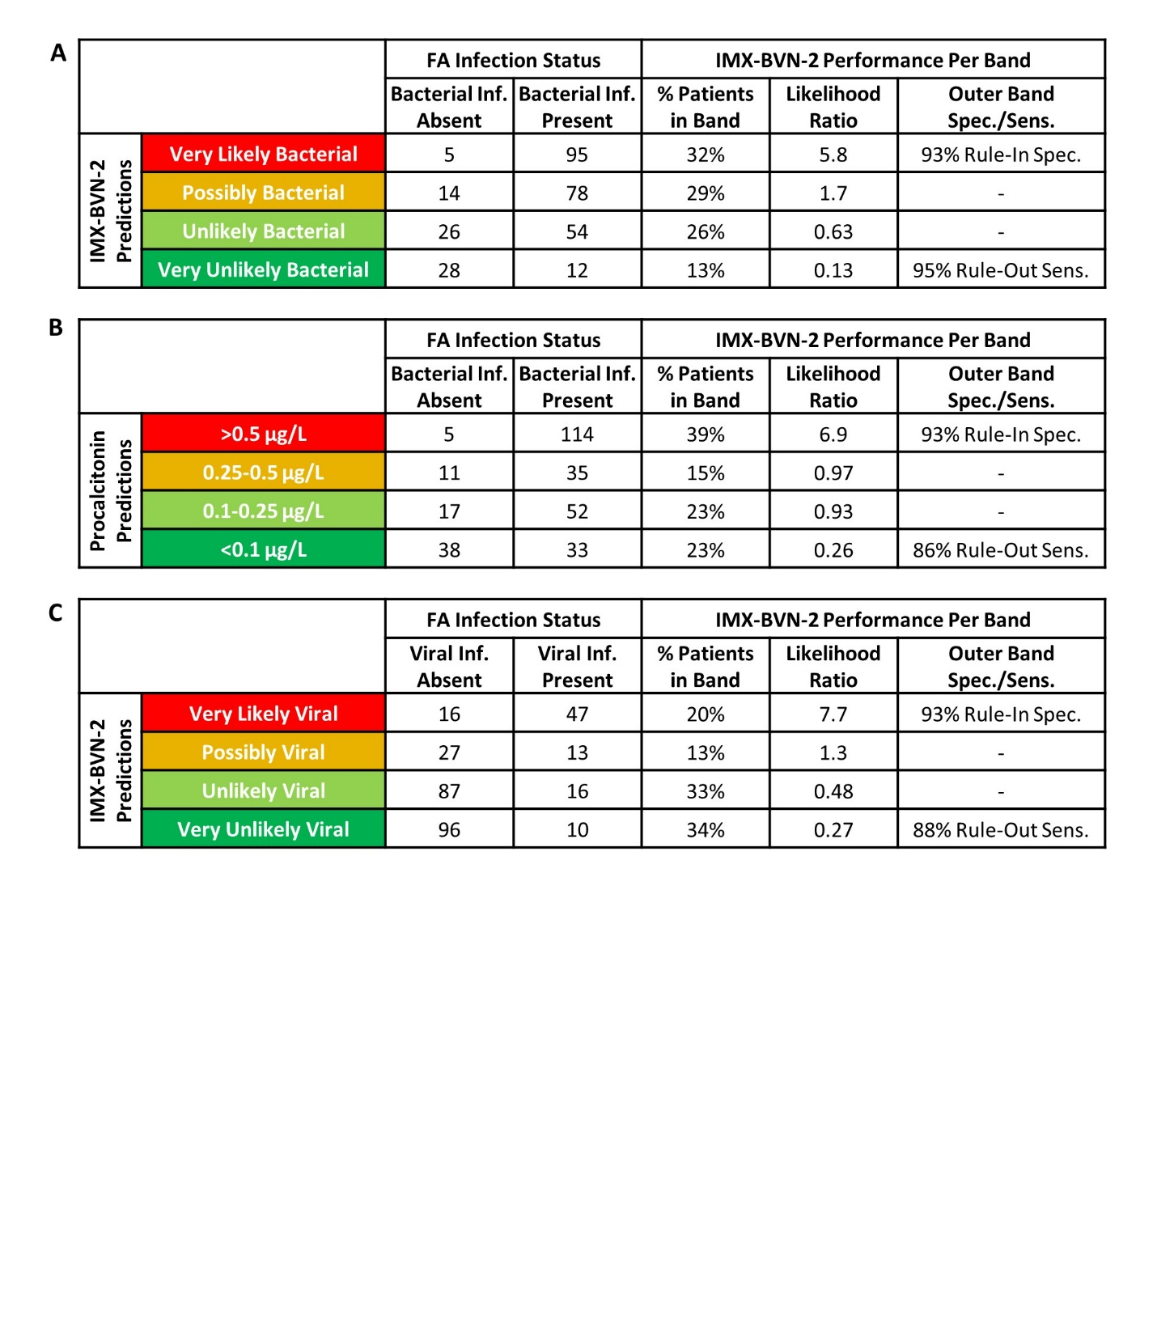

**Supplementary Figure S4. Performance of IMX-BVN-2 after applying previously established cutoffs to segment scores into clinically actionable results interpretation bands, using FA infection status.** Performance characteristics of the (A) IMX-BVN-2 bacterial score, (B) PCT, and (C) IMX-BVN-2 viral score when segmented into the results interpretation bands among patients with known adjudicated infection status. PCT was segmented into interpretation bands using cutoffs established in other studies1. Formulas for calculating performance characteristics are outlined in Supplementary Table S10. Sens. = sensitivity, Spec. = specificity. Performance characteristics calculated under CA is provided in Figure 3.



**Supplementary Figure S5: Post-test probabilities of IMX-BVN-2 results interpretation bands.** Sample pre-test probabilities and post-test probabilities are presented for the IMX-BVN-2 bacterial using(A) FA and (B) CA; PCT using (C) FA and (D) CA; and the IMX-BVN-2 bacterial score using (E) FA and (F) CA. Sample pre-test probabilities for were equivalent to the prevalences of bacterial or viral infection in our patient cohort. Sample post-test probabilities were calculated based on likelihood ratios of each band, using formulas outlined in Supplementary Table S10.