SUPPLEMENTAL DIGITAL CONTENT

Heterogenous renal injury biomarker production reveals human sepsis-associated AKI subtypes

Daniela Jou-Valencia BSc^{1,2,3}, Jacqueline Koeze MD^{1,3}, Eliane R Popa PhD², Adnan Aslan MD¹, Peter J Zwiers BSc², Grietje Molema PhD², Jan G Zijlstra MD, PhD^{1,2}, Matijs van Meurs MD, PhD^{1,2}, Jill Moser PhD^{1,2}

^{1.} Department of Critical Care, University of Groningen, University Medical Center Groningen, Groningen, The Netherlands.
^{2.} Department of Pathology and Medical Biology, Medical Biology section, University of Groningen, University Medical Center Groningen, Groningen, The Netherlands.
^{3.} Equal first authorship

Corresponding author:
Jill Moser PhD, Dept. of Critical Care, University Medical Center Groningen, Hanzeplein 1, 9713 GZ Groningen, The Netherlands. Tel: +31-50-3610229, Fax: +31-50-3619911, E-mail: j.moser@umcg.nl

Key Words: Sepsis, Acute Kidney Injury, subtypes, Neutrophil gelatinase-associated lipocalin (NGAL), Kidney injury molecule-1 (KIM-1)

Supplemental Digital Content 1 – Methods

Patient characteristics
For this study, we included 27 sepsis-AKI patients and 12 controls. The mean age of patients with sepsis was 67.9 years (range 40-85 years), that of control subjects was 59.5 years (range 20-79 years). The mean length of stay in the Intensive Care Unit (ICU) was 3.6 days (range 1-12 days). Common co-morbidities were hypertension, chronic obstructive pulmonary disease, asthma and coronary disease. Most patients with sepsis had an intra-abdominal (n=13) or pulmonary infectious focus (n=9). Other causes of sepsis were fasciitis necroticans (n=2), urinary tract infection (n=1), meningitis (n=1), and endocarditis (n=1). Twelve patients received Renal Replacement Therapy (RRT). All patients needed hemodynamic support with vasopressors and/or inotropic agents. Clinical and laboratory details of the patients from which the biopsies were taken can be found in Tables 1 and 2.

Gene expression analysis by reverse transcription quantitative PCR (RT-qPCR)
Total RNA was isolated from 20 x 5 µm kidney cryosections using the RNeasy Mini Plus Kit (Qiagen, Westburg, Leusden, The Netherlands), according to the manufacturer’s instructions. RNA integrity was determined by gel electrophoresis and consistently found intact. RNA yield and purity were measured by an ND-1000 UV-Vis spectrophotometer (NanoDrop Technologies, Rockland, DE). cDNA was synthesized and RT-qPCR subsequently performed using the ViiA 7 system (Applied Biosystems/ThermoFisher Scientific) as previously described (1). Assay on demand primers from Applied Biosystems (Nieuwerkerk aan de IJssel, The Netherlands) included GADPH (Glyceraldehyde-3-phosphate dehydrogenase, assay ID Hs99999905_m1), NGAL (assay ID Hs01008571_m1) and KIM-1 (assay ID Hs03054855_g1). Duplicate real-time PCR analyses were executed for each sample, and the obtained threshold cycle (CT) values were averaged. Gene expression was normalized to the expression of housekeeping gene (GAPDH) resulting in the ΔCT value. The relative mRNA level was calculated by 2^{- ΔCT}.
Immunohistochemistry and Morphometric analysis
Formalin-fixed paraffin-embedded sections were deparaffinized in xylene, and rehydrated in graded ethanol series and demi-water. Endogenous peroxidase activity was blocked and antigens were retrieved by boiling the sections in 10mM sodium citrate buffer (pH6.0) for 20 minutes in a microwave (300W). Sections were subsequently incubated with the following primary antibodies: rat anti-human Lipocalin-2/NGAL (clone 220310) and mouse anti-human KIM-1/HAVCR (clone 219211) both from R&D Systems, and Rabbit anti-Neutrophil Elastase (ab68672, Abcam) all diluted in 5% fetal calf serum in PBS for 1 hour at room temperature (RT). After washing, sections stained for NGAL were incubated with either rabbit anti-rat IgG antibody (Vector Laboratories, Burlingame, CA, USA). All slides were then incubated with anti-rabbit labeled polymer HRP antibody from the EnVision kit (DAKO Cytomation, Glostrup, Denmark). After washing, peroxidase activity was detected with 3-amino-9-ethylcarbazole (AEC) complex and the sections were subsequently counterstained with Mayer’s haematoxylin (Merck, Darmstadt, Germany) before mounting in Aquatex mounting agent (Merck). To quantify NGAL and KIM-1 immunostaining the sections were first scanned using a Nanozoomer HT (Hamamatsu Photonics, Japan). Morphometric analysis was performed using the Aperio Imagescope positive pixel analysis v9.1 algorithm (Aperio Technologies, Vista, CA, USA). Neutrophil infiltration was quantified by counting the number of neutrophils present in all glomeruli of the kidney sections. Data are shown as the total number of positive pixels/µm² ± SD or Positivity, defined as the number of positive pixels / total number of pixels.

Laser dissection microscopy
Cryosections (9µm) were mounted on Polyethylene Naphthalate (PEN)-membrane slides (Carl Zeiss B.V., Breda, The Netherlands), fixed and stained with Mayer’s haematoxylin, washed with DEPC-treated water and air-dried. Cells were laser microdissected using the LMD6500 system (Leica Microsystems, Wetzlar, Germany) using LMD6500 software v7.0 (Leica Microsystems). 80-100 glomeruli with a total area of 2x10⁶ µm² were dissected and collected in a 0.5 ml adhesive cap (Carl Zeiss B.V.) and stored at -80 °C until analysis of gene expression by RT-qPCR.

References
1. Jou-Valencia D, Molema G, Popa E, Aslan A, van Dijk F, Mencke R, et al. Renal Klotho is Reduced in Septic Patients and Pretreatment With Recombinant Klotho Attenuates Organ Injury in Lipopolysaccharide-Challenged Mice. Crit Care Med. 2018 Dec;46(12):e1196-203.

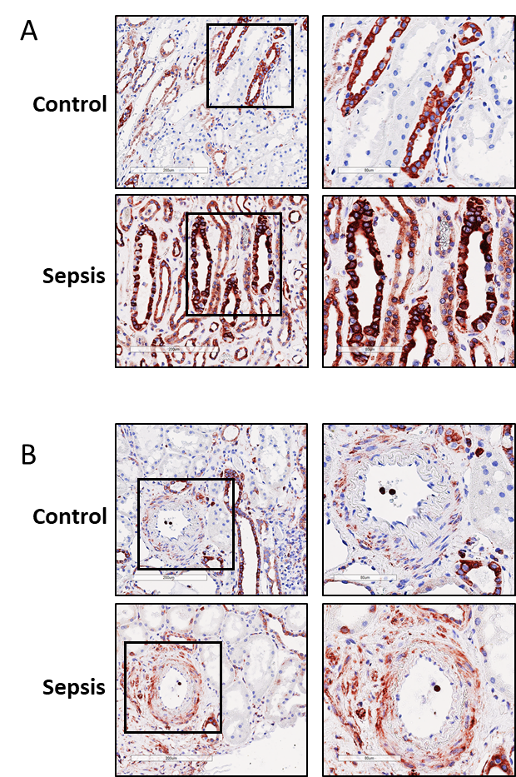

Supplemental Figure 1. Renal NGAL staining in sepsis-AKI patients versus controls subjects. Representative immunohistochemical staining of NGAL (red) in a post-mortem kidney biopsy from a sepsis-AKI patient compared to control renal tissue. (A) Strong NGAL staining localised in the collecting ducts in both sepsis-AKI and controls (B) NGAL staining localised in the adventitia of renal arteries with expression levels being much stronger in biopsies from sepsis-AKI patients. Original magnification 400x.

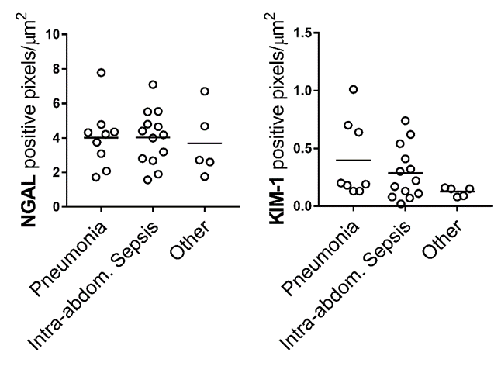

Supplemental Figure 2. Renal NGAL and KIM-1 levels are not influenced by the origin of infection. Morphometric quantification of NGAL and KIM-1 staining in kidney biopsies from sepsis-AKI patients (n=27). Patients categorized by the site of infection. Graphs represent the total number of positive pixels per μm². Each dot represents an individual subject and the bars represent the mean ± SD. *, p< 0.05. The “Other” group represents the following septic patients; Fasciitis Necroticans (n=2), Urinary tract infection (n=1), Meningitis (n=1), Endocarditis (n=1).

