**Supplementary Online Content**

**Clinical Impact of an Electronic Dashboard and Alert System for Sedation Minimization and Ventilator Liberation: A Before-After Study**

Brian J. Anderson, M.D., M.S.C.E.1,2; David Do, M.D.3,5; Corey Chivers, Ph.D.7; Katherine Choi, M.D.5; Yevgeniy Gitelman, M.D.2,6; Shivan J. Mehta, M.D., M.B.A.2,6; Venkat Panchandam, Ph.D.8; Steve Gudowski, RRT9; Margie Pierce, M.S., R.R.T.9; Maurizio Cereda, M.D.4,5; Jason D. Christie, M.D., M.S.C.E.1,2; William D. Schweickert, M.D.1,2; Andrea Gabrielli, M.D.4,10; Ann Huffenberger, D.B.A.10; Mike Draugelis7; Barry D. Fuchs, M.D., M.S.1,2,9

1Division of Pulmonary, Allergy and Critical Care Medicine, 2Department of Medicine, 3Department of Neurology, 4Department of Anesthesiology and Critical Care, 5Department of Radiology, 6Penn Medicine Center for Health Care Innovation, 7Penn Medicine Predictive Healthcare, 8Penn Medicine Penn Value Improvement, 9Respiratory Care Services 10Penn Center for Connected Care, University of Pennsylvania

B.J.A. and D.D. contributed equally to this manuscript.

**Supplemental Methods:**

*Description of the Technology - The ABC Application*

The ABC application (app) is an automated electronic application that continuously screens charted data from the electronic health record (EHR), including nursing flowsheets, respiratory flowsheets, and medication administration records to find opportunities for sedation minimization and ventilator liberation (eFigure 1). The data is applied to pre-specified locally developed algorithms to determine if patients meet criteria to undergo sedation minimization or ventilator liberation (eTable 1). The ABC app communicates the results via two mechanisms, i) an electronic dashboard with nudges that highlight opportunities to minimize sedation and liberate patients from the ventilator, and ii) HIPAA compliant text-message alerts to bedside providers as soon as patients meet criteria to undergo a spontaneous breathing trial (SBT) and spontaneous awakening trial (SAT) (Figure 1).

The ABC App was built as a web-based application in the Ruby programming language and Rails framework (versions 2.1.5 and 4.2.4, respectively) and hosted on a server physically located in the health system and virtually placed behind the health system’s firewall and authentication systems. The clinical data, including nursing flowsheets, laboratory results, medication administration records, ventilator flowsheets, and census were extracted from the Electronic Medical Record (Sunrise Clinical Manager version 5.5, Allscripts, Chicago, Illinois) and made accessible via an internally developed application programming interface. Although most EHRs allow custom visualizations through the configuration of EHR-defined components, the branching logic, mobile device alerts, and custom layouts designed for this intervention required capabilities and flexibility not offered by these components alone. Therefore, we employed custom software development, relying on Application Programming Interfaces (APIs) for integration. Although the ABC App in this study used data from Sunrise Clinical Manager, it was designed with a modular architecture to allow portability to other EHR systems with Application Programming Interfaces (APIs), and is currently in use in our health system using EPIC (EPIC Systems Corporation, Verona Wisconsin).

The electronic dashboard provides real-time data on each patient’s SBT readiness, depth of sedation as defined by the Richmond Agitation Sedation Scale1, and the patient’s current continuous analgesic and sedative infusion doses. For patient’s that are not SBT eligible, the dashboard provides the reason for why an SBT is not recommended as well as nudges to wean oxygen, positive end-expiratory pressure, PEEP, and vasoactive medications according to the pre-specified algorithms (eTable 1). The dashboard also provides a nudge to wean sedation in patients with a RASS <0 who are receiving continuous analgesic or sedative infusions.

To improve the utility of the continuous screening, the ABC app also triggers HIPAA-compliant text message SBT and SAT alerts via the Cureatr mobile app (Cureatr Inc.) once a patient meets all SBT and/or SAT criteria (eTable 1). The SBT alert algorithm is based on our institution’s ventilator liberation protocol, consistent with American Thoracic Society/American College of Chest Physician clinical practice guidelines.2 The algorithm requires at least 6 hours of mechanical ventilation to allow for a minimum period of time for recovery from the initial cause of respiratory failure, and then requires all of the hemodynamic, oxygenation and physiologic criteria to be met for at least two hours. When all SBT criteria are met, a secure text message “Patient AA (Room #) is SBT ready.” is sent to the cell phone of the patient’s respiratory therapist. Simultaneously, to promote sedation minimization, a SAT alert is sent to the cell phone of the bedside nurse in SBT-eligible patients who have a RASS <0 and are receiving an analgesic or sedative infusion. A sample message is as follows: “Patient AA (Room #) is SBT ready, but appears over-sedated. Reassess need for sedation.”

*Validation of the ABC application*

We performed a proof-of-concept study to determine the accuracy and potential benefit of the SBT and SAT alerts. For the purposes of this proof-of-concept study, the alerts were sent only to study investigators and were not used clinically. Patients triggered a maximum of one SBT alert and, if the criteria were met, one SAT alert per admission, even if there were multiple episodes of mechanical ventilation.

We performed a, prospective, validation study in three city hospitals within the University of Pennsylvania Health System (UPHS). All mechanically ventilated patients admitted to medical and surgical ICUs, except cardiothoracic surgery patients who are managed by a separate protocol, were eligible for enrollment. We included all patients who triggered an alert during the proof-of-concept study period from August 20, 2016 to September 10, 2016. This project was reviewed and determined to qualify as Quality Improvement by the University of Pennsylvania’s Institutional Review Board.

The primary goals of the proof-of-concept study were to ensure the alerts were accurate when compared to documentation in the electronic health record (EHR), to ensure there was an opportunity for earlier weaning, and to evaluate whether changes to the alerts were needed before proceeding with a pre-post study. Alert accuracy was assessed by PENN E-LERT® teleICU registered nurses (RNs) who are board certified in critical care and completed a two-hour physician-led training on the UPHS Ventilator Liberation Protocol. The accuracy of the screening algorithms and alerts were assessed by determining whether all the pre-specified screening criteria for SBT and SAT eligibility had been met in those who triggered the alerts. A secure, web-based, electronic survey was developed in REDCap® for data collection. For the first 20 alerts, study investigators conducted concurrent, one-on-one reviews with the teleICU nurses to ensure clarity and accuracy in survey completion, until there were no further survey errors or questions. These initial 20 alerts were excluded from subsequent analyses on the accuracy and value of the alerts. After the training phase, 115 SBT alerts and 70 SAT alerts were sent to individual nurses to determine alert accuracy and value. SBT Alert value was defined as an alert that fired while the patient was still receiving mandatory ventilatory support (i.e. Assist-Control ventilation). We also assessed whether there were any perceived barriers to extubation to ensure that the alerts were not simply identifying patients who were still receiving mandatory ventilatory support because of clinical reasons not to initiate ventilator liberation. Barriers to extubation included lack of ventilatory drive due to sedation, agitation, endotracheal suctioning more frequently than every 4 hours, upper airway obstruction, procedure within the next 12 hours, status epilepticus, drug withdrawal, new sepsis, active bleeding, acute coronary syndrome, hypotension or shock, or arrhythmia. SAT alert value was defined by how frequently it fired in the SBT alerted population, as it reflects the proportion of patients with an opportunity for earlier sedative infusion interruption. We also assessed the depth of sedation at the time the SAT alert triggered, because patients who are more deeply sedated at the time of the SBT alert may receive greater benefit from a sedation interruption than patients with a lower depth of sedation. Because no changes were made to the alerts following the proof-of-concept study, we were able to immediately employ the alerts and perform a pre-post study using pre-implementation data that was collected concurrently with the proof-of-concept study.

*Clinical Impact of the ABC Application*

To assess the clinical impact of the ABC application, we performed a single-center, single-ICU before-after study of 457 critically ill patients receiving invasive mechanical ventilation in the medical ICU of the Hospital of the University of Pennsylvania, a tertiary medical center. Patients with preexisting tracheostomy were excluded and two patients who briefly boardered in the medical ICU from a non-study ICU were excluded. For patients with more than one episode of mechanical ventilation, the first episode was included in the analysis. This study was evaluated by the Institutional Review Board of the University of Pennsylvania and received a letter of exemption on the basis of quality improvement.

During the control period (May 1, 2016 - September 25, 2016) the ABC application ran silently to allow collection of baseline data, and sedation minimization and daily SBTs were performed in accordance with the medical ICU’s preexisting protocols. Nurses weaned sedation to the goal RASS as defined by the medical team and respiratory therapists screened patients for SBT eligibility once daily. A multidisciplinary huddle occurred daily at 8am during which the respiratory therapists reviewed each patient’s SBT eligibility and SBT results, and nurses reviewed each patient’s continuous analgesic and sedative infusions. Based on that information, the medical team made decisions on weaning sedation, interrupting sedation, and ventilator liberation. After the multidisciplinary huddle, these actions were implemented while the medical team completed their in-depth rounds. Bedside providers were unaware of the planned study during the pre-intervention period.

During the intervention period (September 26, 2016 – February 1, 2017) the ABC application was used to promote compliance with the standard protocols and provide 24-hour screening for additional opportunities for sedation minimization and ventilator liberation. The electronic dashboard was used at the 8am multidisciplinary huddle and a mobile version was used by respiratory therapists throughout the day. In addition, respiratory therapists and nurses were provided with phones to receive the secure text alerts. Providers were instructed to use clinical judgement to validate and react to the nudges on the dashboard and the alerts. If a patient did not formally meet SBT criteria, clinicians were instructed to use standard protocols for weaning.

Clinical variables were abstracted from the medical record by trained study personnel at each site. The timing of all events (i.e. time of intubation/extubation) was electronically extracted and secondarily confirmed by manual chart review. Baseline comparisons between the pre-intervention and post-intervention groups were made using *χ*2, Wilcoxon rank sum or student’s *t-*test as appropriate. In our primary analyses, we used multivariable Cox proportional hazards regression to test for a difference in the primary outcomes of time to extubation, time to ICU discharge, and time to hospital discharge between the two groups. We adjusted for illness severity as defined by the Acute Physiology, Age, and Chronic Health Evaluation [APACHE] IV score3 and receipt of vasoactive infusions. Successful extubation was defined as a period of at least 48 hours without invasive ventilatory support. Patients were censored at the time of tracheostomy or death in the time to extubation analyses. Patients were censored at the time of death or transfer to a non-study ICU in all analyses, and patients were censored at the time of tracheostomy in the time to extubation analysis. Cumulative incidence function graphs were created from the Cox proportional hazards model using the stcompadj command in Stata.

In complementary analyses, we used interrupted time-series analysis (ITSA) with data aggregated by week to test for a difference in each outcome when comparing the post-intervention period with the counterfactual scenario (the pre-existing trend).4,5 We used a level and slope change model framework, hypothesizing that introduction of the ABC app would cause an immediate change in each outcome, as well as change the slope of each outcome over time as comfort and implementation of the board into daily practice improved. We defined the total duration of mechanical ventilation as the time to successful extubation or 48 hours without invasive ventilatory support in patients who underwent a tracheostomy. We excluded 21 patients from the interrupted time series analyses who were transferred from the study ICU to a non-study ICU while still receiving invasive ventilation. We also excluded outliers from the pre-intervention period to ensure that a difference between the two groups was not driven by the outliers. In the duration of mechanical ventilation analysis, we excluded four patients in the pre-intervention period with a duration of mechanical ventilation > 50 days, and one patient from week 18 in the pre-intervention period with a duration of mechanical ventilation > 30 days because week 18 visually appeared to strongly influence the pre-intervention trend. In the ICU length of stay analysis, we excluded one patient in the pre-intervention period with an ICU length of stay > 115 days, and one patient during week 12 in the pre-intervention period with an ICU length of stay of 70 days because week 12 visually appeared to strongly influence the pre-intervention trend. In the hospital length of stay analysis, we excluded two patients in the pre-intervention period with a hospital length of stay > 150 days, and one patient during week 12 in the pre-intervention period with a hospital length of stay of 70 days because week 12 visually appeared to strongly influence the pre-intervention trend. We performed sensitivity analyses without removing these outliers from the pre-intervention period to ensure removing the outliers did not impact the pre-intervention trend in a biased manner. We also performed sensitivity analyses assuming the pre-existing trend did not persist in the post-intervention period. Lastly, we performed additional sensitivity analyses to ensure variations in the time to death and time to discharge did not bias our results.

In secondary analyses we tested for differences in 48-hour reintubation rates to ensure the ABC app was not overly aggressive, and the time to extubation among patients who never met SBT criteria to ensure the board did not have the unintended consequence of delaying extubation based on clinical judgement alone. In addition, we explored the potential mechanisms by which the ABC app might improve sedation minimization and ventilator liberation. Because some patients were extubated before triggering an SBT alert and some patients never met SBT criteria, we tested whether the time from enrollment to meeting SBT criteria among patients who received an SBT alert was shorter in the post-intervention group, which would suggest improved ventilator weaning related to the nudges on the electronic dashboard. We also tested whether patients in the post-intervention period received continuous analgesic and/or sedative infusions for a shorter period of time, which would suggest changes in sedation practice due to a combination of the electronic dashboard nudges and SAT alerts. Lastly, we also tested whether the time from SBT alert to extubation was shorter, which would suggest earlier performance of SBTs and fewer barriers to extubation such as improved ventilatory drive and mental status due to reductions in sedation practice, related to a combination of the electronic dashboard nudges and both alerts.

Analyses were performed in Stata version 15.1 (College Station, TX) and a two-sided p < 0.05 was considered statistically significant.

**Figure S1 - Schema of the ABC Application.** The ABC application leverages the electronic health record, including ventilator settings, vital signs, and medications flowsheets, and runs the data through a continuous screening engine against pre-specified algorithms. The results are displayed in real-time on a web-based electronic dashboard (ABC dashboard), and when the criteria are met for a spontaneous breathing trial (SBT) or a spontaneous awakening trial (SAT) an icon appears on the electronic dashboard and a secure HIPAA-complaint text message alert is sent to bedside providers.

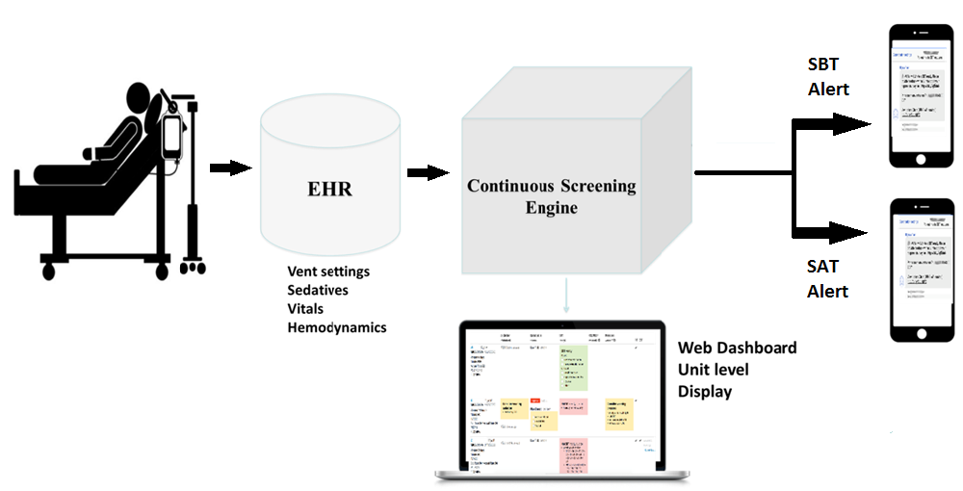

**Table S1.** Criteria for the spontaneous breathing trial (SBT) and spontaneous awakening trial (SAT) alerts, and the ABC dashboard nudges.

|  |  |
| --- | --- |
| **Algorithm** | **Criteria** |
| SBT Alert Criteria | 1. Ventilator duration ≥ 6 hours 2. Stable oxygenation for ≥ 2 hours    1. SpO2 ≥ 88%    2. PEEP ≤ 8    3. FiO2 ≤ 0.50    4. Not receiving paralytics    5. Not receiving inhaled prostacyclin 3. Stable respiratory dynamics for ≥ 2 hours    1. RR ≤ 30    2. HR ≤ 130    3. pH ≥ 7.3    4. VE < 20 4. Stable hemodynamics ≥ 2 hours    1. Norepinephrine ≤ 3mcg/min    2. Vasopressin OFF    3. Epinephrine ≤ 2mcg/min    4. Phenylephrine ≤ 50mcg/min    5. Dobutamine ≤ 5mcg/kg/min    6. Dopamine ≤ 5 mcg/kg.min    7. Milrinone ≤ 0.25 mcg/kg/min |
| SAT Alert criteria | 1. SBT criteria met 2. RASS < 0 3. Receiving continuous opiate or sedative infusion |
| Consider weaning FiO2 nudge | 1. SpO2 > 94% for ≥ 4 hours 2. FiO2 > 0.50 |
| Consider weaning PEEP nudge | 1. SpO2 > 94% for ≥ 4 hours 2. PEEP > 8 |
| Consider weaning Pressors nudge | 1. MAP > 70 mmHg ≥ 1 hour 2. Receiving vasopressors |
| Consider weaning Sedation nudge | 1. RASS < -1 2. Receiving continuous opiate or sedative infusion |

Definition of abbreviations: SBT = spontaneous breathing trial; SpO2 = peripheral oxygen saturation; PEEP = positive end-expiratory pressurs; FiO2 = fraction inspired oxygen; RR = respiratory rate; HR = heart rate; VE = minute ventilation; SAT = spontaneous awakening alert; RASS = Richmond Agitation Sedation Score; MAP = mean arterial pressure

**Table S2.** Patient characteristics of patients enrolled in the proof-of-concept study.

|  |  |
| --- | --- |
| **Characteristic** | **Study Population (N=115)** |
| Hospital |  |
| Hospital of the University of Pennsylvania | 63 (54.8%) |
| Penn Presbyterian Hospital | 37 (32.2%) |
| Pennsylvania Hospital | 15 (13.0%) |
| Admission type |  |
| Emergency | 48 (41.7%) |
| Transfer from another hospital | 46 (40.0%) |
| Elective | 21 (18.3%) |
| Intensive Care Unit Class |  |
| Surgical/Trauma | 25 (21.7%) |
| Medical | 32 (27.8%) |
| Neurologic | 24 (20.9%) |
| Cardiac | 34 (29.6%) |

## 

**Figure S2.** **Before-After Study Consort Diagram.** Flowchart describing enrollment into the before-after study. Twenty-three patients with pre-existing tracheostomy and two patients who briefly boarded in the study ICU were excluded from the study.

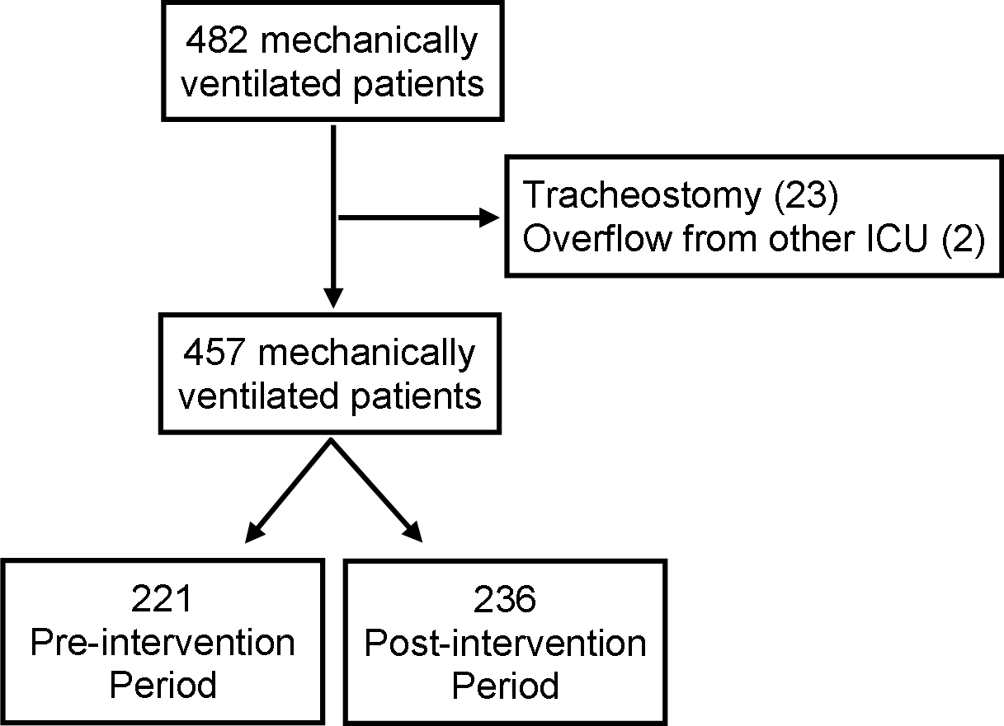

**Figure S3. Trend of Severity of Illness Throughout the Study Period.** Severity of illness was calculated using the Acute Physiology, Age, and Chronic Health Evaluation (APACHE) IV score using data within the first 24 hours of ICU admission. Points represent the mean APACHE IV score aggregated by week of the study and the solid line represents the linear fit with 95% confidence intervals.

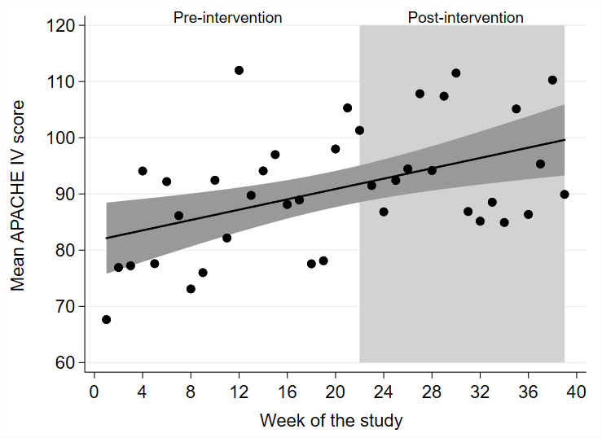

**Table S3. Reduction in the Duration of Mechanical Ventilation in the Post-intervention Period.** Median duration of mechanical ventilation was calculated using an interrupted time series analysis with a level and slope change model with data aggregated on a weekly basis. Data were calculated when excluding outliers with very high durations of mechanical ventilation in the pre-intervention period, when including all patients, and when assuming the preexisting upward trend in the duration of mechanical ventilation did not persist into the post-intervention period.

|  |  |  |  |
| --- | --- | --- | --- |
| **Week of study** | **Reduction in median duration of mechanical ventilation (days)** | | |
| **Excluding outliers** | **All patients** | **Assuming flat trend** |
| 24 | 1.91 (0.12–3.69) | 2.57 (0.45–4.69) | 1.64 (0.06–3.22) |
| 28 | 2.10 (0.15–4.06) | 2.83 (0.51–5.15) | 1.47 (0.09–2.86) |
| 32 | 2.30 (0.00–4.60) | 3.09 (0.36–5.82) | 1.31 (-0.05–2.67) |
| 36 | 2.50 (-0.26–5.26) | 3.35 (0.08–6.63) | 1.14 (-0.37–2.66) |

**Figure S4.** **Interrupted Time Series Analysis of Duration of Mechanical Ventilation: sensitivity analysis including all patients.** Interrupted time series analysis using a level and slope change model with data aggregated on a weekly basis demonstrating the median duration of mechanical ventilation in the pre-intervention period (white background) and post-intervention period (grey background) among all patients. The solid line represents the median duration of mechanical ventilation in the pre- and post-intervention groups from the regression model, and the dotted line represents the counterfactual scenario, which is the expected trend in the absence of the intervention given the pre-existing trend. The model shows a similar reduction in the median duration of mechanical ventilation in the post-intervention group when compared to the counterfactual scenario. For example, midway through the post-intervention period (week 30) the median duration of mechanical ventilation was 2.96 days shorter (95% CI, 0.45–5.47, p = 0.022).



**Figure S5.** **Interrupted Time Series Analysis of Duration of Mechanical Ventilation: sensitivity analysis assuming pre-intervention trend did not persist in post-intervention period.** Interrupted time series analysis using a level and slope change model with data aggregated on a weekly basis demonstrating the median duration of mechanical ventilation in the pre-intervention period (white background) and post-intervention period (grey background) assuming the pre-intervention upward trend in the duration of mechanical ventilation did not persist into the post-intervention period. The solid line represents the median duration of mechanical ventilation in the pre- and post-intervention groups from the regression model, and the dotted line represents the counterfactual scenario assuming a stable duration of mechanical ventilation after the intervention. The model shows a reduction in the median duration of mechanical ventilation in the post-intervention group when compared to the counterfactual scenario. For example, midway through the post-intervention period (week 30) the median duration of mechanical ventilation was 1.39 days shorter (95% CI, 0.04–2.74, p = 0.044).



**Table S4. Reduction in ICU Length of Stay in the Post-intervention Period.** Median duration of the ICU length of stay was calculated using an interrupted time series analysis with a level and slope change model with data aggregated on a weekly basis. Data were calculated when excluding outliers with very high ICU length of stay in the pre-intervention period, including all patients, assuming the pre-existing upward trend in ICU length of stay did not persist into the post-intervention period, and excluding outliers and patients discharged to a long-term ventilator hospital.

|  |  |  |  |  |
| --- | --- | --- | --- | --- |
| **Week of study** | **Reduction in median ICU length of stay (days)** | | | |
| **Excluding outliers** | **All patients** | **Assuming flat trend** | **Excluding long-term vent patients** |
| 24 | 2.08 (0.05–4.21) | 2.37 (-0.97–5.64) | 1.81 (-0.07–3.69) | 1.91 (-0.03–3.84) |
| 28 | 2.46 (0.13–4.79) | 2.67 (-0.92–6.26) | 1.84 (0.19–3.49) | 2.33 (0.21–4.45) |
| 32 | 2.84 (0.10–5.58) | 2.97 (-1.25–7.20) | 1.86 (0.24–3.48) | 2.75 (0.26–5.24) |
| 36 | 3.22 (-0.07–6.50) | 3.27 (-1.78–8.34) | 1.89 (0.08–3.70) | 3.17 (0.19–6.16) |

**Figure S6.** **Interrupted Time Series Analysis of ICU Length of Stay: sensitivity analysis including all patients.** Interrupted time series analysis using a level and slope change model with data aggregated on a weekly basis demonstrating the median ICU length of stay in the pre-intervention period (white background) and post-intervention period (grey background) among all patients. The solid line represents the median ICU length of stay in the pre- and post-intervention groups from the regression model, and the dotted line represents the counterfactual scenario, which is the expected trend in the absence of the intervention given the pre-existing trend. The model shows a similar point estimate for the reduction in the median ICU length of stay in the post-intervention period compared to the counterfactual scenario. For example, midway through the intervention period (week 30) the median ICU length of stay was 2.82 days shorter (95% CI -1.05–6.69, p = 0.15).



**Figure S7.** **Interrupted Time Series Analysis of ICU Length of Stay: sensitivity analysis assuming pre-intervention trend did not persist in post-intervention period.** Interrupted time series analysis using a level and slope change model with data aggregated on a weekly basis demonstrating the median ICU length of stay in the pre-intervention period (white background) and post-intervention period (grey background) assuming the pre-intervention upward trend in the ICU length of stay did not persist into the post-intervention period. The solid line represents the median ICU length of stay in the pre- and post-intervention groups from the regression model, and the dotted line represents the counterfactual scenario. The model shows a reduction in the median ICU length of stay in the post-intervention period compared to the counterfactual scenario. For example, midway through the intervention period (week 30) the median ICU length of stay was 1.85 days shorter (95% CI 0.25–3.46, p = 0.025).



**Figure S8.** **Interrupted Time Series Analysis of ICU Length of Stay: sensitivity analysis excluding patients discharged to a long-term ventilator hospital.** Interrupted time series analysis using a level and slope change model with data aggregated on a weekly basis demonstrating the median ICU length of stay in the pre-intervention period (white background) and post-intervention period (grey background) when excluding patients who underwent a tracheostomy and were discharged to a long-term ventilator hospital. The solid line represents the median ICU length of stay in the pre- and post-intervention groups from the regression model, and the dotted line represents the counterfactual scenario, which is the expected trend in the absence of the intervention given the pre-existing trend. The model shows a reduction in the median ICU length of stay in the post-intervention group compared to the counterfactual scenario. For example, midway through the intervention period (week 30) the median ICU length of stay was 2.54 days shorter (95% CI -4.83, -0.25; p = 0.030).



**Figure S9. Hospital Length of Stay Analysis.** (A) Cumulative incidence function describing the proportion of patients discharged from the hospital alive in the post-intervention (blue line) and pre-intervention (red line) groups, adjusted for severity of illness and vasopressor-dependent shock. Time to hospital discharge was not significantly different, adjusted hazard ratio 1.15 (95% CI, 0.90-1.47, p = 0.27). (B) Interrupted time series analysis using a level and slope change model with data aggregated on a weekly basis demonstrating the median hospital length of stay in the pre-intervention period (white background) and post-intervention period (grey background). The solid line represents the median hospital length of stay in the pre- and post-intervention groups from the regression model, and the dotted line represents the counterfactual scenario, which is the expected trend in the absence of the intervention given the pre-existing trend. The model shows no significant difference in the median hospital length of stay in the post-intervention group.





References cited in online supplement:

1. Ely EW, Truman B, Shintani A, et al. Monitoring sedation status over time in ICU patients: reliability and validity of the Richmond Agitation-Sedation Scale (RASS). *JAMA.* 2003;289(22):2983-2991.

2. Girard TD, Alhazzani W, Kress JP, et al. An Official American Thoracic Society/American College of Chest Physicians Clinical Practice Guideline: Liberation from Mechanical Ventilation in Critically Ill Adults. Rehabilitation Protocols, Ventilator Liberation Protocols, and Cuff Leak Tests. *Am J Respir Crit Care Med.* 2017;195(1):120-133.

3. Zimmerman JE, Kramer AA, McNair DS, Malila FM. Acute Physiology and Chronic Health Evaluation (APACHE) IV: hospital mortality assessment for today's critically ill patients. *Crit Care Med.* 2006;34(5):1297-1310.

4. Bernal JL, Cummins S, Gasparrini A. Interrupted time series regression for the evaluation of public health interventions: a tutorial. *Int J Epidemiol.* 2017;46(1):348-355.

5. Linden A. A comprehensive set of post-estimation measures to enrich interrupted time series analysis *The Stata Journal.* 2017;17(1):73-88.