SUPPLEMENTAL DIGITAL CONTENT

Appendix A – Complete Inclusion and Exclusion Criteria

Inclusion Criteria:

- 19 years old or greater
- admitted to the Intensive Care Unit
- suspected infection
- at least 2 SIRS criteria:
  - HR > 90
  - RR > 20 or paCO2 < 32 mmHg
  - Temperature > 38°C or <36°C
  - WBC > 12000/uL or < 4000/uL or >10% band forms
- any sign of end-organ damage
  - GCS < 15
  - new seizure
  - new lateralizing neurologic signs
  - new brady- or tachyarrhythmia
  - hypotension: SBP < 90 mmHg or 40 mmHg below baseline
  - hypoxemia: spO2 or saO2 less than 90%
  - new need for mechanical ventilation
  - jaundice
  - upper GI bleed
  - lower GI bleed
  - oliguria or anuria
  - azotemia
  - platelet < 100
  - INR > 1.5

Exclusion Criteria:
- not admitted to the ICU
- Do Not Attempt Resuscitation status upon ICU admission
- Do Not Intubate status upon ICU admission

Appendix B – Members of The Medical City Sepsis Alert Working Group 2007-2018

Irmingarda Gueco MD
Jude Erric Cinco MD
Marissa Alejandria MD
Jose Emmanuel Palo MD
Debbie Noblezada-Uy MD
Gerardo Briones MD
Joanne Robles MD
May Agno MD
Armi Carlos MD
Karen Ilagan MD
Kelly Chiu MD
Stephanie Ang MD
Marides San Juan MD
Nina Bumanglag MD
Raul Destura MD
Maan Ponte MD
Patricia Puno-Ramos MD
Meg Goco MD
Israeli Roque MD
Gemma Sarapuddin MD
Nicco Salalima MD
Marian Vita Nova Sodusta MD
Roland Reyes MD
Claire Orden MD
Ma Patricia Therese Virata MD
Agnes Cubillas MD
Ma Antonia Elisa Abello MD
Joan Kristina Diaz MD
Lourdes Trinidad RN
Rina Uriarte
Rose Leopando RN
Alicia Inocencio RN
Cecil Contreras RN
Carson Cortez RN

Appendix C: TMC Sepsis Alert Pathway Version 1

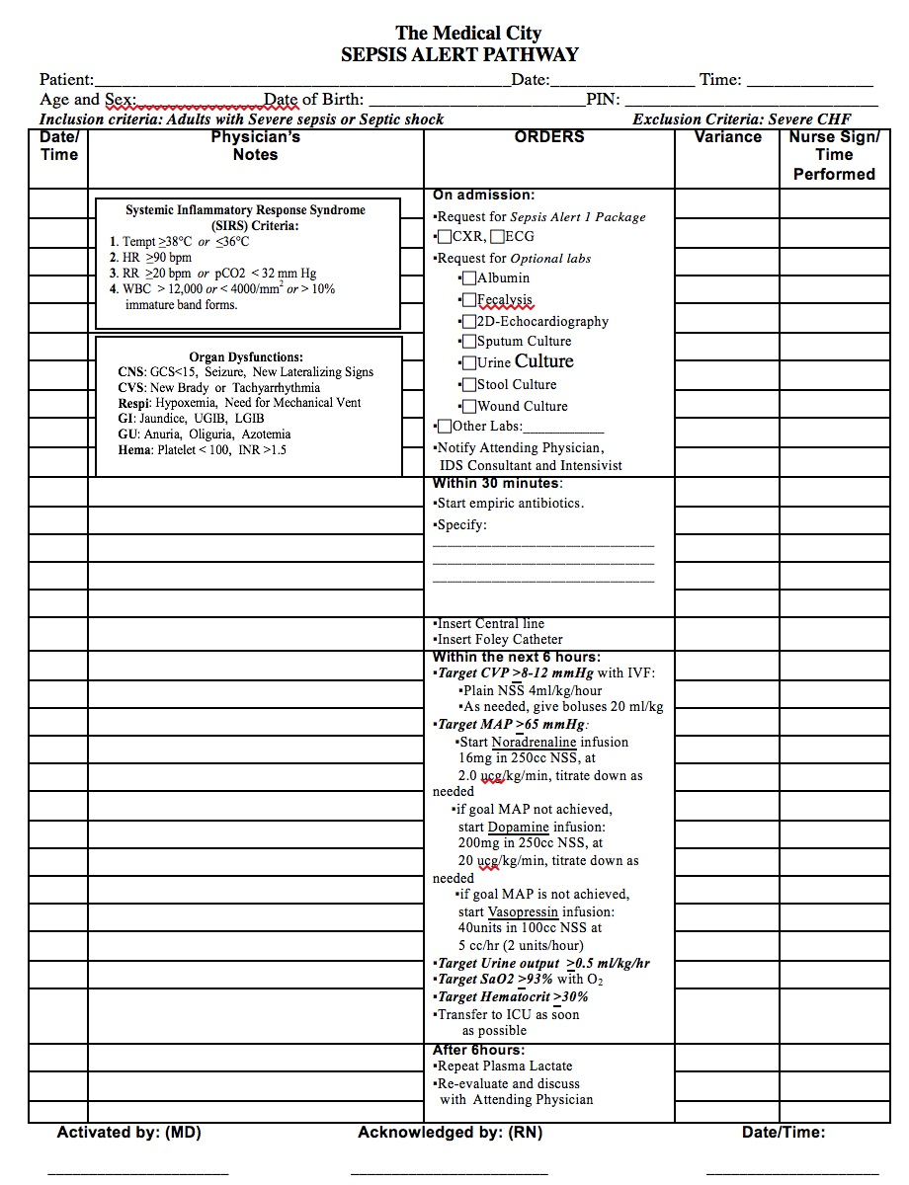
Appendix D: TMC Sepsis Alert Pathway Version 2

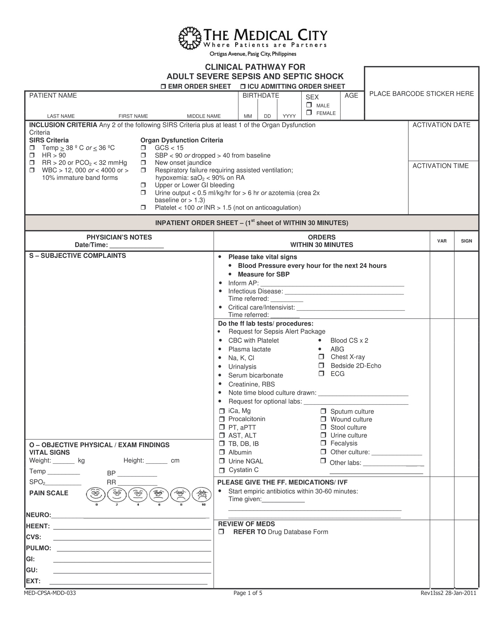
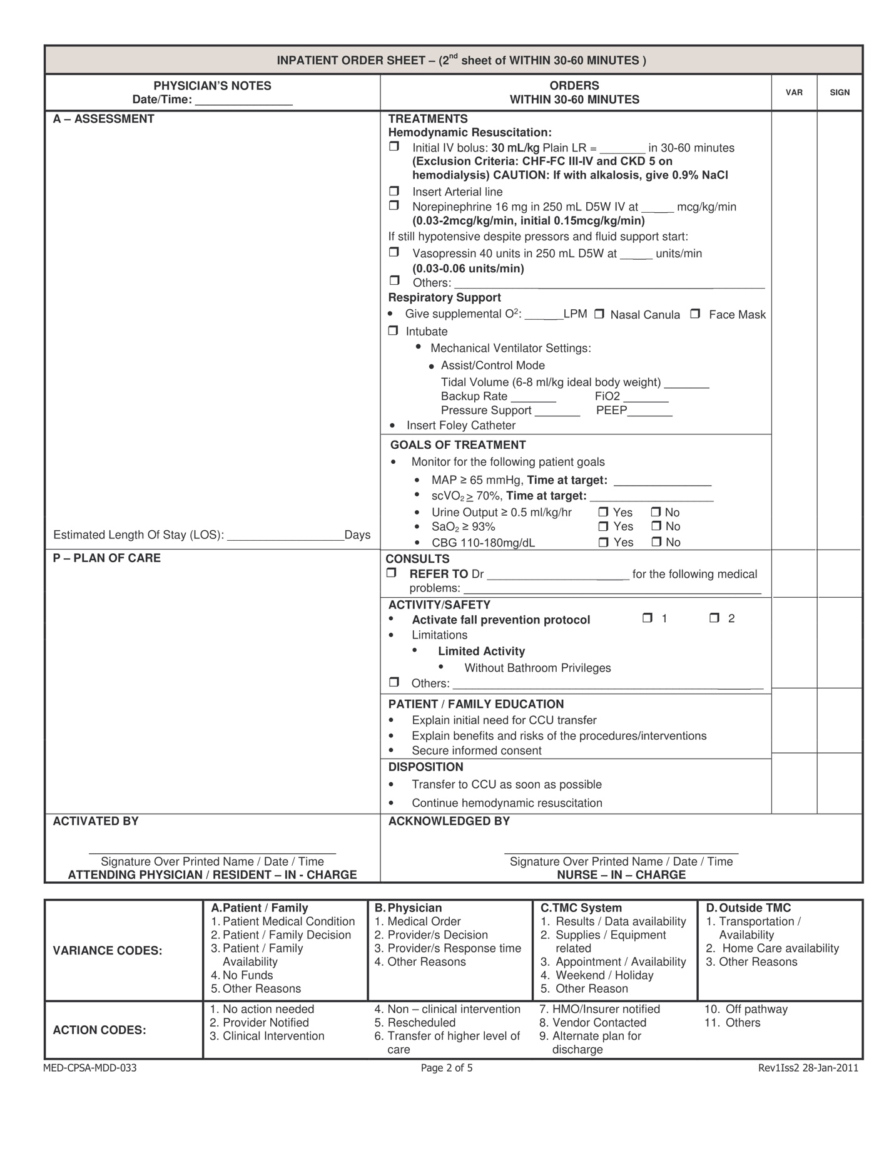

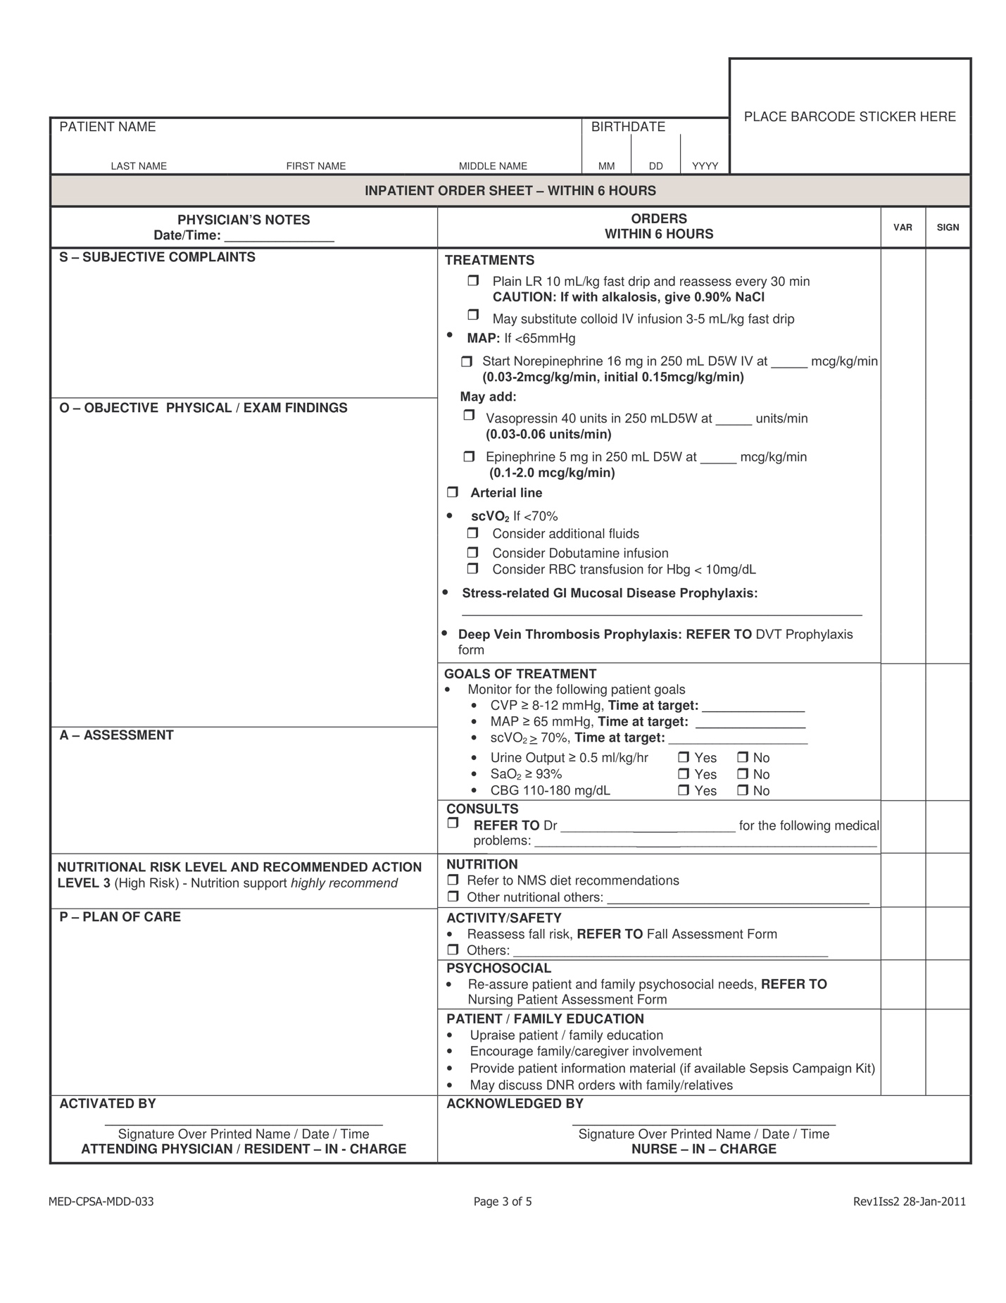

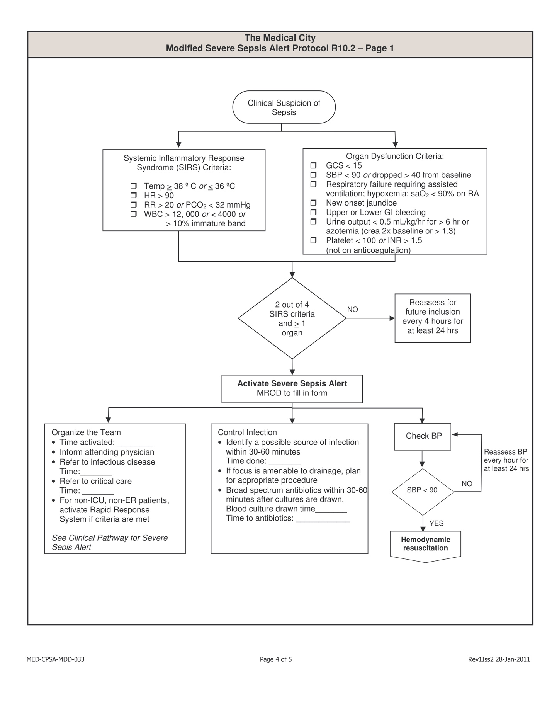

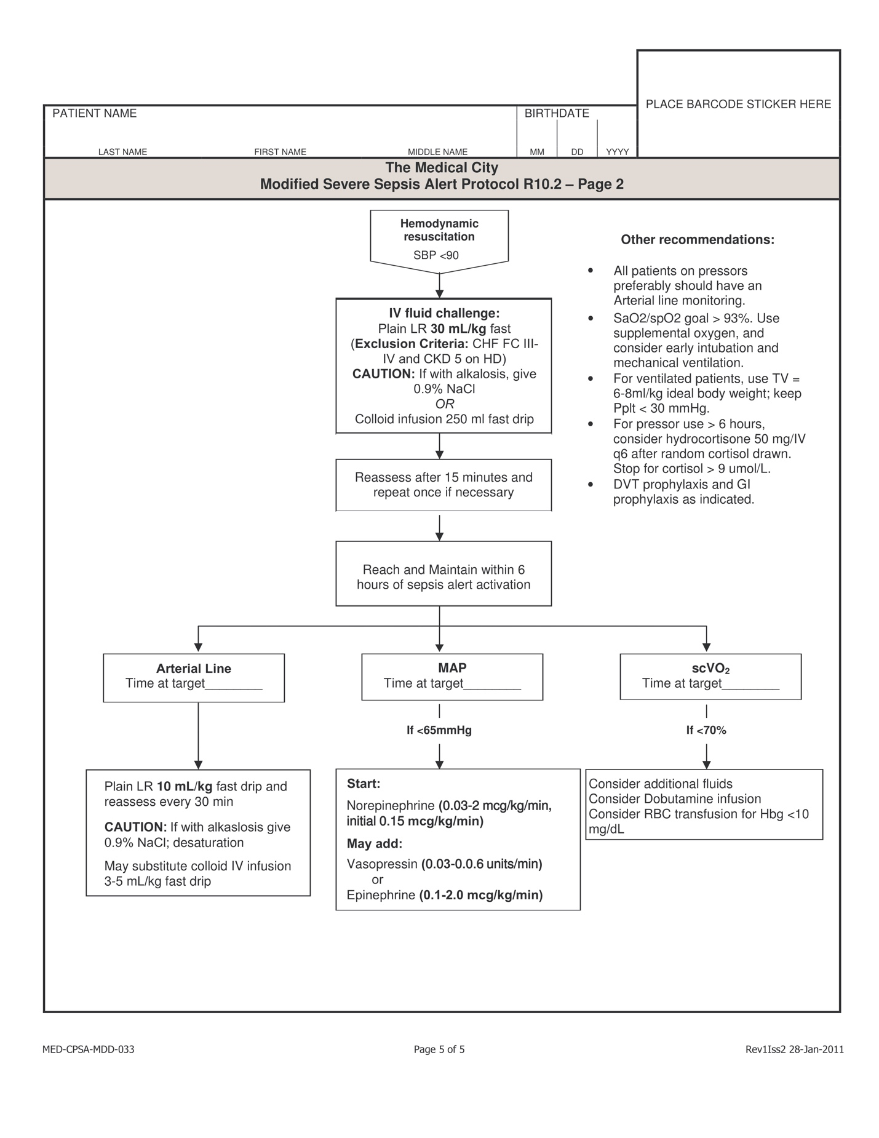

Appendix E – Control Charts

I. Risk-Adjusted Cumulative Sum Control Charts
We constructed RA-CUSUM charts that plot the functions:

$$X_{t}=\max\left(0, X_{t-1}+W_{t}\right), t=1,2,3. . .$$
$$X_{t}=\min\left(0, X_{t-1}-W_{t}\right), t=1,2,3. . .$$

Where weight $W_{t}$ is calculated using:
$$W_{t}=Y_{t}\log{R_{A}}-\log{(1-P_{t}+R_{A}P_{t})}$$

$P_{t}$, the expected probability of mortality was estimated from the Apache II score of each patient. $R_{A}$ is the specified odd ratio increase or decrease in mortality rate that the risk-adjusted CUSUM chart is set to detect. The control limit (CL) is the value that the chart needs to cross in order to “signal” a significant change in mortality. In this study, we set $R_{A}$ at 1.5 for the max function and 0.5 for the min function in order to detect 50% increase and decrease in mortality, respectively. Control limit was set at 1.5 with an average run length (ARL) of 60 (approximately 6 months).

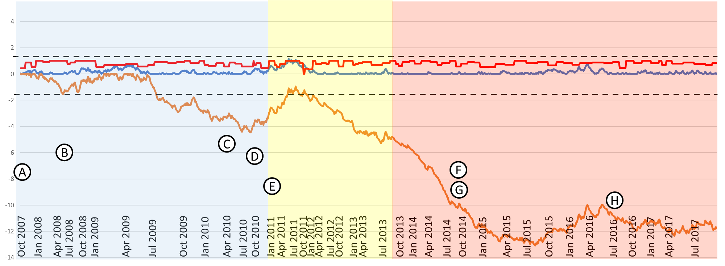

Figure 1. RA-CUSUM chart of entire population. Blue series – Max function with $R_{A}$ of 1.5. Orange series – Min function with $R_{A}$ of 0.5. Red series – quarterly pathway activation rates. Dashed lines indicate control limits at 1.5 and -1.5. Implementation of Institutional changes and events are marked as follows: A. Pilot study of Sepsis Alert Pathway (Sept 2007), B. Hospital-wide launch of first version of the Sepsis Alert Pathway (May 2008), C. Start of fellowship in Critical Care Medicine (April 2010), D. Implementation of Rapid response system (Oct 2010), E. Implementation of RFID in ICU (Jan 2011), F. Start of residency in Emergency Medicine (September 2014), G. Purchase of ultrasound machine dedicated to the ICU (September 2014), I. Management directive regarding pathway activation (July 2016). Pathway version in implementation differentiated by the background: blue – version 1, yellow – version 2, red – version 3.

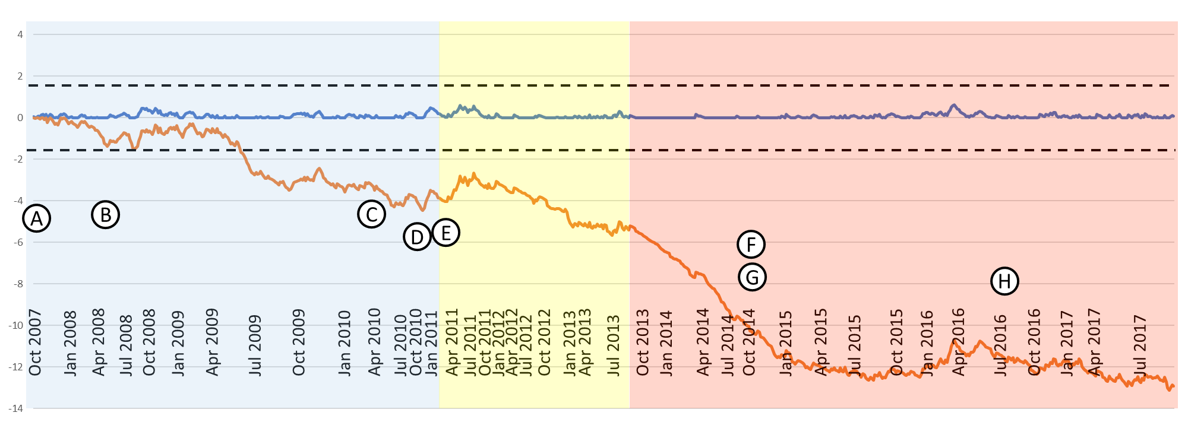

Figure 2. RA-CUSUM for Protocol-Based Group. Blue series – Max function with $R_{A}$ of 1.5. Orange series – Min function with $R_{A}$ of 0.5. Dashed lines indicate control limits at 1.5 and -1.5. Implementation of Institutional changes and events are marked as follows: A. Pilot study of Sepsis Alert Pathway (Sept 2007), B. Hospital-wide launch of first version of the Sepsis Alert Pathway (May 2008), C. Start of fellowship in Critical Care Medicine (April 2010), D. Implementation of Rapid response system (Oct 2010), E. Implementation of RFID in ICU (Jan 2011), F. Start of residency in Emergency Medicine (September 2014), G. Purchase of ultrasound machine dedicated to the ICU (September 2014), I. Management directive regarding pathway activation (July 2016). Pathway version in implementation differentiated by the background: blue – version 1, yellow – version 2, red – version 3.

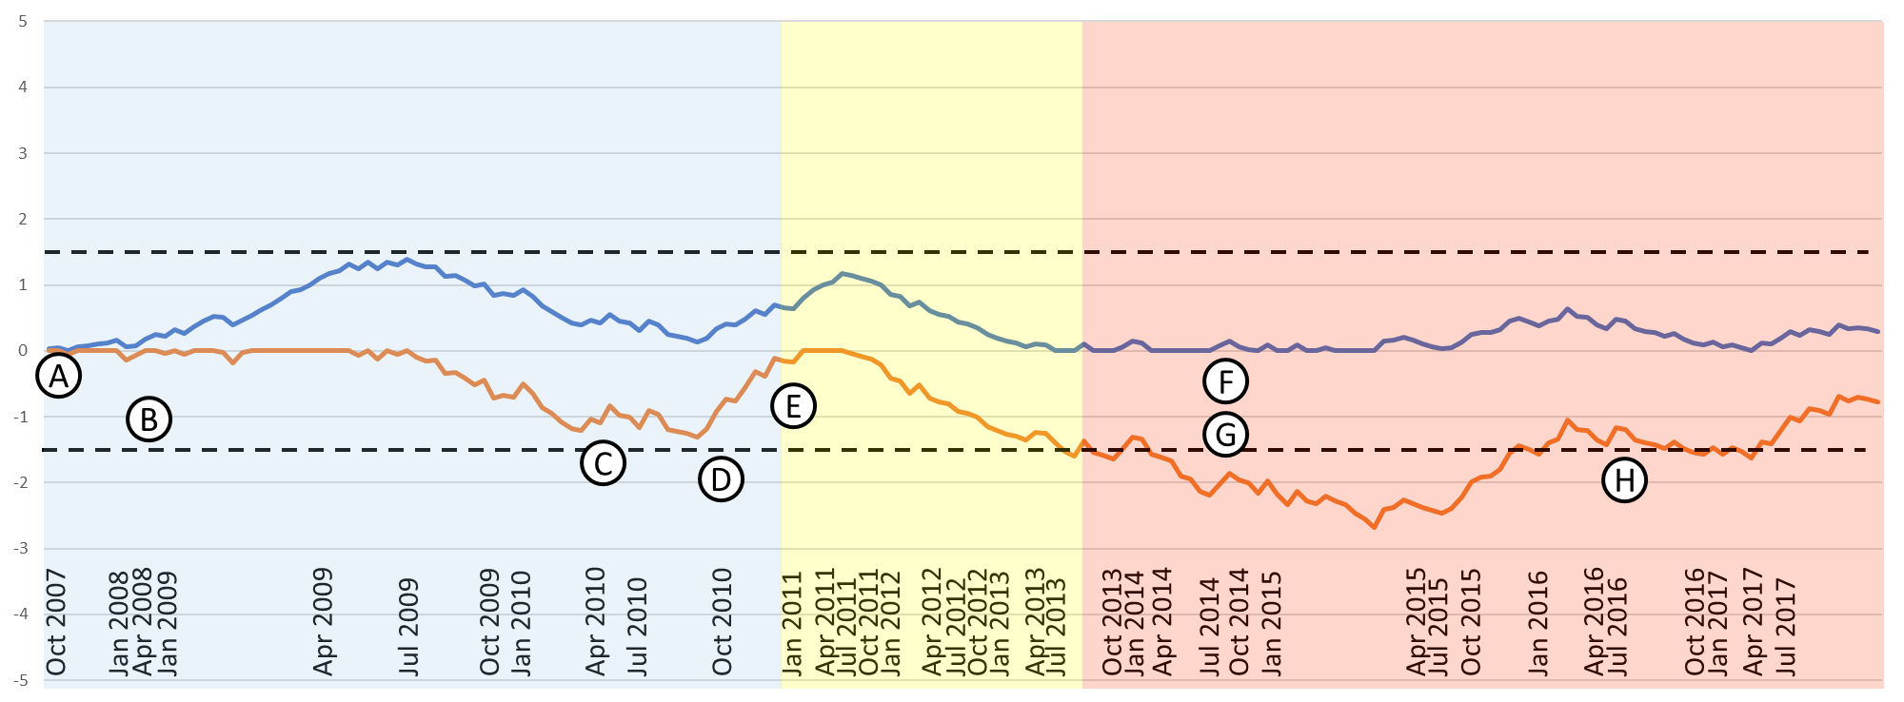

Figure 3. RA-CUSUM for Non-protocolized Management Group. Blue series – Max function with $R_{A}$ of 1.5. Orange series – Min function with $R_{A}$ of 0.5. Dashed lines indicate control limits at 1.5 and -1.5. Implementation of Institutional changes and events are marked as follows: A. Pilot study of Sepsis Alert Pathway (Sept 2007), B. Hospital-wide launch of first version of the Sepsis Alert Pathway (May 2008), C. Start of fellowship in Critical Care Medicine (April 2010), D. Implementation of Rapid response system (Oct 2010), E. Implementation of RFID in ICU (Jan 2011), F. Start of residency in Emergency Medicine (September 2014), G. Purchase of ultrasound machine dedicated to the ICU (September 2014), I. Management directive regarding pathway activation (July 2016). Pathway version in implementation differentiated by the background: blue – version 1, yellow – version 2, red – version 3.

II. Risk-Adjusted Exponentially Weighted Moving Averages Control Chart
The RA-EWMA chart was derived using weighted average of sequential observations with most recent observations having the greatest weight¹²:

$${EWMA}_{j}^{Y}=λY_{j}+{{EWMA}_{j-1}^{Y}\left(1-λ\right)}_{}$$
CL was estimated from the variance of the function, assuming that ${EWMA}_{0}^{Y}$ has a variance of zero¹²:
$$var\left({EWMA}_{j}^{π}\right)=λ^{2}\sum_{k=1}^{j}{({1-λ)}^{2\left(j-k\right)}varY_{k}}$$
Ninety-five percent upper and lower CLs were estimated as follows:
$${CL}_{j}= {EWMA}_{j}^{π}±αλ\sqrt{\sum_{k=1}^{j}{({1-λ)}^{2\left(j-k\right)}π_{j}(1-π_{j})}}$$
Width parameter $α$ is selected so that the in-control ARL (which corresponds to false positive rate) is suitably long while the out-of-control ARL (which corresponds to false negative rate) is suitably short¹³. Smoothing factor $λ$ is used to attenuate noise in the data and smooth an erratic risk model while still being able to detect sudden trend changes. Application of EWMA in critical care¹³ showed that $λ$ between 0.005 and 0.020 allow comparability of expected and observed outcomes. In this study, $λ$ was set at 0.01, OR at 2.0, and $α$ at 2.07, hence having an in-control ARL of 1000 and an out-of-control ARL of 50 (approximately 5 months).
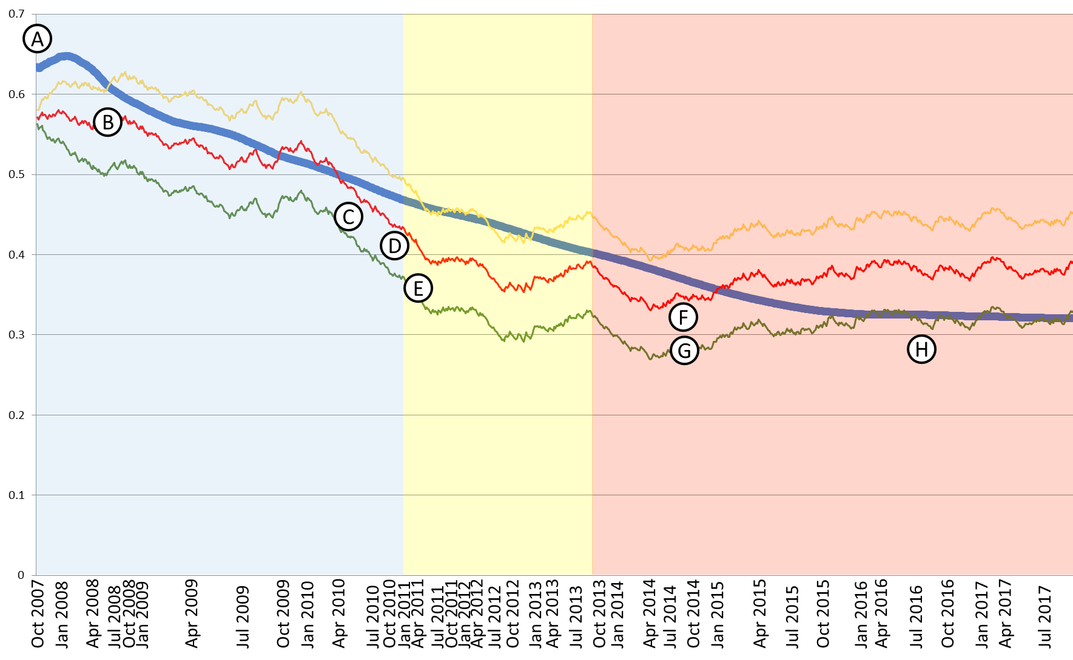

Figure 4. RA-EWMA chart of entire population. Blue series – Observed mortality. Red series – Predicted mortality. Yellow series – upper 95% confidence interval of control limit. Green series – lower 95% confidence interval of control limit. Implementation of Institutional changes and events are marked as follows: A. Pilot study of Sepsis Alert Pathway (Sept 2007), B. Hospital-wide launch of first version of the Sepsis Alert Pathway (May 2008), C. Start of fellowship in Critical Care Medicine (April 2010), D. Implementation of Rapid response system (Oct 2010), E. Implementation of RFID in ICU (Jan 2011), F. Start of residency in Emergency Medicine (September 2014), G. Purchase of ultrasound machine dedicated to the ICU (September 2014), I. Management directive regarding pathway activation (July 2016). Pathway version in implementation differentiated by the background: blue – version 1, yellow – version 2, red – version 3.

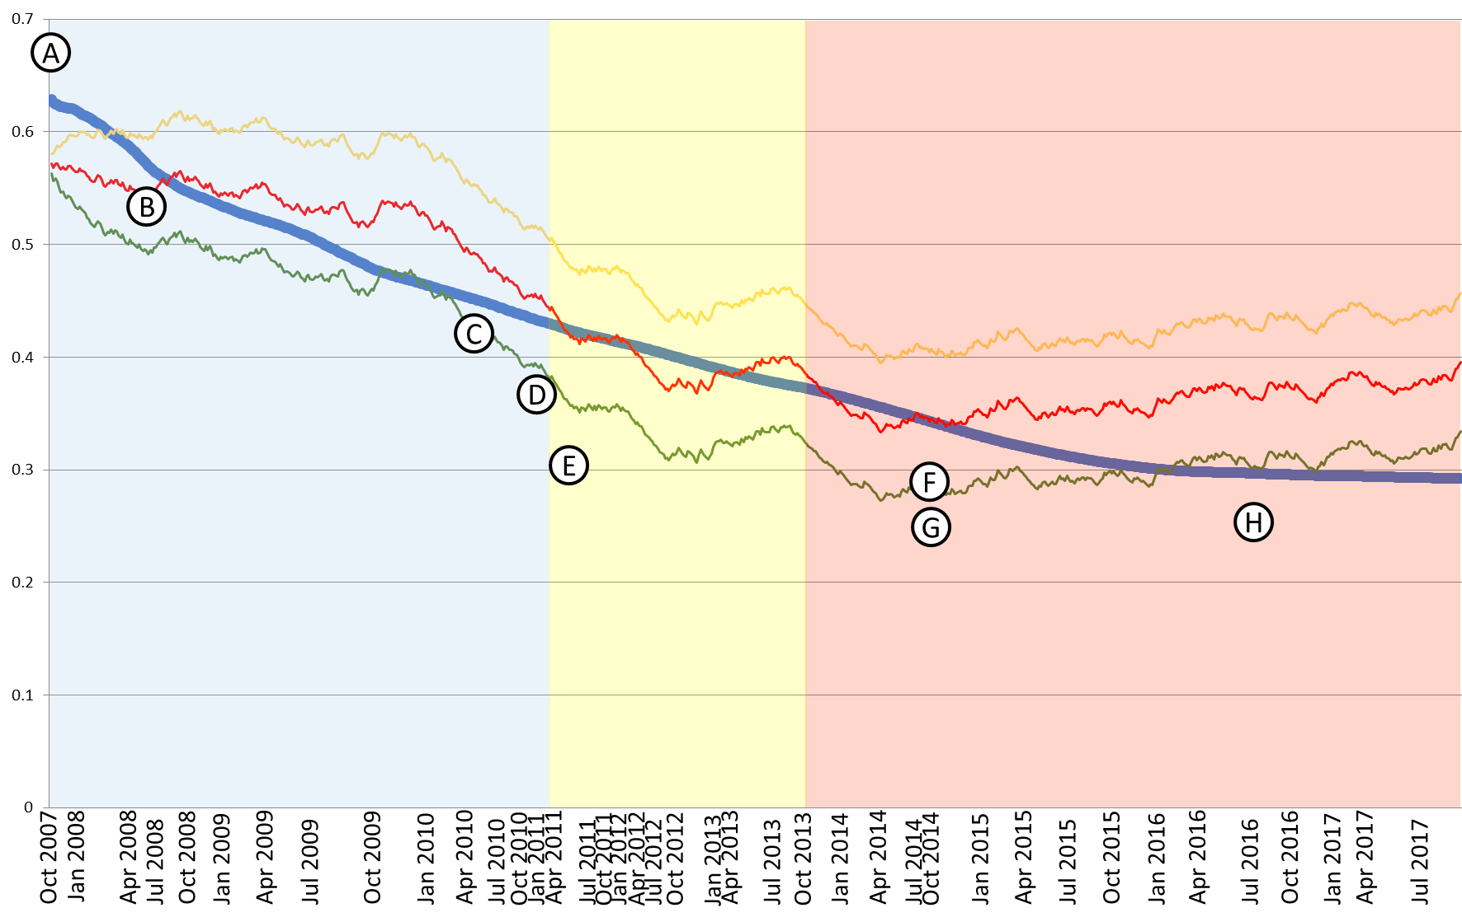

Figure 5. RA-EWMA chart of Protocol-based group only. Blue series – Observed mortality. Red series – Predicted mortality. Yellow series – upper 95% confidence interval of control limit. Green series – lower 95% confidence interval of control limit. Implementation of Institutional changes and events are marked as follows: A. Pilot study of Sepsis Alert Pathway (Sept 2007), B. Hospital-wide launch of first version of the Sepsis Alert Pathway (May 2008), C. Start of fellowship in Critical Care Medicine (April 2010), D. Implementation of Rapid response system (Oct 2010), E. Implementation of RFID in ICU (Jan 2011), F. Start of residency in Emergency Medicine (September 2014), G. Purchase of ultrasound machine dedicated to the ICU (September 2014), I. Management directive regarding pathway activation (July 2016). Pathway version in implementation differentiated by the background: blue – version 1, yellow – version 2, red – version 3.
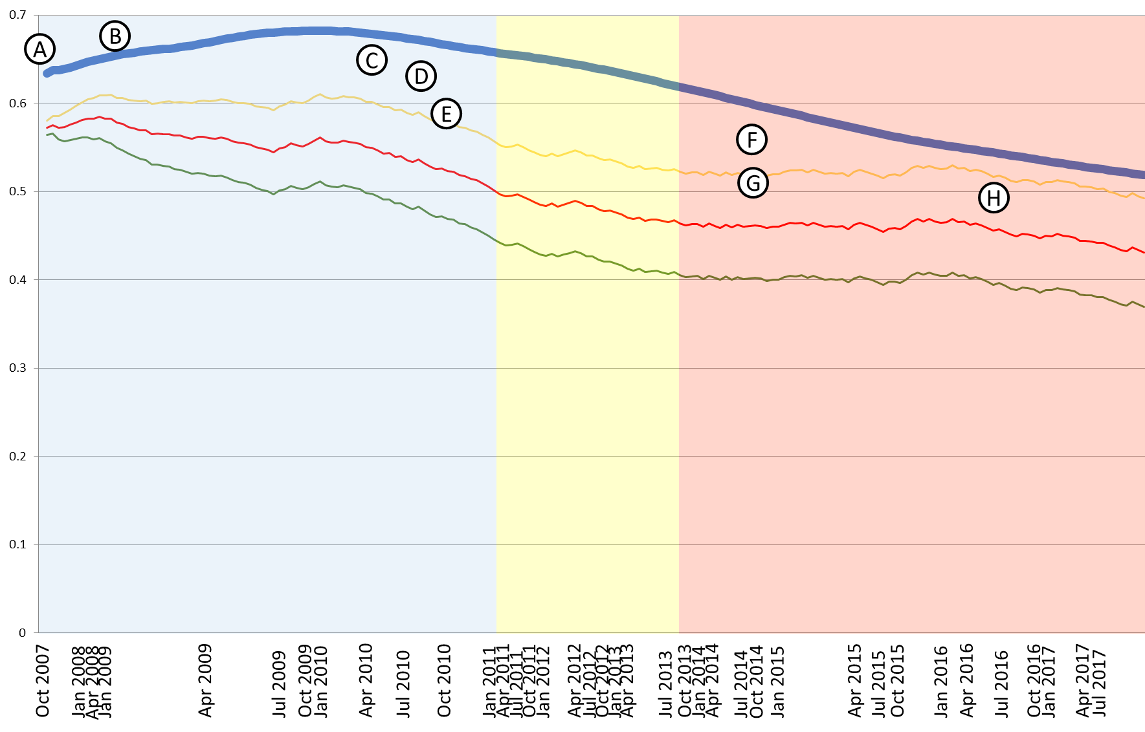

Figure 6. RA-EWMA chart of non-protocolized management group only. Blue series – Observed mortality. Red series – Predicted mortality. Yellow series – upper 95% confidence interval of control limit. Green series – lower 95% confidence interval of control limit. Implementation of Institutional changes and events are marked as follows: A. Pilot study of Sepsis Alert Pathway (Sept 2007), B. Hospital-wide launch of first version of the Sepsis Alert Pathway (May 2008), C. Start of fellowship in Critical Care Medicine (April 2010), D. Implementation of Rapid response system (Oct 2010), E. Implementation of RFID in ICU (Jan 2011), F. Start of residency in Emergency Medicine (September 2014), G. Purchase of ultrasound machine dedicated to the ICU (September 2014), I. Management directive regarding pathway activation (July 2016). Pathway version in implementation differentiated by the background: blue – version 1, yellow – version 2, red – version 3.

Appendix F: Patient Characteristics at Baseline and 6-hours into Resuscitation

Patient Characteristics | Protocol-Based Group | Non-protocolized Group | p value
 | N=750 | N=190
Demographics
Median Age | 69 (55-80) | 67 (56-79) | 0.84*
<40 years old | 88 (11.7%) | 15 (7.9%)
40-49 years old | 47 (6.3%) | 21 (11.1%)
50-79 years old | 432 (57.6%) | 107 (56.3%)
>79 years old | 193 (25.7%) | 47 (24.7%)
Sex
Female | 433 (57%) | 81 (42.6%) | 0**
Point of Entry
ER | 463 (60.9%) | 101 (53.2%) | 0.24*
Ward | 287 (37.8%) | 85 (44.7%)
Operating Room | 6 (0.8%) | 2 (1.1%)
Delivery Room | 4 (0.5%) | 2 (1.1%)
Diagnosis
Severe Sepsis | 145 (19.1%) | 46 (24.2%) | 0.12*
Septic Shock | 615 (80.9%) | 144 (75.8%)
Comorbidities
Hypertension | 339 (44.6%) | 89 (46.8%) | 0.58*
Diabetes | 293 (38.6%) | 62 (32.6%) | 0.13*
Asthma/COPD | 72 (9.5%) | 23 (12.1%) | 0.28*
Stroke | 107 (14.1%) | 27 (14.2%) | 0.96*
Atrial fibrillation | 97 (12.8%) | 31 (16.3%) | 0.20*
Valvular Heart disease | 16 (2.1%) | 7 (3.7%) | 0.21*
CAD | 95 (12.5%) | 23 (12.1%) | 0.88*
Heart failure | 82 (10.8%) | 28 (14.7%) | 0.13*
Malignancy | 158 (20.8%) | 51 (26.8%) | 0.07*
CKD | 158 (20.8%) | 35 (18.4%) | 0.47*
Cirrhosis | 19 (2.5%) | 14 (7.4%) | 0.001*
HIV | 9 (1.2%) | 3 (1.6%) | 0.66*
None | 112 (14.7%) | 15 (7.9%) | 0.01*
Focus of infection
Respiratory | 501 (65.9%) | 121 (63.7%) | 0.56*
Skin/Soft tissue | 107 (14.1%) | 17 8.9%) | 0.06*
Genitourinary | 274 (36.1%) | 42 (22.1%) | 0.00*
Blood | 53 (7%) | 17 (8.9%) | 0.35*
Gastrointestinal | 109 (14.3%) | 45 (23.7%) | 0.002*
Central Nervous System | 12 (1.6%) | 3 (1.6%) | 0.10*
Clinical Parameters
White blood cell count (x 10⁹ cells/mm³) | 14.5 (8.9-20.2) | 14.6 (8.9-22) | 0.56**
Temperature (°C) | 38.0 (37.2-39.0) | 37.9 (36.9-38.8) | 0.01**
Lactate (mmol/L) | 2.76 (1.66-4.30) | 2.82 (1.84-5.01) | 0.46**
Lactate >4 | 195 (26%) | 43 (22.6%) | 0.15**
Creatinine (mg/dL) | 1.36 (0.84-2.47) | 1.21 (0.71-2.6) | 0.08**
Mean arterial pressure (mmHg)
Baseline | 63 (56-70) | 60 (55-71) | 0.76**
6 hours after resuscitation | 74 (67-83) | 76 (67-86) | 0.25**
Heart rate (bpm)
Baseline | 105 (88-120) | 104 (88-121) | 0.80**
6 hours after resuscitation | 95 (84-110) | 94 (84-108) | 0.69**
Total fluid resuscitation (liters) | 2.0 (1.0-2.0) | 1.0 (1.0-2.0) | 0.15**
Antibiotic therapy within 30 minutes of diagnosis | 77.1% | 74.2% | 0.4
APACHE-II Score | 20 (14-27) | 21 (16-28) | 0.13**
Expected mortality | 36% (19%-57%) | 40% (24%-61%) | 0.15**
Values expressed as median with interquartile range
*Chi-square
** Mann-Whitney U test

Appendix G – Propensity Matched Analysis

Variables entered into the equation:
- Age
- Female gender
- Comorbid status (y/n)
  - DM
  - COPD
  - Cancer
  - CKD
  - HTN
  - CVD
  - Cirrhosis
  - HIV
  - Heart failure
  - Coronary artery disease
  - Connective Tissue Disease
- Origin: ER/Floors/OR/other ICUs
- Initial Mean Arterial Pressure
- Initial Heart Rate
- Suspected septic focus
  - central nervous system
  - cardiovascular
  - pulmonary
  - gastrointestinal
  - genitourinary
  - skin or soft tissue
  - blood

Mortality x Pathway Cross-tabulation, Caliper = 0.2
(Pearson’s Chi-square Analysis)

 | Protocolized Management | Non-Protocolized Management | P value
n | 190 | 190
Mortality (%) | 63 (43.4%) | 82 (56.6%) | 0.045

Appendix H – Logistic Regression Analysis

- Binomial Logistic Regression of Clinical Factors Affecting Mortality

 | Odds Ratio | 95% CI | P value
Age > 60 years | 0.820 | 0.584-1.151 | .251
Presence of any comorbidity | 0.749 | 0.476-1.178 | .211
APACHE II score >25 | 5.487 | 4.010-7.508 | .000
Lactate >4 mmol | 2.551 | 1.824-3.569 | .000
Use of Protocol-Based Management | 0.497 | 0.345-0.716 | .000

- Multinomial Logistic Regression of Significant Clinical Factors Affecting Mortality

 | Odds Ratio | 95% CI | P value
APACHE II score >25 | 5.306 | 3.894-7.228 | .000
Lactate >4 mmol | 2.617 | 1.874-3.655 | .000
Use of Protocol-Based Management | 0.509 | 0.354-0.732 | .000

Appendix I – Annual Pathway Activation Compliance Rate

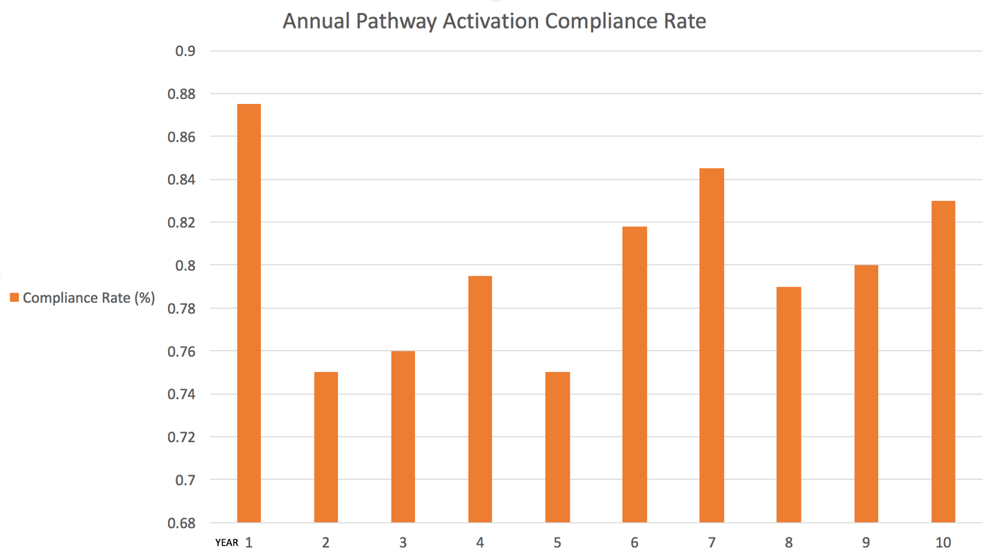

Figure 7. Pathway activation compliance rate by program year.

