Supplemental Data
Near-infrared-based cerebral oximetry for prediction of severe acute kidney injury in critically ill children after cardiac surgery
Marine Flechet PhD¹, Fabian Güiza PhD¹, Isabelle Scharlaeken MD¹, Dirk Vlasselaers MD PhD¹, Lars Desmet MD¹, Greet van den Berghe MD PhD¹, Geert Meyfroidt MD PhD¹
¹Clinical Division and Laboratory of Intensive Care Medicine, Academic Department of Cellular and Molecular Medicine, KU Leuven, Leuven, Belgium
Corresponding author:
Geert Meyfroidt, MD, PhD
E-mail: geert.meyfroidt@uzleuven.be
University of Leuven
Department of Intensive Care Medicine
Herestraat 49; B-3000 Leuven; Belgium
Phone +32 16 344021
Fax +32 16 344015

eMethods. Acute kidney injury definition.
eMethods. Observation window.
eFigure 1. Performance of individual NIRS predictors
eFigure 2. Performance of combined NIRS predictors
eFigure 3. Comparison of performance of clinical model and combined NIRS + clinical model
eFigure 4. Distribution of observation windows
eTable 1. NIRS predictors
eTable 2. Performance of combined NIRS predictors
eTable 3. Interaction analysis between NIRS predictors and mean blood pressure
eTable 4. Interaction analysis between NIRS predictors and arterial carbon dioxide
eReferences.

.

eMethods.
Acute kidney injury definition
Severe AKI was defined as serum creatinine (SCr) level ≥ 2 times the baseline level, or urine output (UO) < 0.5 ml/kg/hour for ≥ 12 hours, or provision of dialysis (AKI stage 2 or 3) according to the Kidney Disease: Improving Global Outcome criteria (1). Baseline SCr was determined as the lowest level in the 3 months before admission or calculated using the Schwarz formula (2) with estimated glomerular filtration rate dependent on age (3) . SCr was measured daily and UO several times a day for all patients. At least 1 SCr measurement or at least 12 hours of UO in the first 7 days were required to assess AKI. The maximum AKI stage was used when the SCr and UO criteria resulted in different stages.
Observation window
For development of the prediction models for acute kidney injury (AKI), data were retrieved during the observation window, which lasted from admission until prediction time (eFigure 4a-b). For patients with AKI, the observation window lasted until 6 hours before AKI onset. To reduce possible bias from monitoring duration, for patients without AKI, the observation window was determined by fitting a similar distribution of observation windows than for the patients with AKI (eFigure4c).

eFigure 1. Performance of individual NIRS predictors
Top row. Performance of maximum NIRS signal, a. ROC curve (AUROC, 0.59; 95% CI 0.59-0.59), b. Decision curve (clinical usefulness in ranges 32-58%), c. Calibration belts (P=0.59). Middle row. Performance of mean NIRS signal, d. ROC curve (AUROC, 0.59; 95% CI 0.58-0.59), e. Decision curve (clinical usefulness in ranges 34-72%), f. Calibration belt (P=0.60). Bottom row. Performance of RMSSD of NIRS signal, g. ROC curve (AUROC 0.68; 95% CI 0.67-0.68). h. Decision curve (clinical usefulness in ranges 27-94%). i. Calibration belt (P=0.61).
Abbreviations: AUROC, area under the ROC curve; NIRS, near-infrared spectroscopy; RMSSD, root mean square of successive differences; ROC, receiver-operating characteristic

eFigure 2. Performance of combined NIRS predictors
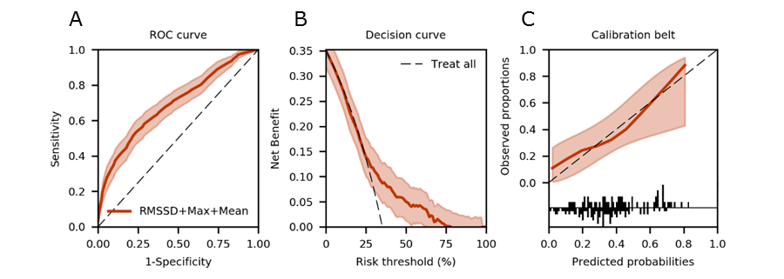
A. ROC curve of model combining maximum, mean and RMSSD of NIRS signal (AUROC 0.69; 95% CI 0.69-0.70). B. Decision curve (clinical usefulness in ranges 25-79%). C. Calibration belt (P=0.59).
Abbreviations: AUROC, area under the ROC curve; NIRS, near-infrared spectroscopy; RMSSD, root mean square of successive differences; ROC, receiver-operating characteristic

eFigure 3. Comparison of performance of clinical model and combined NIRS + clinical model
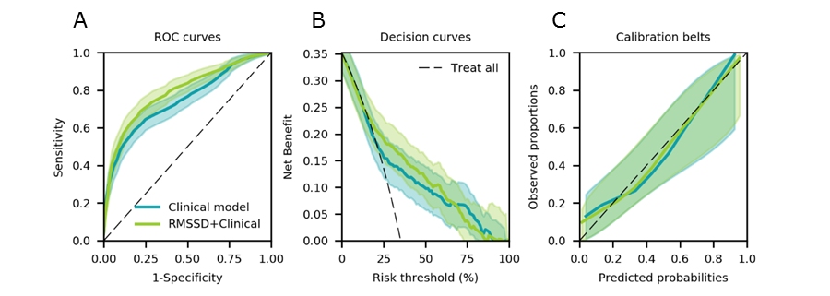
A. Comparison of ROC curves of clinical model (AUROC 0.75; 95% CI 0.75-0.75) and of combined NIRS RMSSD + clinical model (AUROC 0.79; 95% CI 0.79-0.80). B. Decision curve of clinical model (clinical usefulness in ranges 22-94%) and of combined NIRS RMSSD + clinical model (clinical usefulness in ranges 16-97%). Clinical benefit of combined model is improved by 2.2% as compared to only using the clinical model at a risk threshold of 20%; 2.4% at a risk threshold of 40%, and 1.3% at a risk threshold of 60% C. Calibration belt of clinical model (P=0.57) and of combined NIRS RMSSD + clinical model (P=0.56).
Abbreviations: AUROC, area under the ROC curve; NIRS, near-infrared spectroscopy; RMSSD, root mean square of successive differences; ROC, receiver-operating characteristic

eFigure 4. Distribution of observation windows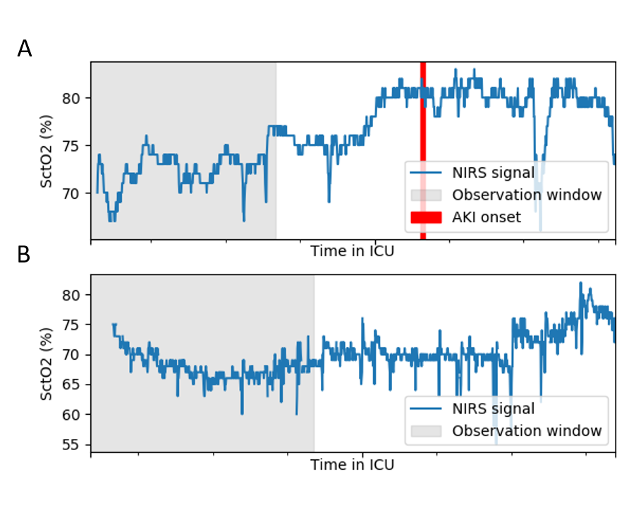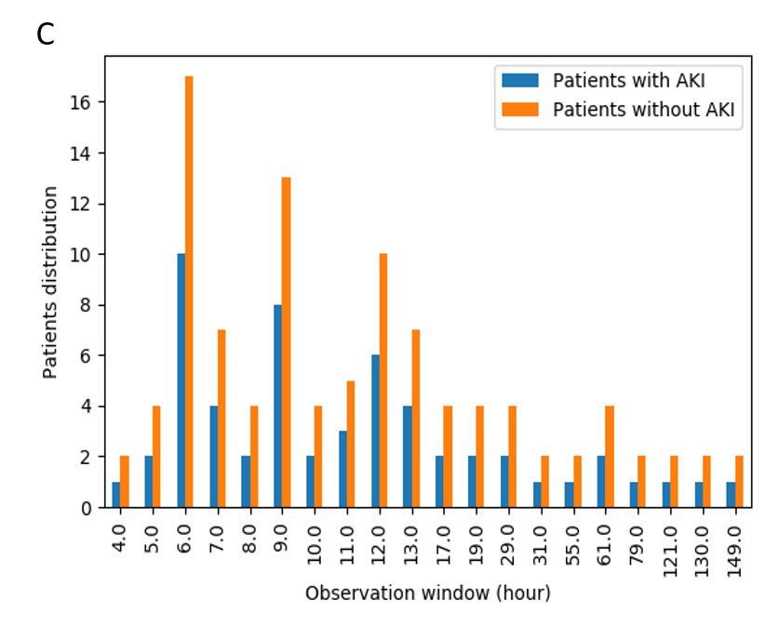
Example of the observation window for a patient who (A) developed AKI during ICU stay, (B) did not develop AKI. For patient with AKI, the observation window corresponds to the time between admission and 6 hours prior to AKI onset. To reduce bias due to monitoring duration, the duration of the observation window for the non-AKI patients was chosen to match that of the AKI cases. (C) Bar chart of the distribution of observation windows for the patients with AKI together with the fitted distribution of observation windows for the patients without AKI.

eTable 1. NIRS predictors
 | All patients (n=156) | AKI patients (n=55) | No AKI patients (n=101) | P-value
Value-based metrics
Mean | 70.2 (64.6-74.8) | 69.8 (60.2-73.8) | 70.4 (66.7-75.1) | 0.007
Minimum | 61 (53-66) | 60 (51-67) | 61 (54-66) | 0.20
Maximum | 78 (72-82) | 76 (68-82) | 79 (73-83) | 0.01
Variability metrics
Maximum-minimum | 16 (12-21) | 15 (11-19) | 16 (12-21) | 0.29
SD | 2.9 (2.0-3.7) | 3.2 (2.0-3.8) | 2.9 (2.0-3.6) | 0.69
SD-s | 2.8 (1.8-3.6) | 3.0 (1.8-3.7) | 2.7 (1.8-2.8) | 0.48
RMSSD | 0.78 (0.63-0.95) | 0.68 (0.56-0.87) | 0.83 (0.69-0.98) | <0.0001
Slope | 0.002 (-0.007-0.011) | 0.005 (-0.006-0.014) | 0.001 (-0.008-0.008) | 0.28
Dose
Dose < patient-specific 25 percentile | 0.4 (0.3-0.6) | 0.4 (0.2-0.6) | 0.4 (0.3-0.6) | 0.98
Dose < 50% | 0.0 (0.0-0.0) | 0.0 (0.0-0.0) | 0.0 (0.0-0.0) | 0.03
Dose < 60% | 0.0 (0.0-0.2) | 0.0 (0.0-0.7) | 0.0 (0.0 -0.0) | 0.001
Dose > patient-specific 75 percentile | 14.2 (10.7-16.5) | 13.4 (10.5-15.8) | 14.4 (11.3-16.7) | 0.13
Dose > 80% | 0.0 (0.0-0.9) | 0.0 (0.0-0.5) | 0.0 (0.0-1.1) | 0.97
Time
Time < patient-specific 25 percentile | 20.0 (15.5-23.2) | 20.0 (13.5-23.3) | 20.0 (16.1-22.9) | 0.41
Time < 50% | 0.0 (0.0-0.0) | 0.0 (0.0-0.0) | 0.0 (0.0-0.0) | 0.01
Time < 60% | 0.0 (0.0-4.7) | 0.0 (0.0-33.3) | 0.0 (0.0-0.9) | 0.001
Time > patient-specific 75 percentile | 19.6 (16.0-22.4) | 20.2 (15.8-21.7) | 19.1 (16.2-23.2) | 0.49
Time > 80% | 0.0 (0.0-1.4) | 0.0 (0.0-1.0) | 0.0 (0.0-1.4) | 0.95
Frequency components
Magnitude of first largest frequency component | 37277 (24816-58793) | 39889 (20301-57287) | 36063 (25421-59083) | 0.93
Frequency of first largest frequency component, Hz | 632 (420-1020) | 625 (404-886) | 660 (420-1020) | 0.82
Magnitude of second largest frequency component | 208 (114-469) | 225 (125-537) | 191 (110-464) | 0.25
Frequency of second largest frequency component, Hz | 225 (151-334) | 203 (134-327) | 225 (156-334) | 0.81
Magnitude of third largest frequency component | 208 (114-469) | 225 (125-537) | 191 (110-464) | 0.25
Frequency of third largest frequency component, Hz | 214 (132-347) | 212 (127-301) | 223 (132-347) | 0.83
Data are reported as median (IQR). Time and dose predictors are reported as time-weighted metrics. P-value is shown for differences between patients with and without AKI. Abbreviations: FFT, fast-Fourier transform; RMSSD, root-mean square of successive differences; SD, standard deviation; SD-s, standard deviation of smoothed signal

eTable 2. Performance of combined NIRS predictors
 | AUROC (95%CI) | OR (95%CI) | P-value
Combined model | 0.69 (0.69-0.70)
RMSSD |  | 0.041 (0.007-0.234) | <0.001
Maximum |  | 1.107 (0.984-1.245) | 0.17
Mean |  | 0.871 (0.773-0.982) | 0.07
Abbreviations: AUROC, area under the ROC curve; CI, confidence interval; OR, odds ratio; RMSSD, root mean square of successive differences; ROC, receiver-operating characteristic

eTable 3. Interaction analysis between NIRS predictors and mean blood pressure
 | AUROC (95%CI) | OR (95%CI) | P-value
NIRS RMSSD | 0.77 (0.77-0.77)
RMSSD |  | 2.28 (0->999999) | 0.86
Blood pressure |  | 0.08 (0-19979) | 0.47
RMSSD*blood pressure |  | 1662928 (4.03->999999) | 0.57
NIRS mean | 0.69 (0.69-0.69)
Mean |  | 0.81 (0.58-1.12) | 0.24
Blood pressure |  | 1270723 (0->999999) | 0.19
Mean*blood pressure |  | 1.3 (0.82-2.06) | 0.32
NIRS max | 0.68 (0.68-0.69)
Max |  | 0.69 (0.49-0.97) | 0.07
Blood pressure |  | 0.13 (0.00->999999) | 0.05
Max*blood pressure |  | 1.66 (1.03-2.68) | 0.09
Abbreviations: AUROC, area under the ROC curve; CI, confidence interval; OR, odds ratio; RMSSD, root mean square of successive differences; ROC, receiver-operating characteristic
Blood pressure has been standardized by dividing by maximum value.

eTable 4. Interaction analysis between NIRS predictors and arterial carbon dioxide
 | AUROC (95%CI) | OR (95%CI) | P-value
NIRS RMSSD | 0.72 (0.72-0.73)
RMSSD |  | 14.93 (0->999999) | 0.92
CO₂ |  | 96.26 (0->999999) | 0.77
RMSSD*CO₂ |  | 0.01 (0->999999) | 0.58
NIRS mean | 0.63 (0.63-0.64)
Mean |  | 0.89 (0.63-1.27) | 0.45
CO₂ |  | >999999 (50442->999999) | 0.47
Mean*CO₂ |  | 1.12 (0.67-1.87) | 0.58
NIRS max | 0.63 (0.63-0.64)
Max |  | 0.88 (0.62-1.25) | 0.43
CO₂ |  | >999999 (52.47->999999) | 0.43
Max* CO₂ |  | 1.16 (0.7-1.92) | 0.53
Abbreviations: AUROC, area under the ROC curve; CI, confidence interval; CO₂, carbon dioxide; OR, odds ratio; RMSSD, root mean square of successive differences; ROC, receiver-operating characteristic
CO₂ has been standardized by dividing by maximum value.

eReferences
1. Kidney Disease: Improving Global Outcomes (KDIGO) Acute Kidney Injury Work Group.: KDIGO Clinical Practice Guideline for Acute Kidney Injury. Kidney Int Suppl 2012; 2:1–138
2. Schwartz GJ, Haycock GB, Edelmann CM, et al.: A simple estimate of glomerular filtration rate in children derived from body length and plasma creatinine. [Internet]. Pediatrics 1976; 58:259–63Available from: http://www.ncbi.nlm.nih.gov/pubmed/951142
3. Custer JW, Rau RE: The Harriet Lane handbook : a manual for pediatric house officers. 2008.

