Emory Healthcare Percutaneous Tracheostomy During Apnea Protocol

Procedural Specifics:
- Tracheostomy kit prepared outside of room to minimize exposure time
- Sedation administered and the patient undergoes neuromuscular blockade
- Patient placed in the supine position with the neck hyperextended.

- Unclamp ETT from tube holder  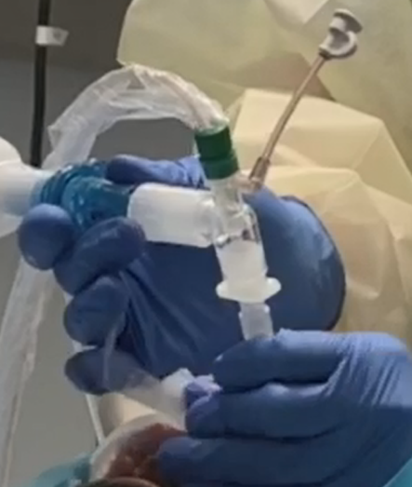 | Ventilator Circuit Closed
- Sterile field created/draped, and neck prepared. 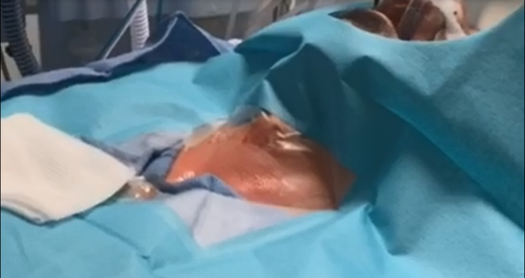 | Ventilator Circuit Closed

- Anatomic landmarks palpated and location for incision identified.  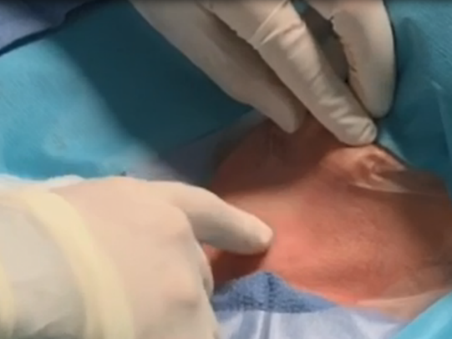 | Ventilator Circuit Closed
- Local anesthetic administered  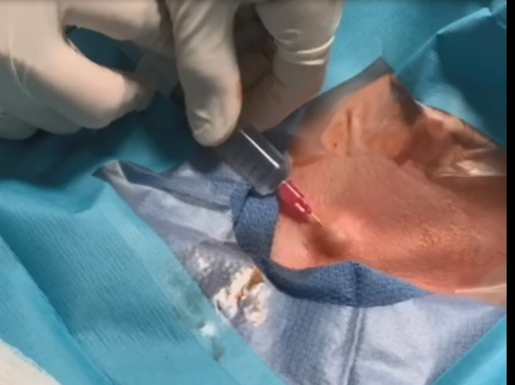 | Ventilator Circuit Closed
- Incision made.  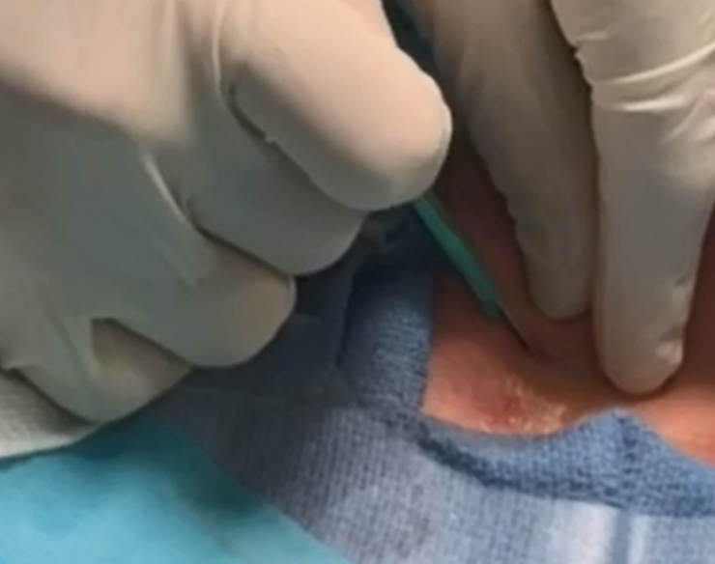 | Ventilator Circuit Closed

- Blunt dissection performed to the trachea. Incision covered with wet gauze to minimize droplets.  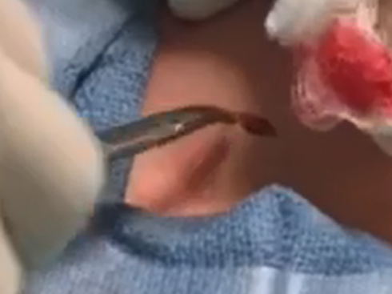 |  | Ventilator Circuit Closed
- Bronchoscope placed through endotracheal tube adaptor but NOT connected to the ventilator circuit  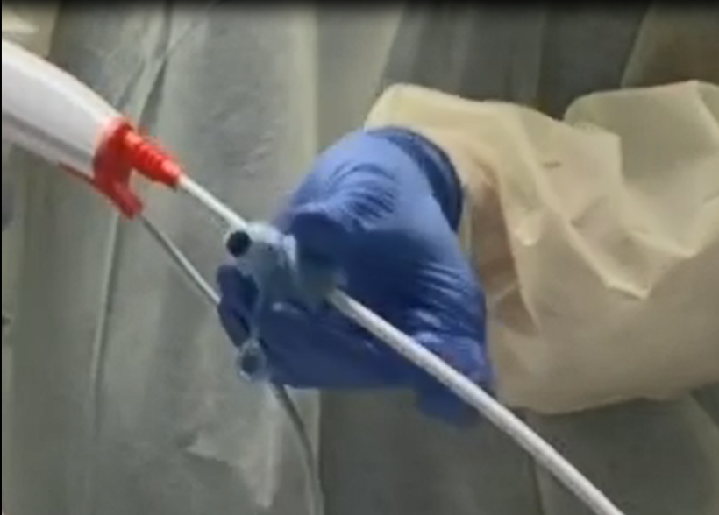 |  | Ventilator Circuit Closed
- Ventilator placed on standby mode. 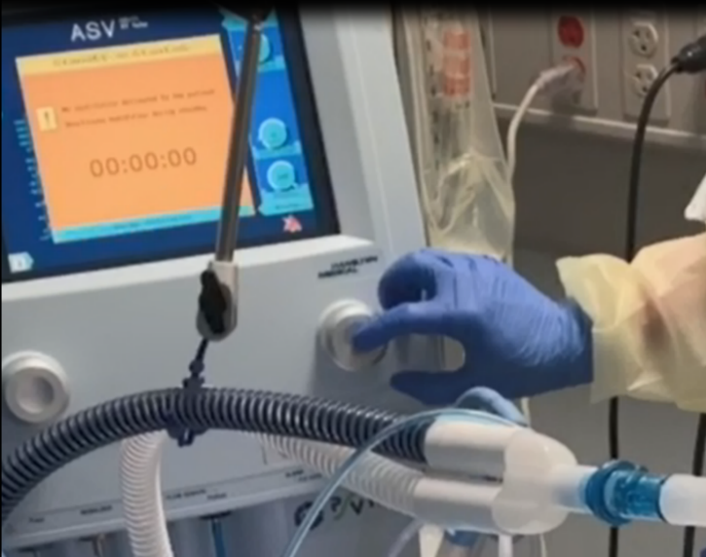 |  | Ventilator Circuit Closed
- After 15 seconds of cessation of airflow, the ETT is disconnected from the ventilator. ETT suction tubing removed. 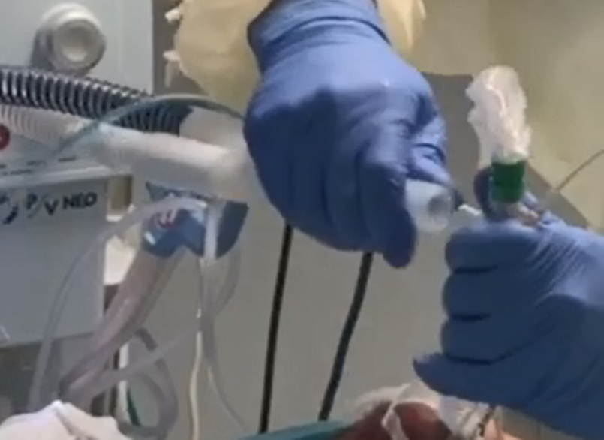 |  | Ventilator Circuit Open  Apnea Time (min:sec): 0:15  Aerosolization Risk Time  0:15
- The adapter (with bronchoscope already through it) then connected to vent circuit and scope advanced through the ETT  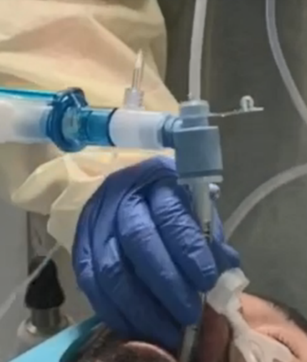 |  | Ventilator Circuit Closed  Apnea Time 0:30  Aerosolization Risk Time  0:15
- ETT cuff deflated. ETT retracted back to subglottic space.  *Although the ventilator circuit is closed, there is a theoretical risk of aerosolization around the deflated cuff and ETT repositioning. This risk is minimized given ventilator is on standby mode. |  | Ventilator Circuit Closed  Apnea Time 1:00  Aerosolization Risk Time  0:45
- Needle inserted and the tracheostomy procedure performed  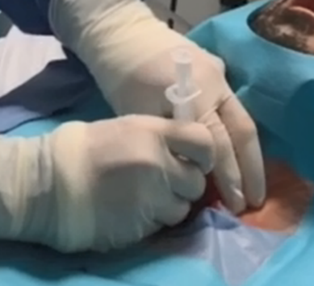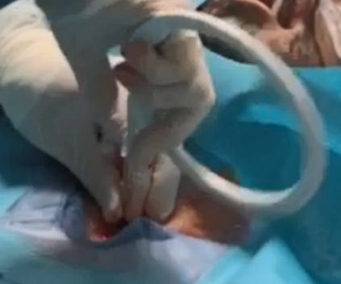  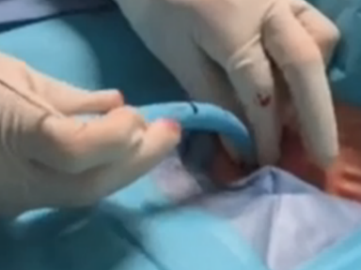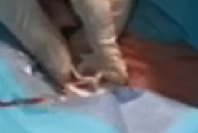 | Ventilator Circuit Closed  Apnea Time: 4:00  Aerosolization Risk Time  3:45
- Bronchoscope inserted via new tracheostomy tube to confirm position  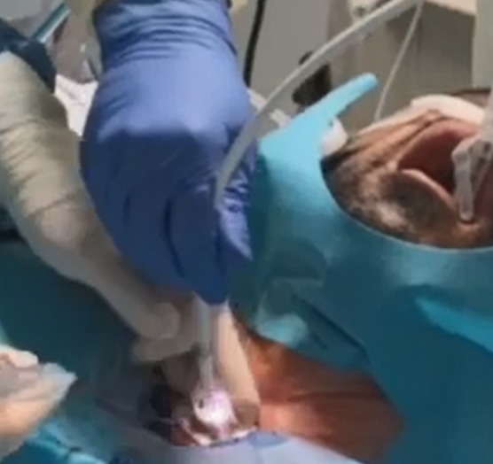 | Ventilator Circuit Open  Apnea Time: 4:30  Aerosolization Risk Time  4:15
- Bronchoscope removed from Trach | Ventilator Circuit Open  Apnea Time: 4:45  Aerosolization Risk Time  4:30
- Inner cannula inserted, and the ventilator circuit connected to the tracheostomy tube.  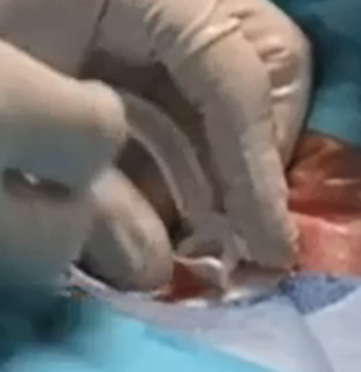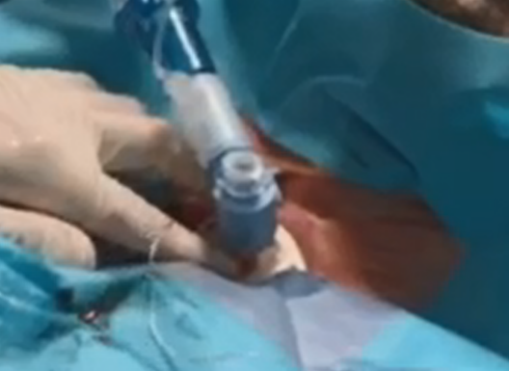 | Ventilator Circuit Closed  Apnea Time: 5:00  Aerosolization Risk Time  4:45
- Tracheostomy tube Cuff inflated  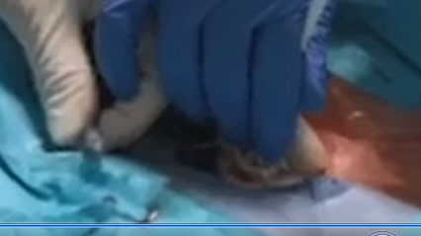 | Ventilator Circuit Closed  Apnea Time: 5:15  Aerosolization Risk Time  5:00
- Ventilator restarted  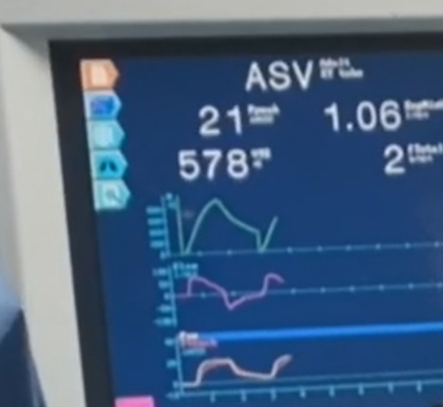 | Ventilator Circuit Closed  Total Apnea Time : 5:15  Aerosolization Risk Time  5:00

Troubleshooting:
- Although the procedure can typically be done safely and without patient desaturation in under 5 minutes, there may be patient specific issues that arise.
- Should desaturation or hemodynamic instability be encountered at any time, the ETT should be repositioned to mid trachea, the ETT cuff re-inflated, and the bronchoscope carefully removed PRIOR to taking the ventilator off standby.
- If the patient can not tolerate apnea, Oxygen tubing can be advanced directly through the ETT adaptor and administered side-by-side with the bronchoscope. Note that this will increase risk of aerosolization of airway secretions.
- If the ETT or airways are densely covered with secretions which impairs the view of the bronchoscope, push the secretions into the lower airways mechanically or using sterile saline via the bronchoscope. Removing the bronchoscope to flush the channel or clear secretions from it poses a high risk for droplet contamination to all staff in the room. If it is absolutely necessary to remove the bronchoscope to flush the channel or wipe off secretions, do this ONLY with the ventilator on standby mode.
- Prepare a resource bag of items (extra trach, spare ETT or adaptor, etc) and a team member (“runner”) outside of the room that could bring in supplies in an emergency. A speaker phone can be used by the team inside the room to communicate to the runner outside of the room.

