SUPPLEMENTAL DATA FILE FOR DEVELOPMENT OF A PEER SUPPORT MODEL USING EBCD TO IMPROVE CRITICAL CARE RECOVERY
Supplemental Appendix 1 - Evaluation of EBCD Focus Group Questions
Supplemental Appendix 2 - Detailed Study Methodology
Supplemental Table 1 – Major Themes and Supporting Quotes
Supplemental Table 2 – Key Design Components and Pragmatic Ideas for Building the Peer Support Model
Supplemental Table 3 – Final Peer Support Model using TiDIER Checklist

Supplemental Appendix 1 – Evaluation of Experience-Based Co-Design Focus Group Questions
Participant Group 1 - Clinicians
- Have you participated in a co-design project before? If yes, please describe.
- What was it like for you to participate in the co-design process for this project, for example interacting with other staff and intensive care survivors?
- How did participating in co-design make you feel?
- How has your involvement in this project impacted upon your understanding of the intensive care recovery experience of patients and their families?
- Have you changed anything about the way you practice, as a result of your involvement in this co-design process / project?
- What was it like for you to share some of your experiences of caring for these patients and their families for this project and to hear their experiences?
- Do you think your perspectives were valued and taken in to consideration in developing the peer support model?

Additional questions if required:
- What were some of the challenges of participating in this co-design project?
- What were some of the advantages and/or opportunities to participating in this co-design project?
- What should we do differently next time if we were to engage with ICU survivors and staff?

Participant Group 2 – Patients/Families:
- Have you participated in a co-design project before? If yes, please describe.
- What was it like for you to participate in the co-design process for this project, for example interacting with other intensive care survivors and staff?
- How did participating in co-design make you feel?
- How has your involvement in this project impacted upon your recovery as either a patient or a family member?
- What was it like for you to recount some of your intensive care recovery experiences for this project?
- Do you think your perspectives were valued and taken in to consideration in developing the peer support model?

Additional questions if required:
- What were some of the challenges of participating in this co-design project?
- What were some of the advantages and/or opportunities to participating in this co-design project?
- What should we do differently next time if we were to engage with ICU survivors and staff?

Participant Group 3 - Project Team:

- Have you participated in a co-design project before? If yes, please describe.
- What was it like for you to participate in the co-design process for this project, for example interacting with other staff and intensive care survivors?
- How did it make you feel?
- What do you think worked well about the co-design process?
  - What were some of the opportunities/benefits?
- What do you think did not work so well about the co-design process?
  - What were the challenges/barriers?
- What could we do differently next time if we were to engage with ICU survivors and staff?

Additional questions if required:
- How has your involvement in this project impacted upon your understanding of the intensive care recovery experience of patients and their families?
- Has your involvement in this project changed the way you practice/work?

Supplemental Appendix 2 - Detailed Study Methodology
Research team and reflexivity
The interprofessional research advisory team comprised clinicians and researchers from medicine, physiotherapy, occupational therapy, psychology, social work and nursing with varied experience and expertise in critical care. Five members of the team had expertise in the design and conduct of critical care research (KH, CF, TJI, ES, SB). Two members had expertise in EBCD methodology in other patient populations (KC, LM). Five members had expertise in qualitative research methods (KH, KC, SH, LM, SB). A consumer (BMS) employed by the health service, who had prior experience as an ICU family member, held a co-leadership role in the team and contributed from study concept to completion. The remaining team members (GS,MS, JC, LH) had clinical and/or managerial expertise in their respective fields.
The Experience-Based Co-Design Workshops were co-facilitated by the project research lead (KH) and the consumer co-lead (BMS) with four to six other members of the project team present at each workshop to support running the event. Due to the content knowledge of the project research lead (KH) and the lived experience of the consumer co-lead (BMS), there was potential for role creep from facilitator to participant. To manage this risk, a team member undertook the role of observer at the EBCD workshops to provide feedback on the maintenance of roles. The project team also debriefed together to reflect on processes, roles and data obtained after each workshop. The Evaluation of Experience-Based Co-Design Focus Groups were facilitated by an independent and experienced qualitative researcher (SH), unknown to the three participant groups (clinicians, patients and family members, and the project team).
Data collection and procedure
The dual processes of this study are detailed here:
- Experience-Based Co-Design Method (Supplemental Fig. 1, Supplemental Digital Content 2, http://links.lww.com/CCX/A7) – Three separate, two-hour workshops took place over three months – Workshop 1 with Participant Group 1 (Clinicians), Workshop 2 with Participant Group 2 (Patients/Families) and Workshop 3 with both participant groups combined. A session plan and facilitation guide was developed by the operational project team.

Prior to the EBCD workshops, three dyads previously known to the project team from clinical care and quality improvement activities, were invited and consented to share their experience of the ICU and recovery via a filmed interview (http://thriveicu.org/melbourne-health-melbourne/). This film was shown at the beginning of the EBCD workshops and provided insights from the perspectives of those being filmed into the recovery experience and highlighted current challenges, opportunities for improvement and the potential usefulness of peer support.
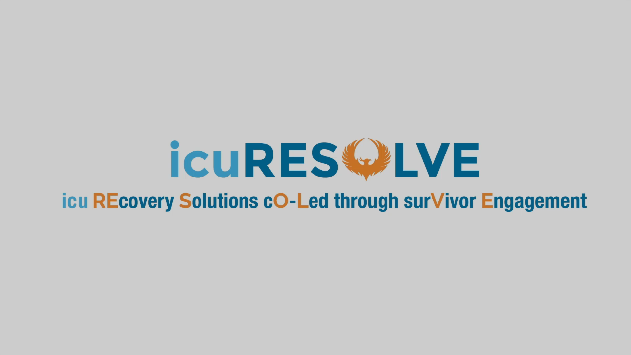

An experience map was created from narratives and ideas generated by participants at the EBCD workshops and an example is provided here:

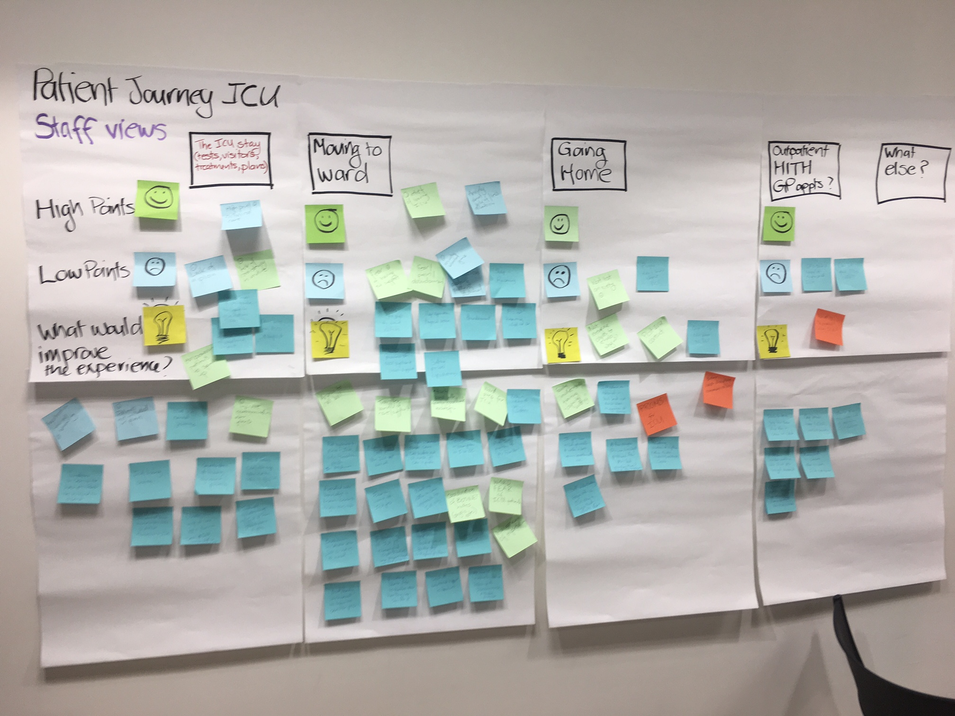
- Qualitative Evaluation of Experience-Based Co-Design
Following the completion of the EBCD workshops, participant groups were invited to participate in three separate, one hour, follow-up focus groups to understand their experiences of participating in the EBCD method. The groups were audio-recorded and transcribed. Field-notes were taken by an experienced qualitative researcher (KC), who attended each workshop to observe and record the interactions and implementation of the EBCD process.

Supplemental Table 1 – Major Themes and Supporting Quotes
Major Themes | Supporting Quotes
Experience-Based Co-Design Method to Develop a Peer Support Model
Key Model Components | “Find out what survivors want - education on Post-Intensive Care Syndrome at a time they can take in.” (Participant 3, clinician)
 | “When should people come to group? At least one month after hospital discharge to give time to settle, but individualise as some people may want to attend … less than one week post hospital discharge.” (Participant 4, family member)
 | “Needs to be optional to come and go. And to be able to continue as long as you like, shouldn't be set. People will come in and out when they need to.” (Participant 8, family member)
 | “These people are likely to have lots of hospital appointments already with different specialities… and may not want to make yet another trip to the hospital.” (Participant 17, clinician)
Managing Potential Risks | “Peer group interactions can trigger trauma – need right supports in place.” (Participant 26, clinician)  “Shame - people may feel ashamed or embarrassed about the problems they are facing and be unwilling to discuss/ acknowledge these or how bad they are - on the other hand perhaps a peer support group like this would normalise those experiences and make them more acceptable. The way this panned out I think would be very dependent on how the meetings were facilitated/ moderated.” (Participant 8, clinician)
 | “Be clear that intent is to share experiences and not advise e.g. sharing of stories.” (Participant 2, family member)
 | “Need the group to focus on the positive.” (Participant 1, patient)
 | “have social worker, psychologist as expert facilitators” (Participant 2, patient)
 | “staff - always needing counsellor, psychologist there, social worker” (Participant 3, patient)
Individualized Needs of Patients and Family Members | “Patients and families need support at different times.” (Participant 10, clinician)
 | “Separate events for patients versus families” (Participant 8, family member) and “would like a group open to family and friends or have two groups that interact at points” (Participant 1, family member).
Evaluation of Experience-Based Co-Design
Participation In EBCD As A Positive Experience | “I thought it was really powerful.” (Participant 8, clinician)
 | “Having the sticky notes was good because sometimes people don’t feel confident saying things out loud.” (Participant 1, clinician)
 | “I feel co-design is a brilliant process for doing that because it gives you that framework and it gives you a method to follow otherwise I think people think maybe they’re doing co-design or think they’re involving patients and families in the design of their own care but it may be at a rather superficial level.” (Participant 4, project team)
Emotional Engagement In The Process | “…At the staff event I was really surprised to see there was a level of emotional response enlisted from staff as well.” (Participant 3, project team)  “…One of the patient’s wives came up and sort of just directed some thanks I guess towards me because of being an ICU nurse, but wanted to sort of use me as a point to disseminate that information… I don’t know how that makes me feel but probably just – I guess it’s a little bit burdensome because – it was good feedback but like I said very emotional.” (Participant 13, clinician)
Patients And Families Feeling Heard | “I also thought that it was just nice for the patient to be able to be heard in a sense that often sometimes when you do get feedback you don’t actually know where that feedback ends up and actually it’s nice to see that they were involved in making just positive change, what they experienced as being heard and actioned upon.” (Participant 1, clinician)
 | “…the emphasis on carers as well as patients for me has been a great thing.” (Participant 6, family member)
Practical Challenges Of EBCD And Readiness To Participate | “Even where do you hold the group, what day do you hold it on, practical considerations, what’s going to suit everyone and I have no doubt that that impacted or biased who was able to come to the session.” (Participant 3, project team)
 | "One of them found it a bit overwhelming just the space, it was quite noisy so I think it was hard for them to contribute." (Participant 5, clinician)
 | “…It’s a tricky one to get them to step outside of their own experience” (Participant 1, project team)
 | “One of the biggest challenges was actually getting through the content and towards [developing] a peer support model with the patients.” (Participant 3, clinician)

Supplemental Table 2 – Key Design Components and Pragmatic Ideas for Building the Peer Support Model
Key Model Component/s | Clinician Ideas | Patient/Family Ideas
How (format) | Face to face, Facebook group, Café group. | Better to do peer support in person.
 | Have a dedicated social event. | Social events - celebrating surviving ICU.
Frequency and duration | Frequency directed by group – possibly start once a fortnight and shift to once a month. | Frequency - once a month. Needs to be optional to come and go. And to be able to continue as long as you like, should not be set. People will come in and out when they need to.
 | Run 6-8 week program in length - theme education, operate as revolving door, e.g. come in at sleep and exit at nutrition. | Duration of participation in group - personal choice for how long you stay in the group, may drop in and out and come back at later time.
 | Timing - have that anyone can drop in at any time point e.g. week 1 versus week 4 post ICU discharge, start and finish at any time - patient self-selects. | Timing - at least 1 month after hospital discharge to give time to settle but individualise - some people may want to attend at <1-week post hospital discharge.
Session length | Length of group directed by members. | Rotate between morning/afternoon to suit different schedules to make more accessible for patients and caregivers.
 | - | Length - two hours.
Location | Run in community - less triggering, local community centre, or onsite at hospital so clinicians can access it. | Run in hospital, somewhere you can sit around.
 | Patients may not like coming back to hospital. | Hospital - conference/separate room like today.
 | Parking costs/practical barriers to physical attendance. | Community centre or hospital, easy to find.
 | Consider accessibility of venue and other disability/needs for example oxygen therapy requirements, wheelchair access. | -
Who | Need a leader - co-led model of patient/family member + clinician, need Western Health + community clinicians. | Have social worker, psychologist as expert facilitators. Train survivors as co-facilitators.
 | Multi-disciplinary support: Consideration of a “link person”/ leader. Medical team to promote as a means of treatment (may increase its perceived value). | Not totally health professionals as could be overwhelming. Group run by - physio, psychologist, nurses, speech pathologist, neurologist, consumer advocate. Professional + carer to attend/talk.
 | Clinicians – social worker, psychologist, project team, other allied health, nurse. | -
Content | Needs to be engaging, right format, timing, personalities, needs to have some form of expert facilitation so not just focus on negative and difficult trajectories of recovery. | Patient and family story telling + professional talk.
 | Get experts in - what info do people want? | Maybe rotating through different topics each session - medical, gym/mobility/exercise, community health centre, what services and supports are available in community, hallucinations/dreams/flash backs, medium/long term psychological support around resilience and goal setting, Linkages with financial and emotional support, return to work.
 | Ask participants what education they would want covered in formal talk. | Videos are great to highlight key points.
 | Structure could be - welcome, formal talk, chat then once/month have just social support. | Information sessions, one person shares a story/experience - others affirm and share similar experiences discuss the 'new normal' and how things change over time.
Advertising | Advertise in ICU wait room. | Give information in ICU about group and keep giving information throughout journey.
 | Think about when information is needed, and when it can be absorbed. | May take time to understand and be ready to process, but if they have written literature/info this can be really helpful to have on hand.
 | Post ICU and hospital discharge phone number to call and what's best format e.g. magnet versus paper. | Advertising = email, letters, Facebook, handout on discharge.
Supporting infrastructure/other ideas | Need to have food. | Provide morning/afternoon tea.
 | Use Facebook/social media to support group | Facebook support group.
 | Different platforms, multi-modalities to suit survivor needs/preferences. | Mobile library at each group, people bring books to share.
 | Shared activities/social option. | Structured program of ICU tour and support - introduce in ICU.
 | Involve volunteers - independent/non-judgmental. | Outreach person who practically gets in touch.
 | - | Different kinds of events.
Sustainability | Structured model through to self-sustaining - co-led to survivor-led. | Sustainable - new people all the time, get them to RSVP, funded by Western Health.
 | Can we brand and hook investors into the model for sustainability. | -
 | Funding/resources to run a formal group. | -
 | If runs in community - would need dedicated staffing attached to it. | -
 | Could get psychologists to Skype or do train the trainer for psychology info/education | -

Supplemental Table 3 Final Peer Support Model using TiDIER Checklist (23)
TIDieR criteria | Study Intervention
Item 1. Brief name: Provide the name or a phrase that describes the intervention. | In-person, facilitated peer support group
Item 2. Why: Describe any rationale, theory, or goal of the elements essential to the intervention. | Physical, cognitive, emotional, financial and social problems are quite common among survivors (patients and families). This is recognised as Post Intensive Care Syndrome (1). When survivors leave ICU, they are required to navigate increasingly complex health systems and reintegrate with their communities, while trying to make sense of their experiences and possible new impairments. This occurs at a time when they may be most vulnerable with potentially little support from the health system. Currently in Australia, ICU survivors receive little to no follow-up. Peer support has potential to address some of these challenges and system deficiencies and is relatively unexplored in critical care.
Item 3. What (materials): Describe any physical or informational materials used in the intervention, including those provided to participants or used in intervention delivery or in training of intervention providers. | Upon recruitment, participants will receive an information letter outlining details of the icuRESOLVE Peer Support Group, including: What is Post Intensive Care Syndrome (PICS), How does it affect me and my family/carer, What is Peer Support, When are the Peer Support Sessions held and what does attendance involve.  Reminder letter posted to their postal address with dates/times of the Peer Support Sessions prior to each session. Reminder text message within the week preceding each Peer Support Session  Intervention Delivery - Each Peer Support Session will be delivered by a clinician/s with ICU and group facilitation experience (e.g. Social Worker, Psychologist). Sessions will incorporate a short talk/presentation on a relevant topic to ICU survival. E.g. What is PICS, Clinician Stories etcetera.  Facilitators: Facilitators will all be registered clinicians in their speciality field of practice (Social Work and/or Psychology) and group facilitation is part of their scope of practice. The Project Manager is a senior intensive care physiotherapist who will co-facilitate the group with expertise in follow-up of intensive care survivors.
Item 4. What (procedures): Describe each of the procedures, activities, and/or processes used in the intervention, including any enabling or support activities. | The icuRESOLVE Peer Support Group that will form the intervention:  Format: Face to face, group based  Duration of program: 6 sessions, fortnightly over 12 weeks. The program will run as a rolling/continuous program so that participants can commence the program upon recruitment in to the study  Location: A non clinical room at the hospital site with space for 20 participants including chairs, tables and access to bathrooms, tea/coffee, accessible for people with disability  Time: Alternating mornings & afternoons e.g. 10am-12pm; 12-2pm  Session length: 2 hours  Facilitator: A clinician with ICU and group facilitation experience. E.g. Social worker, psychologist.  Example format:  - First hour: formal: a short talk on a relevant topic followed by facilitated group discussion with survivors sharing their stories. The group may also work on tasks (e.g. developing information sheets for the ICU waiting room). The group takes ownership of the content of future meetings.  - Tea/Coffee break including a light snack (e.g. biscuits)  - Second hour: informal, non-facilitated conversation/discussion amongst group members  Guest Speakers: Examples include: What is PICS, Physiotherapist, Psychologist, Clinician Stories, Occupational Therapist, HARP, Social Worker. The group will identify the topics for future sessions and the icuRESOLVE Project Officer will identify Professionals to deliver the content at subsequent sessions.  Infrastructure: - icuRESOLVE Session Invite Letter. Reminder letters and text messages for upcoming sessions, attendance: RSVP via phone/text. The group may setup a Facebook page/group.  Enabling Activities: Prior to each icuRESOLVE Peer Support Group, a session plan and overview will be developed by the icuRESOLVE Project Lead and circulated amongst the icuRESOLVE facilitators.  Attendance: Attendance and adherence to the protocol will be documented.
Item 5. Who provided: For each category of intervention provider (for example, psychologist, nursing assistant), describe their expertise, background and any specific training given. | icuRESOLVE Project Lead: An experienced ICU Clinician with expertise in project management, debriefing and consumer engagement  icuRESOLVE Session Facilitator: An experienced ICU Clinician with expertise in group facilitation. Facilitators will all be registered clinicians in their speciality field of practice (Social Work and/or Psychology) and group facilitation is part of their scope of practice. These staff members are co-investigators of the project. The Project Manager is senior intensive care physiotherapist with expertise in follow-up of intensive care survivors and is highly skilled in debriefing (a method used in simulation training which has transferrable skills to group facilitation).  icuRESOLVE Guest Speakers: To be determined by the participants. Speakers will be experts in their field - for example, Social Workers with experience working with ICU Survivors and their carers, ICU Consultants with expertise in management of ICU patients.
Item 6. How: Describe the modes of delivery (such as face to face or by some other mechanism, such as internet or telephone) of the intervention and whether it was provided individually or in a group. | The icuRESOLVE Peer Support Group will be delivered face-to-face.
Item 7. Where: Describe the type(s) of location(s) where the intervention occurred, including any necessary infrastructure or relevant features. | The icuRESOLVE Peer Support Group will be delivered in a non-clinical room within the hospital setting. The room will have tables and chairs for 20 people. Additional rooms will be booked if the group size is anticipated to be greater than 20 to break the group in to smaller sizes if required to enable participants to more easily hear each other and interact.
Item 8. When and how much: Describe the number of times the intervention was delivered and over what period of time including the number of sessions, their schedule, and their duration, intensity or dose. | The icuRESOLVE Peer Support Group will be run fortnightly over a 12-week period. A total of 6 sessions will be offered to each participant. Sessions will be 2 hours in duration. The Group is a rolling program so participants can commence attending following their discharge home.
Item 9. Tailoring: If the intervention was planned to be personalised, titrated or adapted, then describe what, why, when, and how. | The icuRESOLVE Peer Support Group was developed using EBCD. To enable on-going consumer involvement in the peer support Group, session content will in part be determined by the participants. Phase 1 identified the importance of ownership of the Group by participants to enable to sessions to be tailored to their needs to improve engagement and attendance.

