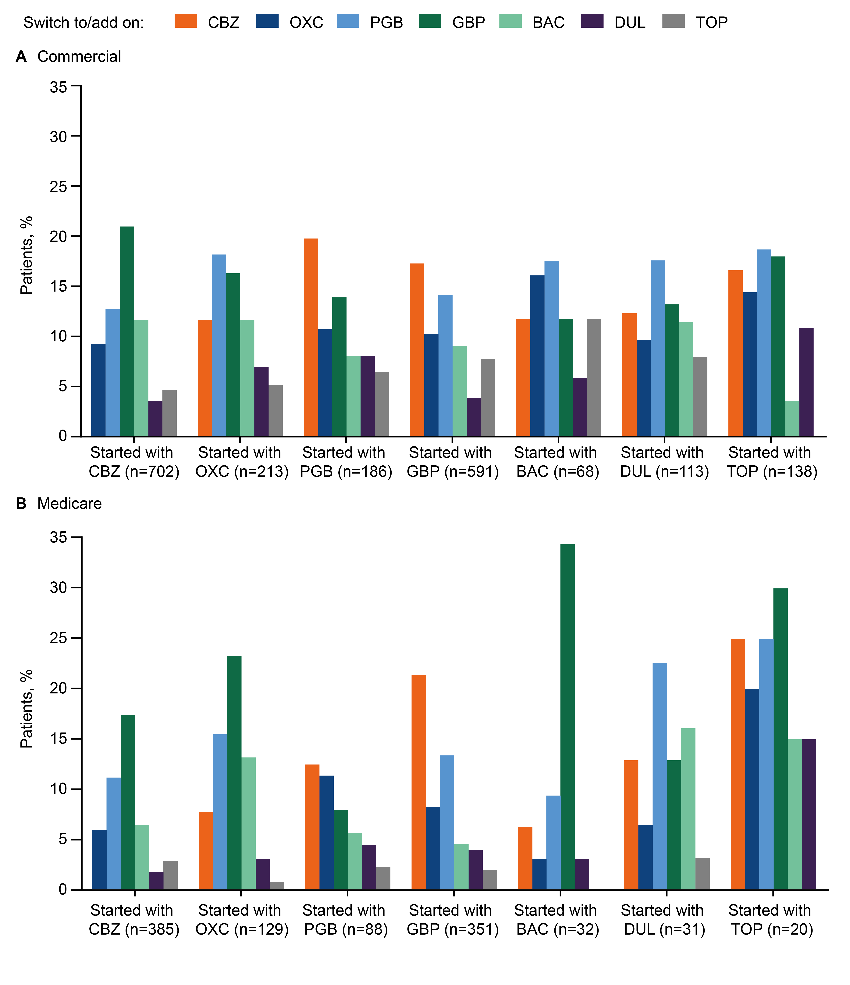
Supplemental Digital Content 10. Pharmacological treatment switch/add on patterns, by medication, in the commercial (A) and Medicare (B) populations.
BAC, baclofen; CBZ, carbamazepine; DUL, duloxetine; GBP, gabapentin; OXC, oxcarbazepine; PGB, pregabalin; TOP, topiramate.

