Supplemental material 1

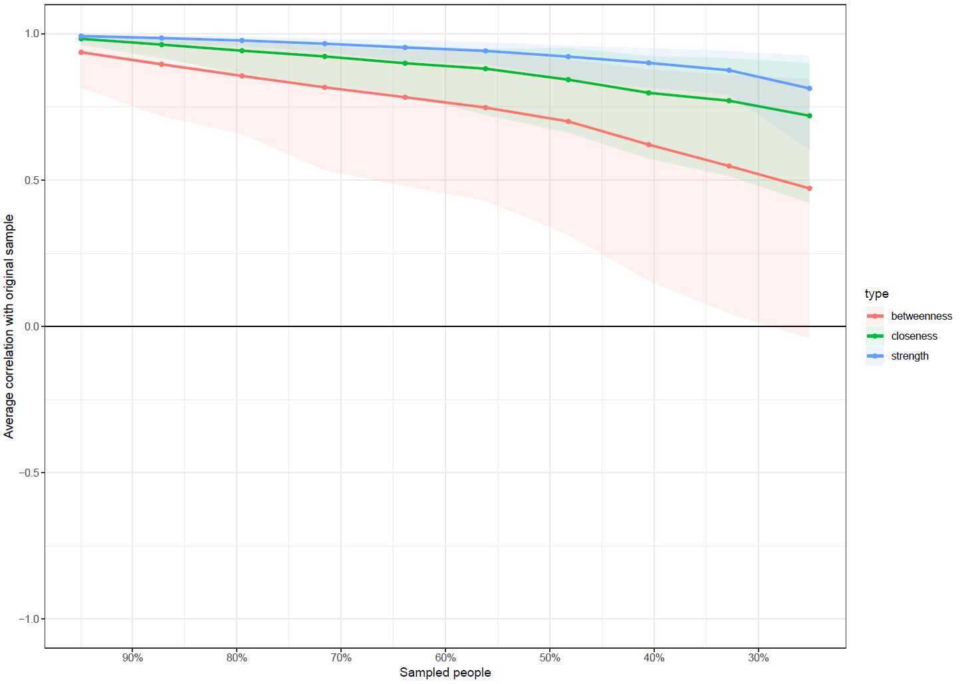 SUPPLEMENTAL MATERIAL 1. Correlation stability plot from the centrality indices.

