Supplemental material 2

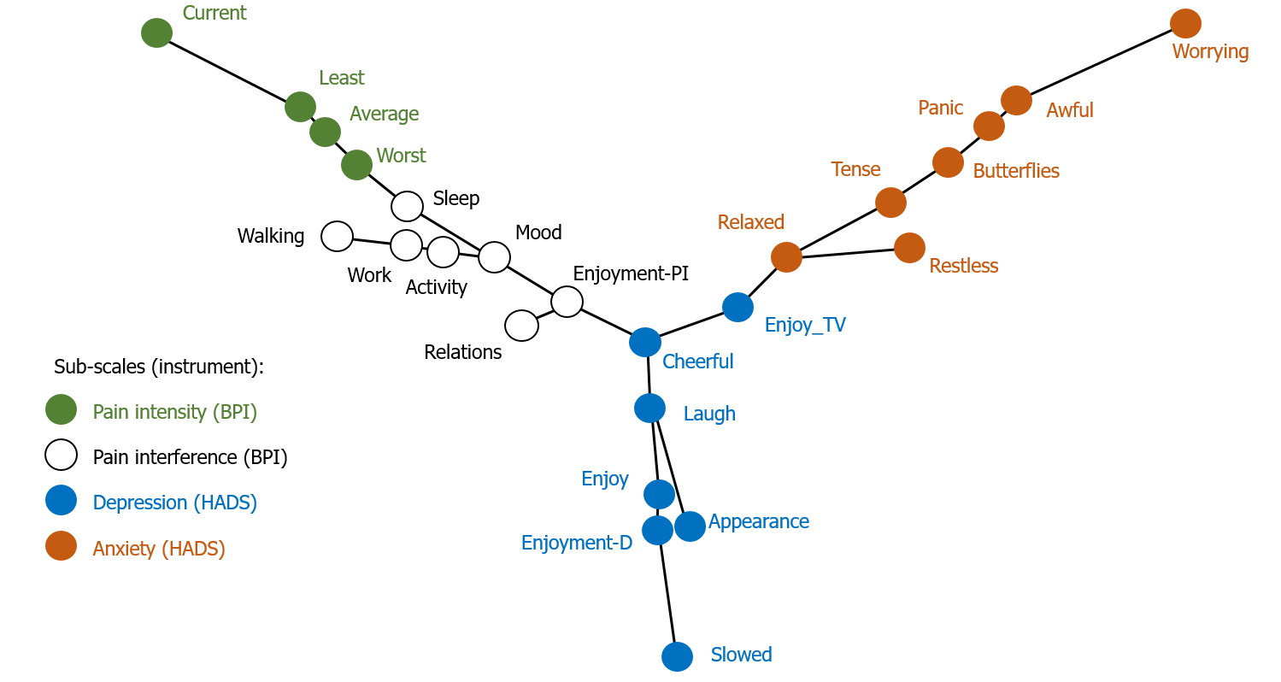
SUPPLEMENTAL MATERIAL 2. Minimum spanning tree differentiating nodes by sub-scales.

