Time horizon
For consistency with the model and assumptions accepted by NICE for TAG159 [1], the base-case analysis utilises a 15-year time horizon. It is felt this is appropriate in the base-case given the chronic nature of the condition and the longevity of the devices, particularly those utilising a rechargeable battery. The Markov model structure allows us to present the incremental cost at various time-points as shown in e-Figure 1. In the base-case analysis, the 10kHz-SCS therapy implantation cost is marginally less than RLF-SCS and therefore 10kHz-SCS therapy is cost-saving from the start of the analysis, additional cost-savings are realised over time due to the superior explant rates associated with 10kHz-SCS therapy.

The NRLF-SCS implantation cost is less than 10kHz-SCS therapy; therefore NRLF-SCS remains less costly until the first NRLF-SCS device replacement. However, after this point 10kHz-SCS therapy is cost-saving.
e-Figure 1 - Incremental cost difference over time
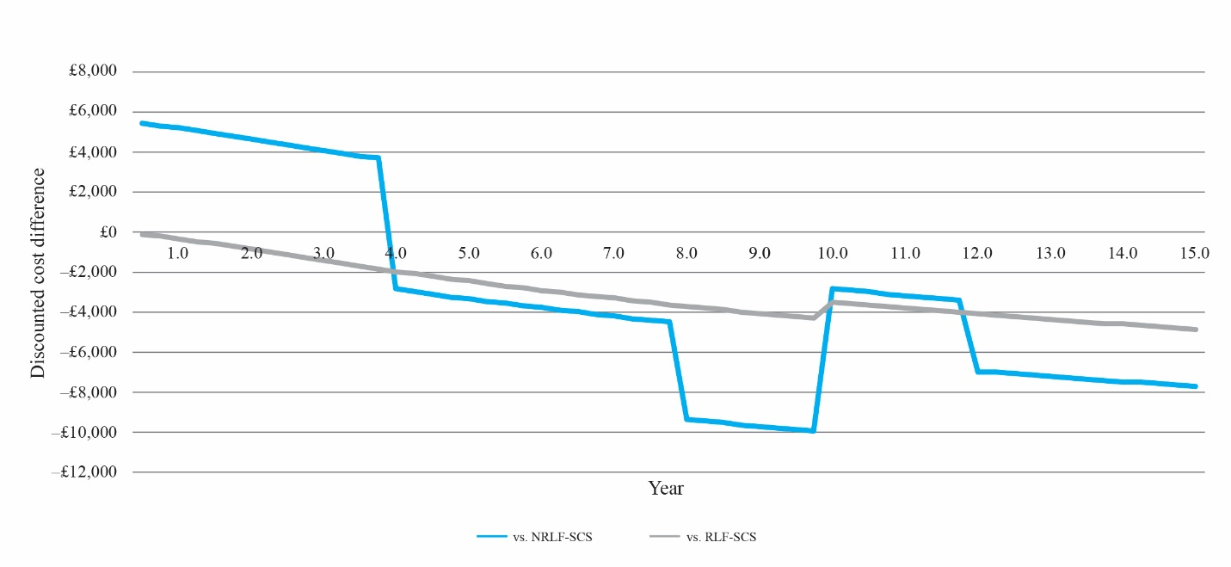
Abbreviations: NRLF-SCS, non-rechargeable low-frequency spinal cord stimulation; RLF SCS, rechargeable low-frequency spinal cord stimulation.

