Appendix

I – Telemedicine Neurological Exam Participant Instructions

Upon receiving informed consent, each participant will be asked to perform two sets of neurological exams: (1) Standard Neurological Exam - a complete set of upper and lower limb motor and sensory exams, and special tests; (2) Telemedicine Neurological Exam - a complete set of upper and lower motor and sensory exams, and special tests, done through self-assessed neurological exam. Both motor and sensory portions of the study will be performed on each side of the body. Participants will receive a 10-minute break in between each arm of the exam. Upon completing the two sets of neurological exams, each participant will be administered a survey to review his or her experience.

IA - Standard Neurological Exam:

Each of the following portions of the exam will be conducted with a trained observer in the room instructing the participant through each component: motor, sensory, and special tests.

Motor

Patients will be asked to participate in traditional neurological testing by resisting force administered from a trained observer to test a variety muscle groups (myotomes):

Upper Limbs (Patient Standing)

C5 (Shoulder Abduction – Deltoids) - Hold arms out to the side and push up against observer's resistance.

C6 (Elbow Flexion – Biceps Brachii) - Hold arms up, then pull out against observer's resistance.

C7 (Elbow Extensors –Triceps Brachii) – Hold arms up, then push out against observer’s resistance.

C8 (Finger Flexors – Flexor Digitorum Superficialis (FDS) and Flexor Digitorum Profundus (FDP)) - Grip observer's pointer and middle fingers with hands and squeeze.

T1 (Finger Abductors – Hand Intrinsic Muscles/Interossei Muscles) - Hold hands out with palms facing down, then push out little finger and pointer finger against observer's resistance.

Lower Limbs (Patient Sitting)

L2 (Hip Flexors – Iliopsoas) - Lift up legs from the hips against observer's resistance.

L3 (Knee Extensors – Quadriceps) - Extend leg from the knee forward against observer's resistance.

L4 (Ankle Dorsiflexors – Tibialis Anterior) – Pull feet back against observer's resistance.
L5 (Long Toe Extensors – Extensor Hallucis Longus (EHL)) – Push big toe up against’ observer’s resistance.

S1 (Ankle Plantar Flexors – Gastrocnemius and Soleus) - Push down feet against observer's hands (i.e. “stepping on a gas pedal”).

Sensory

Observer will administer traditional fine-touch sensory exam in the following sensory distribution areas (dermatomes):

Upper Limbs (Patient Sitting)

C5 (Lateral Shoulder) – Outside of arm just below the shoulder.

C6 (Dorsal Surface of Thumb) – Backside of hand at the tip of the thumb.

C7 (Dorsal Surface of Middle Finger) - Backside of hand at the tip of the middle finger.

C8 (Dorsal Surface of Little Finger) - Backside of hand at the base of the little finger.

T1 (Medial Antecubital Fossa) – Inside of arm just below the elbow.

Lower Limbs (Patient Sitting)

L2 (Anterior Thigh) – Frontside, top of leg in the middle of the thigh.

L3 (Medial Femoral Condyle – Proximal Knee) - Inner part of leg at the knee.

L4 (Medial Malleolus) - Inner part of leg at the ankle.

L5 (Dorsum of Foot – 2nd Metatarsophalangeal Joint (MTP)) - Inner part of foot between webspace of big toe and the second toe.

S1 (Lateral Heel – Calcaneus) - Backside of foot behind the outer portion of the heel.

Special Tests

Rapid Alternating Hand Movements - Touch first the palm and then the dorsal side of one hand repeatedly against the other hand as quick as possible.

Toe-Walking – Walk from one side of the room to the other on just the tip of the toes (making sure to look straight ahead).

Heel-Waling – Walk from one side of the room to the other on just the base of the heels (making sure to look straight ahead).

Tandem Gait – Walk from one side of the room to the other with one foot in front of the other (toes of foot touching heels of other foot with each step, making sure to look straight ahead).

Romberg Test – Hold arms out in front of chest with palms facing upwards. Close eyes and keep hands held up in the same position for 30 seconds.

IB - Telemedicine Neurological Exam:

Each portion of the Telemedicine Neurological Exam will be performed and recorded in front of a GoPro at a fixed distance of 6 feet (1.83 m). Minimize any slack in the TheraBand® prior to performing each exercise in order to provide the most accurate assessment of resistance overcome.

Motor

Upper Limbs (Patient Standing)

C5 (Shoulder Abduction – Deltoids) - Step on tip of resistance band with the other end held in the hand. Raise up band from the side of the body out to the shoulder.

C6 (Elbow Flexion – Biceps Brachii) - Step on tip of resistance band with other end held in the hand. Position hand out in front of the body with the palm side facing up and pull as in performing a biceps curl.

C7 (Elbow Extensors –Triceps Brachii) - Step on tip of resistance band with other end held in the hand. Pull the band behind the back and stretch upwards as in performing a triceps extension.

C8 (Finger Flexors – Flexor Digitorum Superficialis (FDS) and Flexor Digitorum Profundus (FDP)) – Compress ergonomic grip ring with fingers, attempting to grip the object tightly.

T1 (Finger Abductors – Hand Intrinsic Muscles/Interossei Muscles) – Place fingers inside ergonomic finger stretcher tool and separate fingers against resistance

Lower Limbs (Patient Sitting)

L2 (Hip Flexors – Iliopsoas) - With the resistance band tied against a heavy object (i.e. table or chair leg) into a loop, wrap band over knee and lift upwards.

L3 (Knee Extensors – Quadriceps) - With the resistance band tied against a heavy object (i.e. table or chair leg) into a loop, wrap the band around the leg above the ankle and extend leg at the knee

L4 (Ankle Dorsiflexors – Tibialis Anterior) - With the resistance band tied against a heavy object (i.e. table or chair leg) into a loop, wrap the band around the foot below the ankle and raise feet up at the ankle.

L5 (Long Toe Extensors – Extensor Hallucis Longus (EHL)) – With the resistance band tied against a heavy object (i.e. table or chair leg) into a loop, wrap the band around the foot at the toes and extend big toe against resistance

S1 (Ankle Plantar Flexors – Gastrocnemius and Soleus) - Hold both ends of the resistance band in each hand with the loop around the bottom of the foot. Push downwards as in pushing down on a gas pedal.

Sensory

Patient will test their own sensation by administering force from a Semmes-Weinstein Monofilament (3.61 or 6.85 size). SWM testing was conducted by smoothly applying a filament perpendicular to an individual’s skin until there is evidence of bowing (“buckling”) After an initial bowing of the monofilament, there is no increase in applied force as the filament is further bent—this allows the tester to administer a relatively consistent force despite any unintentional/imperceptible movements in the hand during the application of target force.^{39,40}

Upper Limbs (Patient Sitting)

C5 (Lateral Shoulder) – Outside of arm just below the shoulder.

C6 (Dorsal Surface of Thumb) – Backside of hand at the tip of the thumb.

C7 (Dorsal Surface of Middle Finger) - Backside of hand at the tip of the middle finger.

C8 (Dorsal Surface of Little Finger) - Backside of hand at the base of the little finger.

T1 (Medial Antecubital Fossa) – Inside of arm just below the elbow.

Lower Limbs (Patient Sitting)

L2 (Anterior Thigh) – Frontside, top of leg in the middle of the thigh.

L3 (Medial Femoral Condyle – Proximal Knee) - Inner part of leg at the knee.

L4 (Medial Malleolus) - Inner part of leg at the ankle.

L5 (Dorsum of Foot – 2nd Metatarsophalangeal Joint (MTP)) - Inner part of foot between webspace of big toe and the second toe.

S1 (Lateral Heel – Calcaneus) - Backside of foot behind the outer portion of the heel.

Special Tests

Rapid Alternating Hand Movements - Touch first the palm and then the dorsal side of one hand repeatedly against the other hand as quick as possible.

Toe-Walking – Walk from one side of the room to the other on just the tip of the toes (making sure to look straight ahead).

Heel-Waling – Walk from one side of the room to the other on just the base of the heels (making sure to look straight ahead).

Tandem Gait – Walk from one side of the room to the other with one foot in front of the other (toes of foot touching heels of other foot with each step, making sure to look straight ahead).

Romberg Test – Hold arms out in front of chest with palms facing upwards. Close eyes and keep hands held up in the same position for 30 seconds.

IC - Satisfaction Survey

The trial will conclude with the following satisfaction survey (no follow-up visits):

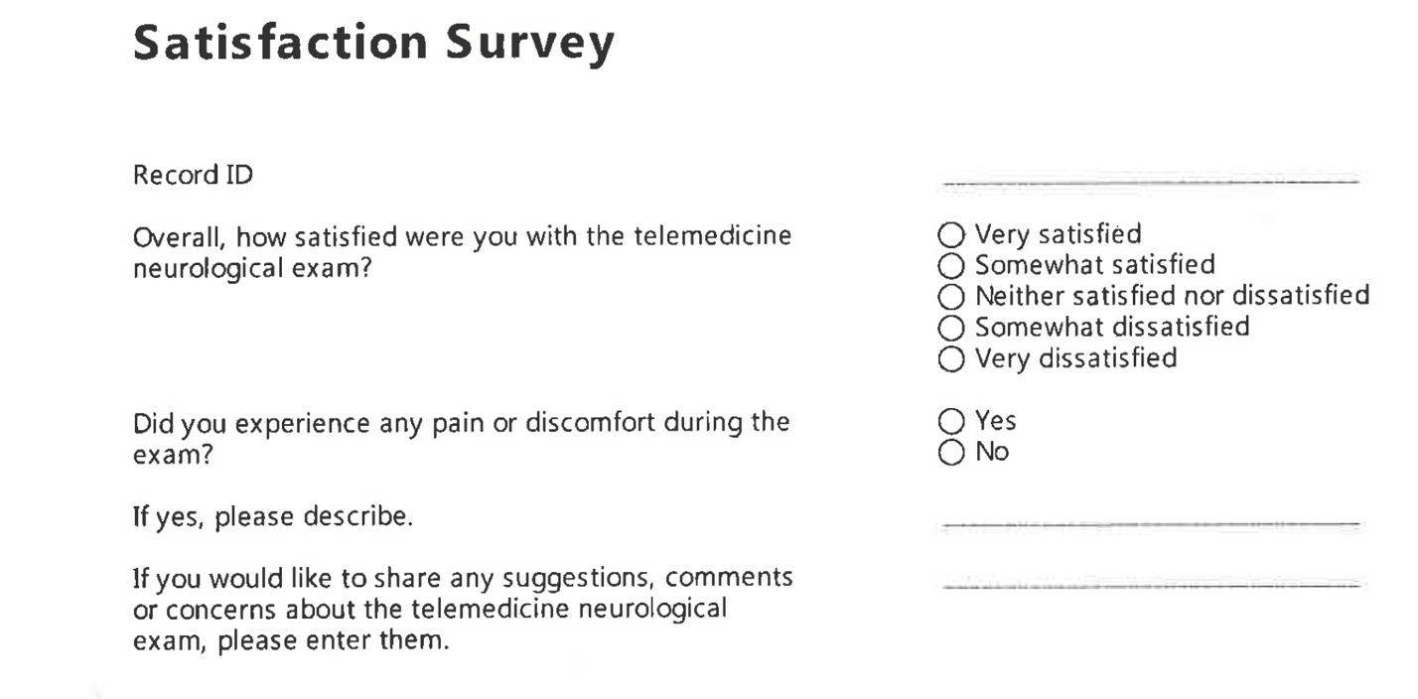

II - Telemedicine Neurological Exam Tools

Motor

TheraBand® resistance tools are a common component employed in physical therapy for muscle strengthening exercises and conditioning. These resistance tools come in two major varieties, bands or tubes, and have been developed to accurately assess one’s resistance effort in pounds, based on the distance each band or tube has been elongated. The bands and tubes come in latex and non-latex equivalents, with 8 colors that progressively increase in the resistance required to stretch to a distance of 100% the original length.^{41,42}

TheraBand® Colors:

Gold = 6.44 kg force

Silver = 4.62 kg force

Black = 3.31 kg force

Blue = 2.63 kg force

Green = 2.09 kg force

Red = 1.68 kg force

Yellow = 1.36 kg force

In the present study, every TheraBand® color was employed except for the Tan band (1.09 kg force)—the lowest resistance band.

HerculesGripTM ergonomic resistance tools are commonly employed for forearm and hand strength strengthening regimens and with varying resistance.⁴³

Grip Ring Colors:

Dark green = “heavy” resistance = 28.0 kg force

Lighter green = “medium” resistance = 23.0 kg force

Lightest green = “light” resistance = 18.0 kg force

Finger Stretcher Colors:

Dark green = “heavy” resistance = 5.0 kg force

Lighter green = “medium” resistance = 4.0 kg force

Lightest green = “light” resistance = 3.0 kg force

Sensory

Semmes-Weinstein Monofilaments (SWM) are commonly used in the objective detection of sensation and are inexpensive and easy to administer. They have been validated in a series of sensory nerve conduction studies for a variety of pathological states.^{39,44,45}

These tools are nylon-based monofilaments that come in 20 standard sizes—each of which has been logarithmically transformed to denote the “target force” (g) that may be administered.

Only green, blue, and red SWM sizes were obtained and considered into this pilot trial:

Green monofilament (size = 2.83) – smallest filament available with lowest amount of graded force (not utilized in trial) (force = 0.07 grams)

Blue monofilament (size = 3.61) - next size up (baseline filament used for trial) (force = 0.4 grams)

Red monofilament (size = 6.85) - largest filament available (utilized if baseline filament did not elicit a sensation) (force = 300.0 grams)

