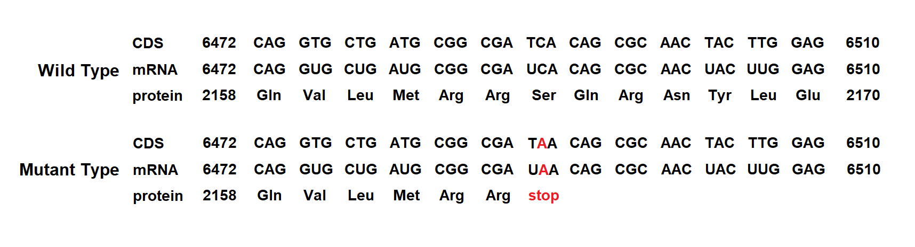

Supplementary Figure 1
The c.6491C>A mutation in the PKD1 gene was predicted to introduce an early stop codon at position 2164 (p.Ser2164Ter), leading to a premature truncated protein with 2140 amino acid shorter than the wildtype protein.

