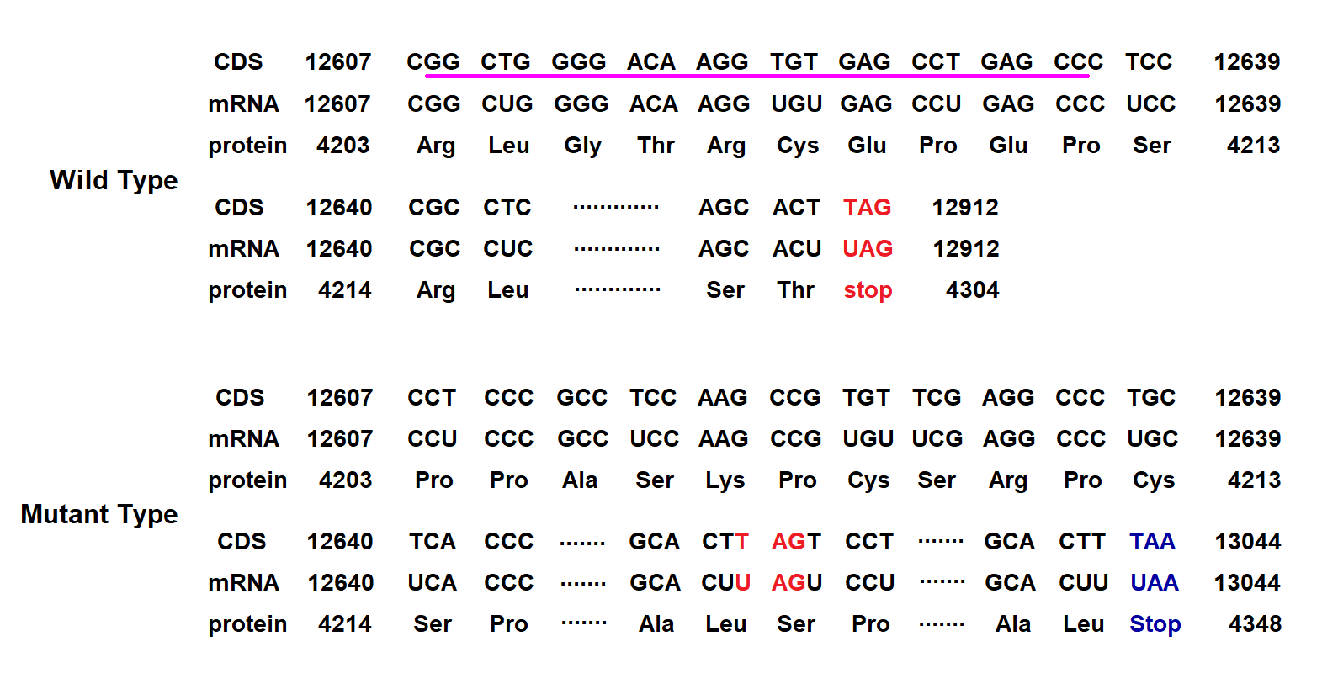

Supplementary Figure 2
The c.12608_12635del mutation in the PKD1 gene was predicted to change the open reading frame, cause the loss of the original stop codon UAG at position 4304, and introduce a new stop codon UAA at position 4348 (p.Arg4203Profs*146), leading to a prolonged abnormal protein with 44 amino acid longer than the wildtype protein. The pink underline indicated the 28bp deletion from c.12608 to c.12635.

