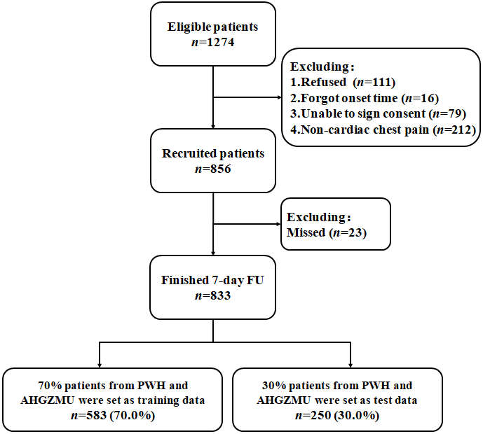

Supplementary Figure 1. Flowchart of patient recruitment

