Supplementary Table 1: Demographic characteristics of outpatients and inpatients with respiratory diseases in Xiamen from 2017 to 2019.
Diagnosis | Total, n | Age (years),  Mean ± SD | Age group, n (%) |  |  |  | Gender, n (%)
 |  |  | 0−19 Years | 20−39 Years | ≥40 Years |  | Female | Male
Outpatients
J40 | 208,119 | 20.59±22.37 | 122,048 (58.64) | 41,071 (19.73) | 44,996 (21.62) |  | 100,559 (48.32) | 107,542 (51.67)
J41 | 97 | 61.70±16.40 | 1 (1.03) | 8 (8.25) | 88 (90.72) |  | 34 (35.05) | 63 (64.95)
J42 | 5916 | 56.40±18.76 | 234 (3.96) | 771 (13.03) | 4911 (83.01) |  | 2364 (39.96) | 3552 (60.04)
J43 | 2358 | 54.98±16.24 | 50 (2.12) | 388 (16.45) | 1920 (81.42) |  | 330 (13.99) | 2,028 (86.01)
J44 | 21,104 | 64.25±14.94 | 365 (1.73) | 645 (3.06) | 20,094 (95.21) |  | 3895 (18.46) | 17,206 (81.53)
J47 | 8810 | 54.30±15.49 | 94 (1.07) | 1498 (17) | 7218 (81.93) |  | 4,911 (55.74) | 3,896 (44.22)
Total | 238,455 | 54.96±25.33 | 122,439 (51.35) | 43,795 (18.37) | 72,217 (30.29) |  | 109,296 (45.84) | 129,135 (54.15)
Inpatients
J40 | 524 | 23.59±26.43 | 306 (58.40) | 59 (11.26) | 159 (30.34) |  | 244 (46.56) | 280 (53.44)
J42 | 129 | 65.97±18.14 | 6 (4.65) | 1 (0.78) | 122 (94.57) |  | 47 (36.43) | 82 (63.57)
J43 | 214 | 43.64±20.19 | 28 (13.08) | 70 (32.71) | 116 (54.21) |  | 32 (14.95) | 182 (85.05)
J44 | 5213 | 72.92±10.78 | 21 (0.40) | 5 (0.10) | 5187 (99.50) |  | 590 (11.32) | 4623 (88.68)
J47 | 2141 | 60.48±15.62 | 23 (1.07) | 189 (8.83) | 1929 (90.10) |  | 1226 (57.26) | 915 (42.74)
Total | 8113 | 65.62±19.09 | 381 (4.70) | 323 (3.98) | 7409 (91.32) |  | 2112 (26.03) | 6001 (73.97)
SD: Standard deviation.
Supplementary Table 2: Summary statistics of daily outpatient and inpatient visits for respiratory diseases (J40–J44, J47) in Xiamen from 2017 to 2019.
Diagnosis | Min | Q₁ | Median | Mean | Q₃ | Max | SD
Outpatient
J40–J42 | 36 | 227 | 321 | 339.13 | 436 | 789 | 141.39
J43–J44 | 5 | 46 | 92 | 91.68 | 133 | 209 | 49.01
J47 | 0 | 12 | 21 | 21.21 | 29 | 54 | 11.10
Total | 52 | 314.00 | 429 | 452.02 | 581.50 | 998 | 183.86
Inpatient
J40–J42 | 0 | 0 | 0 | 0.67 | 1 | 6 | 0.90
J43–J44 | 0 | 5 | 8 | 8.55 | 11 | 26 | 4.88
J47 | 0 | 1 | 2 | 2.59 | 4 | 9 | 1.86
Total | 0 | 7.00 | 11 | 11.81 | 16.00 | 34 | 6.04
Data were presented as n. Min: Minimum; Max: Maximum; SD: Standard deviation.

Supplementary Table 3: Summary statistics of average daily concentration of air pollutants and weather conditions in Xiamen from 2017 to 2019.
Factor | Min | Q₁ | Median | Mean | Q₃ | Max | SD
PM2.5 (μg/m³) | 4 | 16 | 22 | 24.61 | 31 | 100 | 12.25
PM10 (μg/m³) | 9 | 29 | 39 | 43.24 | 53 | 138 | 19.74
O₃_8 h (μg/m³) | 0 | 65 | 83 | 84.53 | 102 | 172 | 28.96
Temperature (℃) | 7 | 17.75 | 23 | 22.72 | 28 | 32.5 | 5.85
Wind force | 1.5 | 3 | 3.5 | 3.57 | 4.5 | 6.5 | 0.88
Min: Minimum; Max: Maximum; PM2.5: Fine particulate matter; PM10: Inhalable particulate matter; O₃: Ozone.

Supplementary Table 4: Lagged effects of weather conditions on outpatient visits for respiratory diseases.
Factors | Diagnosis | Age (years) | Number | Regression coefficients of the interquartile range | Lower bound of the 95% CI | Upper bound of the 95% CI | P values | Percentage changes in patient visits
Inpatients
Temperature | J40–J42 | 20–39 | 60 | －0.655 | －1.132 | －0.178 | 0.007 | －48.05%
Temperature | J43–J44 | ≥40 | 5303 | －0.371 | －0.410 | －0.332 | <0.001 | －30.97%
Temperature | J47 | 20–39 | 189 | 0.281 | 0.027 | 0.534 | 0.030 | 32.38%
Temperature | J47 | ≥40 | 1929 | －0.159 | －0.234 | －0.085 | <0.001 | －14.71%
Wind | J40–J42 | 0–19 | 313 | －0.204 | －0.349 | －0.059 | 0.006 | －18.42%
Wind | J40–J42 | 20–39 | 60 | 0.506 | 0.187 | 0.824 | 0.002 | 65.83%
Wind | J40–J42 | ≥40 | 281 | 0.188 | 0.035 | 0.340 | 0.016 | 20.64%
Wind | J43–J44 | 0–19 | 49 | 0.217 | －0.132 | 0.565 | 0.223 | 24.20%
Wind | J43–J44 | 20–39 | 75 | －0.374 | －0.700 | －0.048 | 0.025 | －31.18%
Wind | J43–J44 | ≥40 | 5303 | 0.061 | 0.033 | 0.089 | <0.001 | 6.25%
Outpatients
Temperature | J40–J42 | 0–19 | 122,283 | －0.180 | －0.188 | －0.172 | <0.001 | －16.46%
Temperature | J40–J42 | 20–39 | 41,850 | －0.286 | －0.302 | －0.270 | <0.001 | －24.86%
Temperature | J40–J42 | ≥40 | 49,995 | －0.392 | －0.406 | －0.379 | <0.001 | －32.45%
Temperature | J43–J44 | 0–19 | 415 | 0.417 | 0.295 | 0.539 | <0.001 | 51.74%
Temperature | J43–J44 | 20–39 | 1033 | －0.133 | －0.228 | －0.037 | <0.001 | －12.41%
Temperature | J43–J44 | ≥40 | 22,014 | －0.155 | －0.167 | －0.143 | <0.001 | －14.38%
Temperature | J47 | ≥40 | 7218 | －0.186 | －0.213 | －0.159 | <0.001 | －17.00%
Wind | J40–J42 | 0–19 | 122,283 | 0.180 | 0.174 | 0.185 | <0.001 | 19.69%
Wind | J40–J42 | 20–39 | 41,850 | 0.090 | 0.079 | 0.102 | <0.001 | 9.46%
Wind | J40–J42 | ≥40 | 49,995 | 0.022 | 0.012 | 0.032 | <0.001 | 2.21%
Wind | J43–J44 | 0–19 | 415 | 0.291 | 0.211 | 0.371 | <0.001 | 33.78%
Wind | J43–J44 | ≥40 | 22,014 | 0.039 | 0.030 | 0.047 | <0.001 | 3.93%
Wind | J47 | 0–19 | 94 | 0.233 | 0.088 | 0.377 | 0.002 | 26.20%
Wind | J47 | ≥40 | 7218 | 0.044 | 0.024 | 0.063 | <0.001 | 4.49%
CI: Confidence interval.
Supplementary Table 5: Instrumental variable regression results of the effects of temperature and wind via the PM or Q₃_8 h on inpatients and outpatients.
Diagnosis | Age | Number | Factors | Instrumental variables | Weak instruments P values | Wu–Hausman P values
Inpatients
J47 | ≥40 | 1929 | O₃_8 h | Wind | <0.001 | 0.482
Outpatients
J43–J44 | 20–39 | 1033 | PM2.5 | Temperature | <0.001 | 0.266
J47 | 0–19 | 94 | PM2.5 | Temperature | <0.001 | 0.651
J40–J42 | ≥40 | 49,995 | PM10 | Wind | 0.008 | 0.514
J43–J44 | 20–39 | 1033 | PM10 | Wind | 0.008 | 0.086
J47 | 0–19 | 94 | PM10 | Temperature | <0.001 | 0.143
J47 | 20–39 | 1498 | O₃_8 h | Temperature | <0.001 | 0.418
PM: Particulate matter; O₃: Ozone; PM2.5: Fine particulate matter; PM10: Inhalable particulate matter.

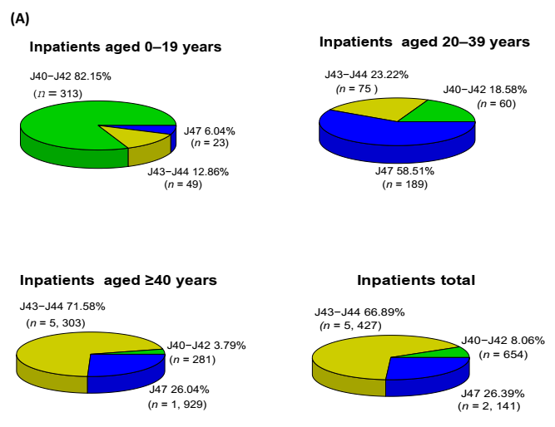
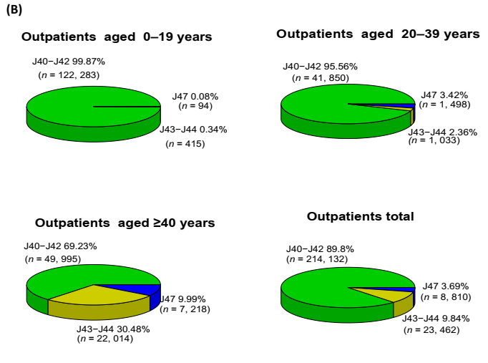
Supplementary Figure 1: Distribution of diagnoses of respiratory diseases (bronchitis [J40–J42], emphysema [J43] and COPD [J44], and bronchiectasis [J47]) among (A) inpatients and (B) outpatients of different age group in Xiamen from 2017 to 2019. COPD: Chronic obstructive pulmonary disease.

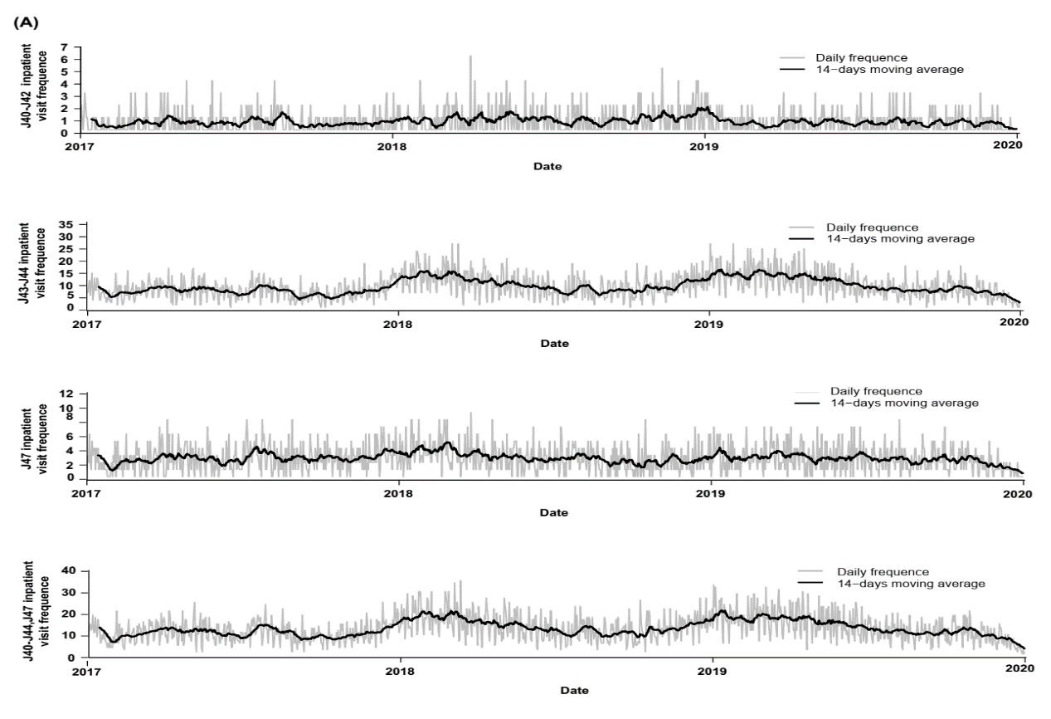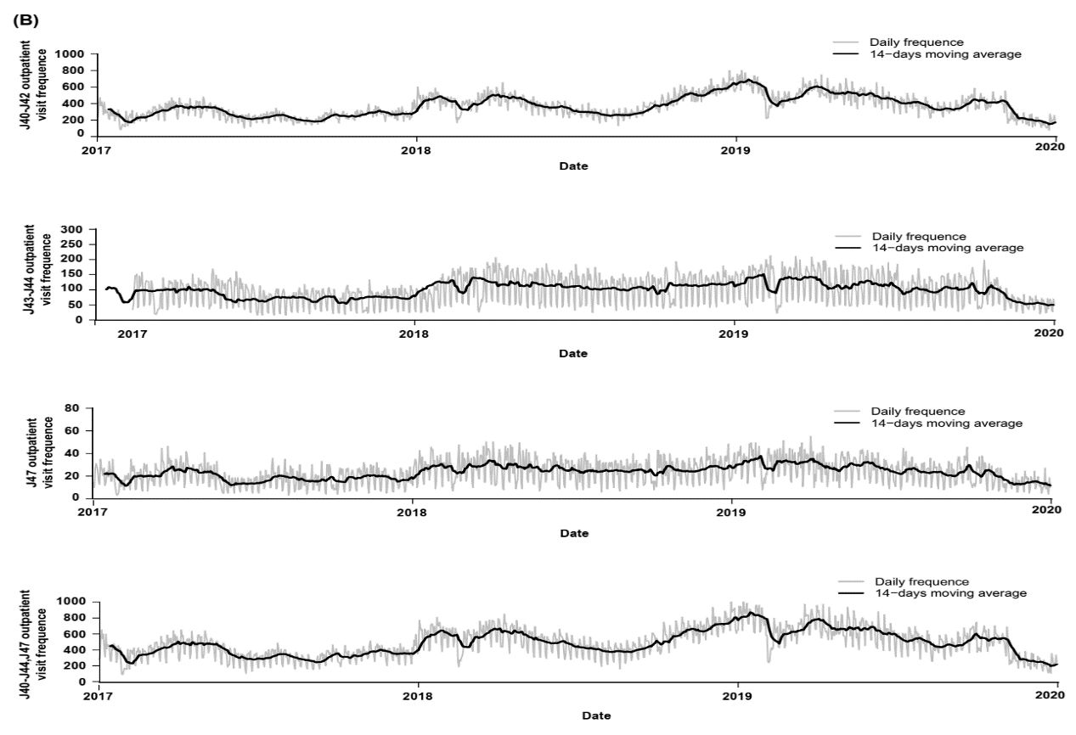
Supplement Figure 2: Trends of daily visits of respiratory diseases (bronchitis, emphysema and COPD, and bronchiectasis). 14-Day moving average (dark line) of (A) inpatients and (B) outpatients visits in Xiamen from 2017 to 2019 are shown with daily visits (gray line) as background. COPD: Chronic obstructive pulmonary disease.
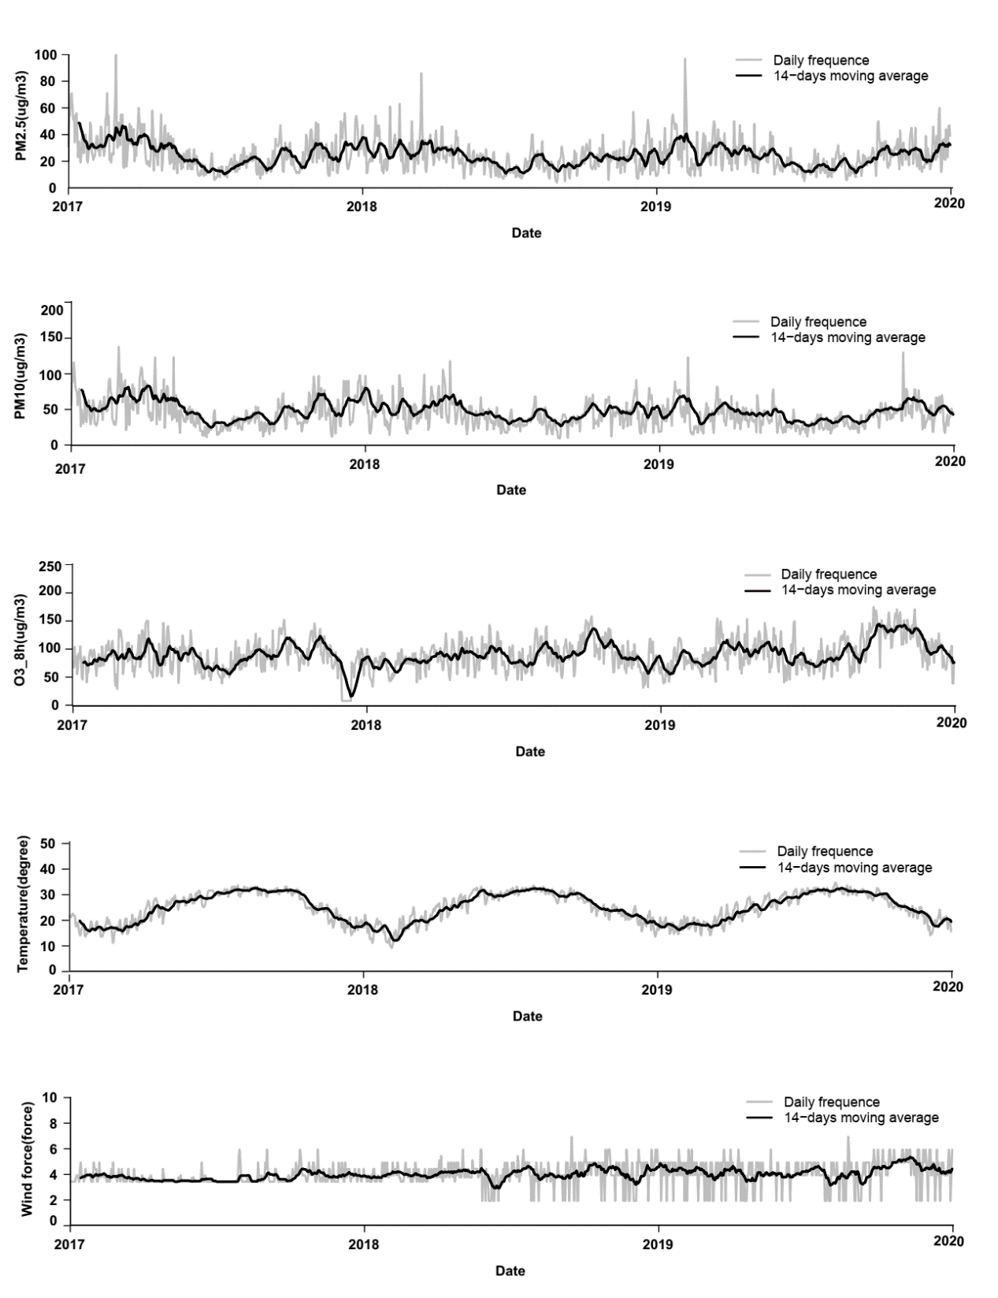
Supplementary Figure 3: Trends of air pollutants and weather conditions. 14-Day moving average (dark line) of PM2.5 (ug/m³), PM10 (ug/m³), O_{3_}8 h (ug/³), temperature (℃), and wind (force) in Xiamen from 2017 to 2019 are shown with daily visits (gray line) as background. PM2.5: Fine particulate matter; PM10: Inhalable particulate matter; O₃: Ozone.

