Supplementary Figure 1. The liver tissues of rats in each group. (A): Normal control (NC) group; (B): diethylnitrosamin (DEN) group; (C): multi-stress group.

(A)
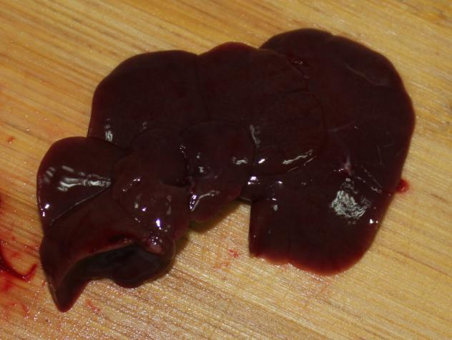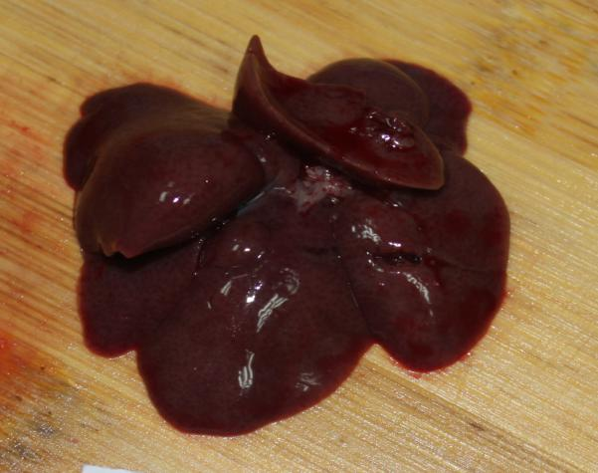
NC-1（normal control rat -1) NC-2(normal control rat -2）
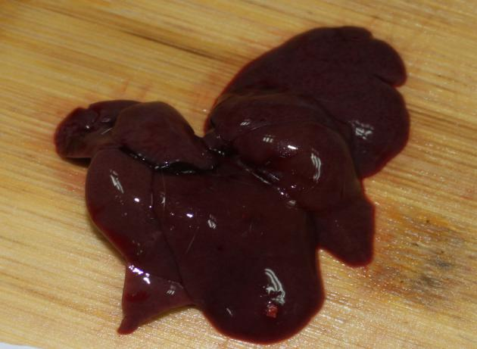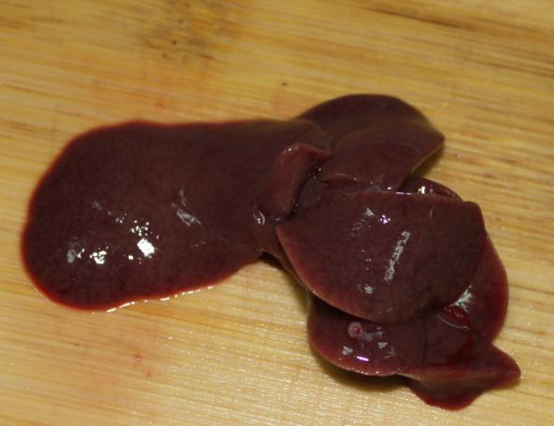
NC-3（normal control rat -3） NC-4（normal control rat -4）
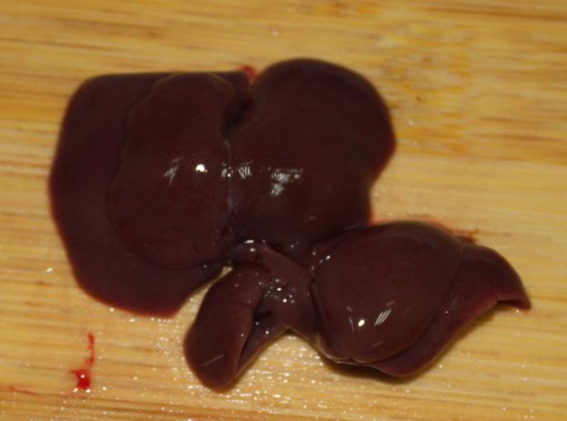
NC-5（normal control rat -5）

(B)
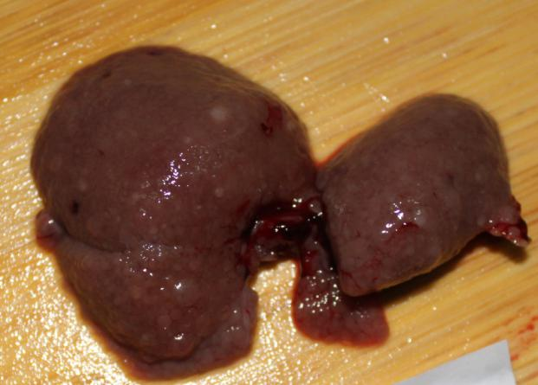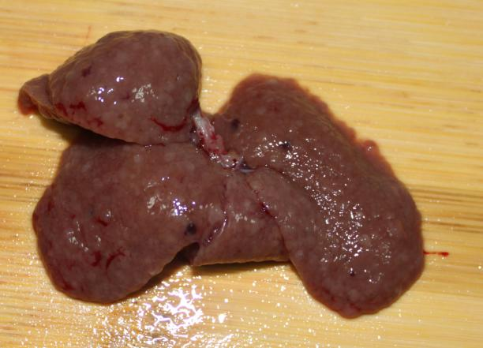
DEN-1（+Den rat -1） DEN-2（+Den rat -2）
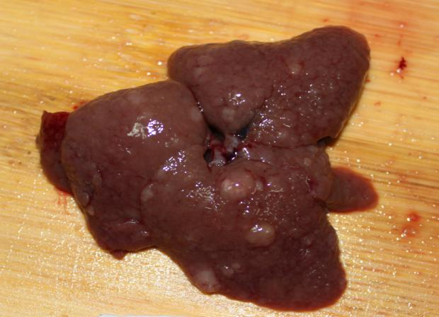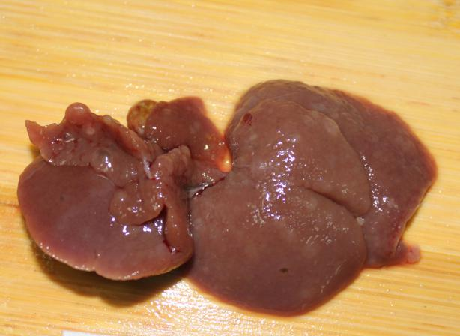
DEN-3（+Den rat -3） DEN-4（+Den rat -4）
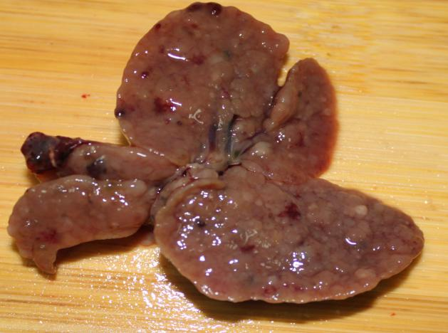

DEN-5（+Den rat -5）

(C)
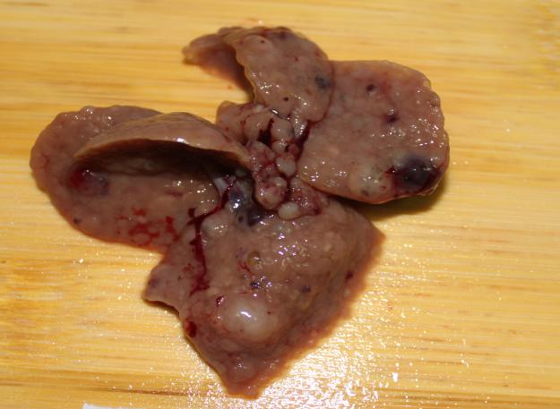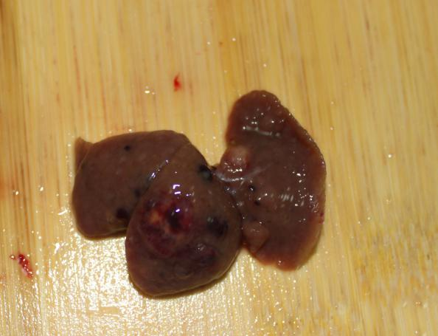
Stress-1（+Stress and Den rat -1） Stress-2（+Stress and Den rat -2）
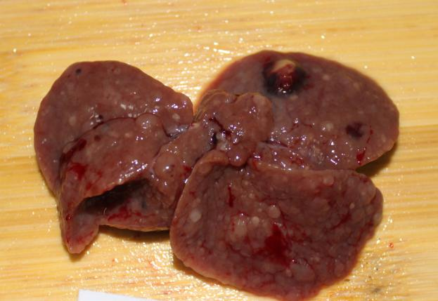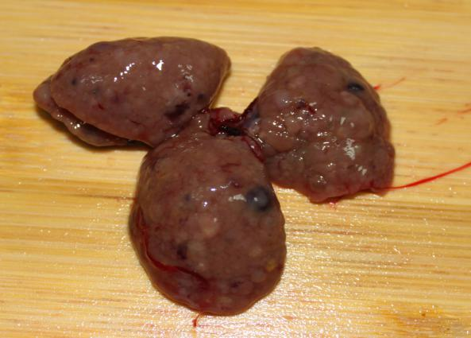
Stress-3（+Stress and Den rat -3） Stress-4（+Stress and Den rat -4）

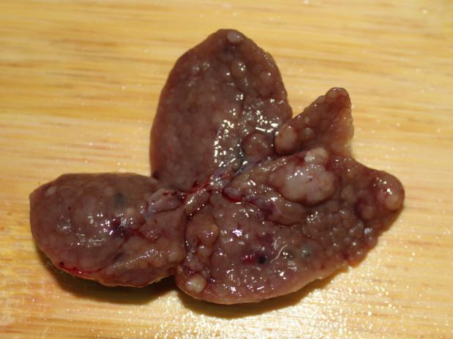
Stress-5（+Stress and Den rat -5）

Supplementary Table 1. Elevated levels of inflammatory cytokines in rats with CF treated with DEN.
Groups | n | IL-1β(pg/ml) | IL-6 (pg/ml) | TNF-α(pg/ml)
NC | 22 | 105.33 ± 6.50 | 211.88 ± 1.74 | 3.16 ± 0.37
DEN | 16 | 114.85 ± 7.08 | 216.35 ± 5.10 | 4.04 ± 0.61
Stress | 10 | 127.24 ± 13.78 * | 236.48 ± 9.32*‡ | 5.49 ± 1.39† §

Compared to normal group,*P＜0.01, †P＜0.001; compared to DEN alone, ‡P＜0.01, §P＜0.001. NC: Normal control; DEN: diethylnitrosamin.

