Supplementary Figure 1: Cumulative incidence of graft- versus-host disease (GVHD). (A) Cumulative incidence of 100-day grade I–IV aGVHD in the allo-HSCT group. (B) Cumulative incidence of 2-year limited and extensive cGVHD in the allo-HSCT group. aGVHD: acute GVHD; auto-HSCT: Autologous hematopoietic stem cell transplantation; allo-HSCT: Allogeneic HSCT; cGVHD: chronic GVHD.
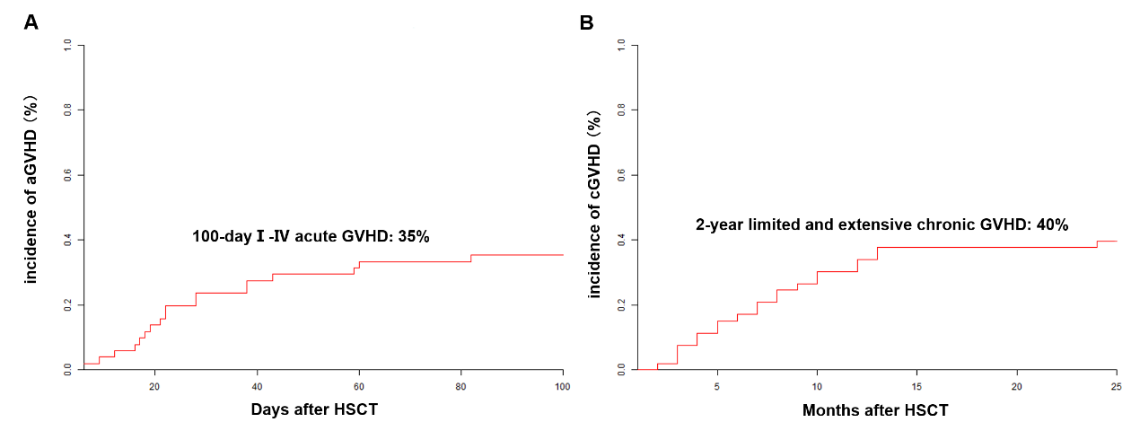
Supplementary Figure 2: Subgroup analysis about patients with different diseases. When excluding ALK+ patient, patients in the auto-HSCT group still had better 3-year OS [71% (95% CI 57–88%) vs. 50% (95% CI 37–67%), P = 0.010] (A) than that in the allo-HSCT group (n = 49), with no difference in PFS [56% (95% CI 42–76%) vs. 46% (95% CI 34–64%), P = 0.080] (B). ALK: Anaplastic lymphoma kinase; auto-HSCT: Autologous hematopoietic stem cell transplantation; allo-HSCT: Allogeneic HSCT; CI: Confidence interval; OS: Overall survival; PFS: Progression-free survival.

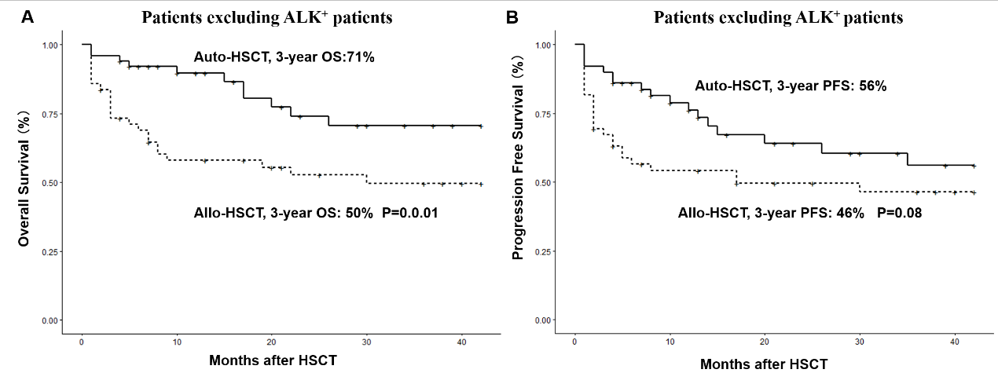

Supplementary Table S1: Causes of death of the study.
Parameters | Auto-HSCT | Allo-HSCT
Disease progression | 9 (56) | 13 (48)
Infection | 4 (25) | 2 (7)
Sepsis | 1 | 1
Pneumonia | 3 | 1
Engraftment failure | 0 | 1 (4)
Graft-versus-host disease | 0 | 3 (11)
Hemorrhage | 1 (6) | 3 (11)
Gastrointestinal Hemorrhage | 0 | 1
Cerebral hemorrhage | 1 | 2
Multi-organ failure | 2 (13) | 5 (19)
Total | 16 (100) | 27 (100)
Values are presented as n (%).Auto-HSCT: Autologous hematopoietic stem cell transplantation; Allo-HSCT: Allogeneic hematopoietic stem cell transplantation.

