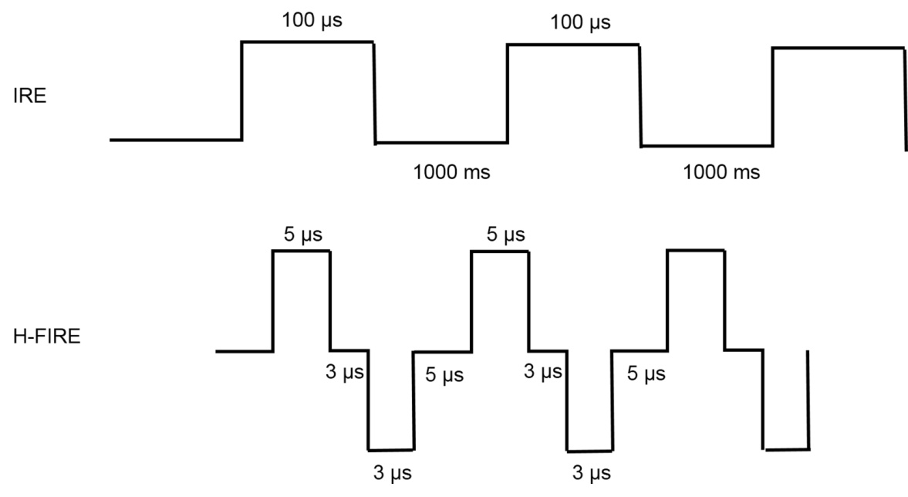

Supplementary Figure 1: Schematic illustration of electrical pulse delivery using conventional IRE (upper) and H-FIRE (lower). IRE therapy was delivered with 2200 V square wave pulses (number of pulses, 100; each pulse duration, 100 μs; interval between pulses, 1000 ms). H-FIRE therapy was delivered with asymmetric square wave pulses (number of pulses, 2400), within an individual burst of bipolar pulses, a 5 μs positive pulse, 3 μs inter-pulse delay, 3 μs negative pulse, and a 5 μs inter-pulse delay pattern was repeated. H-FIRE: High-frequency irreversible electroporation; IRE: Irreversible electroporation.

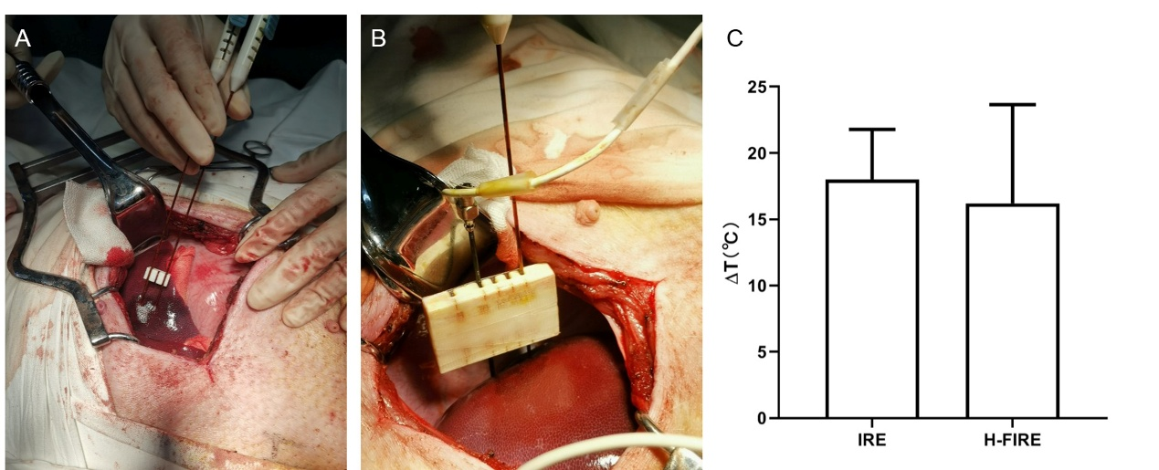

Supplementary Figure 2: Temperature measurement during ablation. (A) Ablation with standard IRE electrodes. (B) Ablation using one standard IRE electrode and one electrode with thermistor in it. The fiber optic probe and cable are enclosed in the electrode. (C) Comparison of temperature variation between IRE and H-FIRE. H-FIRE: High-frequency irreversible electroporation; IRE: Irreversible electroporation.

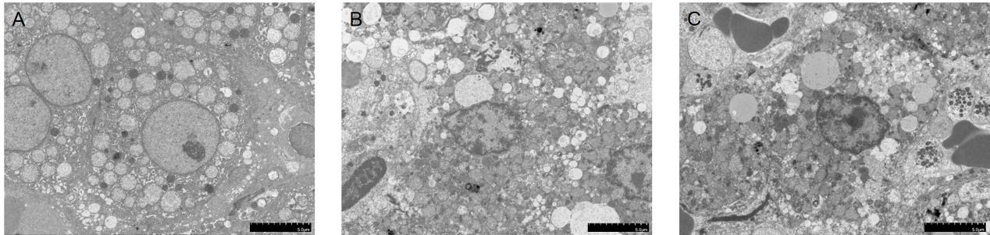

Supplementary Figure 3: Electron microscopy images of ablated lesions following IRE and H-FIRE. (A) Untreated liver tissue; (B) IRE treated tissue; (C) H-FIRE treated tissue. H-FIRE: High-frequency irreversible electroporation; IRE: Irreversible electroporation.

