Supplementary materials
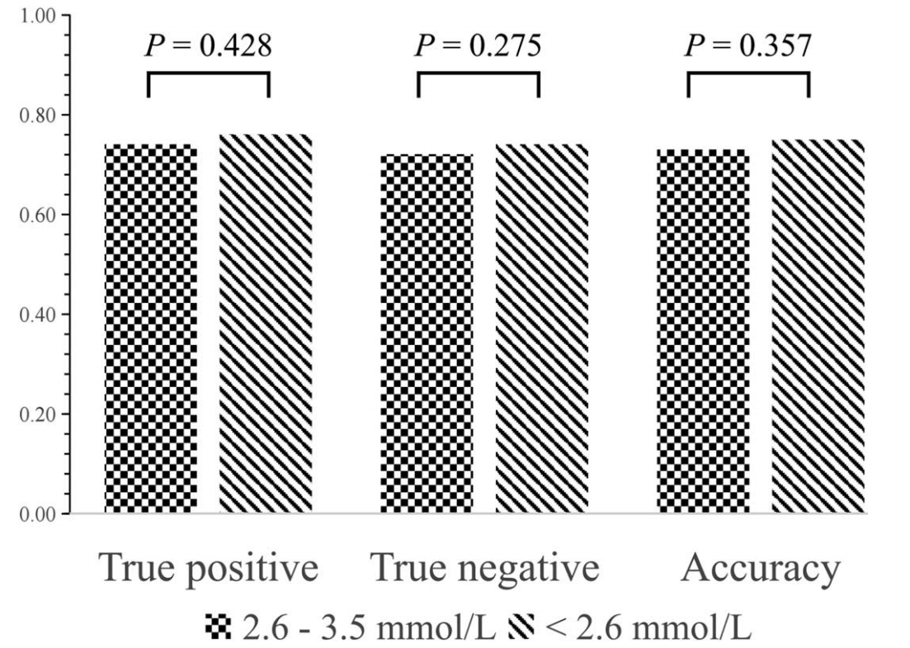

Sup Figure 1 The recognition rate of DLM under different serum potassium concentrations.
DLM: Deep learning model.

