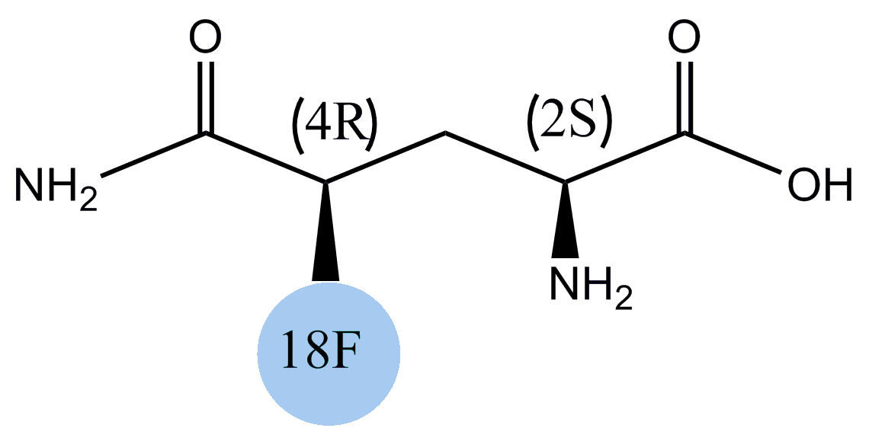
Supplemental Fig. S1 Chemical structure of ¹⁸F-(2S,4R)4-fluoroglutamine.

