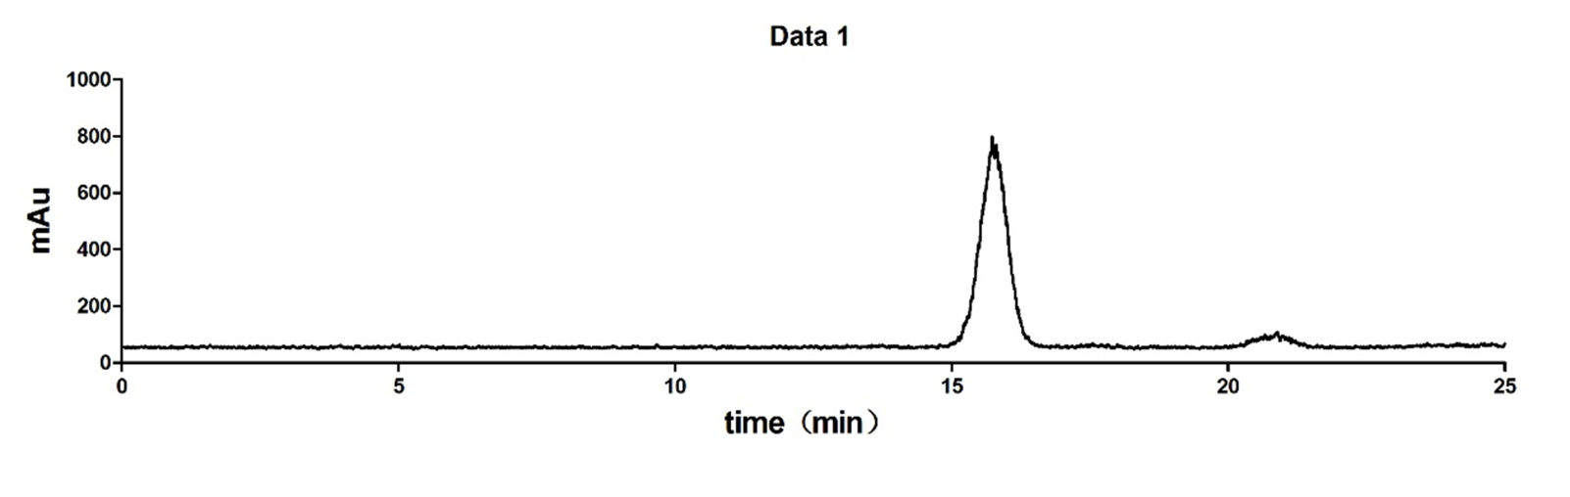
Supplemental Fig. S2 Radio-HPLC analysis of ¹⁸F-(2S,4R)4-fluoroglutamine.

