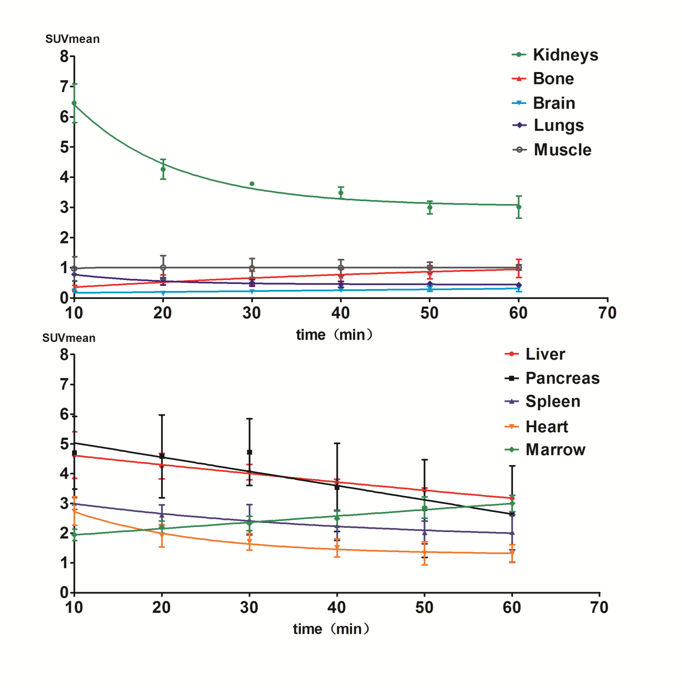
Supplemental Fig. S3 Time activity curve of ¹⁸F-FGln in major normal organs/tissue at all whole-body PET/CT scans over about 60min (n=3).

