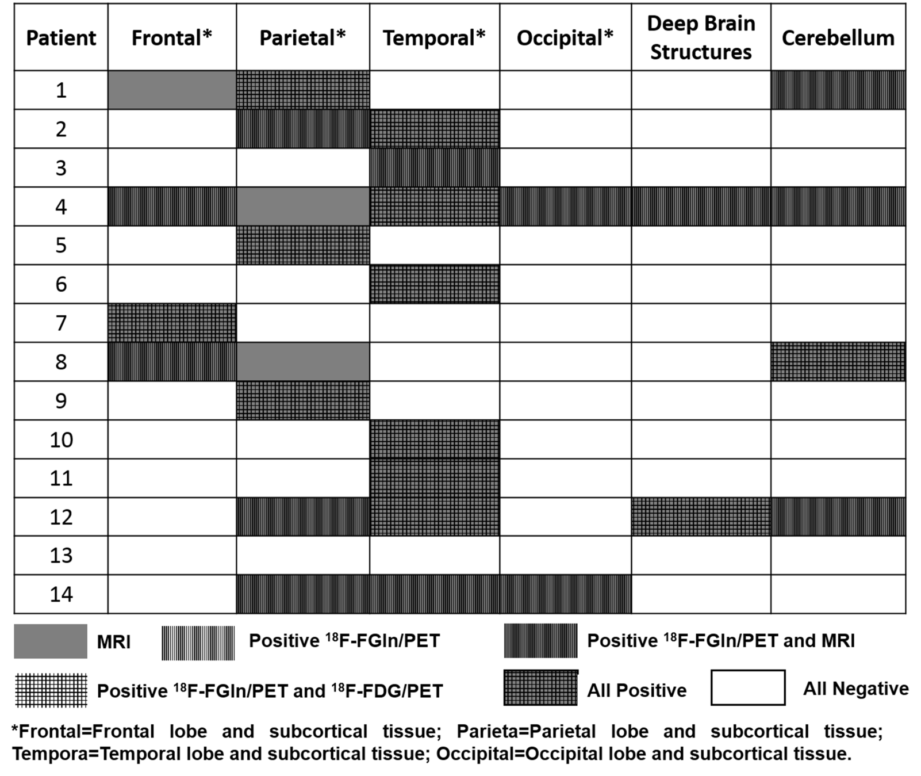
Supplemental Fig. S4 Results of both ¹⁸F-FDG/PET, ¹⁸F-FGln/PET and contrast enhanced MRI in 14 patients with suspected brain metastasis.

