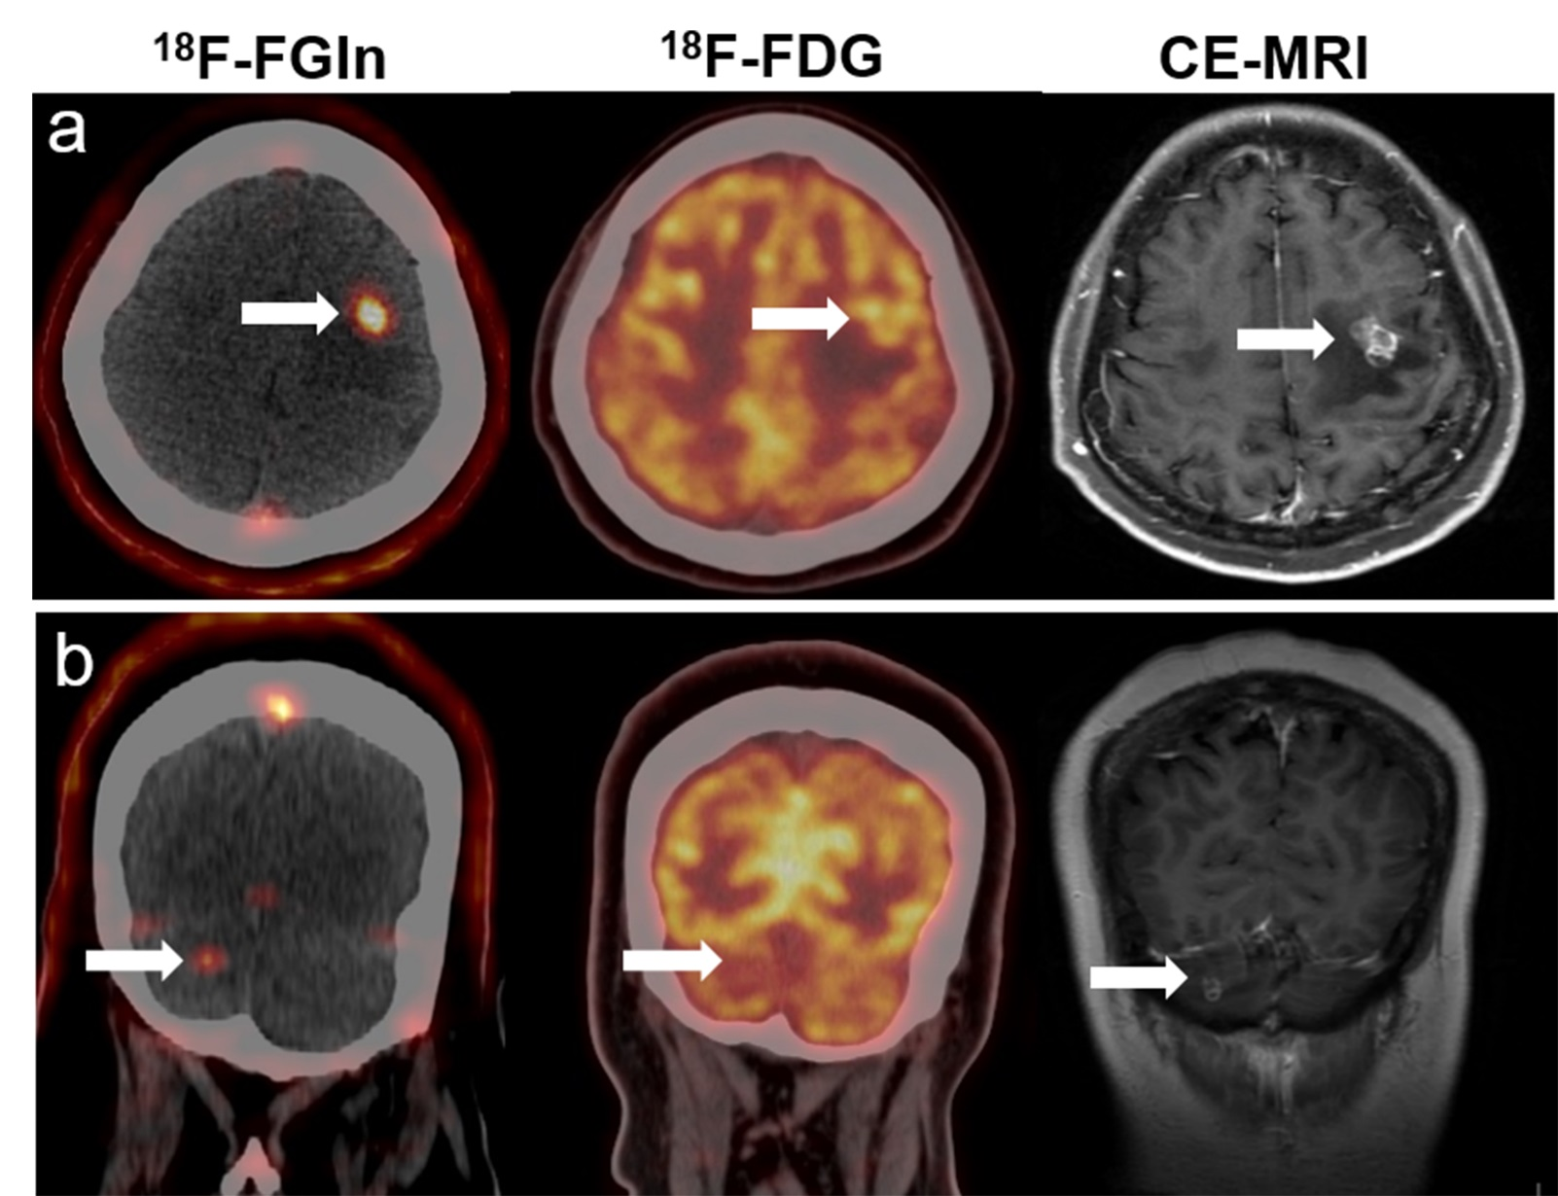
Supplemental Fig. S5 Comparison of MRI, ¹⁸F-FDG and ¹⁸F-FGln PET/CT in a same patient with specific breast cancers.

