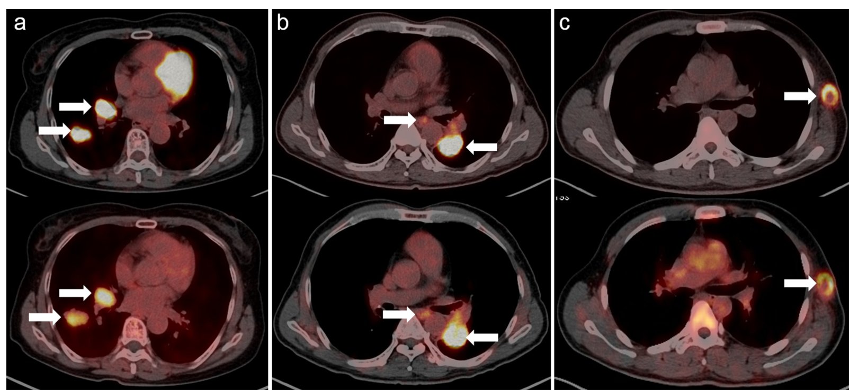
Supplemental Fig. S6 PET/CT fusion images of the primary lesion in 3 patient with malignant tumors. (Upper panels: ¹⁸F-FDG PET/CT images; lower panels: ¹⁸F-FGln PET/CT images.) (a) Female, 62y, lung adenocarcinomas with ¹⁸F-FDG SUVmax of 5.68 and ¹⁸F-FGln SUVmax of 4.64. (b) Male, 59y, lung adenocarcinomas with ¹⁸F-FDG SUVmax of 15.29 and ¹⁸F-FGln SUVmax of 6.23. (c) Male, 54y, malignant melanoma with ¹⁸F-FDG SUVmax of 10.06 and ¹⁸F-FGln SUVmax of 6.06.

