Supplementary data:
Search strategy
DATABASES searched: Web of Science (all collections) / EMBASE + MEDLINE (New-STN source)
Keywords and topics
Products search: “Broncho-Vaxom” OR “Broncho Vaxom” OR “bronchovaxom” OR “Broncho-Munal” OR “Broncho Munal” OR “bronchomunal” OR “Imocur” OR “OM-85” OR “OM 85” OR “OM-85 BV” OR “OM85” OR “PulmonarOM” OR “Pulmonar OM” OR “Pulmonar-OM” OR “Respivax” OR “Bactek” OR “SL-04” OR “Pidotimod” OR “Polimod” OR “Adimod” OR “Polimod” OR “Axil” OR “Ismigen” OR “Immubron” OR “Leucogen” OR “Lantigen B” OR “Ribomunyl” OR “Ribovac” OR “Immuncytal” OR “ru41740” OR “ru-41740” OR “ru 41740” OR “Biostim” OR “Imudon” OR “Luivac” OR “immunobalt” OR “LW 50020” OR “LW50020” OR “Paspat” OR “Munostimn” OR “Lantigen B” OR “IRS 19” OR “IRS-19” OR “IRS19” OR “Vacunace” OR “Pidotimod” OR “Polimod”
Broncho-Vaxom OR Broncho Vaxom OR bronchovaxom OR Broncho-Munal OR Broncho Munal OR bronchomunal OR Imocur OR OM-85 OR OM 85 OR OM-85 BV OR OM85 OR PulmonarOM OR Pulmonar OM OR Pulmonar-OM OR Respivax OR Bactek OR SL-04 OR Pidotimod OR Polimod OR Adimod OR Polimod OR Axil OR Ismigen OR Immubron OR Leucogen OR Lantigen B OR Ribomunyl OR Ribovac OR Immuncytal OR ru41740 OR ru-41740 OR ru 41740 OR Biostim OR Imudon OR Luivac OR immunobalt OR LW 50020 OR LW50020 OR Paspat OR Munostimn OR Lantigen B OR IRS 19 OR IRS-19 OR IRS19 OR Vacunace OR Pidotimod OR Polimod
AND
Respiratory tract infection OR respiratory NEAR/5 infect* OR adjuvant OR immunologic OR immunostimulant* or immunomodulat* OR immunoadjuvant* OR immunologic adjuvant*
AND
asthma* OR wheez* OR adjuvant OR immunologic OR immunostimulant* or immunomodulat* OR immunoadjuvant* OR immunologic adjuvant*
AND
Animal model OR mouse OR murine OR rat* OR rabbit* OR monkey* OR cat* OR dog* OR ferret*
AND
“Cell culture” OR “in vitro”

Supplementary figure 1: Study disposition
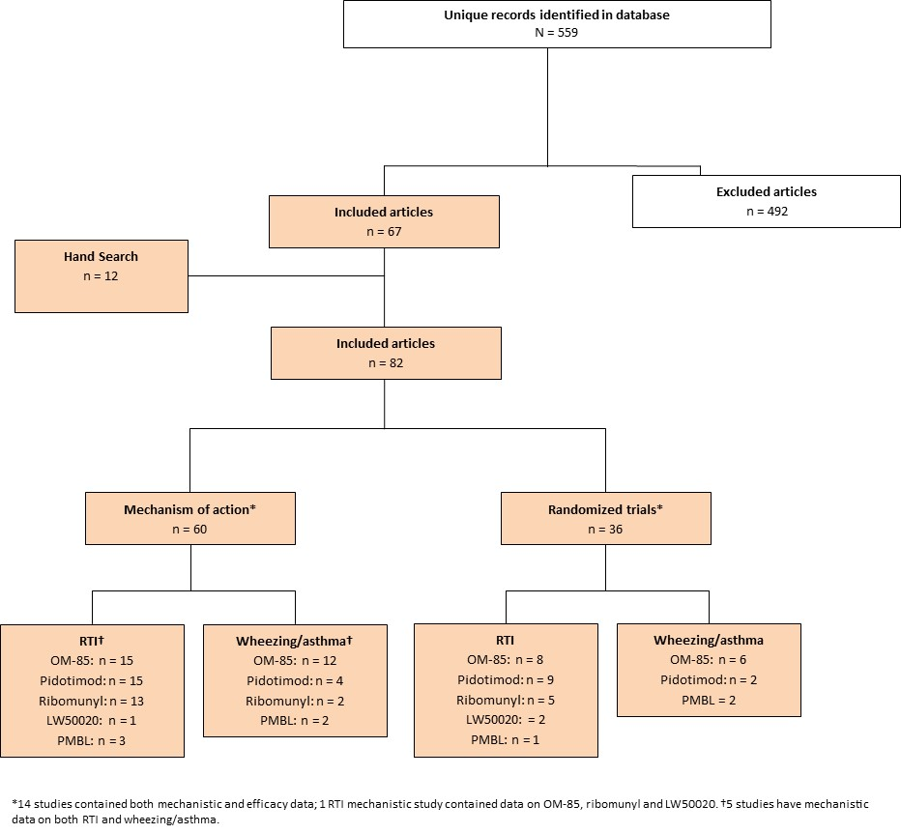
Supplementary table 1: Efficacy of immunomodulators for the prevention of RTIs in children
Therapy | Population (N) | Design and regimen | Immunomodulator RTI outcomes | Adverse events (treatment related) | Reference
OM-85 | Mexican children aged 1−12 years with RRTI (≥ 3 RTIs in previous 6 months) (54) | 12 month, placebo controlled, parallel group, randomized trial: OM-85 standard regimen  (3.5 mg/qd for 10 days a month for 3 consecutive months) at months 1 and 6 | -Reduced acute RTIs –2.96 (95% CI, –4.22 to –1.7; P<0.001)  -Reduced RTI duration –25.52 days (95% CI, –37.56 to –13.47 days; P<0.001)  -Reduced antibiotic use –2.0 (95% CI, –3.14 to –0.86; P<0.001) | Mild and similar between groups (one case of skin rash) | Gutierrez-Tarango and Berber 2001
 | Chinese children with RRTI† (80) | 12 month, randomized active control (probiotic Bifico) | -Reduced symptoms and RTIs | - | Gu, 2015
 | European children aged 3−8 years with acute presentation and recurrent URTI (≥ 3 RTIs in previous 12 months) (232) | 6-month, multicentre, randomized, double-blind, placebo-controlled study: standard regimen | -16% reduction in URTIs (P<0.05)  -11% difference in patients suffering > 3 URTIs  -Reduced use of concomitant non-antibiotic medications (P<0.05) | Mild and similar between groups (GI events) | Schaad, 2002
 | Lebanese children 1−15 years old with recurrent tonsillitis (> 3 infections in previous 12 months) (177) | A five-year single-centre retrospective cohort study: standard regimen | -51.2% had a complete response (> 50% decrease in episodes)  -24.4% had a partial response (≤50% reduction in episodes)  -No patients with a complete response required a tonsillectomy (median follow-up 9 months) | - | Bitar and Saade, 2013
 | Mexican children aged 18 months to 12 years with subacute sinusitis (54) | 6-month, double-blind placebo controlled randomized trial: standard regimen with amoxicillin/clavulanate | -Faster recovery (5.56 [4.98] vs 10 [8.49] days)  -Shorter period of convalescence (15.38 [8.91] vs 20.28 [7.17] days)  -Reduced infections (1.56 [0.3] vs 2.22 [0.43])  -Reduced drug treatments (1.47 [0.32] vs 1.94 [0.42]) | One case of mild rash, which resolved after treatment | Gomez Barreto, 1998
 | Mexican girls aged 6−13 years old living in an orphanage (200) | 6-months, double-blind, placebo-controlled, randomized trial: standard regimen | -Reduced ARTIs (135 vs 299 events; median/per child 1.0 vs 3.0; P<0.001)  -Lower median duration of illness, number of missed school days, number of antibiotic and drug courses, and duration of concomitant treatment (P<0.001) | No treatment-related events | Jara-Perez, 2000
 | Italian children aged 3−5 years with RRTI (≥ 6 RTIs in previous 12 months) (68) | Prospective, single-centre, single-blind, randomized trial: standard regimen with influenza vaccine | -Lower incidence (0.73 vs 2.19) and prevalence (5 vs 15) of URTI and LRTI (P<0.05)  -Lower use of antibiotics (0.49 vs 1.76; P<0.05)  -Less school absenteeism (3.16 vs 6.55 days; P<0.05) | Adverse events were similar | Esposito, 2014
 | Chinese children aged 4–12 years with chronic rhinosinusitis (96) | 12 month randomized trial of OM-85 vs intermittent saline  3.5 mg qd for 10 days a month for 3 consecutive months | -Reduced rhinosinusitis score (P=0.023)  -Reduced nasal obstruction score (P=0.04)  -Reduced nasal discharge score (P=0.04)  -Reduced days/month with rhinitis attacks (P=0.038)  -Reduced days/month with antibiotic use (P<0.01) | - | Chen, 2017
Pidotimod | Russian children aged 3−6 years old with RRTI (> 6 RTI/year) | 6 month active-control study: 400 mg pidotimod qd for 30 days vs amoxicillin/clavulanic acid | -No reduction in incidence of RTI overall  -Reduction in prevalence of moderate RTI (16.6% vs 44.3%; P=0.0004)  -Lower complication rate (rhinopharyngitis, otitis, etc.) (15.4% vs 43%; P<0.05)  -Less antibacterial therapy during follow-up (17.9% vs 53.2%; P<0.05) | - | Namazova-Baranova, 2014
 | Russian children with RRTI† (120) | Double-blind, placebo-controlled, randomized, multicentre trial: not stated | -Decrease in the risk of relapses (35%)  -Reduction of hospitalization (86%)  -Decreased antibiotic therapy (47%) | No observed side-effects | Caramia, 2008
 | Russian adults and children with RRTI (≥ 5 acute, febrile, oropharyngeal infectious episodes) (40) | Randomized, parallel-group active-control clinical study:  Pidotimod vs Lyophilized poly-bacterial lysates | -Lower incidence of infectious episodes | Good tolerance and compliance for both drugs | Di Filippo, 2008
 | Chinese children with RRTI† (86) | Randomized controlled trial: 3 months of pidotimod or spleen amino-peptide with routine treatment | -Reduced duration of clinical symptoms (P<0.01)  -Better clinical efficacy (P<0.05) | - | Zhou and Dai 2012
 | Greek children with RRTI† (50) | 9 month, randomized study: 400 mg pidotimod bid for 15 days and 400 mg qd for 20 days | -Less children had > 2 infections during follow-up (87.5% vs 33.3%; P<0.001). | - | Aivazis, 2002
 | Italian children aged 3−10 years with RRTI (> 6 RTI in previous 12 months) (89) | 3 month randomized parallel-group study:  400 mg pidotimod qd for 60 days | -Reduced prevalence of children with URTI symptoms (P<0.01) and LRTI symptoms (P<0.05)  -Increased school attendance (P<0.05)  -Reduced paediatric visits for RTI (94% vs 71%; P<0.05) | No significant adverse effects | Licari, 2014
 | Chinese children with RRTI† (214) | Randomized controlled trial vs active control | -Higher effective rate (91.5% vs 78.5%; P<0. 05), not defined  -Reduced fever (P<0. 05)  -Improved cough relief and time of reduction or disappearance of pulmonary rales (P<0. 05) | No obvious adverse reactions with pidotimod | Yu, 2014
 | Russian children with RTI* (49) | Open-label controlled clinical trial:  four week course of pidotimod | -Less frequent illness (1.7 times fewer events) | - | Kharit, 2010
 | Russian children aged 3−14 years old with RRTI† (90) | Active control study: 60 days of pidotimod vs standard care | -Reduced RTI, RTI complications,  -Reduced antibacterial drug use | - | Migatcheva 2012
 | Healthy 3-year old Italian children about to enter day care (57) | Multi-centre, randomized, double-blinded, placebo-controlled trial: 400 mg pidotimod bid 10 days/month from October-April vs placebo | -Incidence rate ratio 0.78 (95% CI 0.53−1.15, P=0.211)  -Risk ratio for antibiotic use 0.56 (95% CI 0.27−1.16; P=0.120) | Only one event urticaria, resolved after discontinuation | Mameli, 2015
Ribomunyl | Italian children aged 2–5 years attending or about to start day care with a history of ≤ 5 RTIs [A] of > 5 RTIs [B] (164) | 12-month, multicentre, randomized, double-blind, placebo-controlled, parallel-  group study: ribomunyl or placebo qd for 4 days/week for 3 consecutive weeks then qd 4 days/month for 5-months | -Shorter duration of infective episodes (3.6 vs 4.7;P=0.015) for group A but not group B (5.6 vs 5.3; P=NS)  -Improved well being (A+B)  -Physicians did not rate treated patients as significantly better  -No differences in absenteeism | Well tolerated with only one treatment-related event, fever | Fiocchi, 2012
 | Italian children aged 6−14 years with recurrent acute adenoiditis (4 episodes of acute adenoiditis during a 6-month period) (60) | 6 month, randomized, double blind parallel group study: ribomunyl or placebo qd 8 days/month for 3 months | -Shorter duration of infective episodes (3.6 vs 4.7;P=0.015) for group A but not group B (5.6 vs 5.3; P=NS)  -Improved well being (A+B)  -Physicians did not rate treated patients as significantly better  -No differences in absenteeism | No treatment related adverse events | Mora, 2010
 | Italian children aged between 5−14 years with recurrent pharyngotonsillitis (≥ 3 episodes in the last year) (160) | 6 month, randomized, double blind parallel group study: ribomunyl or placebo qd 8 days/month for 3 months | -Reduced infections (0.62 versus 1.70; P < 0.02)  -Subjective decrease in symptoms (3.9 to 1.9)  -Reduced incidence of fever (P < 0.02), duration of episodes (P < 0.05), ancillary therapy (P < 0.01) and school absence (P < 0.05) were concerned | No treatment related events | Mora, 2007
 | Children aged 6−14 years old with recurrent infection (≥ 5 in the last year) or otitis media (71) | 6-month, randomized, placebo controlled, double blind study: ribomunyl or placebo qd 8 days/month for 3 months | -Reduced upper (0.50 vs 0.67; P > 0.02), and lower respiratory infections (0.03 vs 0.17; P > 0.02).  -Improved fever (P > 0.02), frequency (P > 0.05) and duration (P > 0.05) of infectious episodes, ancillary therapies (P > 0.01) and school absence (P > 0.05)  -Most patients had an improved tympanogram reading | There were no treatment-related adverse events | Mora, 2004
 | Children aged 4–14 years with otitis media (>2 years' history of recurrent or chronic respiratory infections, and/or had experienced at ≥ 3 episodes during the prior winter) | Randomized double-blind parallel group study:  ribomunyl or placebo qd for 4 days/week for 3 consecutive weeks then qd 4 days/month for 5-months | -Reduced incidence of infection  -Reduced incidence of fever, duration of infectious episodes, use of ancillary therapies | - | Mora, 2002
LW50020 | Swizz children 4−11 years old with RRTIs (≥ 10 infections 4−6 years old; ≥ 8 infections 7−11 years old; ≥ 12 years old ≥ 6 infections; or at least 4 severe infections, lasting >2 weeks at any age). (200) | Multicentre, prospective, parallel-group, randomized, double blind study:  3 mg LW50020 qd during 4 week immunization and booster period vs placebo | -Reduced incidence of infections  -Reduced prevalence of infections (21% difference)  -Reduced duration of infection, clinical severity score  -Reduced antibiotic use (64%)  -Reduced absenteeism within group (1.2 to 0.7 days) | Three drug related events, two cases of transient rhinitis ( 1 patient), once case of diarrhoea | Rutishauser, 1998
 | Portuguese children 4−12 years of age with with RRTIs (definition as above). (188) | Multicenter, randomized, 56 week parallel prospective, placebo-controlled, double-blind, dose comparison study: Compared 2 dose regimens, 4 vs 2 active treatment cycles | -Within group reduction in rate of RTI following treatment (1.7 fewer infections /year)  -Within group reduction in duration, of RTI, severity and clinical score following treatment  -Within group 70% reduction in antibiotic use following treatment | Few, transient, and mild | Ruah, 2001
PMBL | Russian children (mean age – 4.3±0.6 years) with recurrent† URTI (27) | - | -Decrease in RTI (P<0,05)  -Decrease in antiviral drugs use (p<0,05) and antibiotic use. | Treatment was well tolerated | Zaplatnikov, 2016
CI, confidence interval, GI, gastrointestinal. *Children described as sickly/frequently ill. †Recurrence not defined.

Supplementary table 2: Efficacy of immunomodulators for the prevention of wheezing and asthma exacerbation
Therapy | Population (N) | Design and regimen | Immunomodulator outcomes | Adverse events (treatment related) | Reference
OM-85 | Turkish children 1−6 years old with recurrent wheezing (≥ 3 attack in previous 6 months) (75) | 12-month randomized placebo controlled, double-blind study: 3.5 mg or placebo qd for 10 days for 3 months (standard dosing) | -Reduced incidence of wheezing attacks (37.9%); P<0.001).  -Reduced duration of each wheezing attack (–2 days; P<0.001).  -Reduced ARTIs (R = –0.805, P < 0.001) | 5 minor transient treatment-related adverse events. | Razi, 2010
 | Chinese infants aged 7 months to 5 years with capillary bronchitis, secondary bronchial asthma (diagnosis based on journals of paediatrics and related guidelines) (136) | 12-month randomized trial: standard dosing with glucocorticoid atomizing inhalation, aminophylline and antibiotic | -Reduced incidence of asthma (10.2 vs 4.5; P=0.032)  -Reduced duration of asthma (4.5 vs 2.9 days; P=0.039)  -Reduced incidence of capillary bronchitis (17.9 vs 6.8; P=0.037)  -Reduced duration of capillary bronchitis (4.7 vs 3.3 days; P=0.042) | - | Han, 2016
 | Chinese children with asthma and RRTI (not defined) (62) | 12-month, randomized, placebo-controlled, double blind trial: OM-85 or placebo, plus inhaled glucocorticoids | - Frequency of respiratory tract infection was reduced (P<0.05) | 3 mild events across the two groups | Liao and Zhang, 2014
 | Chinese infants with wheezing who had received oxygen support, glucocorticoids, or bronchodilator (43), plus healthy controls (10) | Prospective 12-month study: standard dosing OM-85 vs budesonide aerosol 200 µg qd or bid for 3 months | -Reduced recurrent wheezing (>3 episodes) (25% vs 62%; P<0.05)  -Reduced infection rate (P<0.05) | - | Chen, 2007
 | Chinese children with acute-stage asthma (45) | 12-month study: OM-85 with inhaled corticosteroids or corticosteroids alone | -Reduced emergency visits due to asthma (1.32 vs 2.17; P<0.05)  -Reduced emergency visits due to RTI (1.32 vs 3.78; P<0.05)  -Frequency of RTI correlated with asthma in both groups  -Better lung function | - | Chen, 2009
 | Chinese children with a diagnosis of asthma aged 5−15 years old | 12-month study randomized study vs standard care: OM-85 (3.5 mg for those 5–12 years old or 7.0 mg for those >12 years old) qd for 10 days for 3 months +ICS. Two courses beginning at 1st and 7th month | -Reduced incidence of asthma attacks (0.9 vs 1.8; P=0.01)  -Reduced duration of wheeze (2.1 vs 3.1 days; P=0.03)  -Reduced incidence of RTI (3.1 vs 7.4; P<0.01)  -Reduced duration of cough (7.8 vs 12.5 days; P<0.01)  -Reduced duration of antibiotic use (4.9 vs 8.7; P< 0.01) | Adverse events were mild and rates were similar between groups | Lu, 2015
Pidotimod | Mexican children aged 2-16 years old with allergic rhinitis and asthma and RRTI (≥4 cases in previous 6 months) (73) | 6-month study, design unclear: 400 mg pidotimod bid | -Reduced infection incidence after treatment vs before (4.04 vs 5.7; P<0.005)  -Reduced duration of infections after treatment vs before (4.21 vs 6.1; P<0.001) | - | Vargas Correa, 2002
 | Russian children aged 3−10 years old, hospitalised with ARTI and obstructive syndrome (60) | 12-month study: 400 mg pidotimod bid for 14 days vs standard therapy | -Reduced ARTIs  -Obstructive syndrome was rare | - | Lokshina, 2011
PMBL | Polish children 5-16 years with atopic asthma (GINA definition) (150) | 9-month randomized trial | -Reduced prevalence of asthma exacerbations  -Reduced incidence of asthma exacerbations | - | Bartkowiak-Emeryk, 2017
 | Children and adults aged 6−78 years old with allergic rhinitis (26) | Randomized trial controlled trial: PMBL or placebo qd 10 days/month for 3 months | -Improved asthmatic symptoms (38.4%)  -Clinical improvement (61.5%)  -Decrease in nasal blocking (53.8%)  -Decreased ocular symptoms (50%) | No negative side effects | Banche, 2007
CI, confidence interval, GI, gastrointestinal. *Children described as sickly/frequently ill.

