Supplementary Information for the following manuscript submitted to the journal Current Opinion in Ophthalmology

Novel Vitreous Substitutes: the Next Frontier in Vitreoretinal Surgery

André Schulz ^{a,b}, Kai Januschowski ^{a,b,c}, Peter Szurman ^{a,b}

Affiliation
ª Knappschaft Hospital Saar, An der Klinik 10, 66280 Sulzbach, Germany
^{b} Klaus Heimann Eye Research Institute, An der Klinik 10, 66280 Sulzbach, Germany
^{c} Centre for Ophthalmology, University Eye Hospital Tuebingen, Elfriede-Aulhorn-Straße 7, 72076 Tuebingen, Germany

Corresponding author
André Schulz, Dr. rer. nat.
Klaus Heimann Eye Research Institute
An der Klinik 10, 66280 Sulzbach, Germany
andre.schulz@kksaar.de
Phone: +49 6897 574 1119
Fax: +49 6897 574 213
Supplementary Table 1. PubMed search history. The search was performed on December the 7th, 2020.
Number | Search | Search Details | Results
#34 | #33, Filter: from 2019-2020 | Search: ((((((vitreous) OR (vitreous body)) OR (vitreous humor)) OR (vitreal)) AND (((((((((((((gas) OR (air)) OR (sulfur hexafluoride)) OR (perfluoropropane)) OR (oil)) OR (silicone oil)) OR (perfluorocarbon)) OR (semifluorinated alkanes)) OR (salt solution)) OR (balanced salt solution)) OR (polymer)) OR (gel)) OR (hydrogel))) AND ((((((substitute) OR (vitreous substitute)) OR (tamponade)) OR (endotamponade)) OR (retinal tamponade)) OR (tamponading agent))) AND (((retinal detachment) OR (vitreoretinal surgery)) OR (vitrectomy)) Filters: from 2019 - 2020 | 112
#33 | #32 AND # 30 | ((((((vitreous) OR (vitreous body)) OR (vitreous humor)) OR (vitreal)) AND (((((((((((((gas) OR (air)) OR (sulfur hexafluoride)) OR (perfluoropropane)) OR (oil)) OR (silicone oil)) OR (perfluorocarbon)) OR (semifluorinated alkanes)) OR (salt solution)) OR (balanced salt solution)) OR (polymer)) OR (gel)) OR (hydrogel))) AND ((((((substitute) OR (vitreous substitute)) OR (tamponade)) OR (endotamponade)) OR (retinal tamponade)) OR (tamponading agent))) AND (((retinal detachment) OR (vitreoretinal surgery)) OR (vitrectomy)) | 1,043
#32 | #31 AND #12 | (((((vitreous) OR (vitreous body)) OR (vitreous humor)) OR (vitreal)) AND (((((((((((((gas) OR (air)) OR (sulfur hexafluoride)) OR (perfluoropropane)) OR (oil)) OR (silicone oil)) OR (perfluorocarbon)) OR (semifluorinated alkanes)) OR (salt solution)) OR (balanced salt solution)) OR (polymer)) OR (gel)) OR (hydrogel))) AND ((((((substitute) OR (vitreous substitute)) OR (tamponade)) OR (endotamponade)) OR (retinal tamponade)) OR (tamponading agent)) | 1,162
#31 | #5 AND #26 | ((((vitreous) OR (vitreous body)) OR (vitreous humor)) OR (vitreal)) AND (((((((((((((gas) OR (air)) OR (sulfur hexafluoride)) OR (perfluoropropane)) OR (oil)) OR (silicone oil)) OR (perfluorocarbon)) OR (semifluorinated alkanes)) OR (salt solution)) OR (balanced salt solution)) OR (polymer)) OR (gel)) OR (hydrogel)) | 5,510
#30 | #27 OR #28 OR #29 | ((retinal detachment) OR (vitreoretinal surgery)) OR (vitrectomy) | 43,217
#29 | vitrectomy | "vitrectomy"[MeSH Terms] OR "vitrectomy"[All Fields] OR "vitrectomies"[All Fields] | 20,100
#28 | vitreoretinal surgery | "vitreoretinal surgery"[MeSH Terms] OR ("vitreoretinal"[All Fields] AND "surgery"[All Fields]) OR "vitreoretinal surgery"[All Fields] | 4,385
#27 | retinal detachment | "retinal detachment"[MeSH Terms] OR ("retinal"[All Fields] AND "detachment"[All Fields]) OR "retinal detachment"[All Fields] | 28,755
#26 | #13 OR #14 OR #15 OR #16 OR #17 OR #18 OR #19 OR #20 OR #21 OR #22 OR #23 OR #24 OR #25 | ((((((((((((gas) OR (air)) OR (sulfur hexafluoride)) OR (perfluoropropane)) OR (oil)) OR (silicone oil)) OR (perfluorocarbon)) OR (semifluorinated alkanes)) OR (salt solution)) OR (balanced salt solution)) OR (polymer)) OR (gel)) OR (hydrogel) | 2,213,342
#25 | hydrogel | "hydrogel s"[All Fields] OR "hydrogelating"[All Fields] OR "hydrogelation"[All Fields] OR "hydrogelations"[All Fields] OR "hydrogelator"[All Fields] OR "hydrogelators"[All Fields] OR "hydrogels"[MeSH Terms] OR "hydrogels"[All Fields] OR "hydrogel"[All Fields] | 41,711
#24 | gel | "gel"[All Fields] | 442,202
#23 | polymer | "polymer s"[All Fields] OR "polymers"[MeSH Terms] OR "polymers"[All Fields] OR "polymer"[All Fields] | 990,555
#22 | balanced salt solution | ("balance"[All Fields] OR "balanced"[All Fields] OR "balances"[All Fields] OR "balancing"[All Fields]) AND ("sodium chloride"[MeSH Terms] OR ("sodium"[All Fields] AND "chloride"[All Fields]) OR "sodium chloride"[All Fields] OR "salt"[All Fields]) AND ("pharmaceutical solutions"[Pharmacological Action] OR "solutions"[MeSH Terms] OR "solutions"[All Fields] OR "solution"[All Fields] OR "pharmaceutical solutions"[MeSH Terms] OR ("pharmaceutical"[All Fields] AND "solutions"[All Fields]) OR "pharmaceutical solutions"[All Fields] OR "solutal"[All Fields] OR "solute"[All Fields] OR "solute s"[All Fields] OR "soluted"[All Fields] OR "solutes"[All Fields] OR "solution s"[All Fields]) | 5,369
#21 | salt solution | ("sodium chloride"[MeSH Terms] OR ("sodium"[All Fields] AND "chloride"[All Fields]) OR "sodium chloride"[All Fields] OR "salt"[All Fields]) AND ("pharmaceutical solutions"[Pharmacological Action] OR "solutions"[MeSH Terms] OR "solutions"[All Fields] OR "solution"[All Fields] OR "pharmaceutical solutions"[MeSH Terms] OR ("pharmaceutical"[All Fields] AND "solutions"[All Fields]) OR "pharmaceutical solutions"[All Fields] OR "solutal"[All Fields] OR "solute"[All Fields] OR "solute s"[All Fields] OR "soluted"[All Fields] OR "solutes"[All Fields] OR "solution s"[All Fields]) | 51,770
#20 | semifluorinated alkanes | "semifluorinated"[All Fields] AND ("alkanal"[All Fields] OR "alkanals"[All Fields] OR "alkanes"[MeSH Terms] OR "alkanes"[All Fields] OR "alkane"[All Fields]) | 102
#19 | perfluorocarbon | "fluorocarbons"[MeSH Terms] OR "fluorocarbons"[All Fields] OR "perfluorocarbon"[All Fields] OR "perfluorocarbons"[All Fields] | 12,893
#18 | silicone oil | "silicone oils"[MeSH Terms] OR ("silicone"[All Fields] AND "oils"[All Fields]) OR "silicone oils"[All Fields] OR ("silicone"[All Fields] AND "oil"[All Fields]) OR "silicone oil"[All Fields] | 4,855
#17 | oil | "oil"[All Fields] | 161,158
#16 | perfluoropropane | "perflutren"[Supplementary Concept] OR "perflutren"[All Fields] OR "perfluoropropane"[All Fields] | 1,111
#15 | sulfur hexafluoride | "sulphur hexafluoride"[All Fields] OR "sulfur hexafluoride"[MeSH Terms] OR ("sulfur"[All Fields] AND "hexafluoride"[All Fields]) OR "sulfur hexafluoride"[All Fields] | 3,247
#14 | air | "air"[MeSH Terms] OR "air"[All Fields] | 349,108
#13 | gas | "gas"[All Fields] OR "gasoline"[MeSH Terms] OR "gasoline"[All Fields] OR "gasolines"[All Fields] OR "petrol"[All Fields] OR "petroleum"[MeSH Terms] OR "petroleum"[All Fields] OR "petroleums"[All Fields] | 389,760
#12 | #6 OR #7 OR #8 OR #9 OR #10 OR #11 | (((((substitute) OR (vitreous substitute)) OR (tamponade)) OR (endotamponade)) OR (retinal tamponade)) OR (tamponading agent) | 398,608
#11 | tamonading agent | ("tamponade"[All Fields] OR "tamponaded"[All Fields] OR "tamponades"[All Fields] OR "tamponading"[All Fields]) AND ("agent"[All Fields] OR "agents"[All Fields]) | 1,214
#10 | retinal tamponade | ("retinaldehyde"[MeSH Terms] OR "retinaldehyde"[All Fields] OR "retinal"[All Fields] OR "retina"[MeSH Terms] OR "retina"[All Fields] OR "retinally"[All Fields] OR "retinals"[All Fields] OR "retinitis"[MeSH Terms] OR "retinitis"[All Fields]) AND ("tamponade"[All Fields] OR "tamponaded"[All Fields] OR "tamponades"[All Fields] OR "tamponading"[All Fields]) | 2,314
#9 | endotamponade | "endotamponade"[MeSH Terms] OR "endotamponade"[All Fields] OR "endotamponades"[All Fields] | 4,935
#8 | tamponade | "tamponade"[All Fields] OR "tamponaded"[All Fields] OR "tamponades"[All Fields] OR "tamponading"[All Fields] | 15,785
#7 | vitreous substitute | "vitreous"[All Fields] AND ("substitute"[All Fields] OR "substituted"[All Fields] OR "substitutent"[All Fields] OR "substitutents"[All Fields] OR "substitutes"[All Fields] OR "substituting"[All Fields] OR "substitution"[All Fields] OR "substitutional"[All Fields] OR "substitutions"[All Fields]) | 446
#6 | substitute | "substitute"[All Fields] OR "substituted"[All Fields] OR "substitutent"[All Fields] OR "substitutents"[All Fields] OR "substitutes"[All Fields] OR "substituting"[All Fields] OR "substitution"[All Fields] OR "substitutional"[All Fields] OR "substitutions"[All Fields] | 379,271
#5 | #1 OR #2 OR #3 OR #4 | "vitreous"[All Fields] OR ("vitreous (((vitreous) OR (vitreous body)) OR (vitreous humor)) OR (vitreal) | 38,034
#4 | vitreal | "vitreal"[All Fields] | 1,424
#3 | vitreous humor | "vitreous body"[MeSH Terms] OR ("vitreous"[All Fields] AND "body"[All Fields]) OR "vitreous body"[All Fields] OR ("vitreous"[All Fields] AND "humor"[All Fields]) OR "vitreous humor"[All Fields] | 22,089
#2 | vitreous body | "vitreous body"[MeSH Terms] OR ("vitreous"[All Fields] AND "body"[All Fields]) OR "vitreous body"[All Fields] | 21,175
#1 | vitreous | "vitreous"[All Fields] | 37,362

Supplementary Table 2. Web of Science search history. The search was performed on December the 7th, 2020.
Number | Search | Search Details | Results
#34 | #33, Filter: from 2019-2020 | #32 AND #30  Refined by: PUBLICATION YEARS: ( 2020 OR 2019 ) | 102
#33 | #32 AND # 30 | #32 AND #30 | 832
#32 | #31 AND #12 | #31 AND #12 | 967
#31 | #5 AND #26 | #26 AND #5 | 4,234
#30 | #27 OR #28 OR #29 | #29 OR #28 OR #27 | 30,312
#29 | vitrectomy | TOPIC: (vitrectomy) | 16,093
#28 | vitreoretinal surgery | TOPIC: (vitreoretinal surgery) | 3,348
#27 | retinal detachment | TOPIC: (retinal detachment) | 18,388
#26 | #13 OR #14 OR #15 OR #16 OR #17 OR #18 OR #19 OR #20 OR #21 OR #22 OR #23 OR #24 OR #25 | #25 OR #24 OR #23 OR #22 OR #21 OR #20 OR #19 OR #18 OR #17 OR #16 OR #15 OR #14 OR #13 | 4,079,753
#25 | hydrogel | TOPIC: (hydrogel) | 63,727
#24 | gel | TOPIC: (gel) | 520,565
#23 | polymer | TOPIC: (polymer) | 996,134
#22 | balanced salt solution | TOPIC: (balanced salt solution) | 4,154
#21 | salt solution | TOPIC: (salt solution) | 101,061
#20 | semifluorinated alkanes | TOPIC: (semifluorinated alkanes) | 335
#19 | perfluorocarbon | TOPIC: (perfluorocarbon) | 3,893
#18 | silicone oil | TOPIC: (silicone oil) | 8,441
#17 | oil | TOPIC: (oil) | 639,846
#16 | perfluoropropane | TOPIC: (perfluoropropane) | 494
#15 | sulfur hexafluoride | TOPIC: (sulfur hexafluoride) | 3,731
#14 | air | TOPIC: (air) | 884,461
#13 | gas | TOPIC: (gas) | 1,377,226
#12 | #6 OR #7 OR #8 OR #9 OR #10 OR #11 | #11 OR #10 OR #9 OR #8 OR #7 OR #6 | 452,189
#11 | tamonading agent | TOPIC: (tamponading agent) | 44
#10 | retinal tamponade | TOPIC: (retinal tamponade) | 1,778
#9 | endotamponade | TOPIC: (endotamponade) | 264
#8 | tamponade | TOPIC: (tamponade) | 12,547
#7 | vitreous substitute | TOPIC: (vitreous substitute) | 490
#6 | substitute | TOPIC: (substitute) | 439,602
#5 | #1 OR #2 OR #3 OR #4 | #4 OR #3 OR #2 OR #1 | 32,159
#4 | vitreal | TOPIC: (vitreal) | 1,139
#3 | vitreous humor | TOPIC: (vitreous humor) | 3,340
#2 | vitreous body | TOPIC: (vitreous body) | 2,962
#1 | vitreous | TOPIC: (vitreous) | 31,454

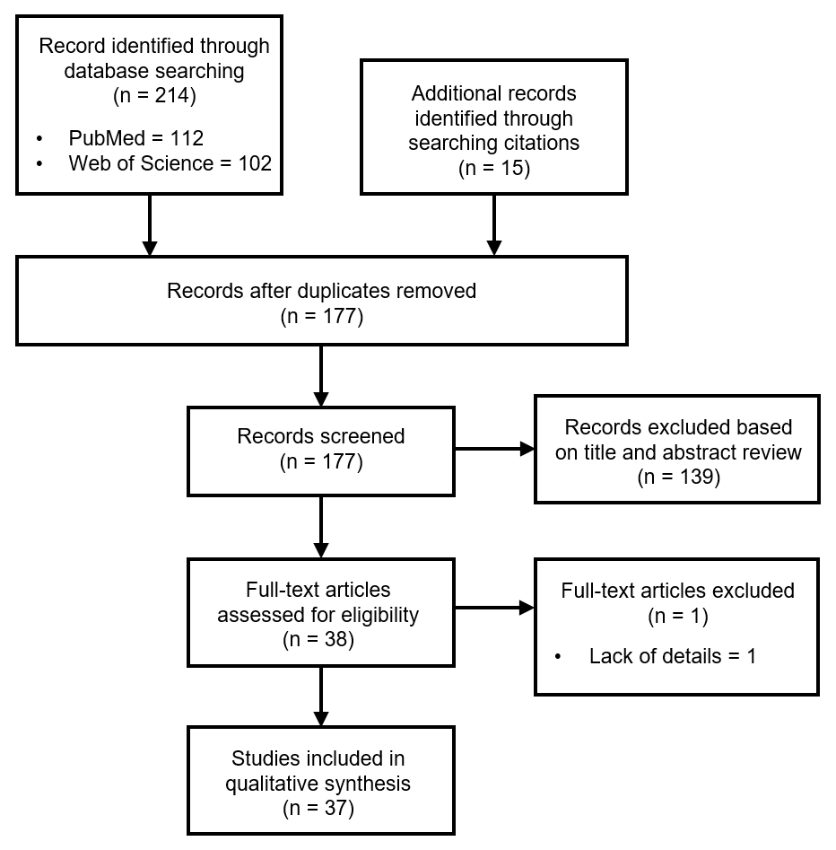 Supplementary Figure 1. PRISMA flow chart.

