Figure e-1: Interview model

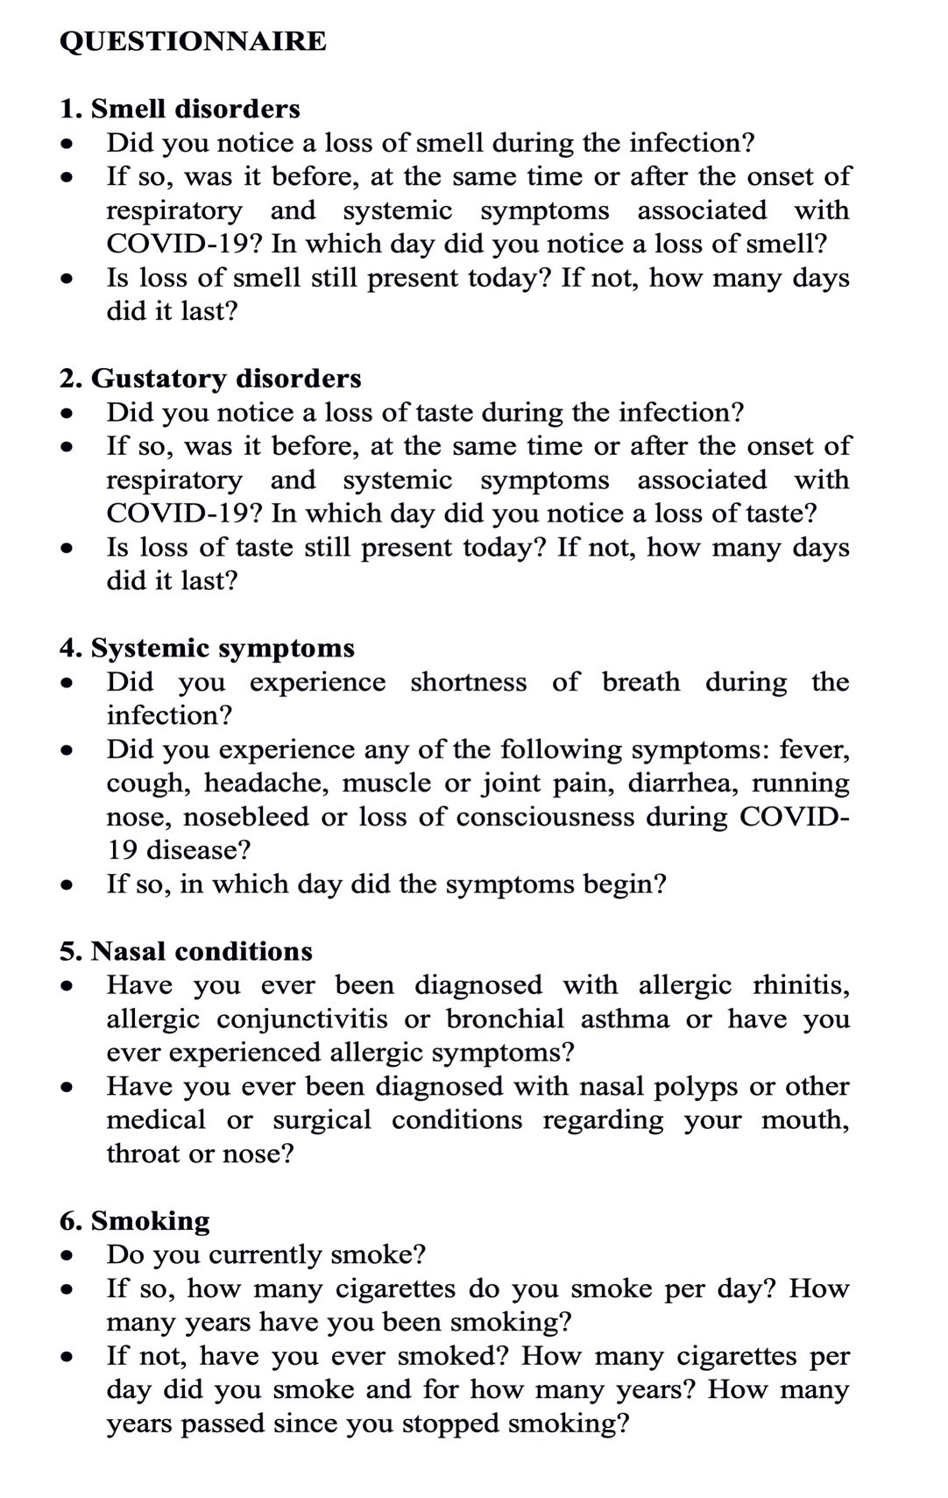

Figure e-2: Charlson score distribution among the entire interviewed population (n = 93). No difference in score distribution was found between hyposmic and normosmic groups, d = 0.28 CI 95% (-0.15 to 0.71).

