
PETER K. KRIZ, M.D.
Assistant Professor (Clinical)
Sports Medicine and Pediatrics
Brown University
Warren Alpert Medical School

Medical Office Center/Suite 200
2 Dudley Street
Providence, RI 02905
Office (401) 457- 2188
Fax (401) 457-2187

Affiliated entity of

Viewing a Pitching Analysis Video on Dartfish TV

- Go to the 2D Video Analysis Adolescent Pitching Biomechanics video on Dartfish TV:
http://www.dartfish.tv/Dispatch.aspx?target=collection&CR=p101315c93397m3192315&sh=li&aid=3bf6efe7-e5a1-493e-ad2f-eba796125830
- You will see a screen shot similar to the one below:
#1

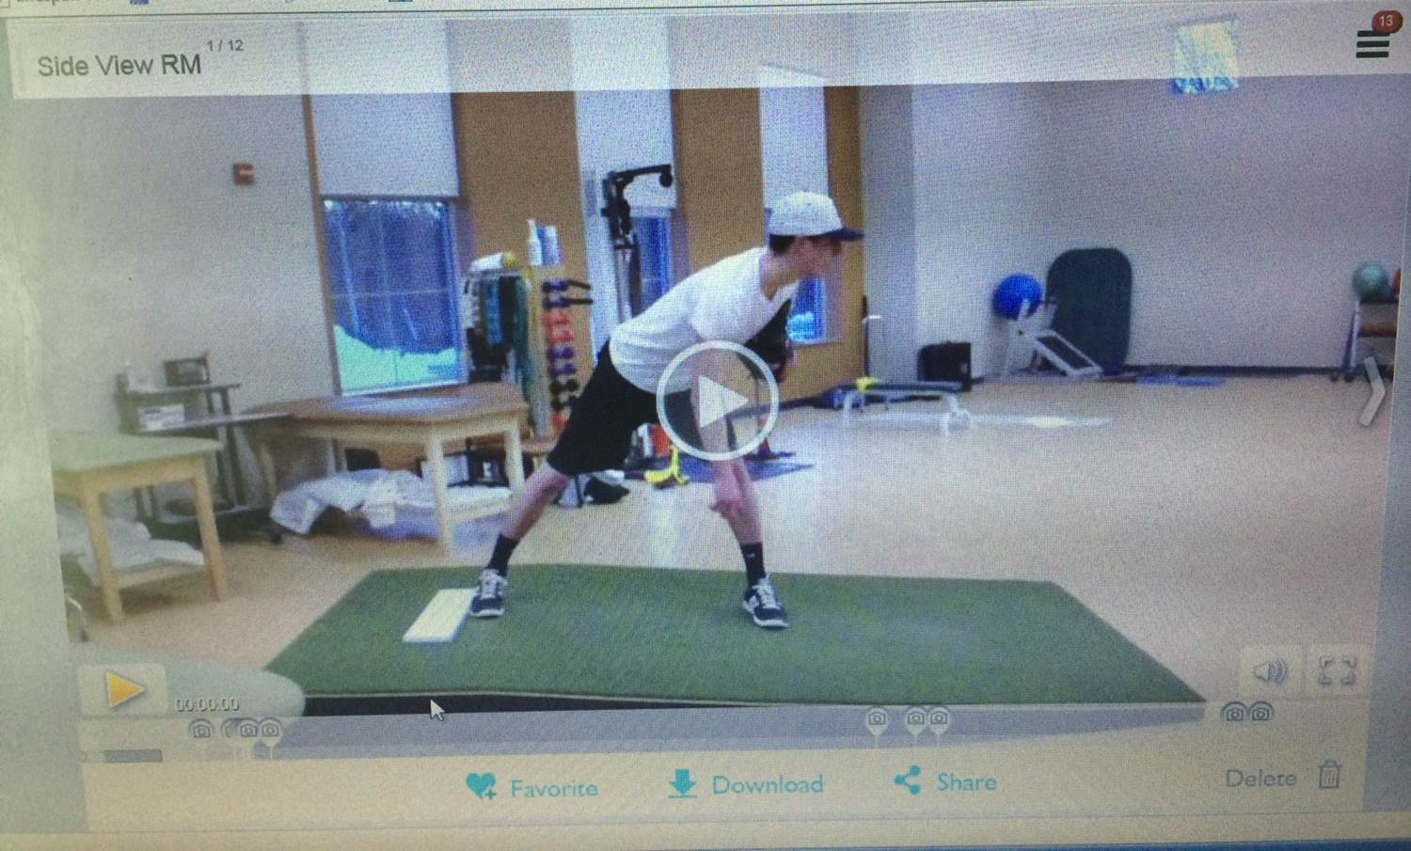

- Move your cursor onto the video. You will see a number of features pop up on the bottom of the video (play button, timer, Mute/Volume, Full Screen). Click on “Display markers list” (red circle #1) in the upper right hand corner. You will see this screen:
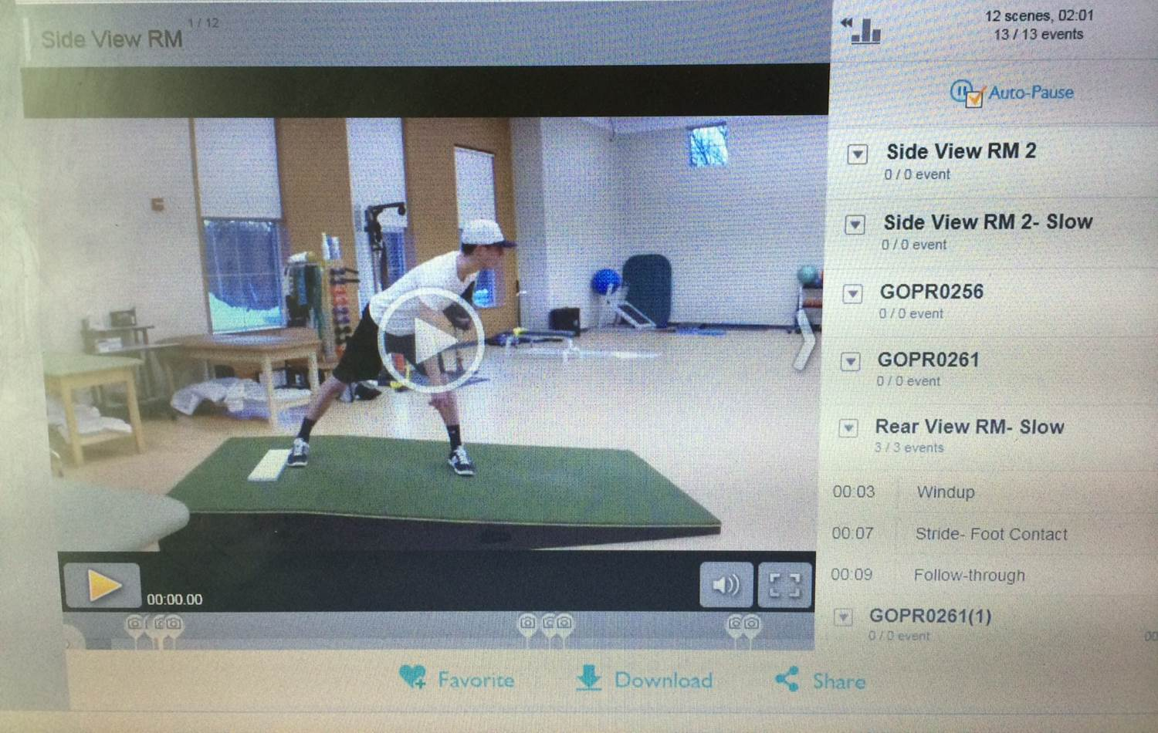
#2

Make sure “Auto-Pause” (red circle #2) is checked. Then click on “Hide markers list” (red circle #3):
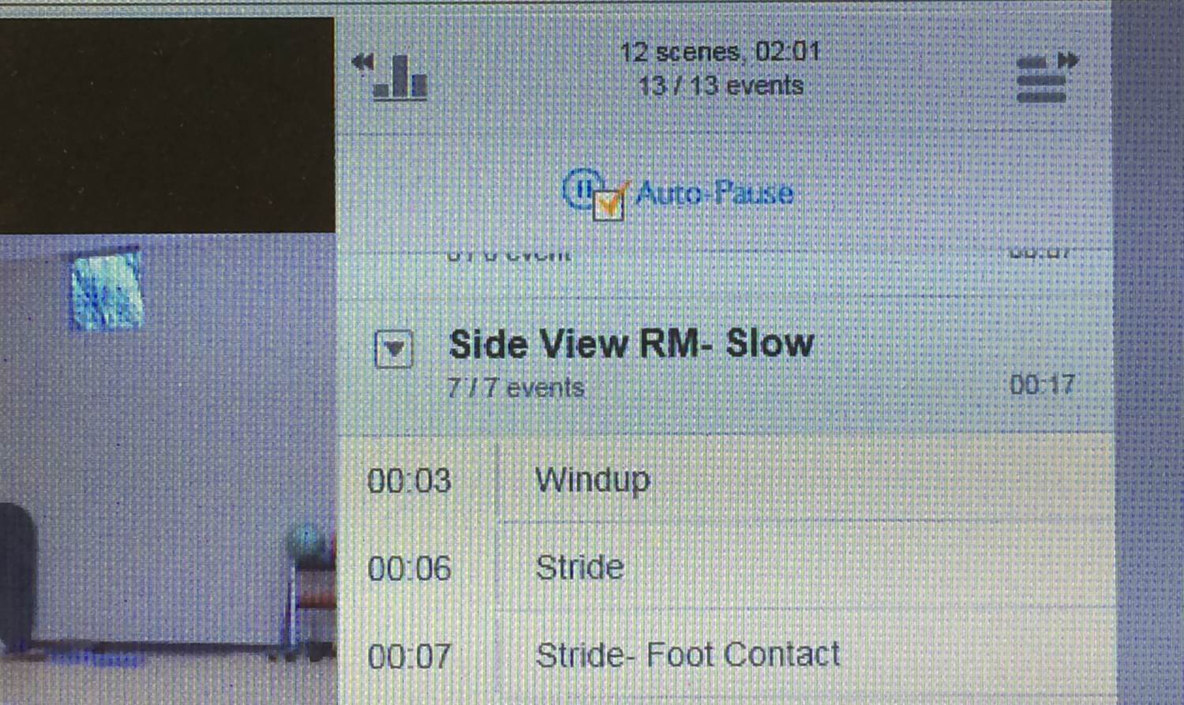
#3

- Now, you will return to the following screen:

#4

#5

Click on the “Full Screen” icon (red circle #4), then click on the yellow “Play” button (red circle #5). This will play the video in its entirety, including all of the Key Positions throughout the pitching delivery. Comments will appear on each of these paused Key Positions. Just click on the yellow “Play/Pause” button after you’ve read the comment(s) to continue viewing the remainder of the video.

Feel free to contact Dr. Kriz at Peter_Kriz@brown.edu with questions.

