Supplementary Material
Methods:
Bayesian network
A Bayesian network is a probabilistic model that represents dependencies and independencies of a set of variables via a directed acyclic graph (DAG). The classifier model used in this study is so called Tree Augmented Naïve Bayesian networks [TAN], in which the class variable has no parents and each attribute has at most two parents including class variable. It means there is an edge from the class variable to each attribute as it’s in the naive Bayesian classifier and each attribute can be pointed by one augmenting edge. An edge from attribute Ai to attribute Aj implies that the influence of Ai on the assessment of the class variable also depends on the value of Aj. Let A1…An be a set of attribute variables and C be the class variable. Then the key to construct a TAN is computing the mutual information I(Ai; Aj | C) between each pair of attributes Ai and Aj, Where $I\left(Ai;Aj \right| C)=\sum_{ai, aj, c}{P(ai, aj, c)log\frac{P\left(ai, aj\right|c)}{P\left(ai\right|c)P(aj|c)}}$ and $i≠$j. Augmenting edges (in total n-1 edges) are then selected by using mutual information with descending order and guaranteeing that each attribute has at most two parents including class variable.

Tables

Supplementary Table 1. Events in the occurrence and recurrence of disabling disease in Crohn’s disease
Disabling events | Occurrence of disabling CD, n(%)[n=105] | Follow-up time of disabling occurrence, median months [IQR] | Recurrence of disabling CD, n(%)[n=20] | Follow-up time of disabling recurrence, median months [IQR]
Surgery | 26(24.8) | 22.4[13.0-38.2] | 7(35.0) | 26.1[11.7-36.3]
Hospitalizations ≥ 3 | 7(6.7) | 34.1[18.4-49.3] | 4(20.0) | 26.8[17.9-35.5]
Steroid dependency | 6(5.7) | 5.6[3.7-16.3] | 0(0.0) | -
New complication events
New penetrating event | 24(22.9) | 23.8[9.9-37.5] | 4(20.0) | 30.8[13.5-48.5]
New stenosis | 29(27.6) | 21.5[10.6-35.7] | 7(35.0) | 36.0[21.5-51.1]
New perianal event | 40(38.1) | 16.3[11.4-34.4] | 3(15.0) | 48.3[46.1-54.5]
CD, Crohn’s disease; IQR: interquartile range

Supplementary Table 2. Mucosal healing and disabling events
The occurrence of disabling events | MH before disabling, n(%)[N=96] | Without MH before disabling, n(%)[N=223] | p-value¹
Surgery | 1(1.0) | 25(11.2) | 0.001
Hospitalizations ≥ 3 | 0(0.0) | 7(3.1) | 0.107
Steroid dependency | 0(0.0) | 6(2.7) | 0184
New complication events
New penetrating event | 0(0.0) | 24(10.8) | < 0.001
New stenosis | 1(1.0) | 28(12.6) | < 0.001
New perianal event | 8(8.3) | 32(14.3) | 0.196
¹ Fisher’s exact probabilities
MH: mucosal healing.

Supplementary Table 3. Baseline demographic and characteristics of the disabling Crohn’s disease patients
 | Total  [n=105] | Recurrence Disabling CD [n=20] | Non-recurrence disabling CD [n=85] | p-value¹
Gender: Male, n (%) | 71 (67.6) | 17 (85.0) | 54 (63.5) | 0.109
Age at diagnosis |  |  |  | 0.236
A1 | 19 (18.1) | 1 (5.0) | 18 (21.2)
A2 | 76 (72.4) | 17 (85.0) | 59 (69.4)
A3 | 10 (9.5) | 2 (10.0) | 8 (9.4)
Location, n (%) |  |  |  | 0.378
L1: ileal | 20 (19.0) | 6 (30.0) | 14 (16.5)
L2: conlonic | 7 (6.7) | 1 (5.0) | 6 (7.1)
L3: ilealcolonic | 65 (76.5) | 13 (65.0) | 65 (76.5)
Upper tract involvement, n (%) | 16 (15.2) | 3 (15.0) | 13 (15.3) | 1.000
Disease behavior, n (%) |  |  |  | 0.718
B1: non-stricturing,non-penetrating | 65 (61.9) | 11 (55.0) | 54 (63.5)
B2: stricturing | 20 (19.0) | 4 (20.0) | 16 (18.8)
B3: penetrating | 20 (19.0) | 5 (25.0) | 15 (17.6)
Perianal disease | 32 (30.5) | 4 (20.0) | 28 (32.9) | 0.295
Smoker, n (%) | 14 (13.3) | 5 (25.0) | 9 (10.6) | 0.136
Follow-up time, median months [IQR] | 49.5 [35.6-60.0] | 48.9 [43.0-58.6] | 49.5 [31.9-60.0] | 0.967*
CRP, median [IQR] | 13.5 [8.2-28.1] | 12.3 [10.8-14.9] | 13.7 [7.2-31.0] | 0.630*
ESR, median [IQR] | 48.0 [28.5-73.5] | 53.0 [25.0-81.3] | 48.0 [29.0-71.5] | 0.557*
¹ Fisher’s exact probabilities; * Mann-Whitney U-test
CD, Crohn’s disease; IQR: interquartile range; CRP, C-reactive protein; ESR, erythrocyte sedimentation rate.

Supplementary Figure
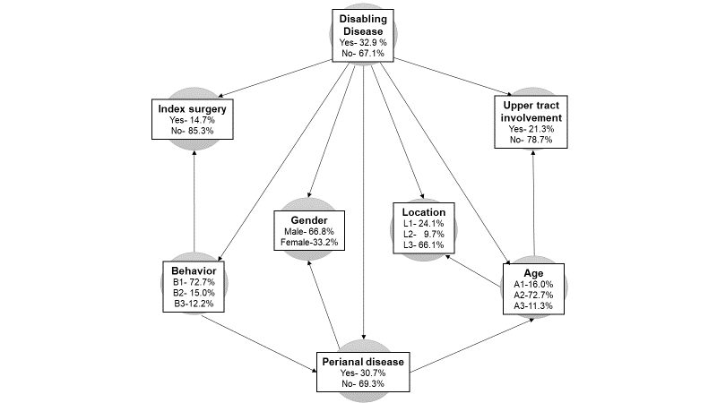
Supplementary Figure 1. The Bayesian network representing the relationship between disabling disease and each clinical variable at baseline. Arrows represent the relationship between variables, but do not demonstrate any causal relationship.

