Figure, Supplemental Digital Content 4. Rates of biologic usage across states among patients with (a) UC and (b) CD. Darker color represents a greater percentage biologic use.
a
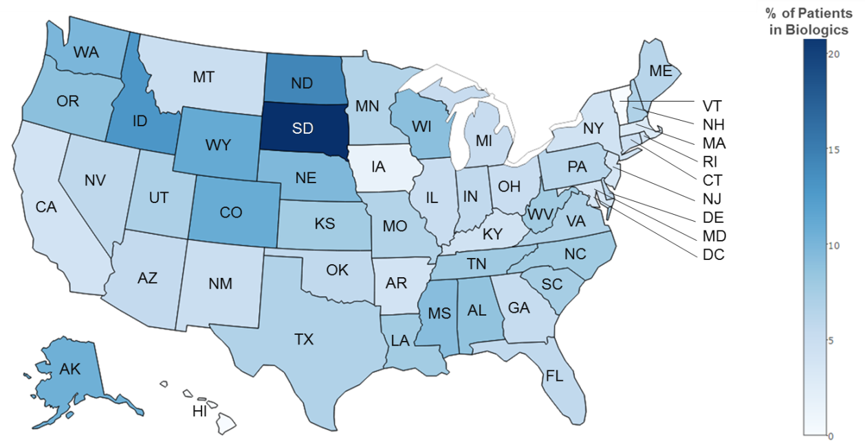
b
