APPENDIX

Supplemental Table 1. Aquaporin mRNA expression data from rectosigmoid mucosa in IBS groups [mean (95% CI)]
 | Fold difference relative to healthy control in  IBS-D with high BA | P-value | Fold difference relative to healthy control in  IBS-D with normal BA | P value | Fold difference relative to healthy control in IBS-C | P value
AQP1 | 0.703 (0.52, 0.89) | 0.019 | 0.767 (0.60, 0.94) | 0.014 | 0.955 (0.77, 1.14) | 0.422
AQP3 | 0.416 (0.31, 0.52) | 5 x10^{-6*} | 0.499 (0.39, 0.61) | 2 x10^{-6*} | 1.128 (0.86, 1.40) | 0.670
AQP7 | 2.865 (1.43, 4.3) | 0.0001* | 3.536 (2.37, 4.70) | 4 x10^{-8*} | 1.009 (0.50, 1.52) | 0.993
AQP8 | 14.491 (5.92, 23.06) | 4 x10^{-8*} | 15.694 (7.18, 24.21) | 1 x10^{-8*} | 1.310 (0.18, 2.44) | 0.429
*indicates a significant p value <0.0042; AQP=aquaporin; IBS=irritable bowel syndrome; IBS-D=diarrhea-predominant irritable bowel syndrome; IBS-C=constipation-predominant irritable bowel syndrome; BA=bile acids

Supplemental Figure 1. The magnitude of mRNA expression demonstrating the relative expression of the different AQPs in the different groups (corrected for GAPDH expression) is shown in the figure.

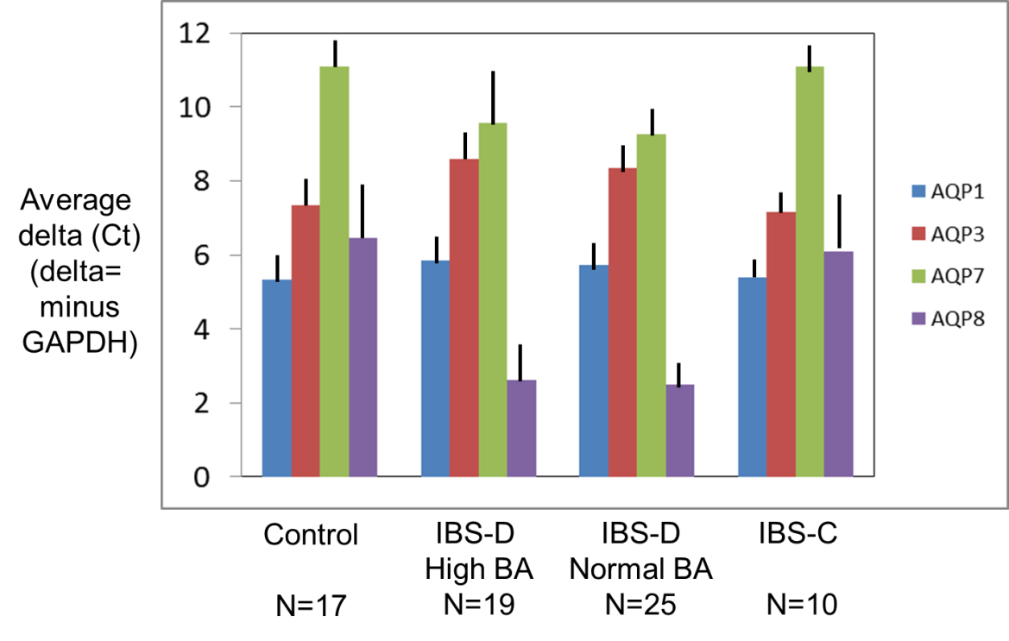

Estimate of concentration of sodium cholate in rat study demonstrating increased AQP7 and 8 expressions

Adult rats eat approximately 15-30g of chow daily, and the average distended volume of the rat colon is 18.8mL [length 24cm (33), diameter 1cm]. Assuming the rats eat 20g of chow per day, the rat ileum reabsorbs 95% of the BAs, and the calculated sodium cholate intake is 2.45mmol per gram of chow (1%w/w) or an average of 49mmol/day, the concentration of sodium cholate could be estimated. Five percent of this load is assumed to reach the colon (2.45mmol) and is diluted in colonic fluid; unfortunately, there are no data on the volume of fluid delivered to the rat colon. Assuming it is equivalent to the colon’s volume (rounded to 20mL), the estimated concentration of sodium cholate (and, presumably, deoxycholate after 7-α dehydroxylation) in the colon is ~122mM/L. Based on average 48-hour fecal BAs in the BAD group of ~5300µmol (90th percentile) per 24 hours, and assuming it is diluted in ~1.5L fluid entering the colon per day in humans (34) and that ~75% of bile acids are absorbed by passive diffusion in the human and mammalian colon (35,36), the estimated BA concentration entering the colon through the ileocolonic junction is 14mM/L (3.5mM/L * 4). Thus, the rat studies may have exposed the colonic epithelium to an 8-fold higher cholate concentration compared to the total fecal BA load in the human colon of patients with BAD associated with IBS-D.

