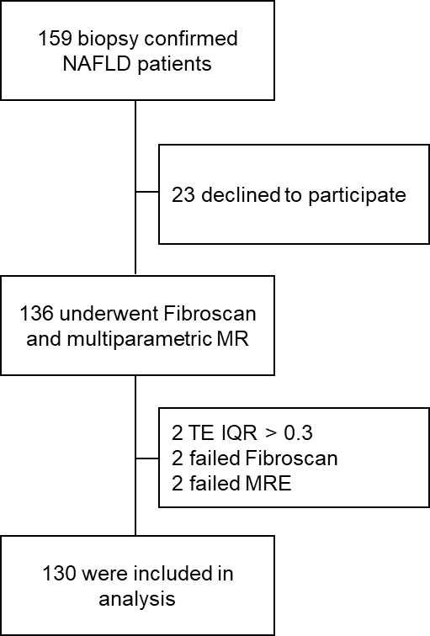

Supplementary Figure 1. Flow chart. NAFLD, nonalcoholic fatty liver disease; MR, magnetic resonance; TE, transient elastography.

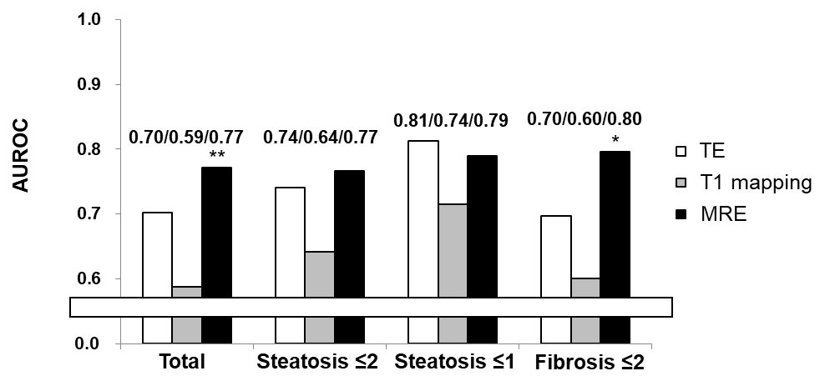
Supplementary Figure 2. Diagnostic accuracy of non-invasive test for diagnosing NASH. AUROC values were compared among T1 mapping and MRE for diagnosing NASH in all patients, patients with steatosis ≤ grade 2, and patients with steatosis ≤ grade 1. * AUROC is significantly different from T1 mapping (P < 0.05). ** AUROC is significantly different from T1 mapping (P < 0.01). AUROC, area under the receiver operating characteristic curve; TE, transient elastography; MRE, magnetic resonance elastography.

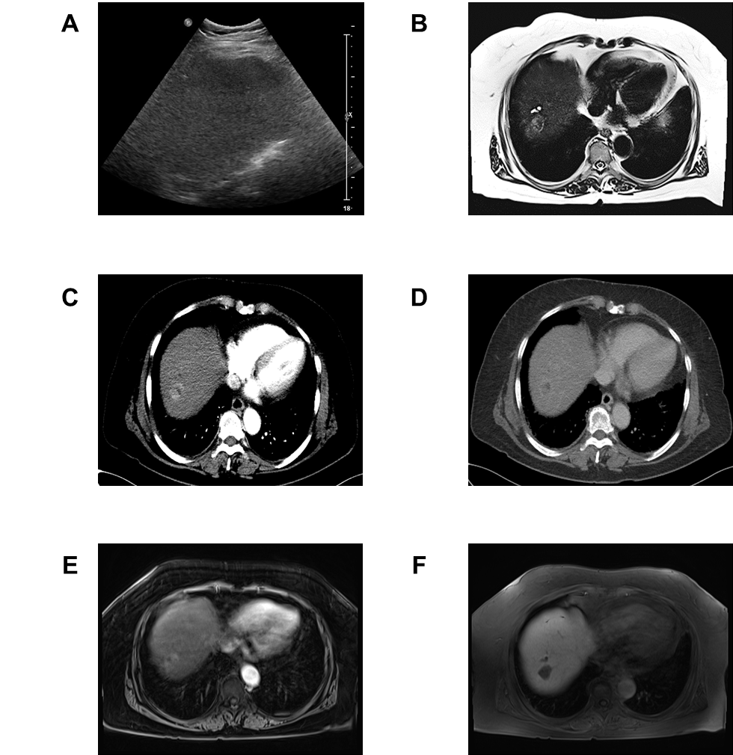

Supplementary Figure 3. Imaging finding in patients with HCC. (A) Sonography (B) T2-weighted MRI (C) and (D) LDCT, (E) and (F) MRI. MRI, magnetic resonance imaging; LDCT, liver dynamic computed tomography.

