Supplementary Figure 1: Word cloud representation of the feelings related to the first episode of hepatic encephalopathy in patients (left) and caregivers (right)

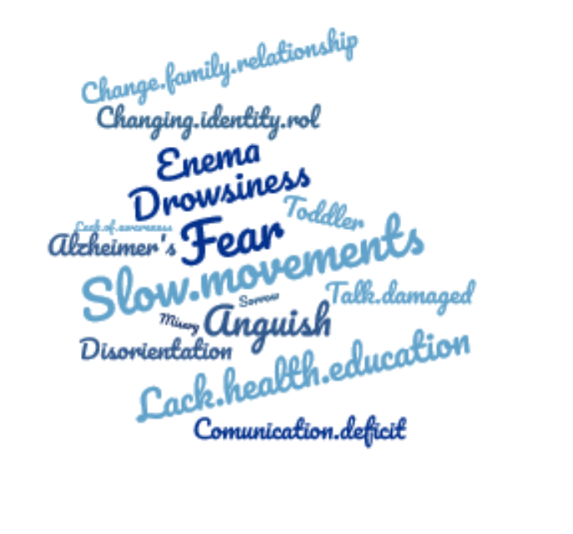
Patients Caregivers

