Reduced efficacy of norfloxacin prophylaxis to prevent spontaneous bacterial peritonitis over time: a systematic review and meta-analysis

Marcus M. Mücke¹, Victoria T. Mücke¹, Christiana Graf¹, Katharina M. Schwarzkopf¹, Philip G Ferstl¹, Javier Fernandez², Stefan Zeuzem¹, Jonel Trebicka¹, Christian M. Lange^{3*}, Eva Herrmann^{4*}

¹Department of Internal Medicine 1, University Hospital Frankfurt, Goethe University, Frankfurt am Main, Germany
²Liver Unit, Hospital Clinic Barcelona, Catalonia, Spain
³Department for Gastroenterology and Hepatology, University Hospital Essen and University of Duisburg-Essen, Essen, Germany
⁴Institute of Biostatistics and Mathematical Modeling, Goethe University, Frankfurt am Main, Germany

* both authors share senior authorship

APPENDIX

ADDITIONAL METHODS

Data Sources and Searches
The PubMed MEDLINE, Embase and Cochrane databases were searched for English language articles from database inception to 31 May 2019 using the following search algorithm: “(antibiotic prophylaxis OR norfloxacin prophylaxis OR ciprofloxacin prophylaxis OR quinolone prophylaxis OR rifaximin prophylaxis OR trimethoprim-sulfamethoxazole prophylaxis) AND (liver cirrhosis OR liver disease OR cirrhosis OR ascites).“ All full papers were considered, there was no limit to the study type. References from relevant reviews and original research articles were examined for other potential studies. Two researchers (MMM and VTM) independently performed all searches, title and abstract screening, study selection, data extraction and quality assessment, resolving discrepancies by discussion or by a third author (CML).
Study Selection and Inclusion/Exclusion Criteria
Inclusion and exclusion criteria were determined a priori. All trials of patients with established diagnosis of liver cirrhosis that assessed SBP occurrence/recurrence under antibiotic prophylaxis with the common antibiotic agents (i.e. ciprofloxacin, norfloxacin, rifaximin, trimethoprim sulfamethoxazole) were eligible for inclusion. As there were many retrospective/low quality papers reporting on SBP prophylaxis, only randomized controlled trials with the current accepted definition of SBP (ascitic fluid with > 250/ml polymorphonuclear cells) were included in the final analysis. We excluded studies involving pediatric patients (aged <18 years), trials that did not provide at least a subgroup analysis for patients on primary or secondary prophylaxis, studies with missing data on mean follow-up (for calculation of incidence rate ratios), trials assessing antibiotic therapy/prophylaxis in patients with gastrointestinal bleeding, as well as case reports or case series with less than 10 patients.

Data Extraction and Quality Assessment
All articles were screened in title and abstract to identify relevant studies for full-text analysis. All relevant data were extracted including study author, study type, publication date, country, study population characteristics (e.g. total number of participants, age, male/female ratio, number of patients with Child Pugh B and C cirrhosis, serum sodium, creatinine, bilirubin, albumin, and ascites protein).
For quality assessment, all included studies were evaluated with the National Institutes of Health quality assessment tools for “Controlled Intervention Studies” as outlined in the tool description (https://www.nhlbi.nih.gov/health-topics/study-quality-assessment-tools), studies were rated to be of “good“, “fair” or “poor” quality, respectively.

APPENDIX

Appendix Table 1. PRISMA checklist.
Section/topic | # | Checklist item | Reported on page #
TITLE
Title | 1 | Identify the report as a systematic review, meta-analysis, or both. | 1
ABSTRACT
Structured summary | 2 | Provide a structured summary including, as applicable: background; objectives; data sources; study eligibility criteria, participants, and interventions; study appraisal and synthesis methods; results; limitations; conclusions and implications of key findings; systematic review registration number. | 3
INTRODUCTION
Rationale | 3 | Describe the rationale for the review in the context of what is already known. | 4-5
Objectives | 4 | Provide an explicit statement of questions being addressed with reference to participants, interventions, comparisons, outcomes, and study design (PICOS). | 5
METHODS
Protocol and registration | 5 | Indicate if a review protocol exists, if and where it can be accessed (e.g., Web address), and, if available, provide registration information including registration number. | 6
Eligibility criteria | 6 | Specify study characteristics (e.g., PICOS, length of follow-up) and report characteristics (e.g., years considered, language, publication status) used as criteria for eligibility, giving rationale. | 6-7
Information sources | 7 | Describe all information sources (e.g., databases with dates of coverage, contact with study authors to identify additional studies) in the search and date last searched. | 6-7
Search | 8 | Present full electronic search strategy for at least one database, including any limits used, such that it could be repeated. | 6
Study selection | 9 | State the process for selecting studies (i.e., screening, eligibility, included in systematic review, and, if applicable, included in the meta-analysis). | 6-7
Data collection process | 10 | Describe method of data extraction from reports (e.g., piloted forms, independently, in duplicate) and any processes for obtaining and confirming data from investigators. | 7
Data items | 11 | List and define all variables for which data were sought (e.g., PICOS, funding sources) and any assumptions and simplifications made. | 7
Risk of bias in individual studies | 12 | Describe methods used for assessing risk of bias of individual studies (including specification of whether this was done at the study or outcome level), and how this information is to be used in any data synthesis. | 7
Summary measures | 13 | State the principal summary measures (e.g., risk ratio, difference in means). | 8
Synthesis of results | 14 | Describe the methods of handling data and combining results of studies, if done, including measures of consistency (e.g., I²) for each meta-analysis. | 8
Section/topic | # | Checklist item | Reported on page #
Risk of bias across studies | 15 | Specify any assessment of risk of bias that may affect the cumulative evidence (e.g., publication bias, selective reporting within studies). | 8
Additional analyses | 16 | Describe methods of additional analyses (e.g., sensitivity or subgroup analyses, meta-regression), if done, indicating which were pre-specified. | 8
RESULTS
Study selection | 17 | Give numbers of studies screened, assessed for eligibility, and included in the review, with reasons for exclusions at each stage, ideally with a flow diagram. | 9, Fig. 1
Study characteristics | 18 | For each study, present characteristics for which data were extracted (e.g., study size, PICOS, follow-up period) and provide the citations. | 9, SI T. 2,3,4
Risk of bias within studies | 19 | Present data on risk of bias of each study and, if available, any outcome level assessment (see item 12). | SI T. 5,6
Results of individual studies | 20 | For all outcomes considered (benefits or harms), present, for each study: (a) simple summary data for each intervention group (b) effect estimates and confidence intervals, ideally with a forest plot. | 10-13, Fig. 3,4, SI Fig 2,3,5
Synthesis of results | 21 | Present results of each meta-analysis done, including confidence intervals and measures of consistency. | 10-13, Fig. 3,4, SI Fig 2,3,5
Risk of bias across studies | 22 | Present results of any assessment of risk of bias across studies (see Item 15). | 10-13, SI Fig.1
Additional analysis | 23 | Give results of additional analyses, if done (e.g., sensitivity or subgroup analyses, meta-regression [see Item 16]). | 10-13
DISCUSSION
Summary of evidence | 24 | Summarize the main findings including the strength of evidence for each main outcome; consider their relevance to key groups (e.g., healthcare providers, users, and policy makers). | 14-17
Limitations | 25 | Discuss limitations at study and outcome level (e.g., risk of bias), and at review-level (e.g., incomplete retrieval of identified research, reporting bias). | 16-17
Conclusions | 26 | Provide a general interpretation of the results in the context of other evidence, and implications for future research. | 14-17
FUNDING
Funding | 27 | Describe sources of funding for the systematic review and other support (e.g., supply of data); role of funders for the systematic review. | 19

Appendix Table 2. Characteristics of prospective studies on SBP prophylaxis identified during search.
First Author | Year of publication | Center | Study design | Type of prophylaxis | Antibiotics for prophylaxis | Mean Length of Therapy & Follow-upª | Total Number of Patients | Etiology of cirrhosis (A/V/O) | Age^{b}  Male:Female | N=Child Pugh C  Child Pugh Score^{b} | Ascites Protein (g/dl)^{b}
Alvarez et al.¹ | 2005 | multiple | RCT | 1°/2° | Norfloxacin  TMP/SMX | 163 days | 57 | 20/?/37 | Aged 52±14 & 44±16  M:F 38:19 | 38/57  - | 0.96±0.6 & 1.37±0.8
Assem et al.² | 2016 | multiple | RCT | 1° | Norfloxacin  Rifaximin | 180 days | 239 | ?/222/17 | Aged 58±15 & 55±18  M:F 176:63 | -  10.1±1.6 &10.2±3.1 | 0.93±0.2 & 0.89±0.8
Bauer et al.³ | 2002 | multiple | RCT | 2° | Norfloxacin  Rufloxacin | 201 days | 79 | 24/51/4 | Aged 59±2 & 62±2  M:F 55:24 | 10.4±0.1 & 10.9±0.1 | NR
Danulescu et al.⁴ | 2013 | multiple | prospective | 1° | Rifaximin | NR | 46 | NR | NR | 46/46  - | NR
Elfert et al.⁵ | 2016 | single | RCT | 2° | Norfloxacin  Rifaximin | 180 days | 262 | NR | Aged 54±7 & 54±8  M:F 142:120 | 141/262  - | 1.0 (0.2-3.0) & 1.1 (0.3-3.1)
Fernandez et al.⁶ | 2007 | multiple | RCT | 1° | Norfloxacin | 210 days | 68 | 36/?/32 | Aged 62±11 & 61±12  M:F 45/23 | 9.9±1.5 & 10.4±1.5 | 0.9±0.4 & 0.9±0.3
Gines et al.⁷ | 1990 | multiple | RCT | 2° | Norfloxacin | 213 days | 80 | 46/?/34 | Aged 59±1 & 56±2  M:F 54/26 | NR | <1.0g/dl in 53/80
Grange et al.⁸ | 1998 | multiple | RCT | 1° | Norfloxacin | 128 days | 107 | 93/10/4 | Aged 55 (35-70) & 55 (31-70) M:F 68:38 | NR | 0.9±3 & 1.0±0.3
Lontos et al.⁹ | 2014 | multiple | RCT | 1°/2° | Norfloxacin  TMP/SMX | 208 days | 80 | 34/29/17 | Aged 53±10 & 56±10  M:F 60:20 | 66/80  - | <1.5g/dl in 69/80
Moreau et al.¹⁰ | 2018 | multiple | RCT | 1°^{c} | Norfloxacin | 83 days | 291 | 223/24/44 | Aged 55±9 & 56±10  M:F 202:89 | 291/291  11.4±1.1 & 11.2±1.0 | 1.3±0.7 & 1.2±0.7
Mostafa et al.¹¹ | 2015 | single | RCT | 2° | Norfloxacin  Rifaximin | NR | 70 | NR | Aged 57±4 & 56±5  M:F 36:4^{d} | -  10.7±1.8 und 10.3±1.1 | NR
Novella et al.¹² | 1997 | multiple | RCT | 1° | Norfloxacin | 329 days | 109 | 62/?/47 | Aged 62±1 & 58±2  M:F 77:32 | 56/109 | 1.0±0.2 & 0.9±0.1
Pande et al.¹³ | 2012 | single | RCT | 1°/2° | Norfloxacin | 180 days | 110 | 59/37/15 | Aged 48 (16-75)  M:F 97:13 | 11.0 (8-13) | NR
Sandhu et al.¹⁴ | 2005 | single | RCT | 1°/2° | Norfloxacin | 375 days | 94 | 50/?/34 | Aged 44±12 & 46±9  M:F NR | 26/94 | 1.0±0.2
Shamseya et al.¹⁵ | 2016 | single | prospective | 1°/2° | Norfloxacin  Rifaximin | 284 days | 86 | 0/86/0 | Aged 50±9 & 53±9  M:F 68:18 | 66/86  11.5±2.1 & 11.5±-2.0 | 0.9±0.6 & 1.0±0.5
Singh et al.¹⁶ | 1995 | multiple | RCT | 1°/2° | TMP/SMX | 90 days | 60 | 24/34/7e | Aged 46 & 44,SD NR  M:F NR | 10.0 & 10.5 (SD NR) | NR
Soriano et al.¹⁷ | 1991 | single | RCT | 1°^{f} | Norfloxacin | 27 days | 63 | 32/20/11 | Aged 62±11 & 61±11  M:F 38/25 | 33/63 | 0.7±0.3 & 0.7±0.3
Rolachon et al.¹⁸ | 1995 | multiple | RCT | 1°/2° | Ciprofloxacin | 156 days | 60 | 55/1/4 | Aged 55±9  M:F 32:28 | 24/60 | 1.0±0.3
Terg et al.¹⁹ | 2008 | multiple | RCT | 1° | Ciprofloxacin | 234 days | 100 | NR | Aged 56±10 & 58±11  M:F NR | 8.5±1.5 & 8.3±1.3 | 0.8±0.3 & 0.9±0.4
Yim et al.²⁰ | 2018 | multiple | RCT | 1°/2° | Norfloxacin  Ciprofloxacin | 360 days | 124 | 53/60/11 | Aged 55±10  M:F 90:34 | 9.6±1.8 | 0.5±0.2

Age, Child Pugh Score and Ascites protein count are given as mean/median (± standard deviation [SD]) or rage)
Definition of SBP in each study was according to current guidelines (with > 250/ml polymorphonuclear cells, PNC) with the following exceptions: Gines et al. defined SBP as PNC > 350/ml, Soriano et al. and Rolachon et al. defined SBP as either PNC > 250/ml and a positive blood culture.
ªof the quinolone group.
^{b}if two figures are given, the first is the quinolone group, the second the other group
^{c}Six patients with a history of spontaneous bacterial peritonitis.
^{d}only reported in 40 patients
^{e}more than one etiology for each patient documented
^{f}Four patients with a history of spontaneous bacterial peritonitis.
Abbreviation: A, alcoholic; V, viral; O, other; RCT, randomized controlled trial

Appendix Table 3. Detailed characteristics of randomized controlled trials included in this meta-analysis with respect to primary and secondary prophylaxis.

First Author | Study recruitment | Center | Antibiotics used | Total Number of Patients | Etiology of cirrhosis (A/V/O) | Age  Male:Female | N=Child Pugh C  Child Pugh Score | Bilirubin  (mg/dl) | Serum Albumin (g/dl)^{b} | Creatinine  (g/dl)^{b} | Ascites Protein (g/dl)^{b}
Primary Prophylaxis
Alvarez et al.¹ | 03/1999-03/2001 | multiple | Norfloxacin  TMP/SMX | 57 | 20/?/37 | Aged 52±14 & 44±16  M:F 38:19 | 38/57 (66.7) | 4.9±6.9 & 3.5 ±3.8 | 2.6±0.6 &2.6±0.6 | 1.8±0.4 & 1.0±0.4 | 1.0±0.6 & 1.4±0.8
Assem et al.² | 04/2014-05/2015 | multiple | Norfloxacin  Rifaximin | 239 | ?/222/17 | Aged 58±15 & 55±18  M:F 176:63 | 10.1±1.6 &10.2±3.1 | 2.8±1.1±2.8±0.7 | 2.6±0.9 & 2.7±0.4 | 1.6±0.4 & 1.5±0.7 | 0.9±0.2 & 0.9±0.8
Fernandez et al.⁶ | 09/2000-07/2004 | multiple | Norfloxacin | 68 | 36/?/32 | Aged 62±11 & 61±12  M:F 45/23 | 9.9±1.5 & 10.4±1.5 | 3.5±2.3 & 4.4±4.6 | 2.8±0.6 & 2.6±0.5 | 1.2±0.4 & 1.2±0.3 | 0.9±0.4 & 0.9±0.3
Grange et al.⁸ | 02/1991-02/1993 | multiple | Norfloxacin | 107 | 93/10/4 | Aged 55 (35-70) & 55 (31-70) M:F 68:38 | NR | 5.2±0.8 & 3.9±0.6 | 3.3±3.4 & 3.0±0.5 | 0.8±.2 & 0.9±0.1 | 0.9±0.3 & 1.0±0.3
Lontos et al.⁹ | 04/2005-07/2005 | multiple | Norfloxacin  TMP/SMX | 80 | 34/29/17 | Aged 53±10 & 54±8  M:F 60:20 | 66/80 (82.5) | NR | NR | NR | NR
Moreau et al.¹⁰ | 04/2010-11/2014 | multiple | Norfloxacin | 291 | 223/24/44 | Aged 55±9 & 56±10  M:F 202:89 | 291/291 (100)*  11.4±1.1 & 11.2±1.0 | 7.7±6.7 & 8.0±7.1 | 2.5±0.5 & 2.5±0.5 | 0.9±0.4 & 0.8±0.04 | 1.3±0.7 & 1.2±0.7
Novella et al.¹² | 01/1992-09/1993 | multiple | Norfloxacin | 109 | 62/?/47 | Aged 62±1 & 58±2  M:F 77:32 | 56/109 (51.4) | 3.8±0.3 & 4.1±0.3 | 2.7±0.1 & 2.7±0.1 | 1.1±0.1 & 0.9±0.1 | 1.0±0.2 & 0.9±0.1
Pande et al.¹³ | 04/2005-08/2007 | single | Norfloxacin | 110 | 59/37/15 | Aged 43 (16-72) & 46 (16-75) M:F 97:13 | 11.0 & 11.0 | 3.2 & 3.4 | 2.5 & 2.6 | 0.9 & 0.8 | NR
Terg et al.¹⁹ | 03/2000-12/2005 | multiple | Ciprofloxacin | 100 | NR | Aged 56±10 & 58±11  M:F NR | 8.5±1.5 & 8.3±1.3 | 2.9±4.6 &2.7±3.2 | 2.7±0.5 & 2.9±0.6 | 0.9±0.3 & 0.9±0.2 | 0.8±0.3 & 0.9±0.4
Yim et al.²⁰ | 11/2011-07/2014 | multiple | Norfloxacin  Ciprofloxacin | 124 | 53/60/11 | Aged 56±10 & 55±10  M:F 90:34 | 9.6±1.9 & 9.7±1.7 | 3.4±3.4 & 3.9±5.8 | 2.9±0.4 & 2.9+0.4 | 0.9±0.3 & 1.0±0.3 | 1.0±0.3 & 1.1±0.3
Secondary Prophylaxis
Alvarez et al.¹ | 03/1999-03/2001 | multiple | Norfloxacin  TMP/SMX | 57 | 20/?/37 | Aged 52±14 & 44±16  M:F 38:19 | 38/57 (66.7) | 4.9±6.9 & 3.5 ±3.8 | 2.6±0.6 &2.6±0.6 | 1.8±0.4 & 1.0±0.4 | 1.0±0.6 & 1.4±0.8
Bauer et al.³ | NR | multiple | Norfloxacin  Rufloxacin | 79 | 24/51/4 | Aged 59±2 & 62±2  M:F 55:24 | 10.4±0.1 & 10.9±0.1 | 2.9±0.3 & 3.0±0.4 | 2.7±0.9 & 2.8±0.9 | 1.1±0.1 & 1.0±0.1 | NR
Elfert et al.⁵ | 01/2014-12/2014 | single | Norfloxacin  Rifaximin | 262 | NR | Aged 54±7 & 54±8  M:F 142:120 | 141/262 (53.4) | 2.5±0.6 & 2.7±0.9 | 2.8±0.5 & 2.7±0.3 | 1.3±0.2 & 1.3±0.2 | 1.0 & 1.1
Lontos et al.⁹ | 04/2005-07/2005 | multiple | Norfloxacin  TMP/SMX | 80 | 34/29/17 | Aged 53±10 & 54±8  M:F 60:20 | 66/80 (82.5) | NR | NR | NR | NR
Pande et al.¹³ | 04/2005-08/2007 | single | Norfloxacin | 110 | 59/37/15 | Aged 48 (16-75)  M:F 97:13 | 11.0 (8-13) | 3.2 & 3.4 | 2.5 & 2.6 | 0.9 & 0.8 | NR
Yim et al.²⁰ | 11/2011-07/2014 | multiple | Norfloxacin  Ciprofloxacin | 124 | 53/60/11 | Aged 56±10 & 55±10  M:F 90:34 | 9.6±1.9 & 9.7±1.7 | 3.4±3.4 & 3.9±5.8 | 2.9±0.4 & 2.9+0.4 | 0.9±0.3 & 1.0±0.3 | 1.0±0.3 & 1.1±0.3
Age, Child Pugh Score and Ascites protein count are given as mean/median (± standard deviation [SD]) or rage), if two figures are given, the first is the quinolone group, the second the other group/placebo
*only patients with low ascites protein (n=102) were used in analysis
Abbreviation: A, alcoholic; V, viral; O, other; RCT, randomized controlled trial

Appendix Table 4. Relevant exclusion criteria explicitly listed in the included studies. Exclusion criteria such as intolerance/hypersensitivity against the antibiotic used, active infections, pregnancy or prior SBP - in case of studies including only patients for primary prophylaxis – and highly individual criteria (i.e. uncontrolled diabetes mellitus) are not listed here.
First Author | Year of Study | <14d before antibiotic therapy | HCC | Other malignancy |  | <14d/current gastrointestinal hemorrhage |  | Severe Liver impairment | Severe renal Impairment | HIV
Alvarez et al.¹ | 2005 | X | X | X | X |  | - |  | - | -
Assem et al.² | 2016 | X | X | - | Xª |  | - |  | X | X
Bauer et al.³ | 2002 | - | X | - | - |  | X |  | X | -
Elfert et al.⁵ | 2016 | X^{b} | X | X | X |  | X |  | - | X
Fernandez et al.⁶ | 2007 | X^{c} | X | - | - |  | - |  | X | X
Grange et al.⁸ | 1998 | - | X | X | X |  | - |  | - | -
Lontos et al.⁹ | 2014 | X | X | - | - |  | - |  | X | X
Moreau et al.¹⁰ | 2018 | - | X^{d} | - | - |  | - |  | - | -
Novella et al.¹² | 1997 | - | X | X | - |  | X |  | - | -
Pande et al.¹³ | 2012 | - | X | X | - |  | X |  | X | -
Terg et al.¹⁹ | 2008 | Xe | X | X | X |  | X |  | X | -
Yim et al.²⁰ | 2018 | X | X | X | - |  | X |  | - | X

ªno gastrointestinal bleeding <30 days
^{b}no antibiotic therapy < 42days
^{c}no prior quinolone therapy
^{d}beyond Milan
^{e}no antibiotic therapy < 30days

Appendix Table 5. Quality assessment for randomized-controlled trials included in the quantitative synthesis.
Study | Q1 | Q2 | Q3 | Q4 | Q5 | Q6 | Q7 | Q8 | Q9 | Q10 | Q11 | Q12 | Q13 | Q14 | Study Quality
Alvarez et al.¹ | Y | NR | NR | NR | NR | N | NR | NR | Y | Y | Y | NR | Y | Y | Fair
Assem et al.² | Y | Y | Y | N | NR | Y | Y | Y | Y | Y | Y | Y | Y | Y | Good
Bauer et al.³ | Y | Y | Y | N | NR | Y | Y | Y | Y | Y | Y | Y | Y | Y | Good
Elfert et al.⁵ | Y | Y | Y | N | NR | Y | Y | Y | Y | Y | Y | Y | Y | Y | Good
Fernandez et al.⁶ | Y | Y | Y | Y | Y | Y | Y | Y | Y | Y | Y | Y | Y | Y | Good
Grange et al.⁸ | Y | NR | NR | Y | Y | Y | Y | Y | Y | Y | Y | Y | Y | Y | Good
Lontos et al.⁹ | Y | NR | NR | Y | Y | Y | N | Y | Y | Y | Y | Y | Y | Y | Fair
Moreau et al.¹⁰ | Y | Y | Y | Y | Y | Y | Y | Y | Y | Y | Y | N | Y | Y | Good
Novella et al.¹² | Y | Y | Y | Y | Y | Y | Y | Y | Y | Y | Y | NR | Y | Y | Good
Pande et al.¹³ | Y | Y | Y | Y | Y | Y | Y | Y | Y | Y | Y | Y | Y | Y | Good
Terg et al.¹⁹ | Y | Y | Y | Y | Y | Y | Y | Y | Y | Y | Y | Y | Y | Y | Good
Yim et al.²⁰ | Y | Y | Y | N | NR | Y | Y | Y | Y | Y | Y | Y | Y | Y | Good

Appendix Table 6. Questions for quality assessment of randomized-controlled trials according to the National Institute of Health quality assessment tool for “controlled interventions studies”.

Q1. Was the study described as randomized, a randomized trial, a randomized clinical trial, or an RCT?
Q2. Was the method of randomization adequate (i.e., use of randomly generated assignment)?
Q3. Was the treatment allocation concealed (so that assignments could not be predicted)?
Q4. Were study participants and providers blinded to treatment group assignment?
Q5. Were the people assessing the outcomes blinded to the participants' group assignments?
Q6. Were the groups similar at baseline on important characteristics that could affect outcomes (e.g., demographics, risk factors, co-morbid conditions)?
Q7. Was the overall drop-out rate from the study at endpoint 20% or lower of the number allocated to treatment?
Q8. Was the differential drop-out rate (between treatment groups) at endpoint 15 percentage points or lower?
Q9. Was there high adherence to the intervention protocols for each treatment group?
Q10. Were other interventions avoided or similar in the groups (e.g., similar background treatments)?
Q11. Were outcomes assessed using valid and reliable measures, implemented consistently across all study participants?
Q12. Did the authors report that the sample size was sufficiently large to be able to detect a difference in the main outcome between groups with at least 80% power?
Q13. Were outcomes reported or subgroups analyzed prespecified (i.e., identified before analyses were conducted)?
Q14. Were all randomized participants analyzed in the group to which they were originally assigned, i.e., did they use an intention-to-treat analysis?

Appendix Table 7. Meta-regression analysis for different prophylactic antibiotic regiments and time effect with respect to norfloxacin.

Investigated Variable | Incidence Rate Ratio  (95% confidence interval) | p-Value
Ciprofloxacin | 1.75 (1.06-2.91) | 0.1229
Norfloxacin+Probiotics | 0.84 (0.43-1.64) | 0.6685
Placebo/intrahosp. Norfloxacin | 5.31 (3.74-7.54) | 0.0011
Rifaximin | 0.55 (0.28-1.08) | 0.1909
Trimethoprim/sulfamethoxazole | 1.57 (0.98-2.53) | 0.1689
Effect over time | 0.92 (0.88-0.95) | 0.0192

Appendix Table 8. SBP incidence and incidence rates per patient year of all three included randomized placebo-controlled trials.

Study | Year of publication | Norfloxacin group |  |  | Placebo group |  |  | Risk ratio: norfloxacin vs. placebo
 |  | n=SBP | n (total) | SBP per patient year | n=SBP | n (total) | SBP per patient year
Grange | 1998 | 0 | 35 | 0 | 5 | 54 | 0.249 | 0
Fernandez | 2007 | 2 | 35 | 0.099 | 10 | 33 | 0.929 | 0.107
Moreau | 2018 | 2 | 46 | 0.191 | 4 | 56 | 0.362 | 2.540

Supplementary Figure 1: Funnel plot of estimated incidence rate ratios (IRRs) of norfloxacin with the respective treatments for primary prophylaxis for spontaneous bacterial peritonitis from direct and indirect comparisons on a logarithmically scaled horizontal axis.
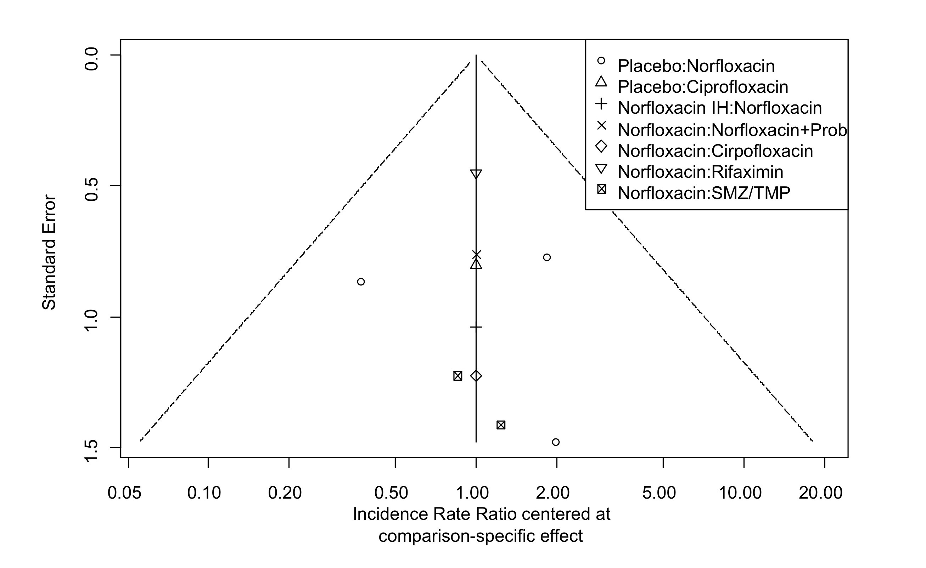

Supplementary Figure 2. Meta-Regression plot of time effects on the incidences rates per 10000 person days for spontaneous bacterial peritonitis in primary prophylaxis, separately for norfloxacin vs. placebo and intrahospital norfloxacin vs. placebo including all studies with norfloxacin^{1, 2, 6, 8-10, 12, 13}, norfloxacin intrahospital¹² and placebo^{6, 8, 10, 19} with direct and indirect comparison. Red points and line correspond to the observations and time trend (p=0.056) in the norfloxacin groups vs. the placebo and grey points and line correspond to the observations and time trend (p=0.679) in the placebo and norfloxacin intra-hospital group. The size of the circles corresponds to 1/standard error.
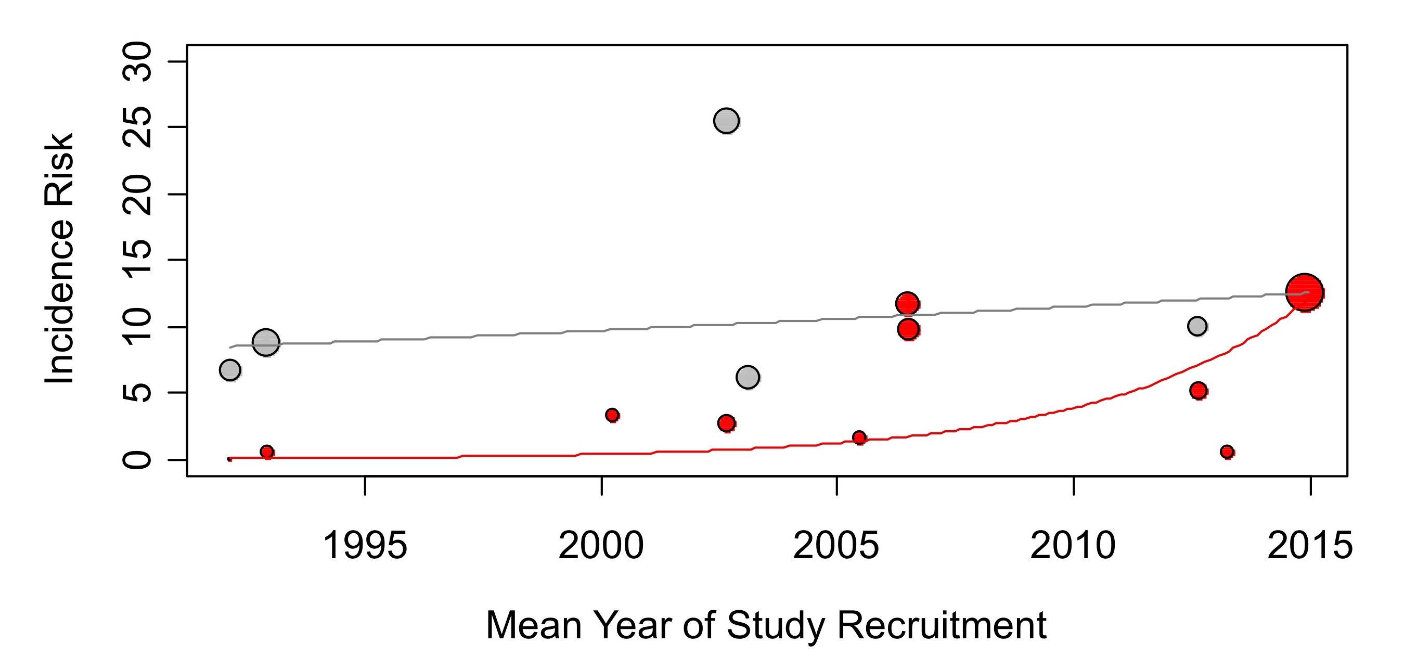

Supplementary Figure 3. Meta-regression analysis illustrating time trends of different co-factors analysed in this meta-analysis. Mean bilirubin (A) and mean albumin (B) slightly but significantly decreased over time, while all other cofactors (mean age, Child-Pugh score, creatinine and ascites protein) did not reveal significant time trends.
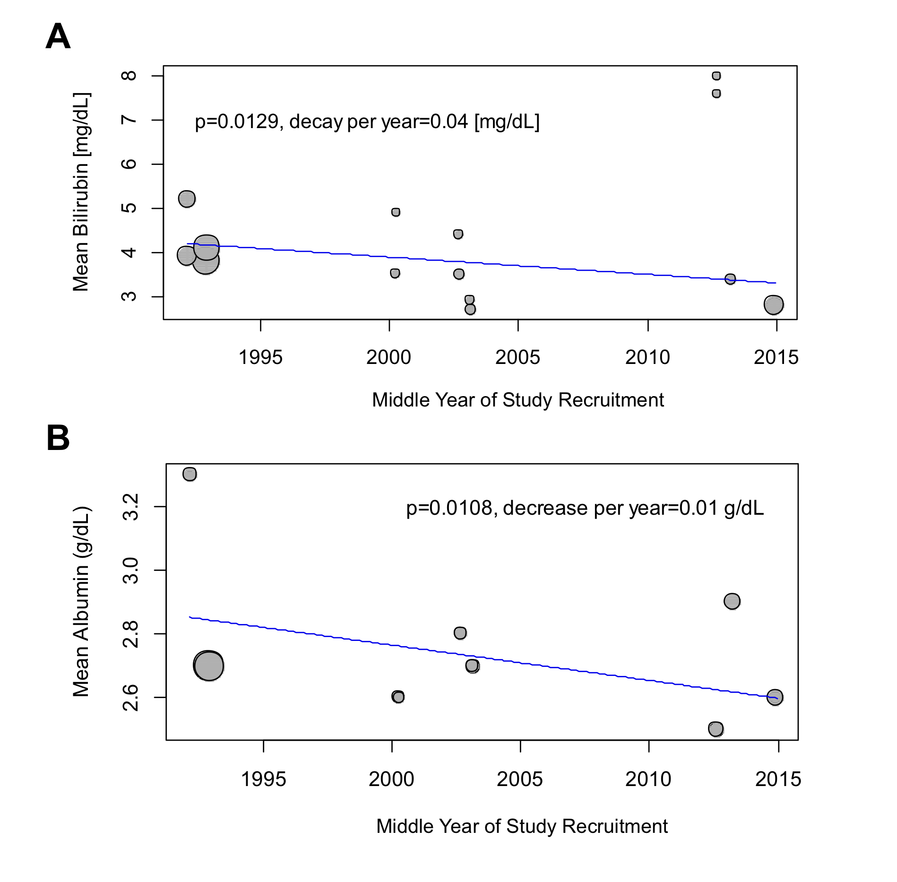

Supplementary Figure 4. Network graphs of secondary outcome analyses for secondary endpoints for primary prophylaxis. Panels A shows the network graph for the secondary endpoint death and Panels B shows the network graph for the secondary endpoint other infections.

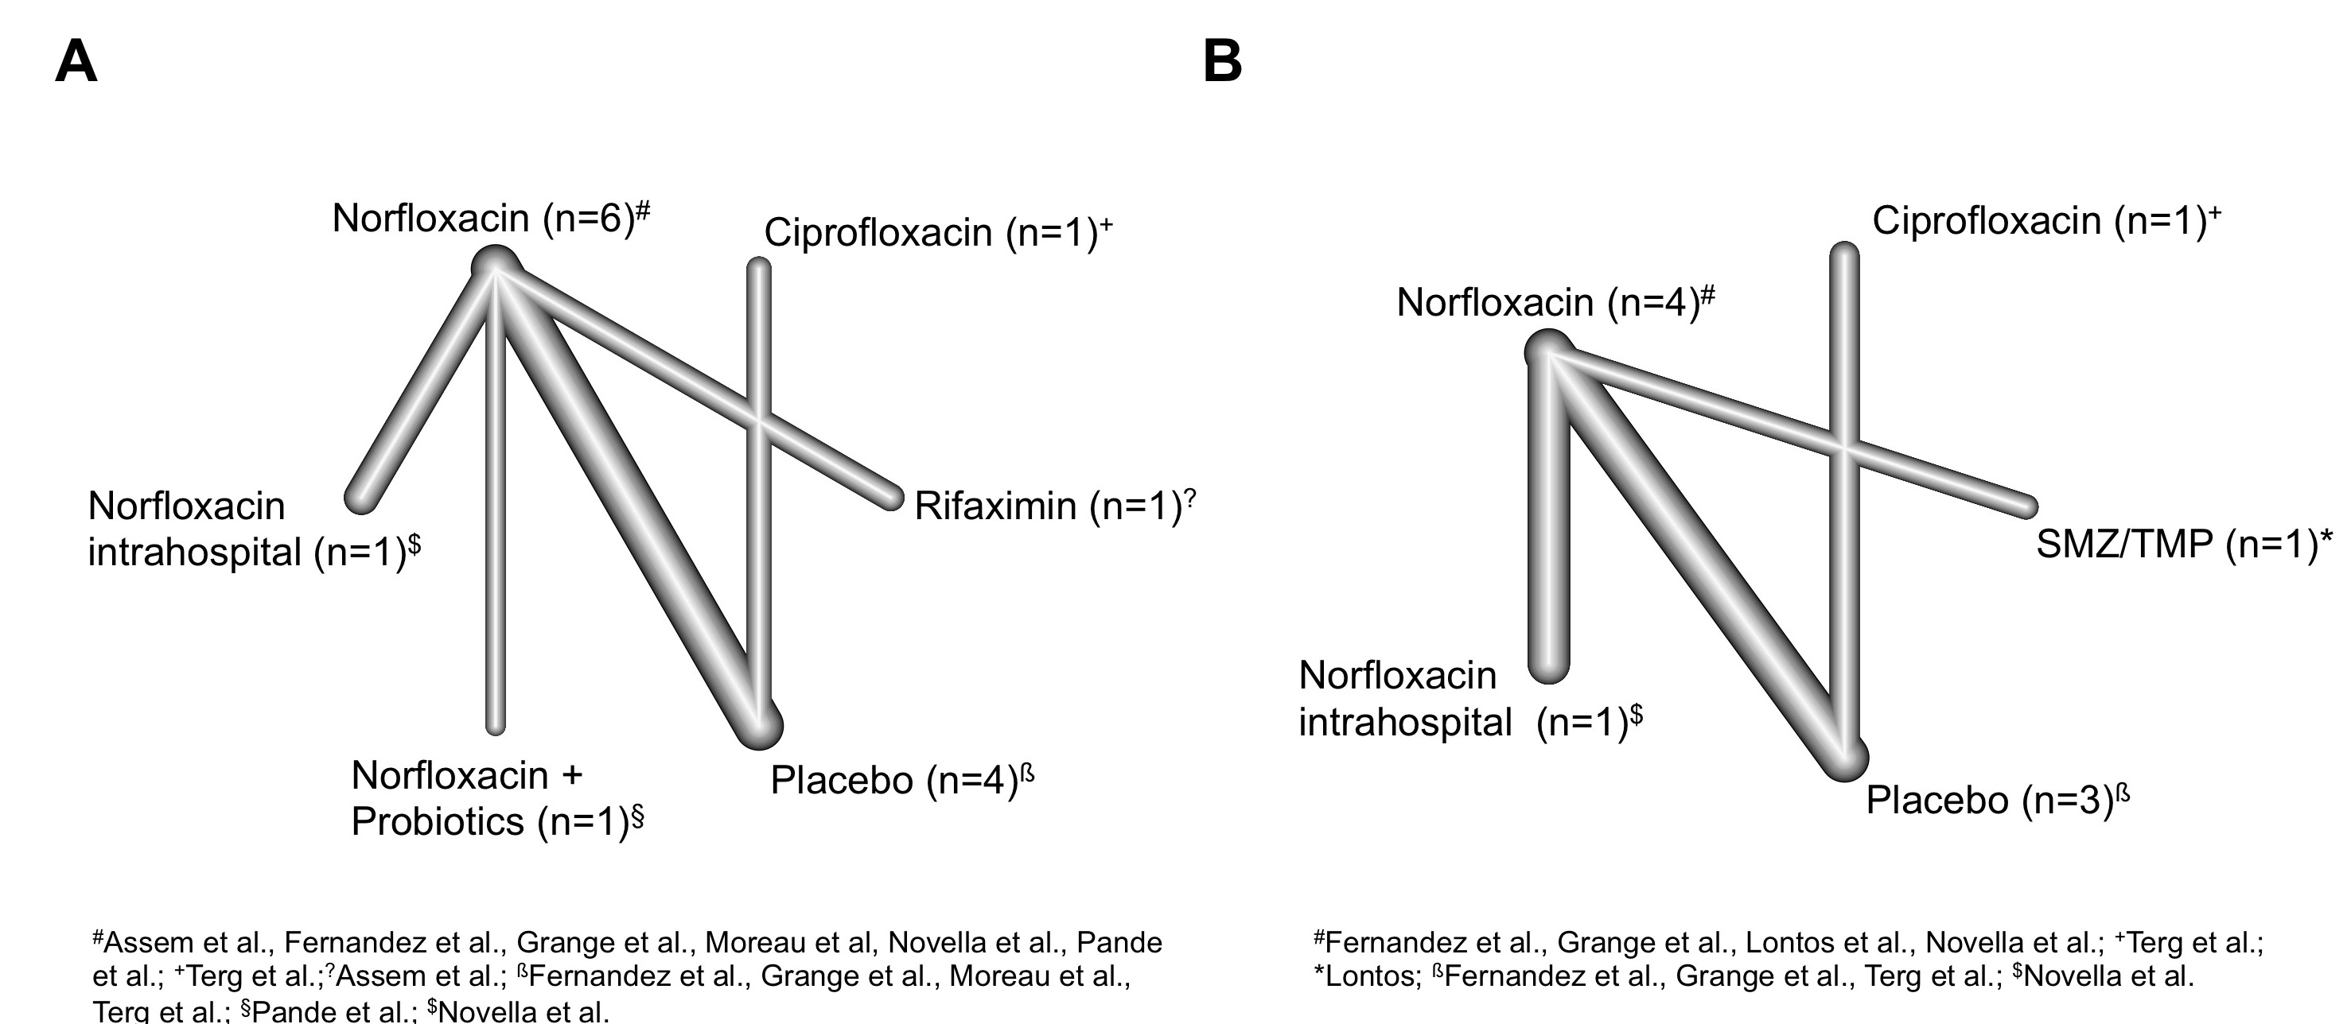

Supplementary Figure 5. Forest plot illustrating estimated incidence risk ratios (IRRs) of norfloxacin with the respective treatments for death from direct and indirect comparisons on a logarithmically scaled horizontal axis. Panels A and B show the results of network meta-analysis for primary prophylaxis, Panels C and D (pairwise meta-analysis) show the results for subgroup meta-analysis for secondary prophylaxis. Panels A and C show the results for the secondary endpoint death and Panels B and D show the results for the secondary endpoint other infections.
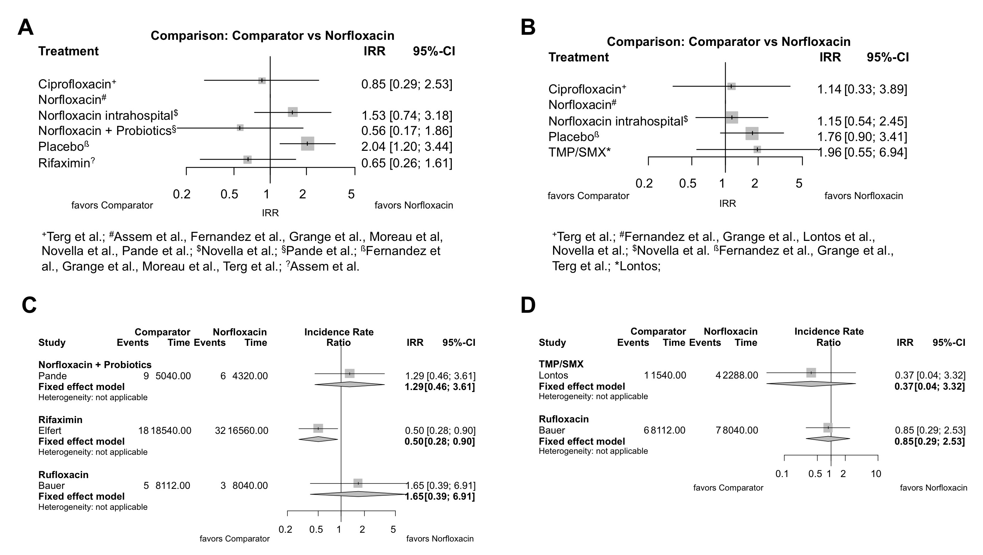

Supplementary Figure 6. Meta-Regression plot of incidence rate ratios (IRRs) for mortality in primary quinolone based prophylaxis. Red points indicate the studies with estimated IRRs of placebo/norfloxacin intra-hospital vs. norfloxacin, open circles indicate the studies with norfloxacin plus probiotics vs. norfloxacin and placebo vs. ciprofloxacin. The size of the circles corresponds to 1/standard error. Red lines show the trend in increasing IRRs for placebo vs. norfloxacin from direct and indirect comparisons in a network meta -egression model.
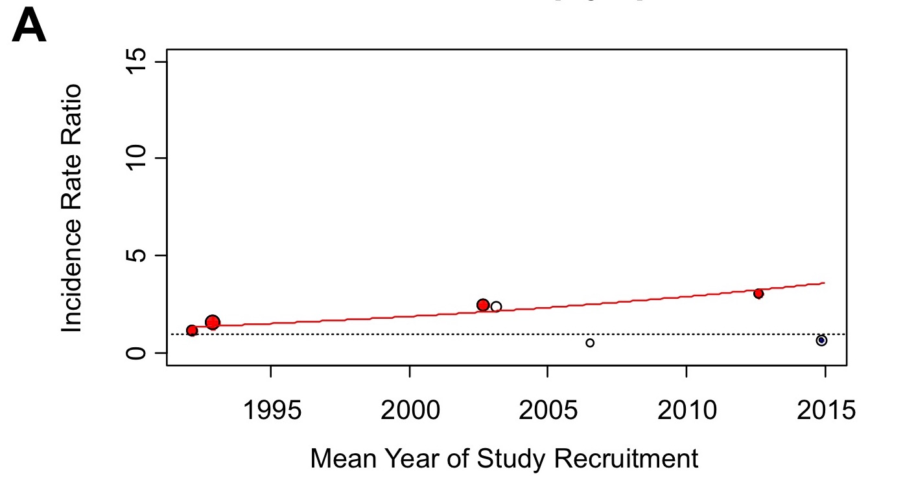
Included studies: all studies with primary prophylaxis (see also Figure 1) except: Alvarez et al., Lontos et al., Yim et al.

REFERENCES

1. Alvarez RF, Mattos AA, Correa EB, Cotrim HP, Nascimento TV. Trimethoprim-sulfamethoxazole versus norfloxacin in the prophylaxis of spontaneous bacterial peritonitis in cirrhosis. Arq Gastroenterol 2005;42(4):256-62.
2. Assem M, Elsabaawy M, Abdelrashed M, et al. Efficacy and safety of alternating norfloxacin and rifaximin as primary prophylaxis for spontaneous bacterial peritonitis in cirrhotic ascites: a prospective randomized open-label comparative multicenter study. Hepatol Int 2016;10(2):377-85.
3. Bauer TM, Follo A, Navasa M, et al. Daily norfloxacin is more effective than weekly rufloxacin in prevention of spontaneous bacterial peritonitis recurrence. Dig Dis Sci 2002;47(6):1356-61.
4. Danulescu RM, Ciobica A, Stanciu C, Trifan A. The role of rifaximine in the prevention of the spontaneous bacterial peritonitis. Rev Med Chir Soc Med Nat Iasi 2013;117(2):315-20.
5. Elfert A, Abo Ali L, Soliman S, Ibrahim S, Abd-Elsalam S. Randomized-controlled trial of rifaximin versus norfloxacin for secondary prophylaxis of spontaneous bacterial peritonitis. Eur J Gastroenterol Hepatol 2016;28(12):1450-1454.
6. Fernandez J, Navasa M, Planas R, et al. Primary prophylaxis of spontaneous bacterial peritonitis delays hepatorenal syndrome and improves survival in cirrhosis. Gastroenterology 2007;133(3):818-24.
7. Gines P, Rimola A, Planas R, et al. Norfloxacin prevents spontaneous bacterial peritonitis recurrence in cirrhosis: results of a double-blind, placebo-controlled trial. Hepatology 1990;12(4 Pt 1):716-24.
8. Grange JD, Roulot D, Pelletier G, et al. Norfloxacin primary prophylaxis of bacterial infections in cirrhotic patients with ascites: a double-blind randomized trial. J Hepatol 1998;29(3):430-6.
9. Lontos S, Shelton E, Angus PW, et al. A randomized controlled study of trimethoprim-sulfamethoxazole versus norfloxacin for the prevention of infection in cirrhotic patients. J Dig Dis 2014;15(5):260-7.
10. Moreau R, Elkrief L, Bureau C, et al. Effects of Long-term Norfloxacin Therapy in Patients with Advanced Cirrhosis. Gastroenterology 2018.
11. Mostafa T, Badra G, Abdallah M. The efficacy and the immunomodulatory effect of rifaximin in prophylaxis of spontaneous bacterial peritonitis in cirrhotic Egyptian patients. Turk J Gastroenterol 2015;26(2):163-9.
12. Novella M, Sola R, Soriano G, et al. Continuous versus inpatient prophylaxis of the first episode of spontaneous bacterial peritonitis with norfloxacin. Hepatology 1997;25(3):532-6.
13. Pande C, Kumar A, Sarin SK. Addition of probiotics to norfloxacin does not improve efficacy in the prevention of spontaneous bacterial peritonitis: a double-blind placebo-controlled randomized-controlled trial. Eur J Gastroenterol Hepatol 2012;24(7):831-9.
14. Sandhu BS, Gupta R, Sharma J, Singh J, Murthy NS, Sarin SK. Norfloxacin and cisapride combination decreases the incidence of spontaneous bacterial peritonitis in cirrhotic ascites. J Gastroenterol Hepatol 2005;20(4):599-605.
15. Shamseya MM, Madkour MA. Rifaximin: A reasonable alternative for norfloxacin in the prevention of spontaneous bacterial peritonitis in patients with HCV-related liver cirrhosis. Alexandria Journal of Medicine 2016;52:219-226.
16. Singh N, Gayowski T, Yu VL, Wagener MM. Trimethoprim-sulfamethoxazole for the prevention of spontaneous bacterial peritonitis in cirrhosis: a randomized trial. Ann Intern Med 1995;122(8):595-8.
17. Soriano G, Guarner C, Teixido M, et al. Selective intestinal decontamination prevents spontaneous bacterial peritonitis. Gastroenterology 1991;100(2):477-81.
18. Rolachon A, Cordier L, Bacq Y, et al. Ciprofloxacin and long-term prevention of spontaneous bacterial peritonitis: results of a prospective controlled trial. Hepatology 1995;22(4 Pt 1):1171-4.
19. Terg R, Fassio E, Guevara M, et al. Ciprofloxacin in primary prophylaxis of spontaneous bacterial peritonitis: a randomized, placebo-controlled study. J Hepatol 2008;48(5):774-9.
20. Yim HJ, Suh SJ, Jung YK, et al. Daily Norfloxacin vs. Weekly Ciprofloxacin to Prevent Spontaneous Bacterial Peritonitis: A Randomized Controlled Trial. Am J Gastroenterol 2018;113(8):1167-1176.

