Supplementary Figures

Supplementary Figure 1 – Reoperation trends: joinpoint regression results. A: IBD reoperation trends per 100,000 inhabitants; B: IBD reoperation trends per 100,000 patients; C: UC reoperation trends per 100,000 inhabitants; D: CD reoperation trends per 100,000 inhabitants. CD: Crohn’s disease; IBD: Inflammatory bowel disease; UC: Ulcerative colitis.

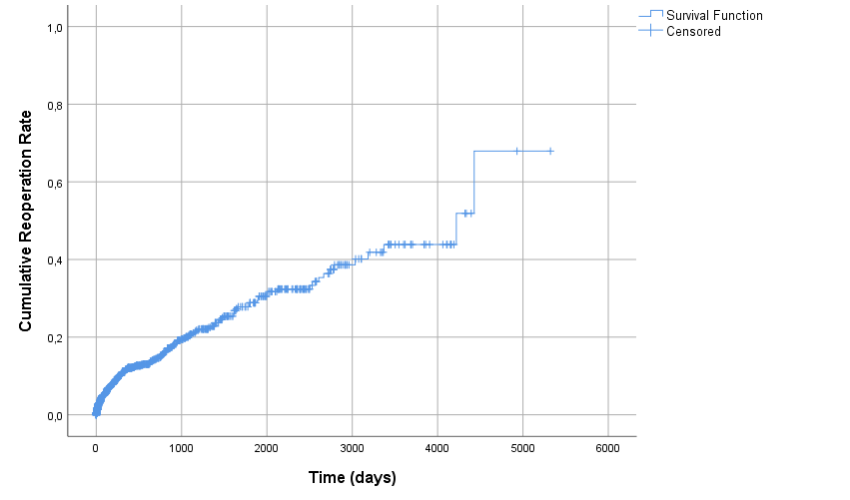

Supplementary Figure 2 – Kaplan-Meier curve demonstrating the cumulative reoperation rate of CD patients. CD: Crohn’s disease

