Controlled delivery of bile acids to the colon
Christoph Steiger, Nhi V. Phan, Haoying Sun, Hen-Wei Huang, Kaitlyn Hess, Aaron Lopes, Joshua Korzenik, Robert Langer, Giovanni Traverso

^{Supplementary Materials}

Supplementary Table 1: Parameters used for pharmacokinetic simulation – see Supplementary Figure 2 for model.
Colon volume and kinetics
Part | Volume [mL] | Half transit time [hour] | Rate [hour⁻¹]  (=K) | Reference
Caecum (CAE) | 50 | 1 | 0.693 | ¹ ^{2, 3} ⁴
Ascending colon (AC) | 203 | 2.5 | 0.277
Transverse colon (TC) | 198 | 2.9 | 0.239
Descending colon (DC) | 160 | 5.5 | 0.126
Sigmoid (SC) | 250 | 12.1 | 0.057
Absorption of CDC
Assuming first order kinetics and an average bile acid concentration of 2 mM: K_{abs(0-5)} = 0.323 h⁻¹ |  |  |  | ⁵
Distribution of CDC
V_{d} = 25.81 L / Kg (1600 L / 62 Kg) Estimated pig weight: 40 Kg |  |  |  | ⁶
Elimination of CDC
Cl = 25 L / h k_{eli} = 0.024218939 h⁻¹ |  |  |  | ⁶
Release kinetics
Assuming first order kinetics
Capsule: t_{1/2} = 0.5 h (k_{(CAE, AC, TC, DC, SC)} = 1.386 h⁻¹); Bilayer pill: t_{1/2} = 2.5 hours (k_{(CAE, AC, TC, DC, SC} = 0.277 h⁻¹); Single layer pill: t_{1/2} = 6 hours (k_{(CAE, AC, TC, DC, SC)} = 0.115 h⁻¹)

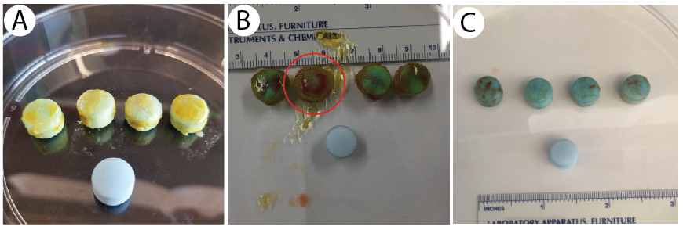
Supplementary Figure 1: Bilayered delivery systems retrieved from the small intestine of a terminal pig model. One (red circle) out of twelve delivery systems disintegrated after 4 hours.

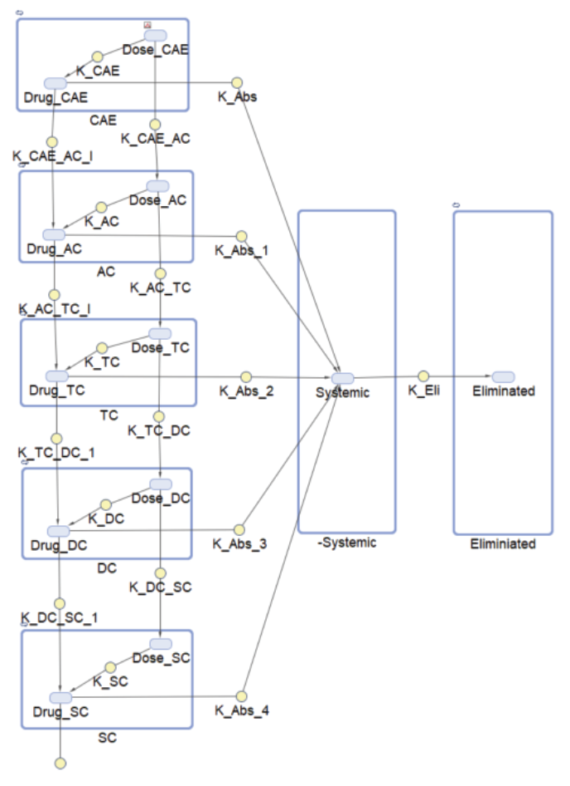
Supplementary Figure 2: Five compartment pharmacokinetic model

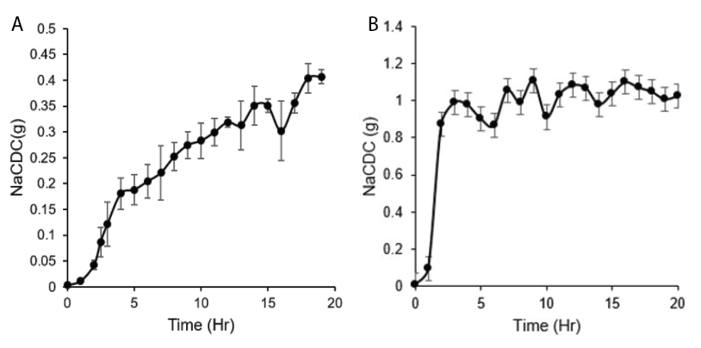
Supplementary Figure 3: In vitro release pattern of A) the bilayer delivery system and B) the capsule formulation. Release was assessed in Simulated Intestinal Fluid (0.2M, SIF, pH 6.8) for one hour before the pH was adjusted to pH 7.4 (0.2M NaOH, 100 rpm).

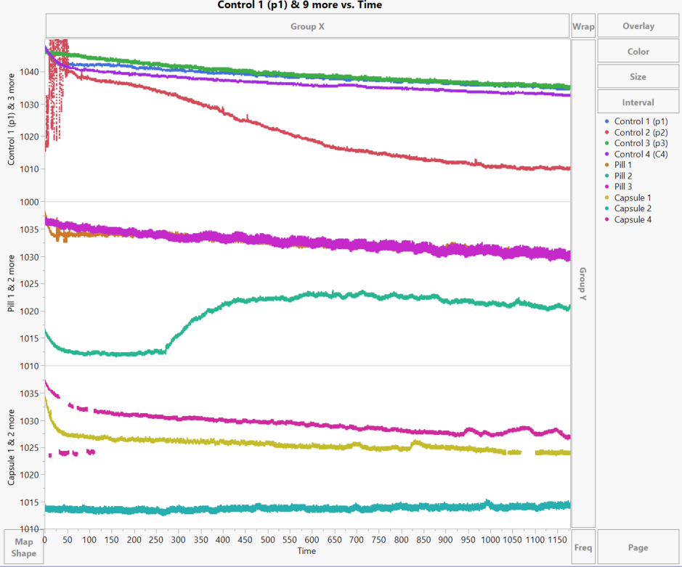
Supplementary Figure 4: Primary data of rectal manometry patterns following rectal placement of uncoated release systems. Control 2 was excluded as pressure significantly dropped presumably due to a leakage. Pressure reading are depicted in mbar / time is depicted in seconds.

1. Pritchard, S.E. et al. Fasting and postprandial volumes of the undisturbed colon: normal values and changes in diarrhea-predominant irritable bowel syndrome measured using serial MRI. Neurogastroenterol Motil 26, 124-130 (2014).
2. Schiller, C. et al. Intestinal fluid volumes and transit of dosage forms as assessed by magnetic resonance imaging. Alimentary Pharmacology & Therapeutics 22, 971-979 (2005).
3. Tomita, R. et al. Study of segmental colonic transit time in healthy men. Hepatogastroenterology 58, 1519-1522 (2011).
4. Rao, A.S. et al. Chenodeoxycholate in females with irritable bowel syndrome-constipation: a pharmacodynamic and pharmacogenetic analysis. Gastroenterology 139, 1549-1558.e1541 (2010).
5. Mekhjian, H.S., Phillips, S.F. & Hofmann, A.F. Colonic absorption of unconjugated bile acids: perfusion studies in man. Dig Dis Sci 24, 545-550 (1979).
6. Crosignani, A. et al. Clinical pharmacokinetics of therapeutic bile acids. Clinical pharmacokinetics 30, 333-358 (1996).

