Liver Cancer-Specific Serine Protease Inhibitor Kazal is a Potentially Novel Biomarker for the Early Detection of Hepatocellular Carcinoma

Felix Lu¹, Pir Ahmad Shah², Abhishek Rao¹, Cynthia Gifford-Hollingsworth³, Anne Chen¹, Gary Trey², Mina Soryal¹, Arslan Talat², Aysha Aslam² Bilal Nasir², Saad Choudhry², Rizwan Ishtiaq², Hanna Sanoff ⁴, Lanla F Conteh⁵, Anne Noonan⁵, Ke-Qin Hu⁶, Carl Schmidt⁷, Min Fu ⁸, Jesse Civan ⁹, Gary Xiao³, Daryl T.-Y. Lau², Xuanyong Lu^{1*}

Supplement 1. Sensitivity of LC-SPIK test Kit

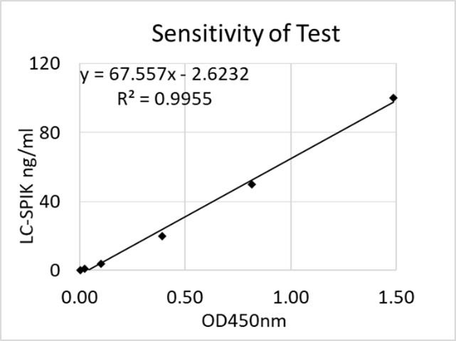
The sensitivity of LC-SPIK test kit was determined by detection of purified LC-SPIK purified from S2-3 cell line, which constantly expressed LC-SPIK²⁰. A set of calibrators with different concentrations of LC-SPIK at 100ng/ml, 50ng/ml, 20ng/ml, 4ng/ml, 1ng/ml and 0ng/ml respectively was constructed as a standard curve. The limit of detection is 0.5ng/ml and the linear range for quantification was between 1ng/ml to 100ng/m (Suppl. 1). The R² value of the linear regression equation ranged from 0.95-0.99 over 10 unique tests, showing excellent linearity of standard calibrator sets. Reliability was analyzed on more than 10 tests using IBM software SPSS 24 (IBM, Armonk, NY), and the Cronbach’s Alpha value for test was 0.993, suggesting excellent consistency.
Suppl. 1: LC-SPIK standard curve and sensitivity.

Supplement 2. Statistical analysis of LC-SPIK in HCC patients, segmented by age, sex, race and LI-RADS score.
Cohort | Sub-group | # of Case | Mean of LC-SPIK (ng/ml) | P-value for comparisons between subset group*
Age | <35** | 1 | 73.0 | 0.353
 | 36-50 | 14 | 42.0
 | 51-60 | 58 | 39.4
 | >60 | 91 | 48.7
Sex | Female | 34 | 48.9 | 0.324
 | Male | 130 | 44.0
Race | White | 68 | 37.0 | 0.590
 | Asian | 19 | 45.6
 | Black | 71 | 53.0
 | Other | 6 | 37.4
LI-RADS | LR-4 | 43 | 42.9 | 0.420
 | LR-5 | 110 | 47.4
The mean difference is significant at the 0.05 level
*The group sizes are unequal. Means for groups in homogeneous subsets are displayed. The harmonic mean of the group sizes is used.
** Only 1 case in Age < 35 group, it is excluded in analysis.

Supplement 3. Pan-SPIK did not interfere LC-SPIK test in blood

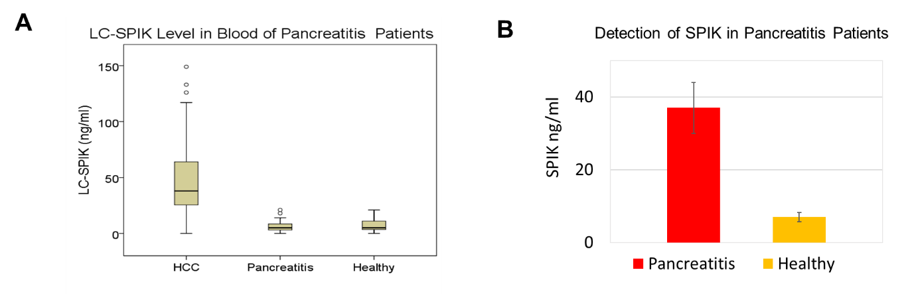
Because LC-SPIK is a liver-cancer specific isoform of SPIK, which contains an additional fragment in its N-terminus, we evaluated if pancreatic SPIK (pan-SPIK) interferes with our LC-SPIK test. 3A. LC-SPIK was evaluated in 24 pancreatitis patients, who are expected to have elevated levels of pancreatic SPIK. We show that LC-SPIK levels in these patients (7.39ng/ml) were similar to those of healthy patients (7.38ng/ml, P > 0.99), and significantly lower than in HCC patients of our primary study (45.2ng/ml, P < 0.001). 3B. We confirm the elevated serum levels of pan-SPIK in our pancreatitis patients and observe that it does not interfere with our LC-SPIK kit.
Suppl. 3. A. The Mean level of LC-SPIK in 164 HCC patients, 24 pancreatitis patients and 79 healthy people. B. The mean level of pan-SPIK in 24 pancreatitis patients and 79 healthy people

Supplement 4. Serum LC-SPIK levels in validation study

Validation study | # of cases | Mean | 95% Confidence Interval for Mean |  | Minimum | Maximum
 |  |  | Lower Bound | Upper Bound
All HCC | 45 | 34.2 | 27.4 | 41.1 | 5 | 107
Early HCC | 30 | 26.6 | 21.2 | 32.0 | 5 | 64
Cirrhosis | 57 | 19.3 | 16.9 | 21.6 | 3 | 45

Supplement 5. Statistical analysis of serum LC-SPIK and AFP levels in Validation study
Validation Study (All HCC with cirrhosis control) |  |  |  |  | 95% Confidence Interval
Sample | Sensitivity | specificity | Cut-Off ng/ml | ROC Area | Lower Bound | Upper Bound
LC-SPIK | 80% | 72% | 21.5 | 0.74 | 0.64 | 0.85
AFP | 51% | 81% | 20.0 | 0.73 | 0.64 | 0.83
Validation Study (Early HCC with cirrhosis control) |  |  |  |  | 95% Confidence Interval
Sample | Sensitivity | specificity | Cut-Off ng/ml | ROC Area | Lower Bound | Upper Bound
LC-SPIK | 70% | 72% | 21.5 | 0.66 | 0.52 | 0.79
AFP | 41% | 81% | 20.0 | 0.71 | 0.59 | 0.83

Supplement 6. The distribution of LC-SPIK false-positive cases (LC-SPIK > 21.5ng/ml) in each control group.

Cohorts | # of cases | LC-SPIK > 21.5ng/ml, Positive
 |  | Number | %
Total | 324 | 25 | 7.7%
Cirrhosis | 125 | 23 | 18.4%
HCV | 37 | 2 | 5.4%
HBV | 83 | 0 | 0.0%
Healthy | 79 | 0 | 0.0%

