**SUPPLEMENTARY INFORMATION**

**Suppl. Fig. 1.** ACF samples flow-chart. NOTE: ACF, aberrant crypt foci; HR-CE, high-resolution chromoendoscopy; HR-NBI, high-resolution narrow band imaging and VPI, vascular pattern intensity.

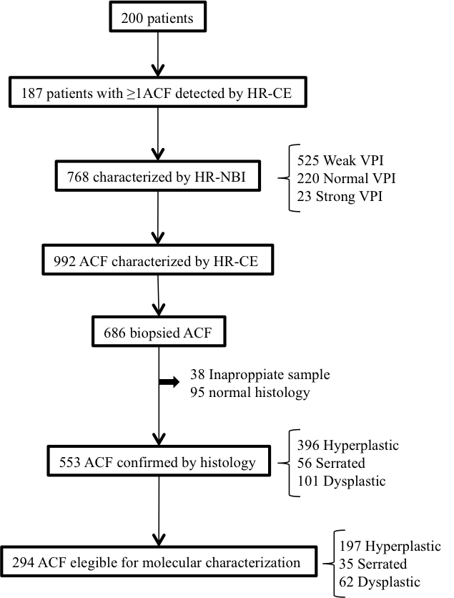

**Suppl. Fig. 2.** MGMT methylation levels in ACF samples. (A) MGMT methylation levels of normal mucosa vs ACF samples. (B) MGMT methylation of ACF with KRAS mutated or *wild-type*. (C) MGMT methylation levels in ACF from control and case patient



**Suppl. Table 1.** Indications for colonoscopy in relation with patient group

|  |  |  |
| --- | --- | --- |
| **Indication for colonoscopy** | **Control**  **N=100** | **Case**  **N=100** |
| **Abdominal pain** | **16** | **5** |
| **Anaemia** | **12** | **8** |
| **Change in bowel habit** | **22** | **8** |
| **Rectal bleeding** | **14** | **7** |
| **Abnormal imaging or laboratory findings** | **4** | **2** |
| **Polyps surveillance** | **0** | **20** |
| **Post-colorectal cancer resection surveillance** | **0** | **22** |
| **Colorectal cancer screening:**   * **Positive immunologic faecal blood test (population screening program)**   **- Family history** | **6**  **26** | **18**  **10** |