Supplementary Materials
Integrating Tumour Sequencing into Clinical Practice for Patients with Mismatch Repair-Deficient Lynch Syndrome Spectrum Cancers
Katherine Dixon¹, Mary-Jill Asrat², Angela C. Bedard², Kristin Binnington², Katie Compton², Carol Cremin², Nili Heidary², Zoe Lohn², Niki Lovick², Mary McCullum², Allison Mindlin², Melanie O'Loughlin², Tammy Petersen², Cheryl Portigal-Todd², Jenna Scott², Genevieve St-Martin², Jennifer Thompson², Ruth Turnbull², Sze Wing Mung², Quan Hong², Marjorie Bezeau^{2,3}, Ian Bosdet⁴, Tracy Tucker⁴, Sean Young⁴, Stephen Yip⁴, Gudrun Aubertin⁵, Katherine A. Blood^{1,2,5}, Jennifer Nuk^{1,2}*, Sophie Sun^{2,6}*, Kasmintan A. Schrader^{1,2}*
¹ Department of Medical Genetics, University of British Columbia, Vancouver, BC, Canada
² Hereditary Cancer Program, BC Cancer, Vancouver, BC, Canada
³ Laboratory of Transdisciplinary Research in Genetics, Medicines and Social Sciences, Sherbrooke's University Hospital Center of Clinical Research, QC, Canada
⁴ Department of Pathology and Laboratory Medicine, University of British Columbia, Vancouver, BC, Canada
⁵ Department of Medical Genetics, Vancouver Island Health Authority, Victoria, BC, Canada
⁶ Department of Medical Oncology, BC Cancer, Vancouver, BC, Canada
*Co-senior authors

Supplementary Table 1. Demographic and clinical information by predicted cancer origin
 | Lynch syndrome | MLH1 promoter hypermethylation | Double somatic variants | Unexplained
Total (n = 84) | 23 (27) | 22 (26) | 19 (23) | 20 (24)
Age at earliest diagnosis, median (range) | 52 (32-86) | 71.5 (33-87) | 53 (28-77) | 55.5 (24-84)
PREMM₅ score, median (range) | 7.7 (0.9-50) | 2.2 (0.9-14) | 2.9 (1.7-9.0) | 2.9 (1.2-50)
Clinical testing criteria
Amsterdam I/II (n = 7) | 5 | 1 | 0 | 1
Revised Bethesda (n = 59) | 16 | 15 | 13 | 15
None (n = 18) | 2 | 6 | 6 | 4
PREMM₅ score
< 2.5% (n = 35) | 5 | 15 | 8 | 7
≥ 2.5% (n = 49) | 18 | 7 | 11 | 13
Colorectal (n = 52) | 14 (27) | 19 (37) | 10 (19) | 9 (17)
Sex
Female | 5 | 7 | 3 | 6
Male | 9 | 12 | 7 | 3
TNM stage
I/II | 0 | 1 | 2 | 4
III/IV | 12 | 17 | 4 | 4
Unknown | 2 | 1 | 4 | 1
Histologic grade
Well- to moderately-differentiated | 11 | 7 | 5 | 6
Poorly- to undifferentiated | 2 | 12 | 5 | 2
Unknown | 1 | 0 | 0 | 1
Endometrial (n = 26) | 7 (27) | 2 (8) | 9 (35) | 8 (31)
TNM stage
I/II | 4 | 2 | 6 | 6
III/IV | 1 | 0 | 2 | 1
Unknown | 2 | 0 | 1 | 1
FIGO grade
1 | 6 | 1 | 4 | 4
2-3 | 1 | 1 | 5 | 3
Unknown | 0 | 0 | 0 | 1
Other (n = 6) | 2 (33) | 1 (17) | 0 | 3 (50)

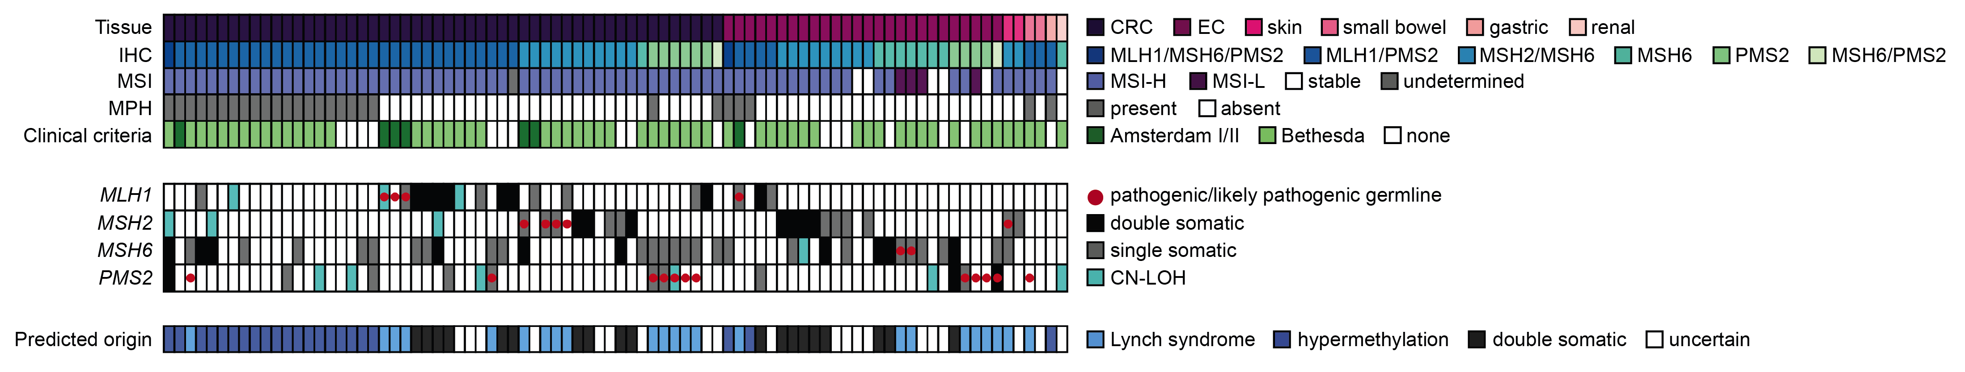
Supplementary Figure 1. Tumour characteristics and sequencing results for dMMR Lynch syndrome spectrum cancers identified by IHC-based tumour screening. CN-LOH, copy neutral loss of heterozygosity; CRC, colorectal cancer; EC, endometrial cancer; IHC, immunohistochemistry; MPH, MLH1 promoter hypermethylation; MSI, microsatellite instability; MSI-H, MSI high; MSI-L, MSI low.

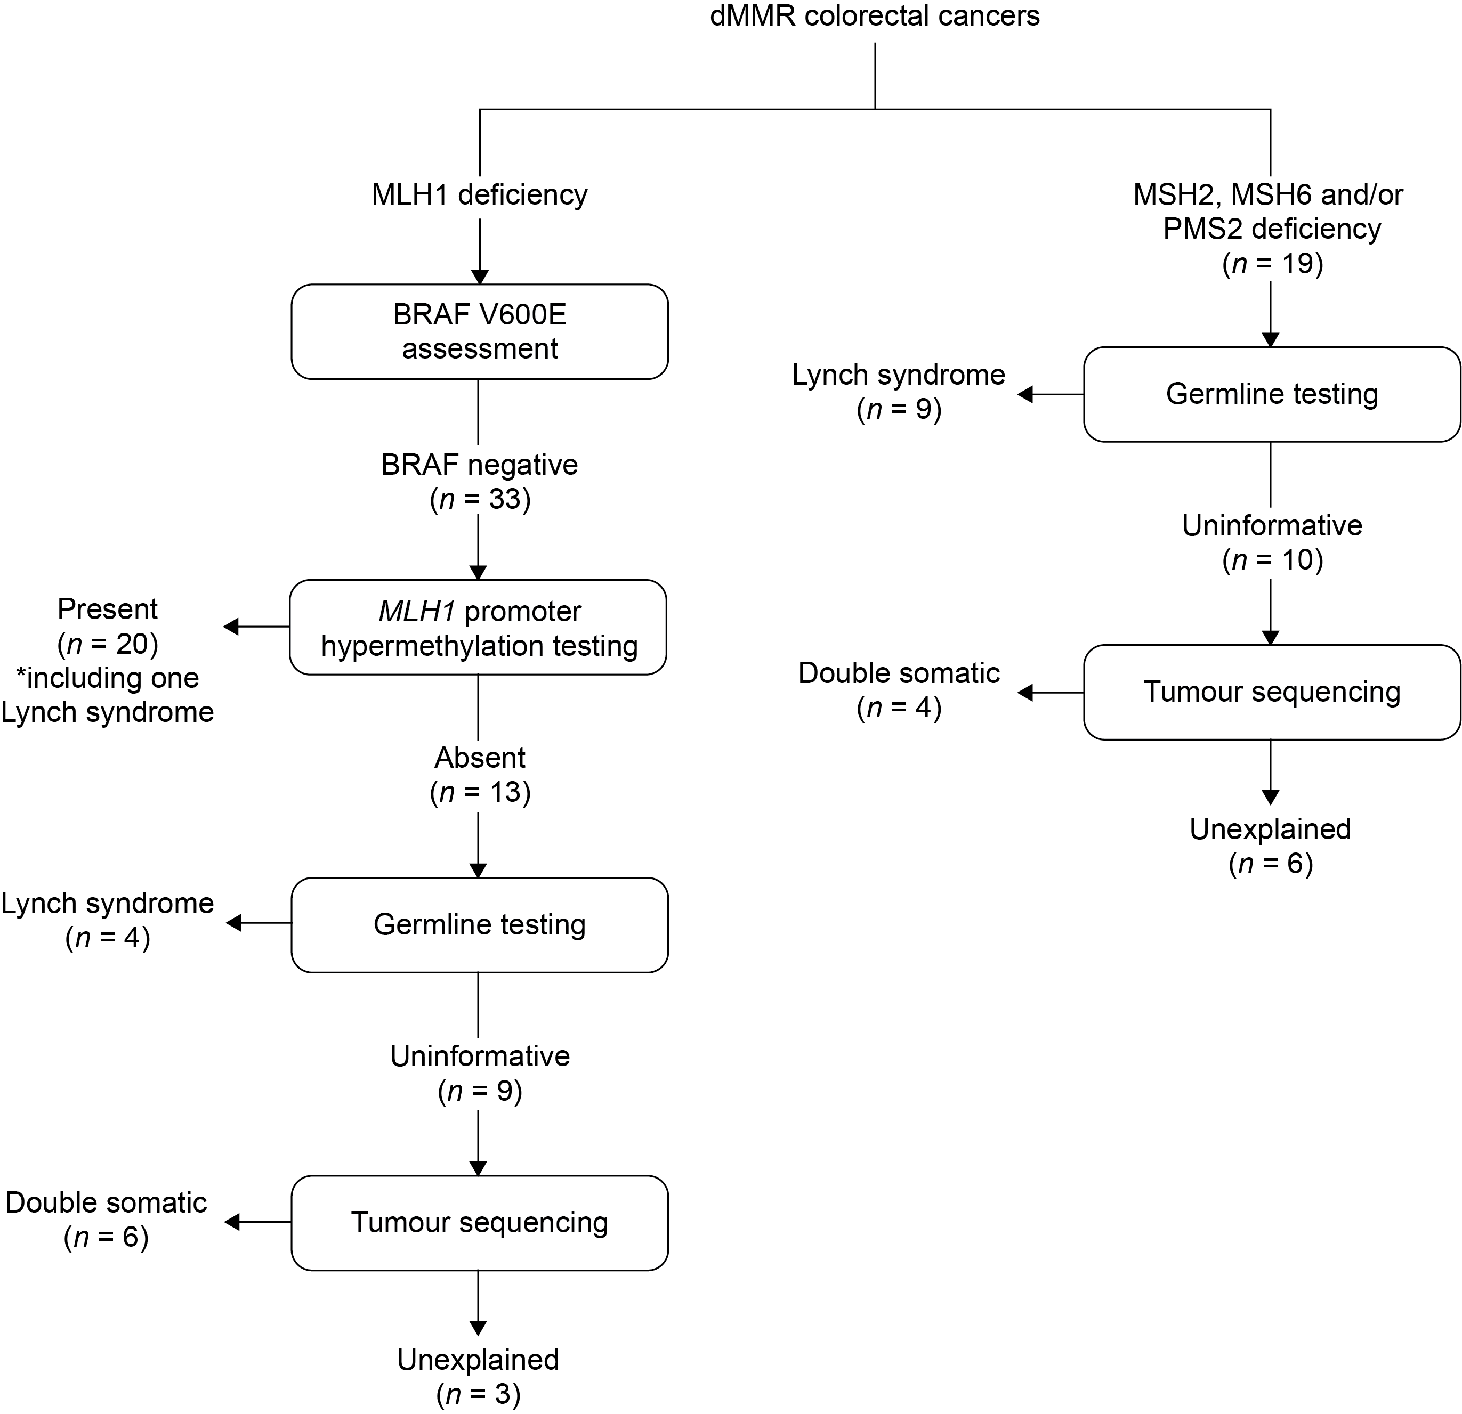
Supplementary Figure 2. Updated testing algorithm for dMMR colorectal cancers and distribution of cases based on data from the current study. *One PMS2 carrier would not have been referred for germline genetic testing based on MLH1 promoter methylation in their tumour and absence of a personal or family history suggestive of Lynch syndrome.

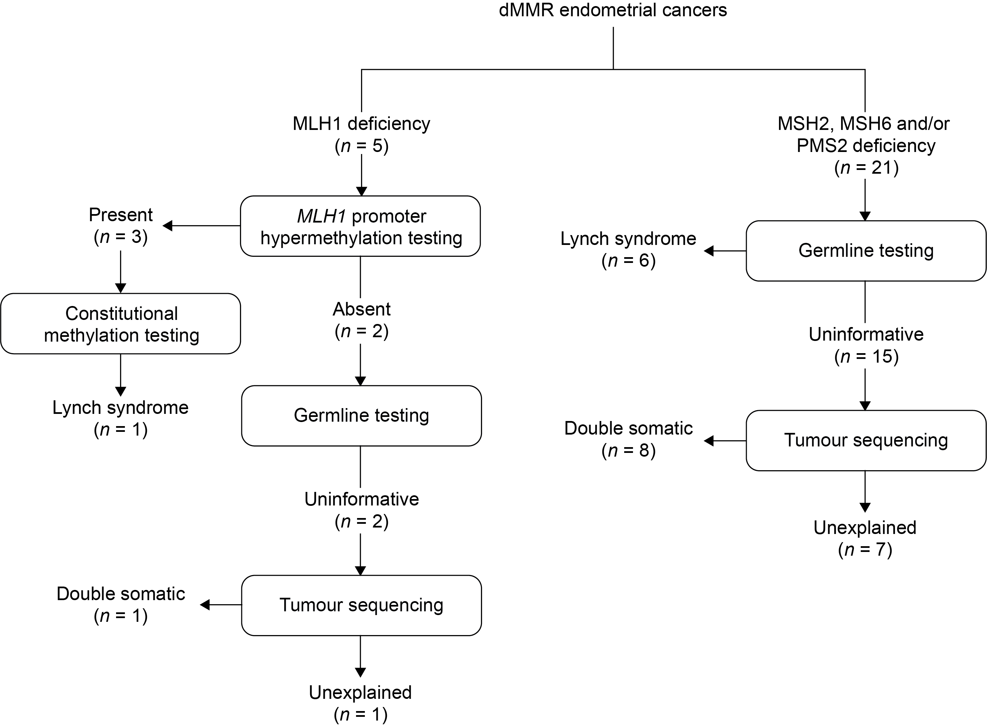
Supplementary Figure 3. Updated testing algorithm for dMMR endometrial cancers and distribution of cases based on data from the current study. *Testing for constitutional methylation was indicated for one individual meeting Amsterdam I criteria.

