Supplementary data
S-text-1:
CT image parameters
All CT imaging examinations were performed with a 64-MDCT (SOMATOM, Definition AS⁺, Siemens, Forchheim, Germany) in our institution before the surgical treatment. The parameters involved in CT scan were as follows: 120 kVp; effective 180 mAs; rotation time, 0.5 s; detector collimation, 32×1.2 mm; ﬁeld of view, 350 × 350 mm; matrix, 512 × 512; and reconstruction section thickness, 1.5 mm. Filter back projection was employed as reconstruction algorithm. Non-ionic contrast medium (Ultravist; 300 mgI/mL, Bayer Schering Pharma AG, Berlin, Germany) was injected into the antecubital vein with a dose of 60-110 ml (1.5 ml per kilogram of body weight) and an average injection rate of 3.0 ml s^{–1} through a venous indwelling needle (20 or 22 gauge). By using the automated scan-triggering software (Care-Bolus; Siemens Medical Systems, Iselin, NJ), the arterial phase and portal venous phase scan started automatically with a 15 s delay and a 50 s delay after the attenuation value of abdominal aorta reached 100 HU, respectively. After the acquisition of the portal venous phase images, delayed phase images were acquired with a delay of 180 s.

Table S1:

Table S1
Histopathologic results of nodes resected at surgery
Packages | No. of nodes resected | No. of positive nodes | Percentage of Positive nodes, %
Station 1 | 1625 | 245 | 15.1
Station 2 | 574 | 113 | 19.7
Station 3 | 6254 | 1359 | 21.7
Station 4 | 3607 | 661 | 18.3
Station 5 | 757 | 117 | 16.5
Station 6 | 1411 | 239 | 16.7
Station 7 | 911 | 136 | 14.9
Station 8 | 847 | 108 | 12.8
Station 9 | 712 | 109 | 15.3
Station 10 | 193 | 24 | 12.4
Station 11 | 404 | 77 | 19.1
Station 12 | 328 | 30 | 9.1
Station 13 | 62 | 14 | 22.6
Station 14 | 88 | 7 | 7.9
Station 15 | 13 | 0 | 0
Station 16 | 35 | 2 | 5.7
Nodal status
N0 | 6817 | 0 | 0
N1 | 2689 | 119 | 4.4
N2 | 2671 | 383 | 14.3
N3a | 3191 | 1046 | 32.8
N3b | 2852 | 1776 | 62.3
Total | 18219 | 3305 | 18.1
Note. -No. regional lymph node metastasis, N1 = 1 or 2 positive lymph nodes, N2 = 3 to 6 positive lymph nodes, and N3a = 7 or more positive lymph nodes, N3b = more than 15 positive lymph nodes

Table S2:

Table S2:
life table for 1-yr to 5-yr recurrence-free surviving
Interval Time | Number Entering | Number withdrawing | Number Exposed to Risk | Number of Terminal Events | Proportion Terminating | Proportion Surviving | Cumulative Proportion Surviving at End of Interval
0 | 554 | 0 | 554 | 52 | 0.09 | 0.91 | 0.91
12 | 502 | 20 | 492 | 66 | 0.13 | 0.87 | 0.78
24 | 416 | 116 | 358 | 23 | 0.06 | 0.94 | 0.73
36 | 277 | 152 | 201 | 14 | 0.07 | 0.93 | 0.68
48 | 111 | 105 | 58.5 | 2 | 0.03 | 0.97 | 0.66
60 | 4 | 3 | 2.5 | 1 | 0.4 | 0.6 | 0.4
The median survival time is 60 months

Table S3:

Table S3:
life table for 1-yr to 5-yr overall surviving
Interval Time | Number Entering | Number Withdrawing | Number Exposed to Risk | Number of Terminal Events | Proportion Terminating | Proportion Surviving | Cumulative Proportion Surviving at End of Interval
0 | 554 | 0 | 554 | 33 | 0.06 | 0.94 | 0.94
12 | 521 | 19 | 511.5 | 63 | 0.12 | 0.88 | 0.82
24 | 439 | 120 | 379 | 30 | 0.08 | 0.92 | 0.76
36 | 289 | 157 | 210.5 | 17 | 0.08 | 0.92 | 0.7
48 | 115 | 108 | 61 | 3 | 0.05 | 0.95 | 0.66
60 | 4 | 3 | 2.5 | 1 | 0.4 | 0.6 | 0.4
The median survival time is 60 months

Fig. S1: Recruitment pathway for patients and the workflow of computational models. We first extract radiomic features from masked pretreatment CT imaging. Next, feature selection steps were applied on the extracted features with the least absolute shrinkage and selection operator (Lasso) to form adverse histopathological status (AHS)-related radiomics scores (R-scores). Thereafter, R-scores, together with radiographic scores, were converted into computational model that connects to AHS and clinical outcomes. L&B = Lauren-Borrmann; WHO = world health organization; LVI = lymphatic vascular infiltration; H-score = an overall histopathological score.

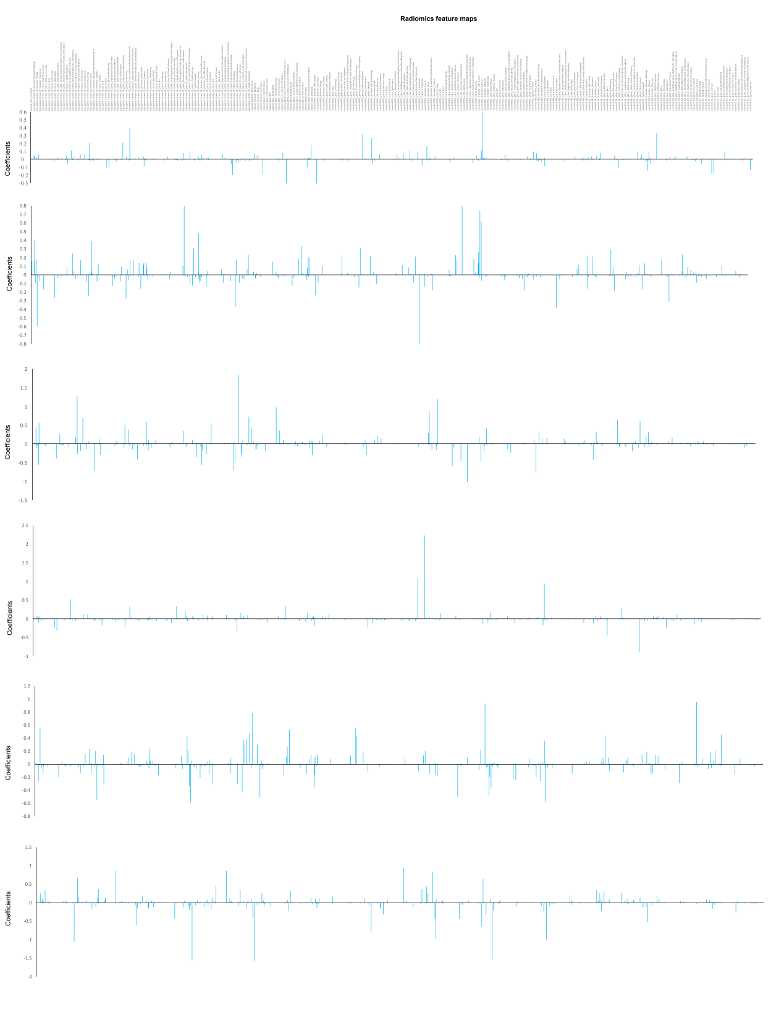
Fig. S2: Weights of AHS-related radiomic features.7000+ radiomics features at CT images were extracted from gastric cancer (GC) patients and each feature was generated correlation coefficients for ASH used by Lasso regression analysis.

