SUPPLEMENT

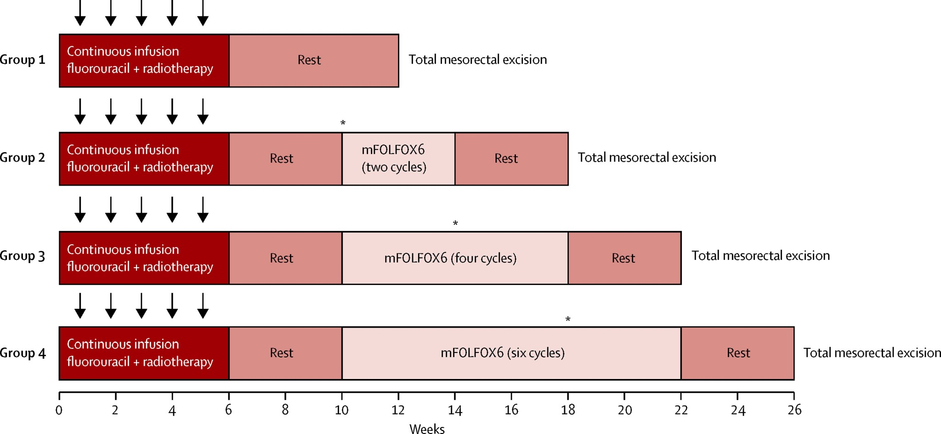

SUPPLEMENTARY FIGURE. 1. Trial protocol. Radiotherapy was given 5 days/week for 5 weeks (arrows) for a total of 45 Gy, with a minimum boost of 5.4 Gy. Fluorouracil was given as a 225-mg/m²/day continuous infusion for 7 days/week during radiation therapy for 5–6 weeks, depending on the number of radiation boosts given. mFOLFOX6 was given in 2-week cycles of leucovorin 200 mg/m² or 400 mg/m² and oxaliplatin 85 mg/m² in a 2-h infusion, bolus fluorouracil 400 mg/m² on day 1, and a 46-h infusion of fluorouracil 2400 mg/m². *Interim assessments were performed by proctoscopic examination; total mesorectal excision was performed if the patient had stable or progressive disease. (Reprinted with permission from Lancet Oncol. 16:957–966, 2015.)

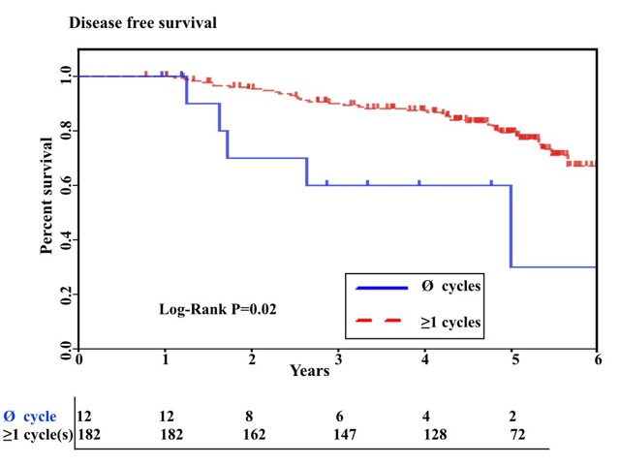
SUPPLEMENTARY FIGURE. 2. Kaplan-Meier curves of disease-free survival (with numbers of subjects at risk at the bottom) for patients who did not receive any chemotherapy cycles after CRT (Ø cycles) and patients who received at least 1 chemotherapy cycle, either as consolidation chemotherapy after CRT, as adjuvant chemotherapy after TME, or both.
SUPPLEMENTARY TABLE 1. Baseline patient characteristics in relation to follow-up availability

Characteristic | No. of patients (%)
 | Follow-up available (n = 211) | Follow-up not available (n = 48)
Study group
SG1 | 40 (19) | 20 (42)
SG2 | 56 (27) | 11 (23)
SG3 | 53 (25) | 14 (29)
SG4 | 62 (29) | 3 (6)
Age (years; mean ± SD) | 57 ± 11 | 59 ± 11
Sex
Male | 124 (59) | 28 (58)
Female | 87 (41) | 20 (42)
ECOGª performance status
0 | 179 (85) | 43 (90)
1 | 32 (15) | 5 (10)
Clinical stage
II | 50 (24) | 14 (29)
III | 161 (76) | 34 (71)
Distance from anal verge (cm; mean ± SD) | 6.8 ± 3.2 | 6.9 ± 2.9
ypTNM stage
0 | 65 (31) | 16 (33)
I | 58 (28) | 11 (23)
II | 41 (19) | 13 (27)
III | 47 (22) | 8 (17)
Pathological complete response
Yes | 58 (27) | 15 (31)
No | 153 (73) | 33 (69)
ªECOG, Eastern Collaborative Oncology Group.

