Original Article – Supplemental Digital Content
Advanced Concepts in Rheology for the Evaluation of Hyaluronic Acid-based Soft Tissue Fillers
Jimmy Faivre¹, Ph.D., Mélanie Gallet¹, B.Sc., Elodie Tremblais¹, B.Sc., Patrick Trevidic¹, M.D., and François Bourdon¹, M.Sc.
Research and Development Department, Teoxane SA, Rue de Lyon 105, 1203 Genève, Switzerland.
Correspondence to: François Bourdon, Research and Development Department, Teoxane SA, Rue de Lyon 105, 1203 Genève, Switzerland. E-mail: f.bourdon@teoxane.com
All authors are employed by Teoxane SA.

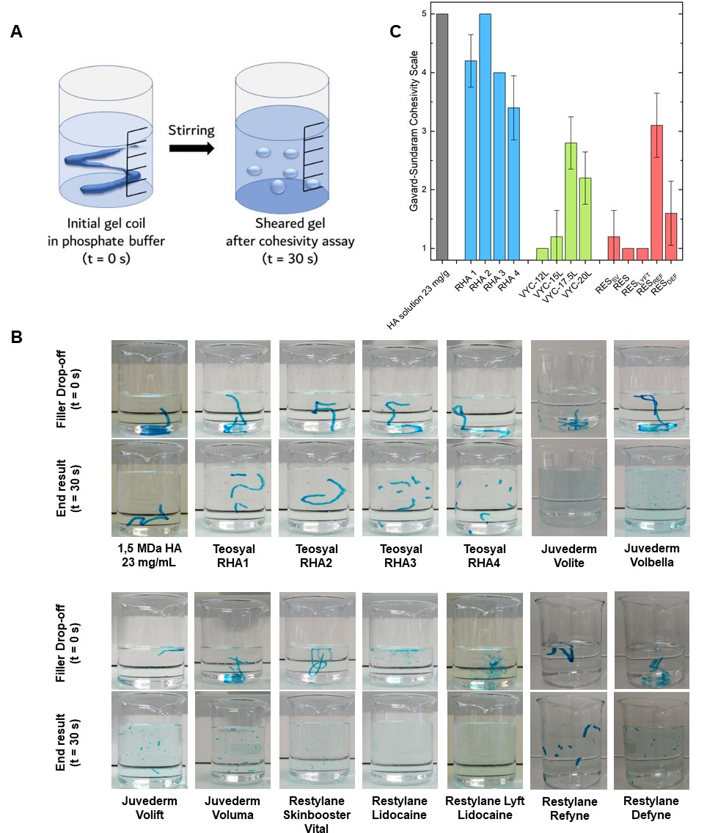
Figure SI 1. Study of the cohesivity of gels under mild shear. (A) Schematic of the experiment, (B) images of the gels extruded in saline buffer before stirring (t = 0 s) and after the end of the experiment (t = 30 s), and (C) cohesivity scores of the fillers according to the 5-grade Cohesivity Scale. A 23 mg/mL solution of non-crosslinked 1.5 MDa HA was used as control.

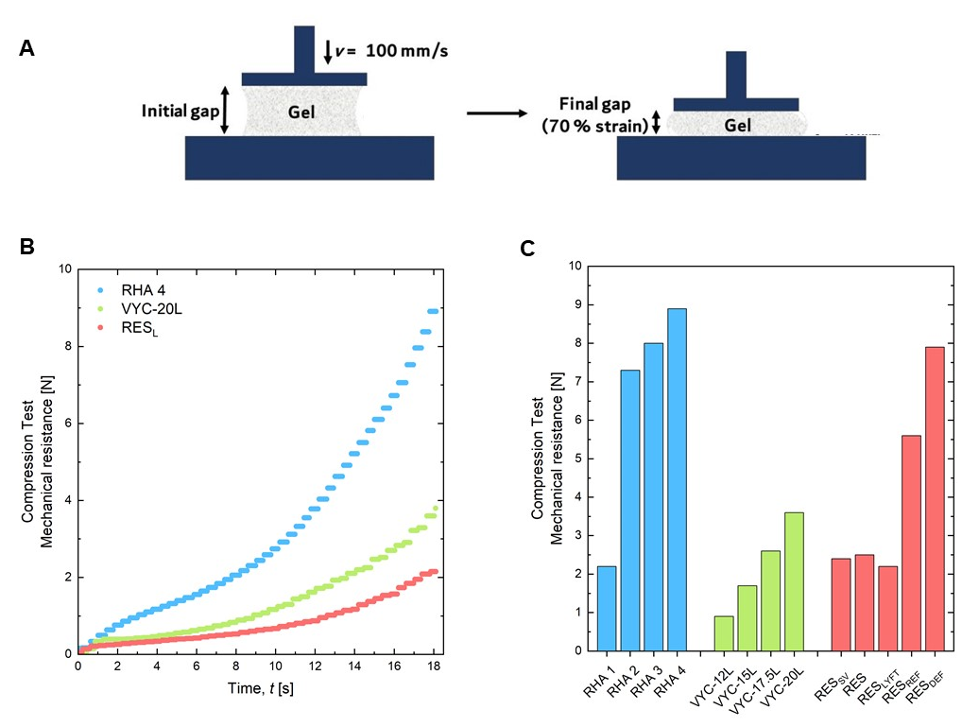
Figure SI 2. Study of the mechanical resistance of gels under compression. (A) Schematics of experiment, (B) compression force profiles of gels (only volumizers are represented), and (C) compression forces values.

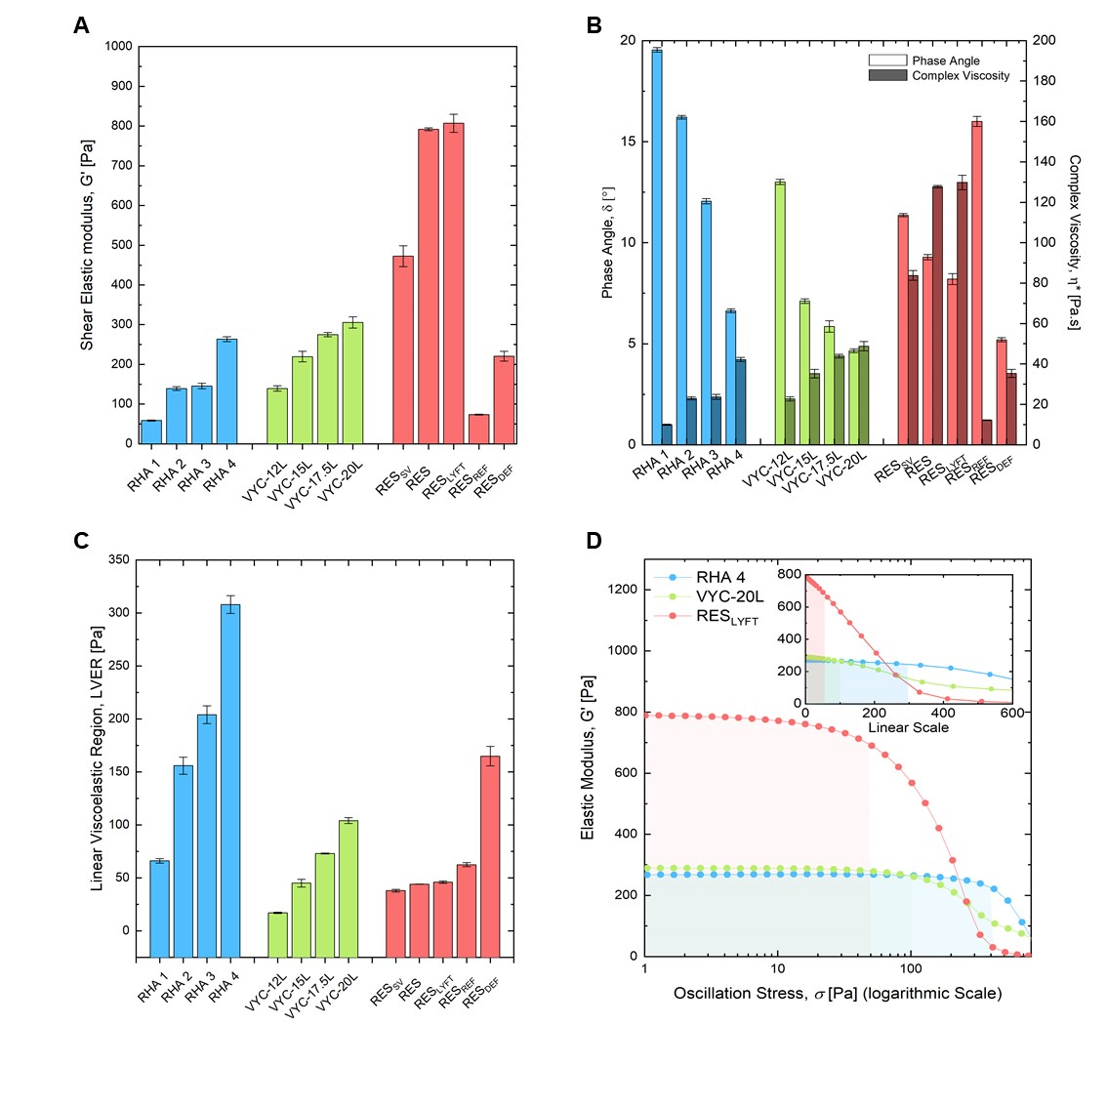
Figure SI 3. Rheological characterizations of the investigated gels. (A) Shear elastic modulus, G’ (B) phase angle and complex viscosity, (C) linear viscoelastic region, LVER, and (D) plot of G’ as a function of the applied stress. For improved clarity, only volumizers are represented (Stresses are represented in a logarithmic scale). The inset is the G’ plot in a linear scale.

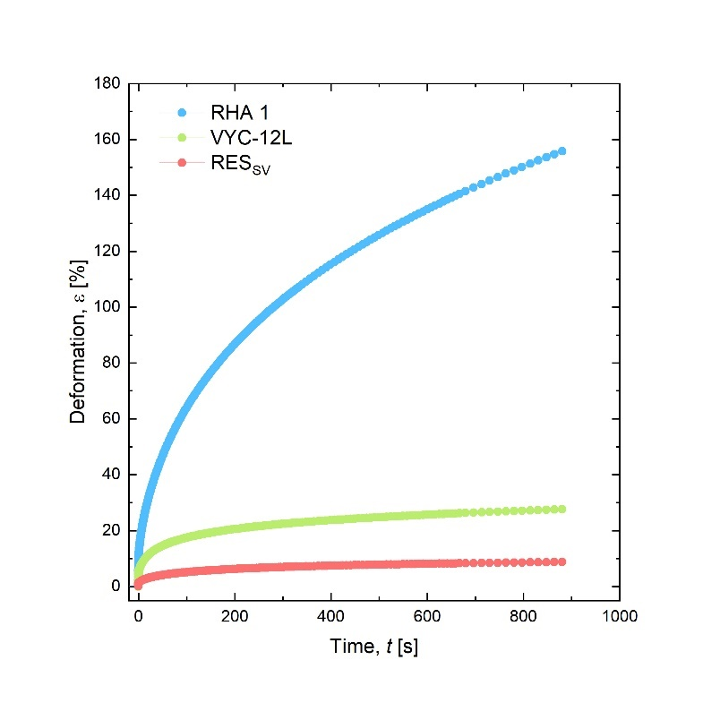
Figure SI 4. Creep test to assess the Stretch score. For improved clarity, only fillers intended for superficial wrinkle filling are represented.

