Supplemental Appendix
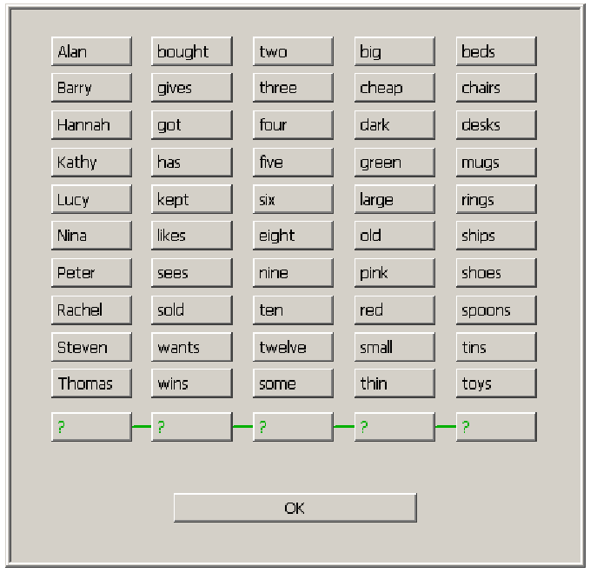
Screenshot of the response screen showing the matrix of possible words that make up the sentences in the Matrix Sentence Test. Each sentence consists of one word from each column, for example: ‘Nina kept three small desks’.

