Online Supplement for: Short-term effects of air pollution on hospital admissions in 8 cities in Korea, 2003-2008, Ji-Young Son, Jong-Tae Lee, Yoon Hyeong Park, Michelle L. Bell, Epidemiology

List of Supplemental Figure
eFigure 1. Locations of the cities
eFigure 2. Sensitivity analysis to the degrees of freedom for time trend, overall across 8 cities for all 4 causes of hospitalizations and all 5 pollutants

List of Supplemental Tables
eTable 1. Comparison of the environmental, health, and economic indicators for South Korea to other countries
eTable 2. Correlation coefficients among air pollutants by city and on average across cities
eTable 3. Percent increase in risk of hospitalization per IQR increase in air pollutant by cause for each city and overall
eTable 4. Percent increase in risk of hospitalization per IQR increase in air pollutant by cause, overall across the cities by lag structure
eTable 5. Percent increase in risk of hospitalization per IQR increase in air pollutant by cause, overall across the cities by degree of freedom for meteorological variables (temperature, relative humidity, and pressure)
eTable 6. Percent increase in risk of hospitalization per IQR increase in air pollutant by cause, overall across the cities by lag structure for meteorological variables (temperature, relative humidity, and pressure)
eTable 7. Air pollution levels by season
eTable 8. Percent increase in risk of hospitalization per IQR increase in air pollutant by cause for each city and overall by season.
eTable 9. Percent increase in risk of hospitalization per IQR increase in O₃ by cause for each city and overall by season, for weekdays only.
eTable 10. Overall percent increase in risk of hospitalization per IQR increase in air pollutant by cause and sex
eTable 11. Overall percent increase in risk of hospitalization per IQR increase in air pollutant by cause and age
eTable 12. Comparison of findings with other Asian studies of air pollution and hospital admissions

eFigure 1. Locations of the cities

eFigure 2. Sensitivity analysis to the degrees of freedom for time trend, overall across 8 cities for all 4 causes of hospitalizations and all 5 pollutants
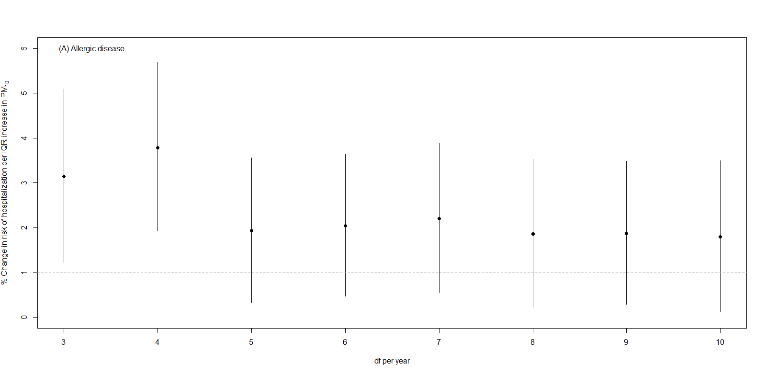
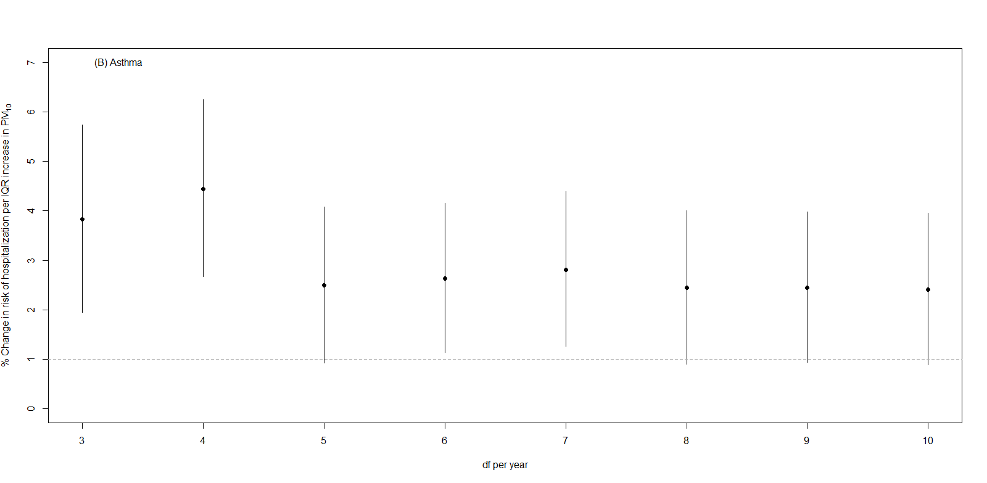
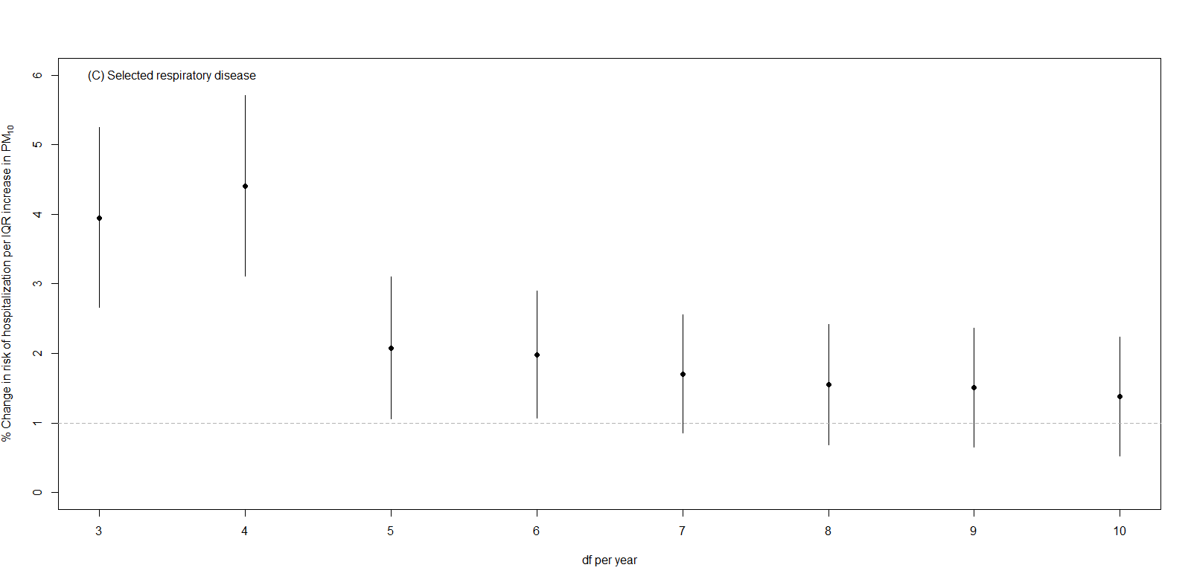
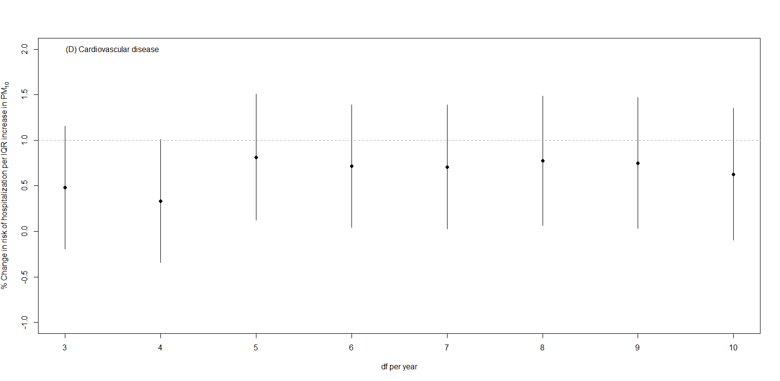
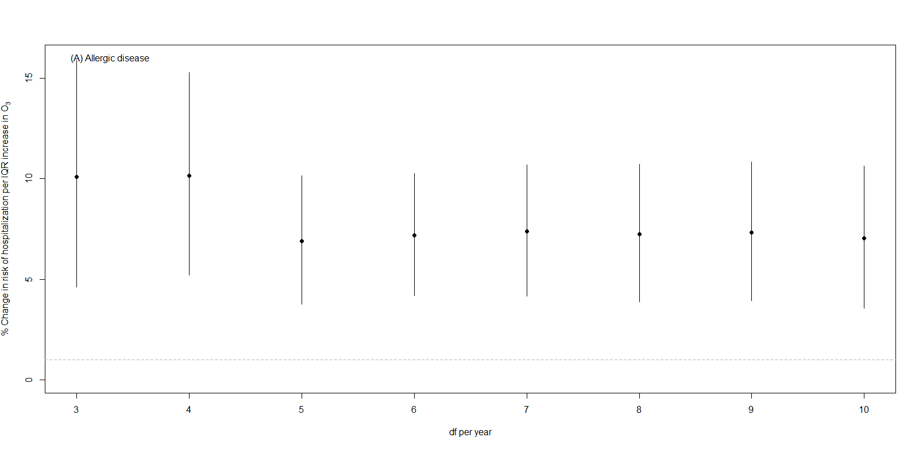
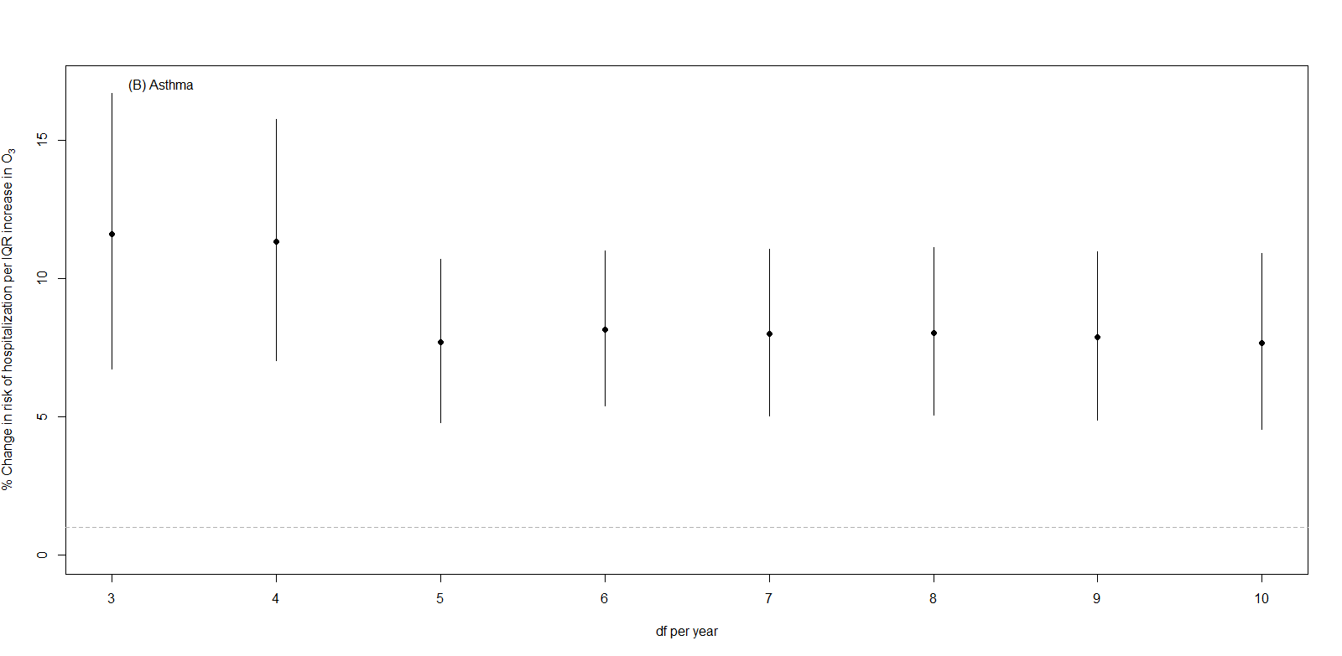
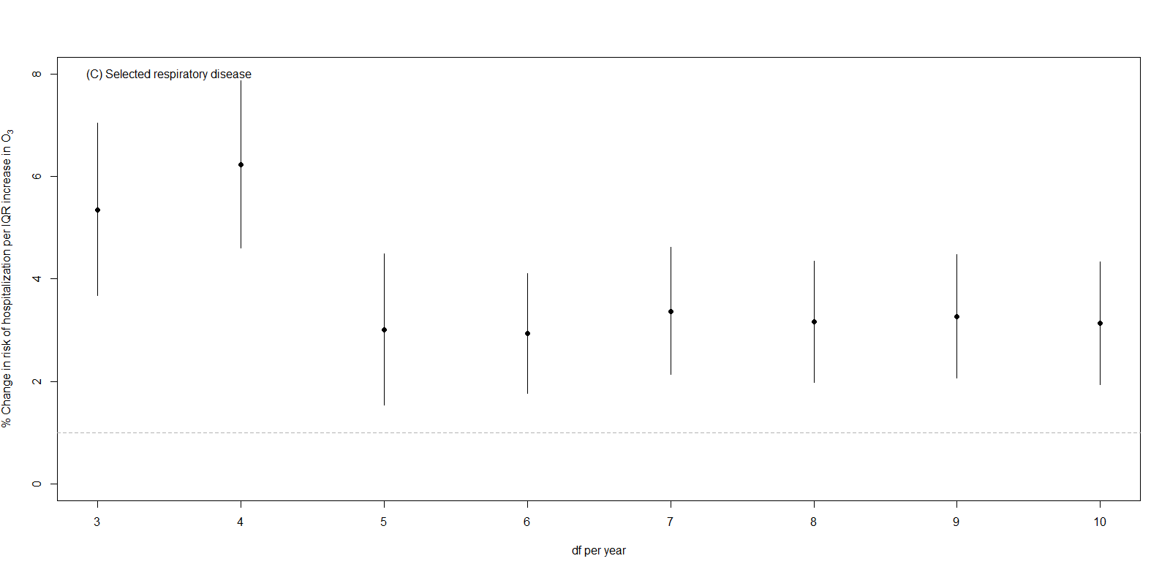
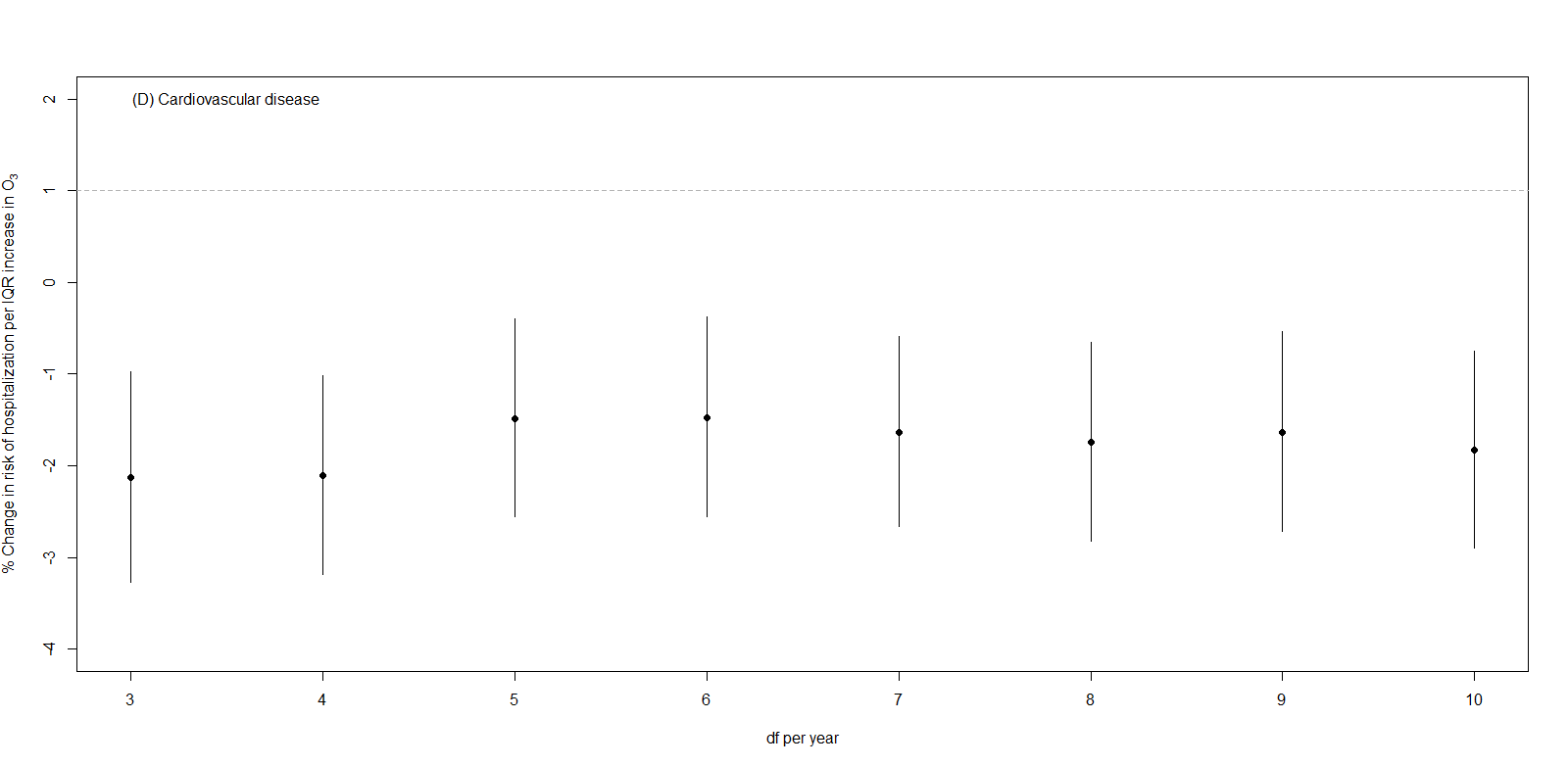
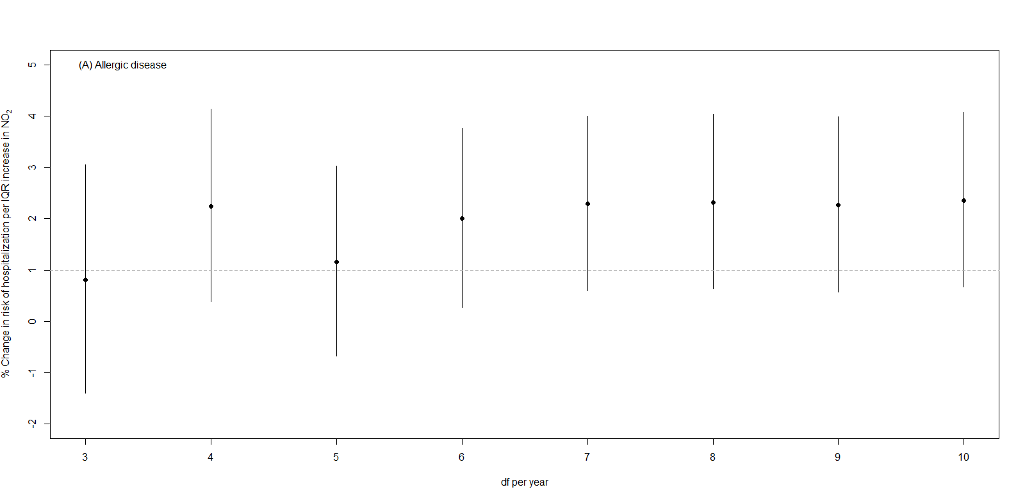
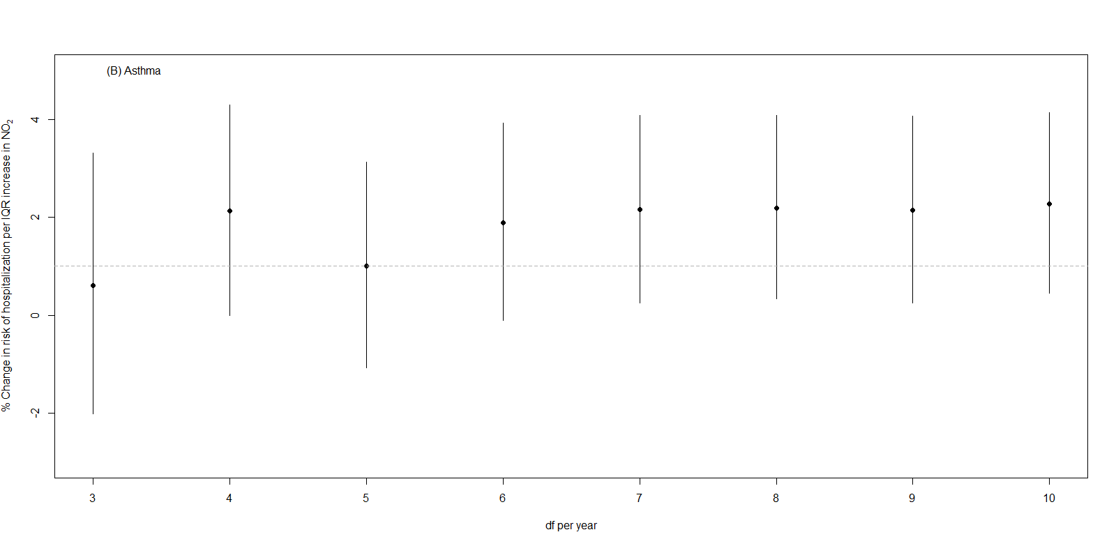
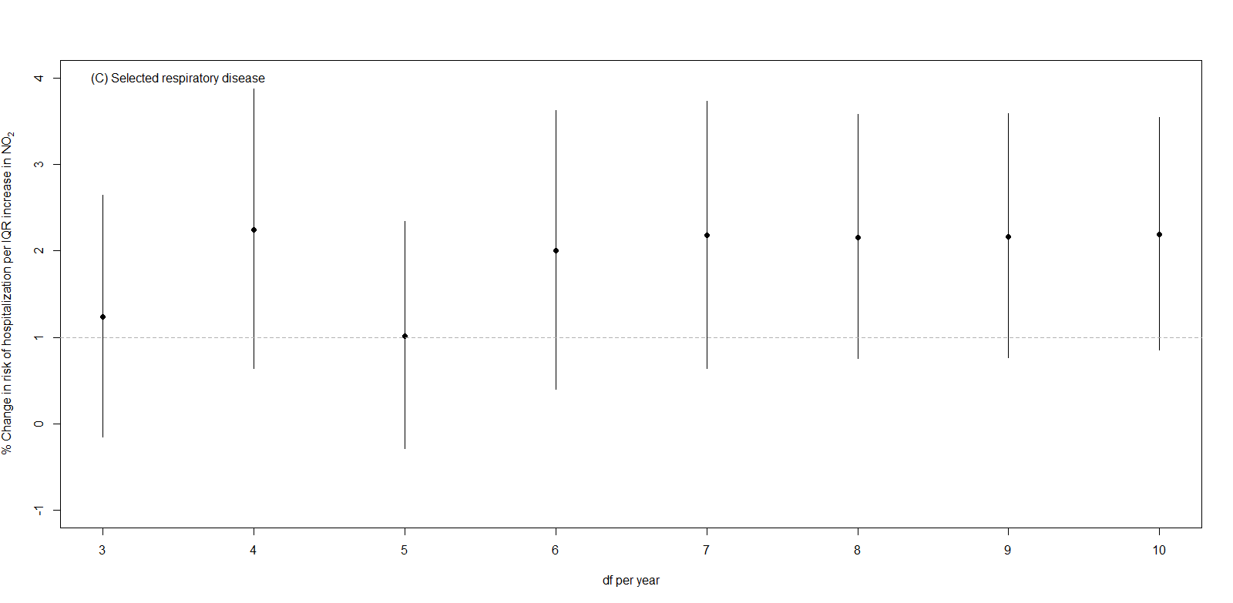
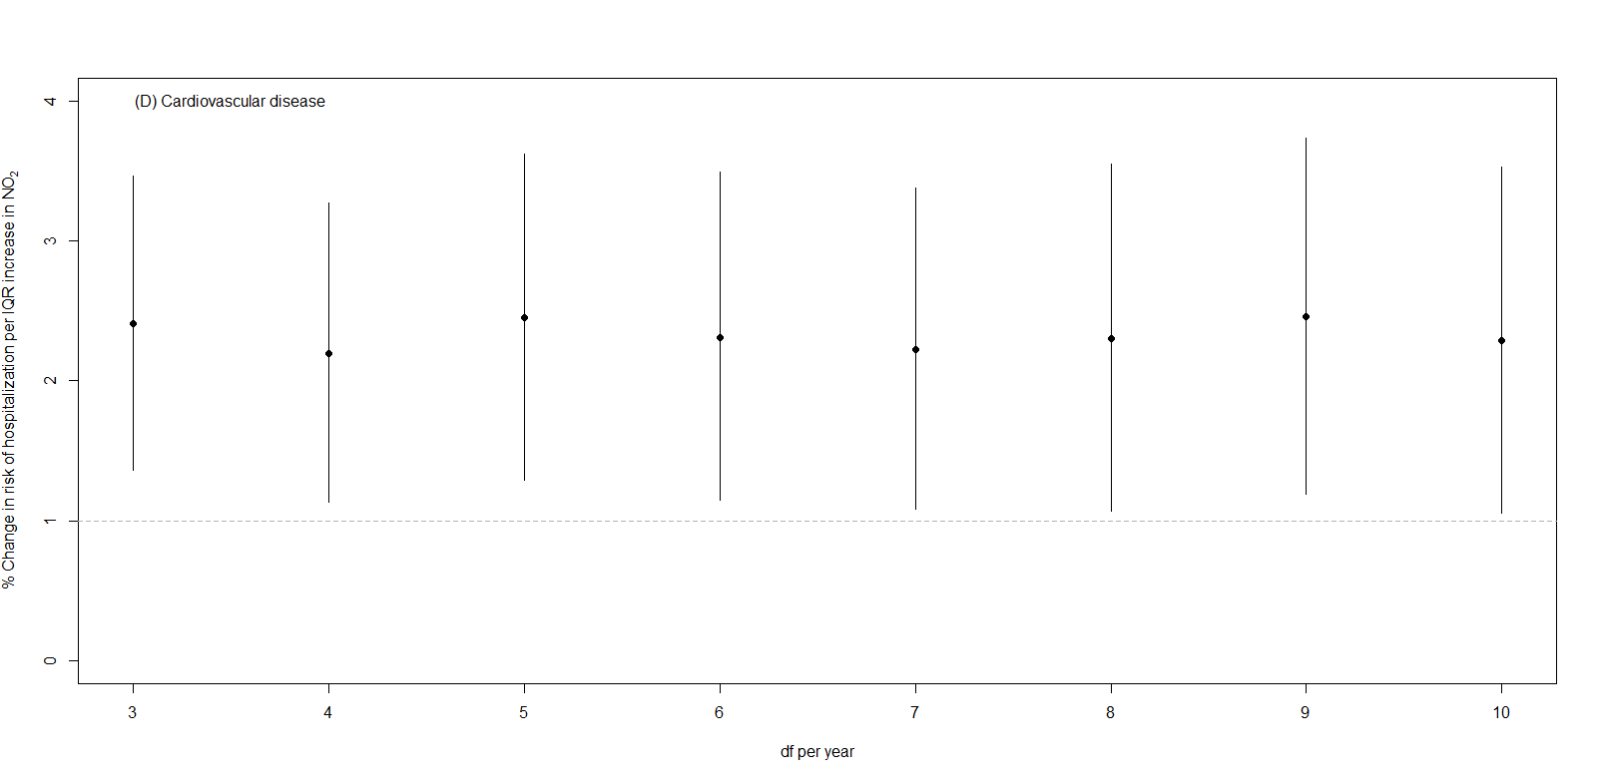
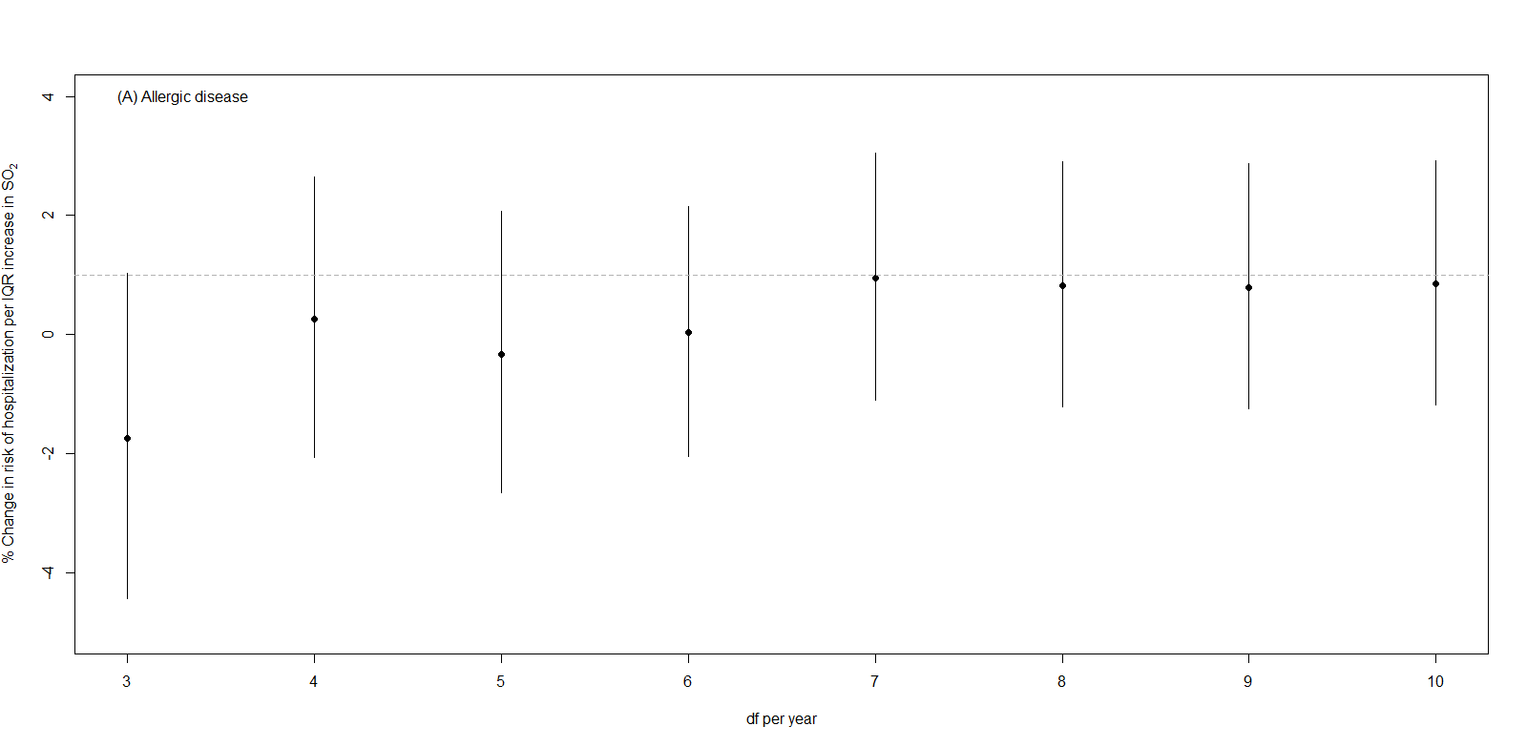
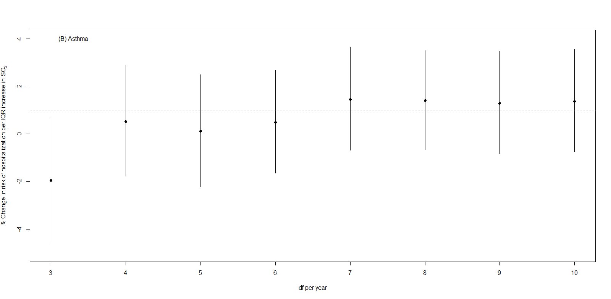
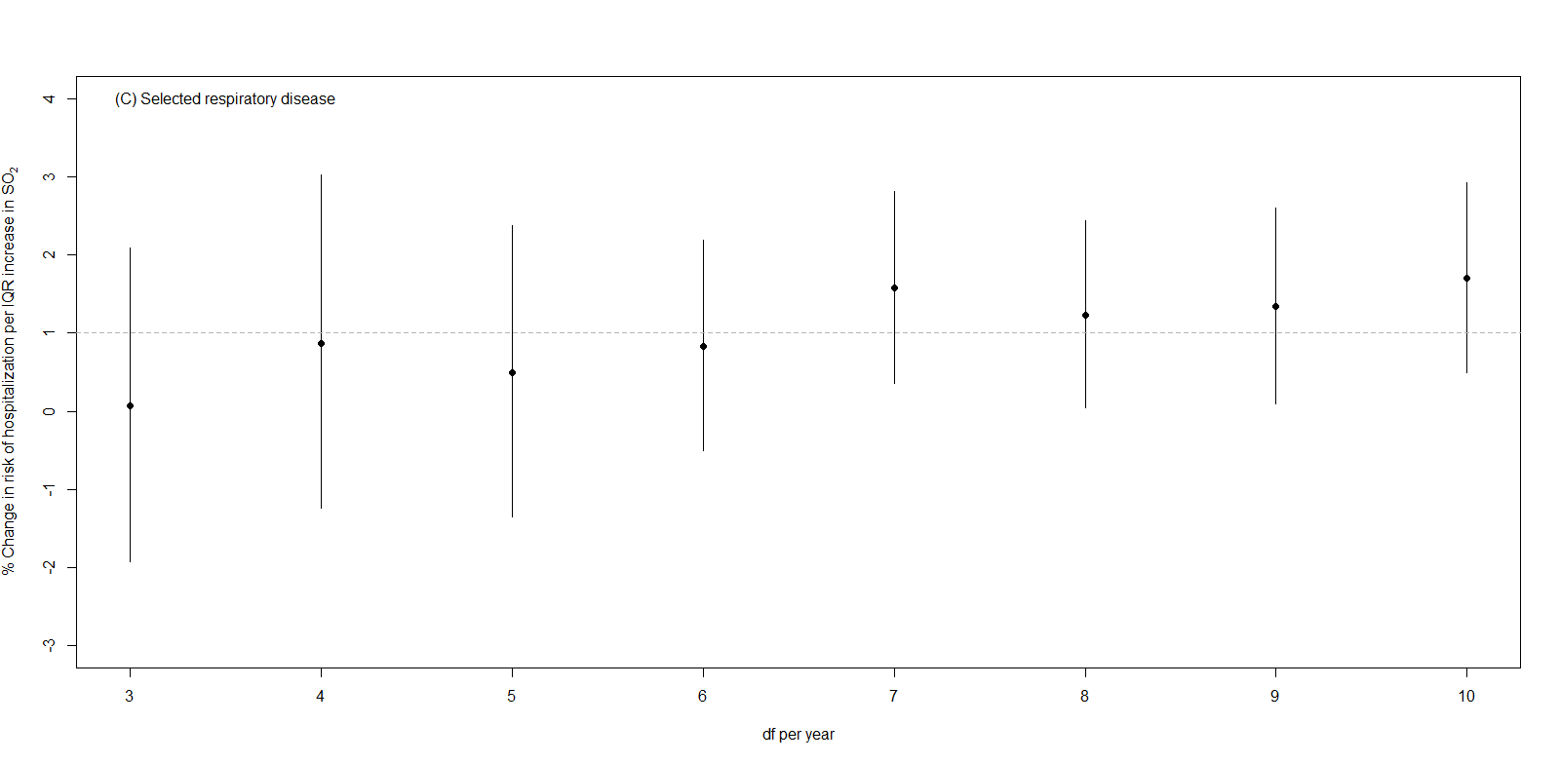
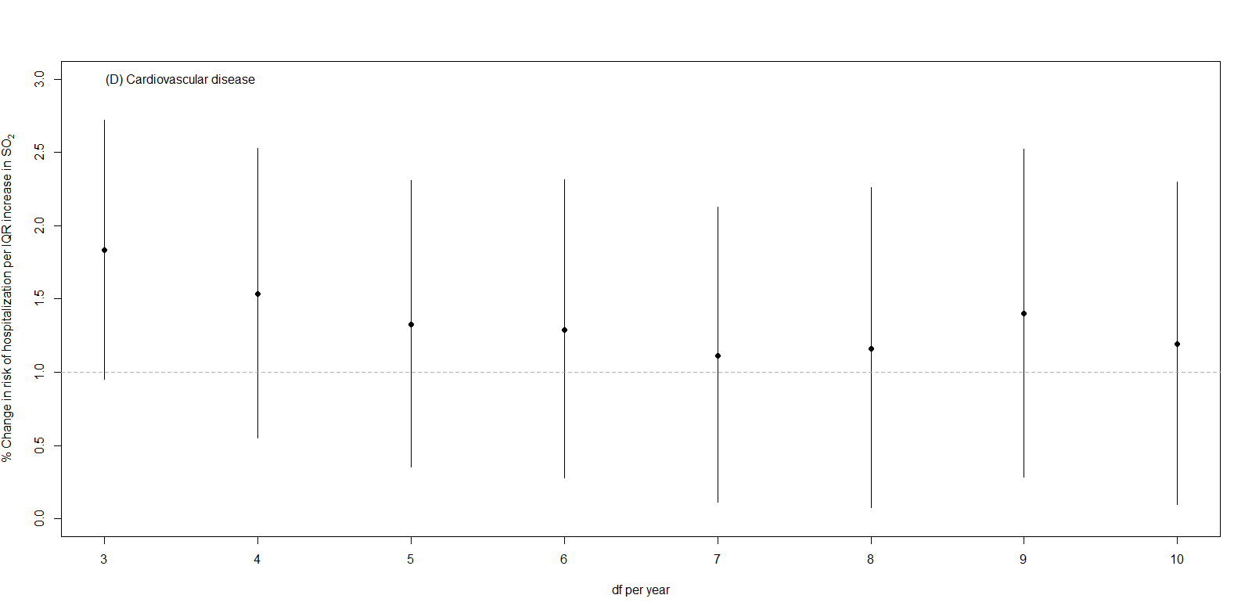
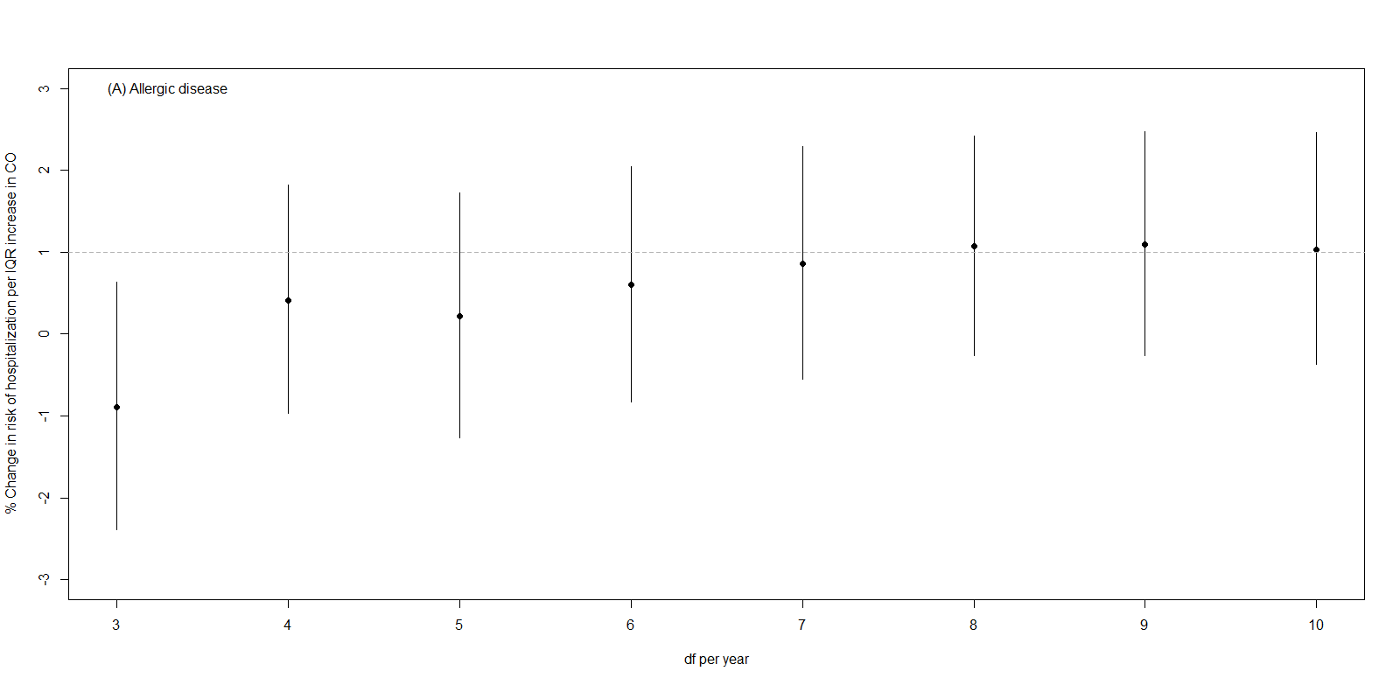
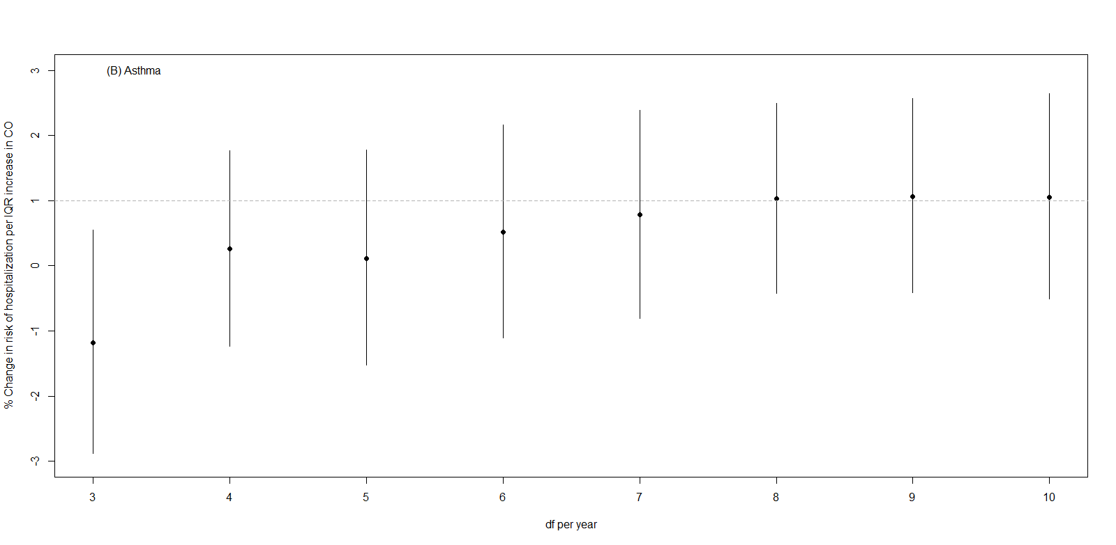
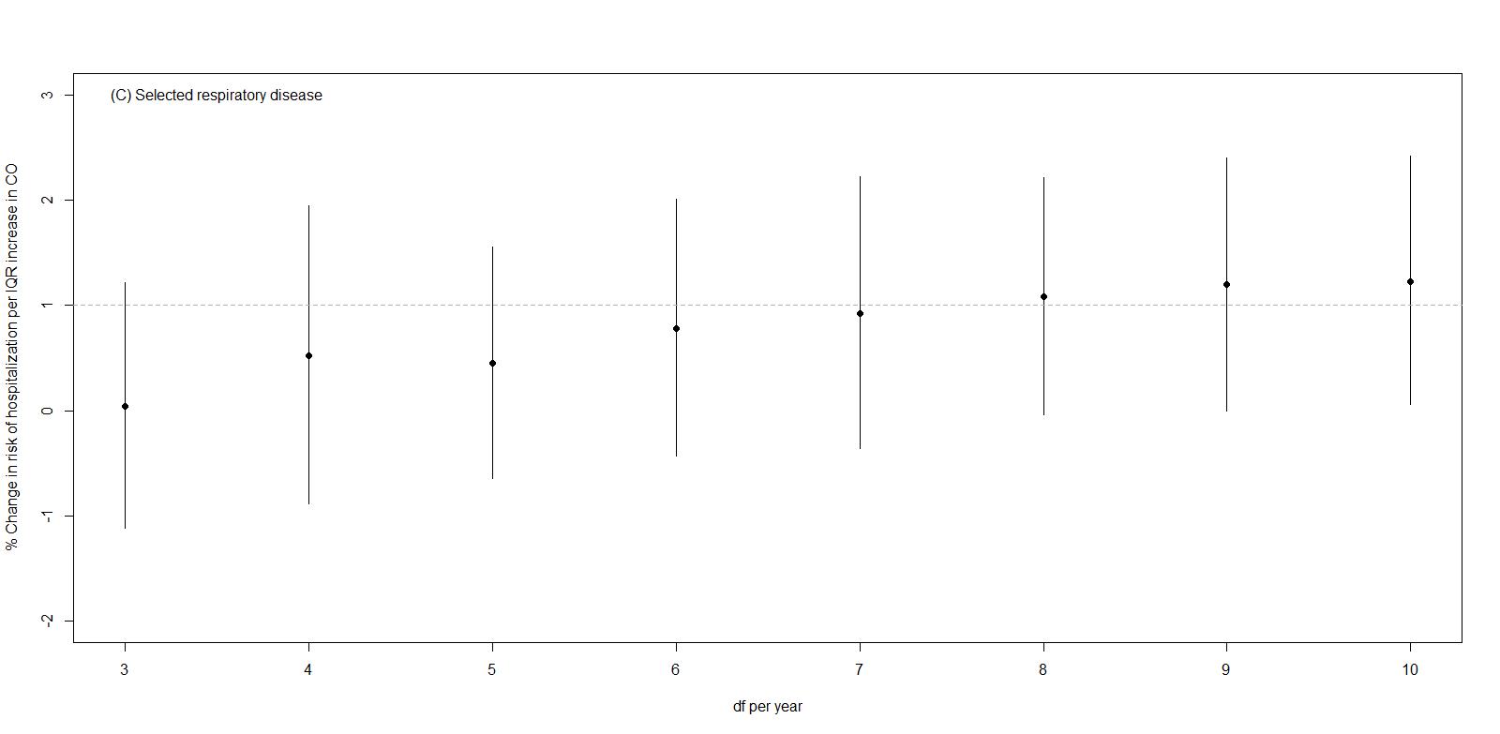
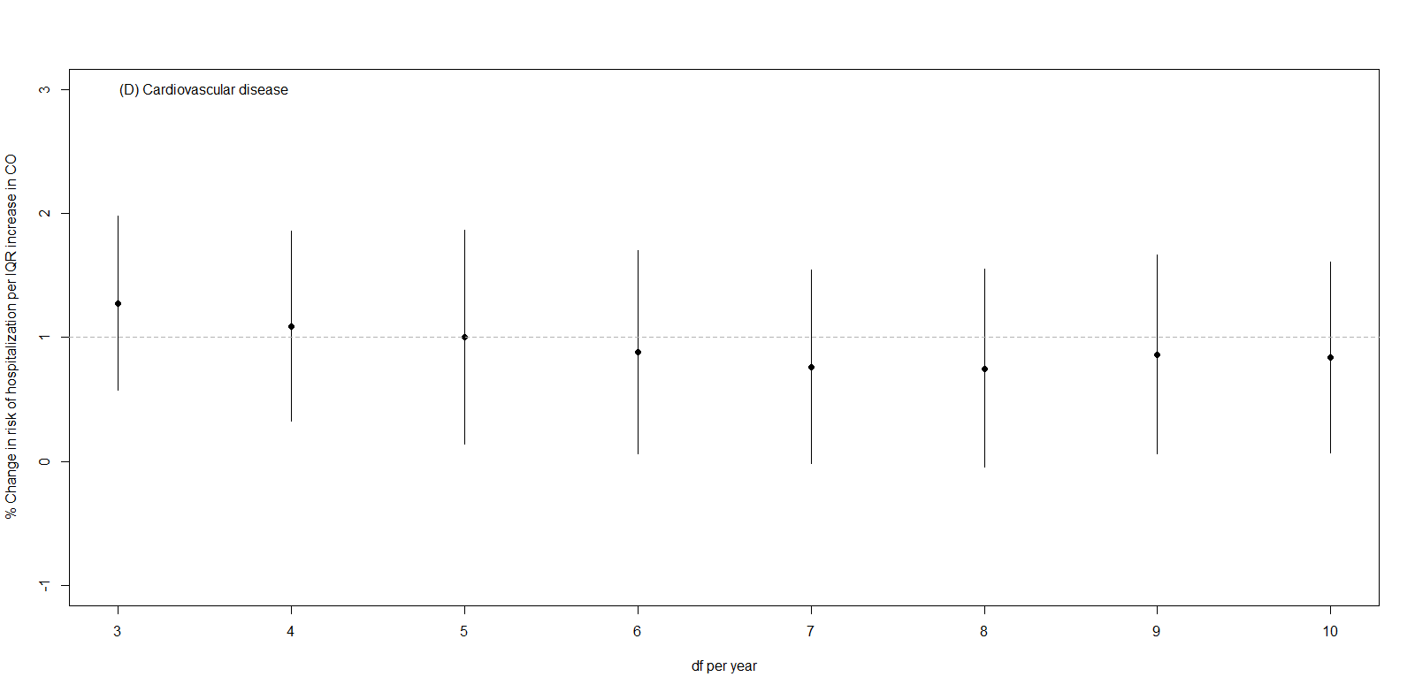

eTable 1. Comparison of the environmental, health, and economic indicators for South Korea to other countries (World Bank 2012)

 | Maternal mortality ratio per 100,000 live births, modeled estimate (2010) | Life expectancy at birth for males (2010) [years] | Life expectancy at birth for females (2010) [years] | % with access to improved sanitation facilities (2010) | CO₂ emissions (2008) [metric tons/capita] | % urban population (2011) | Motor vehicles /1,000 persons (2009) | GDP per capita (2011) [$US]
South Korea | 16 | 77 | 84 | 100% | 10.4 | 83% | 355 | 22,424
India | 200 | 64 | 67 | 34% | 1.5 | 31% | 18 | 1,489
Thailand | 48 | 71 | 77 | 96% | 4.2 | 34% | - | 4,972
China | 37 | 72 | 75 | 64% | 5.3 | 51% | 47 | 5,455
Japan | 5 | 80 | 86 | 100% | 9.5 | 91% | 589 | 45,903
Canada | 12 | 79 | 83 | 100% | 16.3 | 81% | 607 | 50,345
France | 8 | 78 | 85 | 100% | 5.9 | 86% | 598 | 42,377
United Kingdom | 12 | 79 | 82 | 100% | 8.5 | 80% | 523 | 38,818
United States | 21 | 76 | 81 | 100% | 18.0 | 82% | 802 | 48,442

eTable 2. Correlation coefficients among air pollutants by city and on average across cities
 | O₃ | NO₂ | SO₂ | CO
Seoul
PM₁₀ | 0.1 | 0.5 | 0.5 | 0.5
O₃ |  | -0.2 | -0.2 | -0.4
NO₂ |  |  | 0.7 | 0.8
SO₂ |  |  |  | 0.8
Busan
PM₁₀ | 0.3 | 0.5 | 0.5 | 0.5
O₃ |  | 0.0 | 0.1 | -0.1
NO₂ |  |  | 0.7 | 0.8
SO₂ |  |  |  | 0.7
Incheon
PM₁₀ | 0.1 | 0.5 | 0.5 | 0.5
O₃ |  | -0.1 | -0.1 | -0.3
NO₂ |  |  | 0.7 | 0.7
SO₂ |  |  |  | 0.7
Daegu
PM₁₀ | 0.2 | 0.5 | 0.5 | 0.4
O₃ |  | -0.3 | -0.3 | -0.4
NO₂ |  |  | 0.7 | 0.7
SO₂ |  |  |  | 0.7
Daejeon
PM₁₀ | 0.2 | 0.4 | 0.5 | 0.4
O₃ |  | -0.2 | -0.2 | -0.4
NO₂ |  |  | 0.7 | 0.8
SO₂ |  |  |  | 0.7
Gwangju
PM₁₀ | 0.3 | 0.5 | 0.5 | 0.5
O₃ |  | -0.1 | -0.1 | -0.2
NO₂ |  |  | 0.6 | 0.7
SO₂ |  |  |  | 0.6
Ulsan
PM₁₀ | 0.3 | 0.5 | 0.5 | 0.4
O₃ |  | 0.0 | 0.2 | -0.1
NO₂ |  |  | 0.5 | 0.7
SO₂ |  |  |  | 0.5
Jeju
PM₁₀ | 0.4 | 0.3 | 0.4 | 0.4
O₃ |  | 0.2 | 0.1 | 0.2
NO₂ |  |  | 0.4 | 0.4
SO₂ |  |  |  | 0.4
Average of city-specific correlations
PM₁₀ | 0.2 | 0.5 | 0.5 | 0.5
O₃ |  | -0.1 | -0.1 | -0.2
NO₂ |  |  | 0.6 | 0.7
SO₂ |  |  |  | 0.6

eTable 3. Percent increase in risk of hospitalization per IQR increase in air pollutant by cause for each city and overall
City | Cause | Air pollutant
 |  | PM₁₀ |  |  | O₃ |  |  |  | NO₂ |  |  |  | SO₂ |  |  |  | CO
Seoul | Allergic disease | 2.7 | 1.1 | 4.4 |  | 6.1 | 2.3 | 10.1 |  | 1.8 | 0.1 | 3.5 |  | 2.3 | -0.8 | 5.6 |  | 1.4 | -0.3 | 3.1
 | Asthma | 3.1 | 1.5 | 4.8 |  | 6.5 | 2.6 | 10.6 |  | 1.4 | -0.2 | 3.1 |  | 3.1 | -0.1 | 6.4 |  | 1.0 | -0.7 | 2.7
 | Respiratory | 1.8 | 0.8 | 2.8 |  | 2.0 | 0.6 | 3.5 |  | 1.4 | 0.4 | 2.4 |  | 2.2 | 0.3 | 4.1 |  | 1.1 | 0.1 | 2.1
 | Cardiovascular | 0.6 | -0.2 | 1.5 |  | -1.1 | -2.4 | 0.3 |  | 1.3 | 0.4 | 2.2 |  | 0.8 | -0.7 | 2.4 |  | 0.9 | 0.0 | 1.8
Busan | Allergic disease | 1.0 | -1.8 | 3.9 |  | 10.2 | 4.9 | 15.7 |  | 2.9 | -0.1 | 6.0 |  | -0.8 | -3.8 | 2.4 |  | 0.5 | -2.7 | 3.8
 | Asthma | 1.8 | -1.0 | 4.7 |  | 10.7 | 5.4 | 16.2 |  | 2.9 | -0.1 | 5.9 |  | -0.6 | -3.7 | 2.5 |  | 0.9 | -2.3 | 4.2
 | Respiratory | 2.4 | 0.8 | 4.0 |  | 4.5 | 2.4 | 6.6 |  | 4.5 | 2.7 | 6.3 |  | 1.7 | -0.1 | 3.6 |  | 2.6 | 0.7 | 4.6
 | Cardiovascular | 0.5 | -0.8 | 1.9 |  | -3.1 | -4.9 | -1.2 |  | 3.2 | 1.6 | 4.8 |  | 0.7 | -0.8 | 2.3 |  | 1.4 | -0.3 | 3.2
Incheon | Allergic disease | 3.1 | 0.5 | 5.8 |  | 7.9 | 2.7 | 13.4 |  | 1.8 | -0.8 | 4.4 |  | 1.1 | -2.4 | 4.8 |  | 1.9 | -0.3 | 4.2
 | Asthma | 3.8 | 1.2 | 6.5 |  | 9.0 | 3.8 | 14.5 |  | 1.6 | -1.0 | 4.1 |  | 1.8 | -1.6 | 5.4 |  | 2.3 | 0.1 | 4.5
 | Respiratory | 1.0 | -0.4 | 2.5 |  | 3.3 | 1.4 | 5.3 |  | 1.2 | -0.2 | 2.7 |  | 0.6 | -1.4 | 2.6 |  | 0.5 | -0.8 | 1.8
 | Cardiovascular | 0.4 | -0.9 | 1.6 |  | -2.3 | -4.0 | -0.5 |  | 2.0 | 0.6 | 3.4 |  | 0.6 | -1.1 | 2.3 |  | 0.7 | -0.5 | 1.9
Daegu | Allergic disease | 3.9 | 0.3 | 7.8 |  | 6.7 | 0.8 | 12.9 |  | 1.8 | -1.7 | 5.5 |  | -0.1 | -4.6 | 4.6 |  | 0.4 | -2.4 | 3.3
 | Asthma | 3.8 | 0.2 | 7.5 |  | 6.4 | 0.7 | 12.5 |  | 1.3 | -2.2 | 4.9 |  | 0.2 | -4.2 | 4.8 |  | -0.2 | -3.0 | 2.6
 | Respiratory | 1.5 | -0.2 | 3.3 |  | 3.9 | 2.0 | 5.9 |  | 1.6 | -0.2 | 3.4 |  | 0.9 | -1.2 | 3.2 |  | -0.2 | -1.6 | 1.3
 | Cardiovascular | 1.2 | -0.2 | 2.6 |  | -2.5 | -4.2 | -0.7 |  | 2.2 | 0.7 | 3.8 |  | 1.2 | -0.5 | 3.0 |  | 0.3 | -0.9 | 1.5
Daejeon | Allergic disease | 2.4 | -2.2 | 7.2 |  | 12.1 | 4.3 | 20.6 |  | 5.7 | 0.3 | 11.5 |  | 3.1 | -4.2 | 10.9 |  | 1.6 | -1.9 | 5.3
 | Asthma | 3.0 | -1.6 | 7.9 |  | 11.4 | 3.6 | 19.8 |  | 7.9 | 2.3 | 13.8 |  | 4.8 | -2.5 | 12.8 |  | 2.9 | -0.6 | 6.6
 | Respiratory | 1.1 | -1.9 | 4.2 |  | 2.7 | -0.8 | 6.4 |  | 0.6 | -3.2 | 4.5 |  | 0.8 | -4.3 | 6.1 |  | -1.0 | -3.4 | 1.6
 | Cardiovascular | 0.0 | -1.7 | 1.6 |  | -1.8 | -3.9 | 0.4 |  | 1.9 | -0.3 | 4.1 |  | 1.0 | -1.6 | 3.7 |  | 0.2 | -1.2 | 1.7
Gwangju | Allergic disease | -1.3 | -5.0 | 2.5 |  | 3.2 | -3.0 | 9.8 |  | 1.1 | -3.1 | 5.5 |  | 0.4 | -5.4 | 6.6 |  | -1.3 | -3.9 | 1.4
 | Asthma | -0.6 | -4.4 | 3.2 |  | 4.0 | -2.3 | 10.7 |  | 0.2 | -4.1 | 4.7 |  | -1.2 | -7.0 | 5.1 |  | -2.1 | -4.7 | 0.6
 | Respiratory | 1.7 | -0.1 | 3.5 |  | 3.3 | 1.1 | 5.5 |  | 1.9 | -0.2 | 4.0 |  | 1.2 | -1.7 | 4.1 |  | 0.0 | -1.3 | 1.2
 | Cardiovascular | -0.1 | -1.8 | 1.7 |  | 0.2 | -2.1 | 2.6 |  | 1.2 | -0.9 | 3.3 |  | 0.7 | -1.8 | 3.3 |  | -0.1 | -1.4 | 1.2
Ulsan | Allergic disease | 3.8 | -0.6 | 8.3 |  | 12.7 | 4.8 | 21.1 |  | 2.3 | -2.7 | 7.6 |  | 2.3 | -2.3 | 7.0 |  | 0.8 | -3.5 | 5.3
 | Asthma | 3.9 | -0.5 | 8.5 |  | 13.2 | 5.1 | 21.8 |  | 1.9 | -3.2 | 7.2 |  | 2.5 | -2.1 | 7.4 |  | 0.8 | -3.6 | 5.3
 | Respiratory | 1.3 | -1.9 | 4.7 |  | 6.3 | 2.2 | 10.5 |  | 1.7 | -2.1 | 5.6 |  | 2.7 | -0.8 | 6.3 |  | 4.6 | 1.2 | 8.2
 | Cardiovascular | 1.9 | 0.0 | 4.0 |  | -1.8 | -4.4 | 0.9 |  | 2.4 | -0.1 | 4.9 |  | 0.8 | -1.2 | 2.8 |  | 1.0 | -1.1 | 3.2
Jeju | Allergic disease | 0.8 | -4.5 | 6.4 |  | -0.1 | -8.2 | 8.7 |  | 6.3 | -4.2 | 17.9 |  | -0.5 | -8.4 | 8.1 |  | 1.7 | -4.9 | 8.6
 | Asthma | 3.1 | -1.7 | 8.2 |  | 4.0 | -3.8 | 12.4 |  | 5.8 | -3.9 | 16.5 |  | 2.6 | -4.5 | 10.3 |  | 0.9 | -5.1 | 7.2
 | Respiratory | 3.3 | -0.3 | 7.0 |  | 1.7 | -2.6 | 6.2 |  | 10.7 | 3.2 | 18.8 |  | 4.3 | -1.0 | 9.8 |  | 2.8 | -1.8 | 7.6
 | Cardiovascular | 1.9 | -0.3 | 4.1 |  | 0.1 | -2.7 | 3.0 |  | 9.4 | 4.2 | 14.8 |  | 5.5 | 2.1 | 9.0 |  | 4.5 | 1.3 | 7.8
Overall | Allergic disease | 2.2 | 0.5 | 3.9 |  | 7.4 | 4.2 | 10.7 |  | 2.3 | 0.6 | 4.0 |  | 0.9 | -1.1 | 3.0 |  | 0.9 | -0.6 | 2.3
 | Asthma | 2.8 | 1.3 | 4.4 |  | 8.0 | 5.0 | 11.1 |  | 2.2 | 0.3 | 4.1 |  | 1.5 | -0.7 | 3.6 |  | 0.8 | -0.8 | 2.4
 | Respiratory | 1.7 | 0.9 | 2.6 |  | 3.4 | 2.1 | 4.6 |  | 2.2 | 0.6 | 3.7 |  | 1.6 | 0.4 | 2.8 |  | 0.9 | -0.4 | 2.2
 | Cardiovascular | 0.7 | 0.0 | 1.4 |  | -1.6 | -2.7 | -0.6 |  | 2.2 | 1.1 | 3.4 |  | 1.1 | 0.1 | 2.1 |  | 0.8 | 0.0 | 1.5
Note: IQR for PM₁₀, 30.7 ㎍/m³; O₃, 19.4 ppb; NO₂, 12.2 ppb; SO₂, 2.9 ppb; CO, 0.3 ppm. Lags for allergic disease PM₁₀ [lag03] O₃ [lag02] NO₂ [lag0] SO₂ [lag03] CO [lag0]; Asthma PM₁₀ [lag03], O₃ [lag02], NO₂ [lag0] SO₂ [lag03], CO [lag0]; Respiratory PM₁₀ [lag03], O₃ [lag1], NO₂ [lag0], SO₂ [lag03], CO [lag0]; Cardiovascular PM₁₀ [lag02], O₃ [lag0], NO₂ [lag0], SO₂ [lag02], CO [lag0].

eTable 4. Percent increase in risk of hospitalization per IQR increase in air pollutant by cause, overall across the cities by lag structure
Pollutant | Lag | Allergic disease |  |  | Asthma |  |  | Respiratory |  |  | Cardiovascular
 |  | Estimate % | 95% PI |  | Estimate % | 95% PI |  | Estimate % | 95% PI |  | Estimate % | 95% PI
PM₁₀ | Lag 0 | 1.1 | -0.2 | 2.3 | 1.2 | -0.1 | 2.4 | 0.8 | 0.2 | 1.4 | 0.5 | 0.0 | 1.0
 | Lag 1 | 1.2 | 0.0 | 2.3 | 1.5 | 0.4 | 2.6 | 0.9 | 0.3 | 1.4 | 0.4 | -0.1 | 0.9
 | Lag 2 | 0.9 | -0.2 | 1.9 | 1.2 | 0.2 | 2.2 | 0.6 | 0.1 | 1.1 | 0.3 | -0.2 | 0.7
 | Lag 3 | 0.6 | -0.4 | 1.6 | 0.8 | -0.2 | 1.8 | 0.5 | 0.0 | 1.0 | 0.0 | -0.4 | 0.5
 | Lag 0-1 | 1.6 | 0.1 | 3.2 | 1.9 | 0.4 | 3.6 | 1.2 | 0.6 | 1.9 | 0.6 | 0.0 | 1.3
 | Lag 0-2 | 2.0 | 0.4 | 3.5 | 2.4 | 1.0 | 3.9 | 1.5 | 0.7 | 2.2 | 0.7 | 0.0 | 1.4
 | Lag 0-3 | 2.2 | 0.5 | 3.9 | 2.8 | 1.3 | 4.4 | 1.7 | 0.9 | 2.6 | 0.7 | 0.0 | 1.4
O₃ | Lag 0 | 1.8 | -0.4 | 4.0 | 1.7 | -0.3 | 3.8 | 0.5 | -0.7 | 1.7 | -1.6 | -2.7 | -0.6
 | Lag 1 | 5.0 | 2.7 | 7.4 | 5.5 | 3.3 | 7.8 | 3.4 | 2.1 | 4.6 | 0.5 | -0.6 | 1.5
 | Lag 2 | 3.4 | 1.5 | 5.4 | 4.0 | 2.0 | 5.9 | 2.3 | 1.2 | 3.3 | 0.8 | -0.1 | 1.7
 | Lag 3 | 1.8 | -0.4 | 4.1 | 1.9 | -0.6 | 4.5 | 1.3 | 0.1 | 2.6 | 1.0 | 0.0 | 2.1
 | Lag 0-1 | 5.8 | 2.7 | 9.1 | 6.1 | 3.3 | 9.1 | 3.4 | 1.9 | 4.9 | -0.7 | -2.0 | 0.5
 | Lag 0-2 | 7.4 | 4.2 | 10.7 | 8.0 | 5.0 | 11.1 | 4.5 | 2.8 | 6.2 | 0.0 | -1.4 | 1.4
 | Lag 0-3 | 7.6 | 4.0 | 11.4 | 8.2 | 4.6 | 12.0 | 4.9 | 3.0 | 6.8 | 0.7 | -1.0 | 2.4
NO₂ | Lag 0 | 2.3 | 0.6 | 4.0 | 2.2 | 0.3 | 4.1 | 2.2 | 0.6 | 3.7 | 2.2 | 1.1 | 3.4
 | Lag 1 | -0.1 | -2.0 | 1.9 | -0.4 | -2.1 | 1.3 | 0.1 | -1.1 | 1.4 | 0.0 | -0.9 | 0.9
 | Lag 2 | 0.0 | -1.6 | 1.7 | 0.2 | -1.5 | 2.0 | 0.3 | -0.6 | 1.3 | 0.2 | -0.6 | 1.0
 | Lag 3 | 0.2 | -2.0 | 2.5 | 0.6 | -1.6 | 2.7 | 1.1 | -0.1 | 2.2 | -0.1 | -0.8 | 0.6
 | Lag 0-1 | 1.7 | -0.5 | 3.9 | 1.3 | -0.9 | 3.6 | 1.8 | 0.0 | 3.6 | 1.6 | 0.5 | 2.8
 | Lag 0-2 | 1.4 | -0.9 | 3.8 | 1.3 | -1.1 | 3.8 | 1.8 | -0.2 | 3.9 | 1.5 | 0.3 | 2.7
 | Lag 0-3 | 1.6 | -1.1 | 4.4 | 1.7 | -1.0 | 4.5 | 2.6 | 0.1 | 5.1 | 1.2 | 0.0 | 2.5
SO₂ | Lag 0 | 0.4 | -1.2 | 1.9 | 0.2 | -1.4 | 1.9 | 0.7 | -0.1 | 1.5 | 0.5 | -0.1 | 1.2
 | Lag 1 | 0.6 | -0.9 | 2.1 | 0.8 | -0.7 | 2.4 | 0.6 | -0.3 | 1.5 | 0.7 | -0.1 | 1.4
 | Lag 2 | 0.2 | -1.2 | 1.5 | 0.6 | -0.8 | 2.0 | 0.6 | -0.2 | 1.4 | 0.5 | -0.2 | 1.2
 | Lag 3 | 0.4 | -1.0 | 1.8 | 0.7 | -0.8 | 2.2 | 0.6 | -0.1 | 1.4 | -0.5 | -1.2 | 0.3
 | Lag 0-1 | 0.7 | -1.1 | 2.6 | 0.8 | -1.3 | 3.0 | 1.0 | 0.0 | 2.1 | 0.9 | 0.0 | 1.7
 | Lag 0-2 | 0.7 | -1.2 | 2.7 | 1.1 | -1.0 | 3.3 | 1.3 | 0.1 | 2.5 | 1.1 | 0.1 | 2.1
 | Lag 0-3 | 0.9 | -1.1 | 3.0 | 1.5 | -0.7 | 3.6 | 1.6 | 0.4 | 2.8 | 0.7 | -0.5 | 1.9
CO | Lag 0 | 0.9 | -0.6 | 2.3 | 0.8 | -0.8 | 2.4 | 0.9 | -0.4 | 2.2 | 0.8 | 0.0 | 1.5
 | Lag 1 | 0.1 | -1.7 | 1.8 | 0.1 | -1.6 | 1.8 | 0.4 | -1.1 | 1.8 | 0.2 | -0.5 | 1.0
 | Lag 2 | -0.4 | -2.0 | 1.2 | 0.1 | -1.4 | 1.7 | 0.3 | -0.7 | 1.2 | 0.1 | -0.5 | 0.8
 | Lag 3 | -0.3 | -2.3 | 1.8 | 0.2 | -1.7 | 2.1 | 0.4 | -0.4 | 1.1 | -0.1 | -0.8 | 0.7
 | Lag 0-1 | 0.7 | -1.2 | 2.6 | 0.7 | -1.3 | 2.7 | 1.1 | -0.9 | 3.0 | 0.7 | -0.3 | 1.8
 | Lag 0-2 | 0.3 | -2.0 | 2.6 | 0.7 | -1.5 | 3.0 | 1.1 | -0.9 | 3.2 | 0.7 | -0.5 | 2.0
 | Lag 0-3 | 0.1 | -2.6 | 3.0 | 0.8 | -1.7 | 3.4 | 1.3 | -0.8 | 3.3 | 0.6 | -0.7 | 2.0
Note: IQR for PM₁₀, 30.7 ㎍/m³; O₃, 19.4 ppb; NO₂, 12.2 ppb; SO₂, 2.9 ppb; CO, 0.3 ppm.
eTable 5. Percent increase in risk of hospitalization per IQR increase in air pollutant by cause, overall across the cities by degree of freedom for meteorological variables (temperature, relative humidity, and pressure)
pollutants | Degree of freedom for temperature, humidity, pressure | Estimate % (95% PI)
 |  | Allergic disease | Asthma | Selected respiratory disease | Cardiovascular disease
PM₁₀ | 3, 3, 3 | 2.2 (0.5, 3.9) | 2.8 (1.2, 4.4) | 1.7 (0.9, 2.6) | 0.7 (-0.0, 1.4)
 | 4, 4, 4 | 2.2 (0.5, 3.9) | 2.8 (1.2, 4.4) | 1.7 (0.8, 2.5) | 0.8 (0.1, 1.5)
 | 5, 5, 5 | 2.2 (0.6, 3.9) | 2.8 (1.2, 4.4) | 1.7 (0.8, 2.5) | 0.8 (0.1, 1.5)
 | 6, 6, 6 | 2.2 (0.5, 3.9) | 2.8 (1.2, 4.4) | 1.7 (0.9, 2.6) | 0.8 (0.1, 1.4)
O₃ | 3, 3, 3 | 7.4 (4.2, 10.8) | 8.0 (5.1, 11.1) | 3.4 (2.1, 4.6) | -1.6 (-2.7, -0.6)
 | 4, 4, 4 | 7.4 (4.1, 10.8) | 8.0 (4.9, 11.1) | 3.4 (2.1, 4.6) | -1.6 (-2.6, -0.5)
 | 5, 5, 5 | 7.5 (4.2, 10.8) | 8.0 (4.9, 11.1) | 3.4 (2.1, 4.6) | -1.5 (-2.6, -0.4)
 | 6, 6, 6 | 7.4 (4.2, 10.8) | 8.0 (4.9, 11.1) | 3.3 (2.1, 4.6) | -1.5 (-2.5, -0.4)
NO₂ | 3, 3, 3 | 2.3 (0.6, 4.0) | 2.2 (0.3, 4.1) | 2.2 (0.6, 3.7) | 2.2 (1.1, 3.3)
 | 4, 4, 4 | 2.3 (0.6, 4.0) | 2.1 (0.2, 4.1) | 2.2 (0.6, 3.7) | 2.3 (1.1, 3.5)
 | 5, 5, 5 | 2.2 (0.5, 3.9) | 2.1 (0.2, 4.0) | 2.1 (0.6, 3.6) | 2.3 (1.1, 3.4)
 | 6, 6, 6 | 2.1 (0.4, 3.8) | 2.0 (0.1, 3.9) | 2.1 (0.5, 3.7) | 2.3 (1.1, 3.4)
SO₂ | 3, 3, 3 | 0.9 (-1.2, 3.0) | 1.4 (-0.8, 3.6) | 1.6 (0.3, 2.8) | 1.1 (0.1, 2.1)
 | 4, 4, 4 | 0.9 (-1.1, 3.0) | 1.4 (-0.8, 3.6) | 1.6 (0.4, 2.8) | 1.2 (0.2, 2.2)
 | 5, 5, 5 | 0.9 (-1.2, 3.0) | 1.4 (-0.8, 3.6) | 1.6 (0.4, 2.8) | 1.1 (0.1, 2.1)
 | 6, 6, 6 | 1.0 (-1.1, 3.1) | 1.4 (-0.7, 3.6) | 1.7 (0.4, 2.9) | 1.2 (0.1, 2.2)
CO | 3, 3, 3 | 0.8 (-0.6, 2.3) | 0.7 (-0.9, 2.3) | 0.9 (-0.4, 2.2) | 0.7 (-0.0, 1.5)
 | 4, 4, 4 | 0.8 (-0.6, 2.3) | 0.7 (-1.0, 2.4) | 0.9 (-0.3, 2.1) | 0.8 (0.1, 1.6)
 | 5, 5, 5 | 0.8 (-0.7, 2.2) | 0.6 (-1.1, 2.4) | 0.9 (-0.4, 2.1) | 0.9 (0.1, 1.6)
 | 6, 6, 6 | 0.7 (-0.7, 2.2) | 0.6 (-1.1, 2.3) | 0.9 (-0.4, 2.1) | 0.9 (0.1, 1.7)
Note: IQR for PM₁₀, 30.7 ㎍/m³; O₃, 19.4 ppb; NO₂, 12.2 ppb; SO₂, 2.9 ppb; CO, 0.3 ppm. Lags for allergic disease PM₁₀ [lag03] O₃ [lag02] NO₂ [lag0] SO₂ [lag03] CO [lag0]; Asthma PM₁₀ [lag03], O₃ [lag02], NO₂ [lag0] SO₂ [lag03], CO [lag0]; Respiratory PM₁₀ [lag03], O₃ [lag1], NO₂ [lag0], SO₂ [lag03], CO [lag0]; Cardiovascular PM₁₀ [lag02], O₃ [lag0], NO₂ [lag0], SO₂ [lag02], CO [lag0].
eTable 6. Percent increase in risk of hospitalization per IQR increase in air pollutant by cause, overall across the cities by lag structure for meteorological variables (temperature, relative humidity, and pressure)
pollutants | Cause | Weather lag
 |  | Lag0 | Lag0-3
PM₁₀ | Allergic disease | 2.2 (0.5, 3.9) | 2.5 (0.6, 4.5)
 | Asthma | 2.8 (1.3, 4.4) | 3.0 (1.1, 4.9)
 | Selected respiratory disease | 1.7 (0.9, 2.6) | 1.7 (0.8, 2.7)
 | Cardiovascular disease | 0.7 (0.0, 1.4) | 0.6 (-0.1, 1.2)
O₃ | Allergic disease | 7.4 (4.2, 10.7) | 7.5 (4.2, 10.8)
 | Asthma | 8.0 (5.0, 11.1) | 7.5 (4.5, 10.7)
 | Selected respiratory disease | 3.4 (2.1, 4.6) | 3.1 (1.9, 4.4)
 | Cardiovascular disease | -1.6 (-2.7, -0.6) | -0.8 (-1.7, 0.0)
NO₂ | Allergic disease | 2.3 (0.6, 4.0) | 1.9 (0.4, 3.5)
 | Asthma | 2.2 (0.3, 4.1) | 1.9 (0.2, 3.6)
 | Selected respiratory disease | 2.2 (0.6, 3.7) | 2.2 (0.9, 3.6)
 | Cardiovascular disease | 2.2 (1.1, 3.4) | 2.4 (1.4, 3.4)
SO₂ | Allergic disease | 0.9 (-1.1, 3.0) | 0.9 (-1.4, 3.1)
 | Asthma | 1.5 (-0.7, 3.6) | 1.2 (-1.1, 3.6)
 | Selected respiratory disease | 1.6 (0.4, 2.8) | 1.6 (0.3, 3.0)
 | Cardiovascular disease | 1.1 (0.1, 2.1) | 1.2 (0.1, 2.3)
CO | Allergic disease | 0.9 (-0.6, 2.3) | 1.0 (-0.2, 2.2)
 | Asthma | 0.8 (-0.8, 2.4) | 1.0 (-0.3, 2.3)
 | Selected respiratory disease | 0.9 (-0.4, 2.2) | 1.1 (0.2, 2.1)
 | Cardiovascular disease | 0.8 (0.0, 1.5) | 1.0 (0.4, 1.6)
Note: IQR for PM₁₀, 30.7 ㎍/m³; O₃, 19.4 ppb; NO₂, 12.2 ppb; SO₂, 2.9 ppb; CO, 0.3 ppm. Lags for allergic disease PM₁₀ [lag03] O₃ [lag02] NO₂ [lag0] SO₂ [lag03] CO [lag0]; Asthma PM₁₀ [lag03], O₃ [lag02], NO₂ [lag0] SO₂ [lag03], CO [lag0]; Respiratory PM₁₀ [lag03], O₃ [lag1], NO₂ [lag0], SO₂ [lag03], CO [lag0]; Cardiovascular PM₁₀ [lag02], O₃ [lag0], NO₂ [lag0], SO₂ [lag02], CO [lag0].

eTable 7. Air pollution levels by season

 | Mean (SD)
 | Spring | Summer | Fall | Winter
PM₁₀ | 65.2 (39.1) | 44.7 (21.0) | 46.7 (23.9) | 54.5 (24.7)
O₃ | 43.6 (12.0) | 36.6 (16.1) | 30.2 (11.2) | 23.1 (7.9)
NO₂ | 24.6 (7.7) | 17.9 (5.7) | 24.1 (8.8) | 26.8 (9.4)
SO₂ | 5.7 (2.2) | 4.4 (1.4) | 4.8 (1.9) | 7.0 (2.8)
CO | 0.7 (0.2) | 0.5 (0.1) | 0.7 (0.3) | 0.9 (0.3)
Note: Values are the average of city-specific values.

eTable 8. Percent increase in risk of hospitalization per IQR increase in air pollutant by cause for each city and overall by season.

(A) Allergic disease
 |  | Percent increase in risk of hospitalization per IQR increase
 |  | Spring |  |  | Summer |  |  | Fall |  |  | Winter
PM₁₀ | Seoul | 1.7 | -0.5 | 4.0 | 6.0 | 0.7 | 11.6 | 1.7 | -2.0 | 5.5 | 2.3 | -1.7 | 6.4
 | Busan | 1.9 | -2.1 | 6.0 | 12.1 | 1.4 | 23.9 | 2.6 | -4.2 | 10.0 | -3.3 | -10.6 | 4.6
 | Incheon | 1.7 | -2.3 | 5.8 | 7.0 | -2.2 | 17.2 | 6.2 | 0.6 | 12.0 | 2.0 | -4.1 | 8.5
 | Daegu | 6.5 | 1.0 | 12.4 | 3.8 | -10.5 | 20.3 | 4.5 | -4.5 | 14.3 | -2.4 | -11.2 | 7.3
 | Daejeon | 8.6 | 1.8 | 15.8 | 4.0 | -10.3 | 20.7 | -0.6 | -11.0 | 11.0 | -1.3 | -11.7 | 10.4
 | Gwangju | -0.3 | -6.6 | 6.5 | 7.3 | -4.7 | 20.7 | -1.9 | -9.9 | 6.7 | -2.7 | -11.9 | 7.5
 | Ulsan | 0.5 | -5.9 | 7.3 | 3.5 | -11.6 | 21.3 | 15.2 | 3.2 | 28.7 | 1.5 | -9.6 | 14.0
 | Jeju | 1.6 | -6.7 | 10.7 | 22.1 | 1.3 | 47.2 | -5.8 | -16.1 | 5.6 | 0.2 | -12.2 | 14.3
 | Overall | 2.6 | 0.0 | 5.1 | 7.5 | 2.1 | 13.1 | 2.7 | -1.5 | 7.1 | 0.1 | -3.6 | 3.9
O₃ | Seoul | 2.6 | -4.3 | 10.0 | 4.2 | -1.3 | 9.9 | 7.7 | -0.5 | 16.6 | 9.1 | -6.3 | 27.1
 | Busan | 17.6 | 6.3 | 30.2 | 14.1 | 5.4 | 23.5 | 5.4 | -5.0 | 17.0 | 16.2 | -2.2 | 38.1
 | Incheon | 0.8 | -8.1 | 10.5 | 4.8 | -3.1 | 13.4 | 7.4 | -3.3 | 19.2 | 12.1 | -6.9 | 34.8
 | Daegu | 7.3 | -5.0 | 21.1 | -0.9 | -9.3 | 8.3 | 13.3 | 1.1 | 27.0 | -3.2 | -21.1 | 18.8
 | Daejeon | 18.7 | 4.1 | 35.3 | 3.8 | -7.8 | 16.9 | 15.3 | -3.1 | 37.2 | 18.1 | -5.4 | 47.4
 | Gwangju | 0.4 | -12.6 | 15.4 | 9.1 | -1.5 | 20.7 | -1.6 | -13.6 | 12.1 | -7.7 | -26.1 | 15.4
 | Ulsan | -1.8 | -15.8 | 14.5 | 6.8 | -4.7 | 19.7 | 28.8 | 10.1 | 50.7 | 25.5 | -4.7 | 65.2
 | Jeju | -3.1 | -20.1 | 17.5 | 12.5 | -1.9 | 29.0 | -0.9 | -15.7 | 16.5 | -26.0 | -43.4 | -3.2
 | Overall | 5.5 | -1.3 | 12.9 | 6.3 | 1.5 | 11.3 | 8.5 | 1.6 | 15.9 | 5.2 | -7.2 | 19.3
NO₂ | Seoul | 0.7 | -2.2 | 3.8 | 3.6 | -1.1 | 8.6 | 2.5 | -0.6 | 5.7 | -0.3 | -3.5 | 3.0
 | Busan | 3.2 | -2.0 | 8.7 | 11.5 | 2.9 | 20.9 | 3.2 | -2.8 | 9.5 | 0.6 | -5.4 | 7.0
 | Incheon | -1.7 | -6.6 | 3.4 | 10.2 | 1.2 | 20.1 | 4.1 | -0.4 | 8.8 | -0.1 | -4.9 | 4.9
 | Daegu | 4.5 | -3.5 | 13.1 | 13.4 | -2.7 | 32.0 | 2.2 | -4.4 | 9.2 | -3.4 | -9.1 | 2.7
 | Daejeon | -0.5 | -10.8 | 10.9 | 5.8 | -13.5 | 29.3 | 7.7 | -2.9 | 19.4 | 6.0 | -2.9 | 15.7
 | Gwangju | -0.8 | -9.9 | 9.3 | 19.7 | 2.2 | 40.2 | 1.1 | -7.3 | 10.3 | -1.3 | -8.5 | 6.5
 | Ulsan | 4.9 | -4.6 | 15.5 | 6.0 | -8.6 | 22.8 | 3.2 | -7.1 | 14.5 | -1.0 | -10.3 | 9.4
 | Jeju | 11.1 | -8.2 | 34.3 | 25.7 | -6.8 | 69.6 | -0.9 | -19.5 | 22.1 | 2.5 | -17.6 | 27.6
 | Overall | 1.5 | -1.9 | 5.0 | 9.4 | 2.8 | 16.5 | 3.1 | -0.0 | 6.3 | -0.2 | -3.3 | 3.1
SO₂ | Seoul | 4.6 | -1.1 | 10.5 | 8.0 | -6.2 | 24.3 | 2.6 | -3.8 | 9.5 | -1.9 | -6.9 | 3.3
 | Busan | 5.0 | -1.7 | 12.2 | 7.6 | -2.5 | 18.8 | -0.9 | -8.7 | 7.5 | -1.1 | -6.2 | 4.4
 | Incheon | -5.0 | -11.7 | 2.2 | 0.1 | -12.3 | 14.2 | 4.1 | -2.7 | 11.3 | 1.0 | -4.6 | 7.0
 | Daegu | -2.4 | -12.1 | 8.3 | 17.3 | -10.0 | 53.0 | 11.7 | -0.1 | 24.7 | -4.4 | -10.7 | 2.3
 | Daejeon | 11.6 | -4.3 | 30.2 | 5.0 | -25.4 | 47.9 | -6.3 | -21.4 | 11.6 | -1.0 | -11.6 | 10.9
 | Gwangju | -10.5 | -21.6 | 2.0 | 2.6 | -27.1 | 44.3 | 6.8 | -7.1 | 22.8 | -3.5 | -12.3 | 6.1
 | Ulsan | 0.2 | -7.9 | 9.0 | 7.1 | -3.8 | 19.2 | 7.9 | -5.4 | 23.1 | 1.2 | -7.2 | 10.4
 | Jeju | 19.4 | -0.2 | 42.7 | -0.9 | -21.9 | 25.7 | 24.7 | 1.4 | 53.2 | -5.5 | -17.2 | 8.0
 | Overall | 1.6 | -4.4 | 7.9 | 5.9 | -2.0 | 14.3 | 4.6 | -1.1 | 10.7 | -1.6 | -4.8 | 1.8
CO | Seoul | 0.4 | -3.6 | 4.7 | 4.5 | -2.3 | 11.7 | 3.5 | 0.4 | 6.8 | -0.8 | -3.2 | 1.7
 | Busan | 3.9 | -3.1 | 11.5 | 9.8 | -0.6 | 21.3 | 1.5 | -4.9 | 8.2 | -0.2 | -5.9 | 5.9
 | Incheon | -5.9 | -11.4 | 0.0 | 7.8 | -2.0 | 18.5 | 5.0 | 0.8 | 9.2 | 0.7 | -2.6 | 4.1
 | Daegu | 5.4 | -2.3 | 13.8 | 8.4 | -3.3 | 21.5 | 6.5 | 0.6 | 12.8 | -4.0 | -8.1 | 0.3
 | Daejeon | 1.0 | -7.4 | 10.1 | -4.9 | -18.7 | 11.3 | 4.3 | -3.3 | 12.6 | 2.0 | -3.1 | 7.3
 | Gwangju | -5.0 | -11.1 | 1.5 | 8.7 | -2.3 | 20.8 | -1.5 | -7.0 | 4.3 | -2.5 | -6.5 | 1.7
 | Ulsan | 6.1 | -4.1 | 17.5 | -2.1 | -14.5 | 12.0 | 3.5 | -5.7 | 13.5 | -3.1 | -10.0 | 4.3
 | Jeju | -1.6 | -13.5 | 11.9 | -3.5 | -18.8 | 14.8 | 11.8 | -2.8 | 28.7 | 11.2 | -2.6 | 26.9
 | Overall | 0.1 | -4.0 | 4.4 | 4.8 | -0.6 | 10.5 | 3.6 | 0.6 | 6.8 | -0.7 | -3.1 | 1.8
Note: IQR for PM₁₀, 30.7 ㎍/m³; O₃, 19.4 ppb; NO₂, 12.2 ppb; SO₂, 2.9 ppb; CO, 0.3 ppm. Lags for allergic disease PM₁₀ [lag03] O₃ [lag02] NO₂ [lag0] SO₂ [lag03] CO [lag0]; Asthma PM₁₀ [lag03], O₃ [lag02], NO₂ [lag0] SO₂ [lag03], CO [lag0]; Respiratory PM₁₀ [lag03], O₃ [lag1], NO₂ [lag0], SO₂ [lag03], CO [lag0]; Cardiovascular PM₁₀ [lag02], O₃ [lag0], NO₂ [lag0], SO₂ [lag02], CO [lag0].

(B) Asthma
 |  | Percent increase in risk of hospitalization per IQR increase
 |  | Spring |  |  | Summer |  |  | Fall |  |  | Winter
PM₁₀ | Seoul | 2.3 | 0.1 | 4.5 | 7.3 | 1.7 | 13.2 | 0.8 | -2.8 | 4.6 | 2.6 | -1.3 | 6.6
 | Busan | 1.7 | -2.3 | 5.9 | 14.1 | 3.2 | 26.1 | 5.4 | -1.5 | 12.8 | -4.0 | -11.3 | 3.8
 | Incheon | 2.8 | -1.1 | 6.7 | 3.6 | -5.4 | 13.4 | 6.4 | 0.8 | 12.2 | 2.8 | -3.2 | 9.2
 | Daegu | 5.2 | -0.2 | 10.8 | 16.0 | 0.7 | 33.7 | 2.4 | -6.1 | 11.7 | -0.5 | -9.4 | 9.4
 | Daejeon | 6.2 | -0.4 | 13.1 | 15.1 | -1.0 | 33.8 | 1.3 | -9.5 | 13.4 | 2.0 | -9.4 | 14.7
 | Gwangju | 0.3 | -6.2 | 7.2 | 12.7 | -0.1 | 27.0 | -1.7 | -9.7 | 6.9 | -4.5 | -13.5 | 5.6
 | Ulsan | 0.6 | -5.8 | 7.5 | 4.1 | -11.3 | 22.0 | 16.4 | 4.2 | 30.0 | -0.9 | -12.1 | 11.7
 | Jeju | 4.7 | -2.8 | 12.9 | 9.2 | -8.2 | 29.8 | -3.7 | -13.7 | 7.5 | 5.4 | -6.3 | 18.6
 | Overall | 2.7 | 0.5 | 5.0 | 9.5 | 3.8 | 15.4 | 3.1 | -1.2 | 7.6 | 0.7 | -3.2 | 4.7
O₃ | Seoul | 2.0 | -4.9 | 9.4 | 4.9 | -0.8 | 11.0 | 6.5 | -1.5 | 15.2 | 12.9 | -2.7 | 31.0
 | Busan | 18.3 | 6.7 | 31.0 | 11.9 | 3.3 | 21.2 | 6.8 | -3.7 | 18.4 | 14.2 | -3.8 | 35.5
 | Incheon | 3.9 | -4.9 | 13.6 | 5.0 | -2.9 | 13.5 | 9.3 | -1.4 | 21.2 | 9.8 | -8.2 | 31.3
 | Daegu | 5.1 | -6.7 | 18.4 | 2.8 | -5.6 | 11.9 | 10.7 | -0.9 | 23.5 | -4.3 | -22.1 | 17.5
 | Daejeon | 18.6 | 4.0 | 35.3 | 7.1 | -4.9 | 20.5 | 14.3 | -4.0 | 36.2 | 12.9 | -10.5 | 42.3
 | Gwangju | -0.1 | -13.3 | 15.1 | 13.8 | 2.8 | 26.1 | -3.4 | -15.1 | 10.0 | -5.8 | -24.7 | 18.0
 | Ulsan | 0.9 | -13.6 | 17.9 | 8.4 | -3.2 | 21.4 | 28.8 | 10.0 | 50.8 | 23.8 | -6.5 | 64.0
 | Jeju | 9.5 | -8.6 | 31.3 | 8.3 | -4.9 | 23.3 | -0.2 | -14.7 | 16.8 | -11.8 | -30.1 | 11.2
 | Overall | 6.8 | 0.3 | 13.8 | 7.3 | 2.9 | 11.9 | 8.1 | 1.3 | 15.4 | 6.2 | -4.1 | 17.6
NO₂ | Seoul | 0.9 | -2.0 | 3.9 | 3.5 | -1.4 | 8.7 | 2.5 | -0.5 | 5.6 | -1.9 | -4.9 | 1.3
 | Busan | 1.6 | -3.5 | 7.1 | 10.5 | 1.9 | 19.8 | 5.9 | -0.1 | 12.2 | -0.6 | -6.5 | 5.7
 | Incheon | -0.6 | -5.4 | 4.5 | 9.5 | 0.6 | 19.2 | 3.1 | -1.3 | 7.8 | 0.5 | -4.1 | 5.4
 | Daegu | 1.5 | -6.1 | 9.7 | 13.9 | -1.7 | 31.9 | 1.9 | -4.5 | 8.6 | -3.5 | -9.2 | 2.6
 | Daejeon | 2.6 | -7.8 | 14.2 | 11.6 | -8.9 | 36.6 | 6.2 | -4.2 | 17.8 | 7.9 | -1.6 | 18.3
 | Gwangju | 1.1 | -8.4 | 11.5 | 18.4 | 0.9 | 38.9 | -1.4 | -9.7 | 7.7 | -3.1 | -10.3 | 4.6
 | Ulsan | 2.7 | -6.7 | 13.2 | 10.1 | -5.1 | 27.6 | 3.0 | -7.2 | 14.4 | -1.6 | -11.1 | 8.8
 | Jeju | 13.8 | -4.6 | 35.9 | 20.6 | -8.1 | 58.3 | -8.2 | -25.0 | 12.4 | 4.1 | -14.6 | 26.8
 | Overall | 1.4 | -1.8 | 4.7 | 9.6 | 3.1 | 16.6 | 2.7 | -0.5 | 6.1 | -0.7 | -4.0 | 2.7
SO₂ | Seoul | 4.8 | -0.8 | 10.8 | 16.2 | 0.4 | 34.5 | 2.3 | -4.1 | 9.0 | -1.8 | -6.6 | 3.3
 | Busan | 3.0 | -3.6 | 10.2 | 9.4 | -0.8 | 20.8 | 2.4 | -5.6 | 11.0 | -1.8 | -6.9 | 3.5
 | Incheon | -4.1 | -10.7 | 3.0 | 4.2 | -8.6 | 18.7 | 5.0 | -1.8 | 12.2 | 1.7 | -3.8 | 7.6
 | Daegu | -1.9 | -11.4 | 8.7 | 22.9 | -4.9 | 58.9 | 9.0 | -2.0 | 21.3 | -2.8 | -9.3 | 4.0
 | Daejeon | 9.0 | -6.3 | 26.8 | 4.1 | -26.0 | 46.4 | -4.5 | -19.9 | 13.8 | 2.4 | -9.0 | 15.2
 | Gwangju | -11.5 | -22.8 | 1.3 | 1.1 | -28.2 | 42.4 | 4.7 | -9.0 | 20.5 | -5.0 | -13.8 | 4.6
 | Ulsan | 0.5 | -7.8 | 9.5 | 5.3 | -5.4 | 17.2 | 12.7 | -1.2 | 28.6 | -0.9 | -9.4 | 8.5
 | Jeju | 17.1 | -0.3 | 37.5 | -23.4 | -38.7 | -4.4 | 18.6 | -3.0 | 45.0 | 2.9 | -7.6 | 14.6
 | Overall | 1.3 | -4.3 | 7.1 | 5.2 | -5.7 | 17.4 | 5.1 | -0.1 | 10.6 | -1.0 | -4.2 | 2.4
CO | Seoul | 1.3 | -2.8 | 5.6 | 4.5 | -2.5 | 12.1 | 3.4 | 0.3 | 6.6 | -1.9 | -4.2 | 0.5
 | Busan | 1.9 | -5.1 | 9.4 | 12.1 | 1.4 | 23.8 | 4.2 | -2.2 | 11.1 | -0.4 | -6.1 | 5.5
 | Incheon | -3.1 | -8.6 | 2.7 | 5.2 | -4.3 | 15.5 | 4.7 | 0.6 | 9.0 | 1.3 | -2.0 | 4.6
 | Daegu | 3.2 | -4.3 | 11.2 | 9.0 | -2.4 | 21.6 | 5.7 | 0.0 | 11.8 | -4.5 | -8.7 | -0.2
 | Daejeon | 3.7 | -4.6 | 12.7 | -3.0 | -17.2 | 13.7 | 3.1 | -4.5 | 11.3 | 3.8 | -1.6 | 9.4
 | Gwangju | -3.6 | -9.8 | 3.0 | 6.2 | -4.7 | 18.4 | -3.3 | -8.7 | 2.5 | -3.9 | -7.9 | 0.2
 | Ulsan | 6.9 | -3.6 | 18.5 | 1.9 | -11.0 | 16.7 | 2.8 | -6.3 | 12.9 | -4.2 | -11.1 | 3.4
 | Jeju | -4.7 | -15.5 | 7.5 | -1.7 | -16.2 | 15.3 | 12.8 | -1.1 | 28.7 | 8.4 | -3.5 | 21.7
 | Overall | 0.5 | -3.0 | 4.1 | 5.1 | -0.0 | 10.6 | 3.5 | 0.3 | 6.8 | -1.0 | -3.9 | 2.1
Note: IQR for PM₁₀, 30.7 ㎍/m³; O₃, 19.4 ppb; NO₂, 12.2 ppb; SO₂, 2.9 ppb; CO, 0.3 ppm. Lags for allergic disease PM₁₀ [lag03] O₃ [lag02] NO₂ [lag0] SO₂ [lag03] CO [lag0]; Asthma PM₁₀ [lag03], O₃ [lag02], NO₂ [lag0] SO₂ [lag03], CO [lag0]; Respiratory PM₁₀ [lag03], O₃ [lag1], NO₂ [lag0], SO₂ [lag03], CO [lag0]; Cardiovascular PM₁₀ [lag02], O₃ [lag0], NO₂ [lag0], SO₂ [lag02], CO [lag0].

(C) Selected respiratory disease
 |  | Percent increase in risk of hospitalization per IQR increase
 |  | Spring |  |  | Summer |  |  | Fall |  |  | Winter
PM₁₀ | Seoul | 1.1 | -0.3 | 2.5 | 4.1 | 1.2 | 7.1 | 1.9 | -0.3 | 4.3 | 2.1 | -0.5 | 4.7
 | Busan | 2.9 | 0.7 | 5.2 | 4.9 | -0.4 | 10.5 | 3.6 | -0.4 | 7.8 | 3.7 | -1.2 | 8.8
 | Incheon | -0.9 | -3.0 | 1.2 | 4.3 | -0.7 | 9.5 | 3.3 | 0.2 | 6.4 | 2.0 | -1.7 | 5.9
 | Daegu | 2.1 | -0.3 | 4.6 | 9.0 | 2.1 | 16.5 | 2.2 | -2.5 | 7.0 | 3.2 | -1.4 | 8.0
 | Daejeon | 2.4 | -2.1 | 7.1 | 7.9 | -3.4 | 20.5 | -1.7 | -9.1 | 6.3 | -1.5 | -9.0 | 6.6
 | Gwangju | 5.0 | 2.0 | 8.1 | 3.9 | -1.1 | 9.3 | 2.3 | -1.8 | 6.5 | -5.3 | -9.8 | -0.6
 | Ulsan | -1.7 | -6.5 | 3.5 | 13.0 | 0.3 | 27.3 | 2.5 | -5.9 | 11.6 | 8.2 | -0.4 | 17.4
 | Jeju | -0.4 | -5.6 | 5.0 | 10.4 | -1.7 | 24.1 | -2.6 | -10.2 | 5.7 | 10.3 | 0.9 | 20.7
 | Overall | 1.5 | -0.4 | 3.4 | 5.6 | 2.5 | 8.9 | 2.1 | 0.0 | 4.2 | 2.2 | -1.4 | 5.8
O₃ | Seoul | 2.1 | -0.4 | 4.7 | 2.0 | 0.2 | 3.9 | 0.4 | -2.7 | 3.6 | 8.5 | 2.6 | 14.7
 | Busan | 4.8 | 1.0 | 8.6 | 3.3 | 0.3 | 6.3 | 4.9 | 0.7 | 9.4 | 9.1 | 1.9 | 16.9
 | Incheon | 2.4 | -0.9 | 5.7 | 3.6 | 0.6 | 6.7 | 1.3 | -2.6 | 5.3 | 4.6 | -2.5 | 12.2
 | Daegu | 2.4 | -0.9 | 5.9 | 3.7 | 1.0 | 6.5 | 4.6 | 0.2 | 9.1 | 6.6 | 0.0 | 13.6
 | Daejeon | 0.1 | -5.8 | 6.4 | 1.0 | -4.9 | 7.2 | 4.5 | -3.2 | 12.9 | 8.7 | -1.9 | 20.6
 | Gwangju | 2.1 | -1.9 | 6.2 | 2.8 | -0.3 | 6.1 | 0.6 | -3.9 | 5.3 | 5.7 | -1.7 | 13.6
 | Ulsan | 4.2 | -3.3 | 12.2 | 4.9 | -1.6 | 11.8 | 9.4 | 1.1 | 18.4 | 10.4 | -2.9 | 25.5
 | Jeju | 2.2 | -5.7 | 10.7 | 2.3 | -4.6 | 9.8 | -4.0 | -12.2 | 5.0 | 8.4 | -4.9 | 23.7
 | Overall | 2.6 | 0.7 | 4.5 | 2.9 | 1.4 | 4.5 | 2.5 | -0.3 | 5.4 | 7.4 | 3.8 | 11.2
NO₂ | Seoul | 1.4 | -0.3 | 3.2 | 3.1 | 0.5 | 5.7 | 1.3 | -0.5 | 3.1 | -0.3 | -2.3 | 1.8
 | Busan | 3.7 | 0.7 | 6.8 | 5.8 | 1.5 | 10.3 | 6.5 | 2.8 | 10.2 | 2.9 | -0.9 | 6.9
 | Incheon | -0.6 | -3.3 | 2.2 | 7.7 | 2.9 | 12.8 | 2.3 | -0.2 | 4.8 | -0.2 | -3.1 | 2.9
 | Daegu | 4.5 | 0.9 | 8.3 | 2.6 | -4.2 | 9.8 | 2.4 | -1.1 | 6.1 | 0.4 | -2.6 | 3.6
 | Daejeon | -2.8 | -10.2 | 5.1 | 7.9 | -7.1 | 25.2 | -1.4 | -8.1 | 5.7 | 2.4 | -4.0 | 9.3
 | Gwangju | 0.9 | -3.4 | 5.5 | 4.0 | -2.8 | 11.3 | 1.6 | -2.6 | 6.0 | 1.0 | -2.7 | 4.7
 | Ulsan | -3.4 | -10.3 | 4.0 | 5.8 | -5.9 | 18.8 | -0.2 | -7.8 | 7.9 | 2.8 | -4.5 | 10.6
 | Jeju | 4.1 | -7.0 | 16.6 | 15.9 | -5.5 | 42.2 | 6.5 | -8.7 | 24.2 | 14.6 | -1.6 | 33.6
 | Overall | 1.4 | -1.1 | 3.9 | 5.0 | 1.7 | 8.5 | 2.3 | -0.1 | 4.7 | 1.0 | -1.1 | 3.2
SO₂ | Seoul | 1.6 | -1.7 | 5.0 | 11.5 | 3.5 | 20.2 | 2.2 | -1.4 | 6.0 | -0.9 | -4.1 | 2.3
 | Busan | 1.6 | -2.2 | 5.5 | 5.5 | 0.2 | 11.1 | 2.3 | -2.4 | 7.3 | 3.2 | -0.1 | 6.6
 | Incheon | -1.8 | -5.6 | 2.1 | 2.1 | -4.8 | 9.6 | 3.5 | -0.1 | 7.3 | -1.7 | -5.1 | 1.8
 | Daegu | 1.4 | -3.2 | 6.2 | 12.4 | -0.5 | 26.9 | 0.5 | -5.1 | 6.4 | 0.6 | -2.6 | 3.9
 | Daejeon | 0.1 | -10.2 | 11.5 | 1.4 | -21.8 | 31.3 | -2.7 | -13.7 | 9.6 | -2.0 | -9.6 | 6.3
 | Gwangju | -5.1 | -10.6 | 0.6 | 17.6 | 2.0 | 35.6 | 7.3 | 0.3 | 14.8 | -5.5 | -9.7 | -1.1
 | Ulsan | 0.4 | -6.0 | 7.2 | -1.8 | -9.6 | 6.7 | -0.5 | -9.4 | 9.3 | 4.7 | -1.6 | 11.4
 | Jeju | -0.9 | -11.0 | 10.4 | -1.4 | -17.0 | 17.1 | 6.3 | -8.5 | 23.5 | 6.6 | -1.8 | 15.7
 | Overall | -0.1 | -2.7 | 2.6 | 5.8 | -0.2 | 12.1 | 2.5 | -0.4 | 5.6 | 0.2 | -2.8 | 3.3
CO | Seoul | 2.4 | -0.1 | 4.9 | 4.0 | 0.3 | 7.8 | 0.8 | -1.0 | 2.6 | -0.1 | -1.6 | 1.5
 | Busan | 2.8 | -1.3 | 7.1 | 3.3 | -1.9 | 8.9 | 5.7 | 1.8 | 9.7 | 2.7 | -1.0 | 6.6
 | Incheon | -1.2 | -4.4 | 2.1 | 3.8 | -1.4 | 9.3 | 2.4 | 0.1 | 4.7 | -0.8 | -2.9 | 1.3
 | Daegu | 3.5 | -0.1 | 7.2 | 2.9 | -2.2 | 8.3 | 1.6 | -1.5 | 4.8 | -0.2 | -2.4 | 2.1
 | Daejeon | -4.1 | -10.0 | 2.3 | -0.4 | -11.6 | 12.2 | -3.3 | -8.2 | 1.9 | 0.9 | -2.8 | 4.7
 | Gwangju | -0.6 | -3.5 | 2.5 | 1.2 | -3.3 | 5.9 | -0.7 | -3.4 | 2.1 | -0.3 | -2.3 | 1.7
 | Ulsan | -0.2 | -7.9 | 8.1 | 16.8 | 5.7 | 29.0 | 1.9 | -5.0 | 9.2 | 2.8 | -2.7 | 8.5
 | Jeju | -1.7 | -9.4 | 6.7 | 9.6 | -2.5 | 23.1 | -0.7 | -10.5 | 10.1 | 9.7 | 0.0 | 20.4
 | Overall | 0.6 | -1.7 | 3.0 | 4.1 | 0.7 | 7.6 | 1.2 | -1.1 | 3.5 | 0.4 | -1.2 | 2.1
Note: IQR for PM₁₀, 30.7 ㎍/m³; O₃, 19.4 ppb; NO₂, 12.2 ppb; SO₂, 2.9 ppb; CO, 0.3 ppm. Lags for allergic disease PM₁₀ [lag03] O₃ [lag02] NO₂ [lag0] SO₂ [lag03] CO [lag0]; Asthma PM₁₀ [lag03], O₃ [lag02], NO₂ [lag0] SO₂ [lag03], CO [lag0]; Respiratory PM₁₀ [lag03], O₃ [lag1], NO₂ [lag0], SO₂ [lag03], CO [lag0]; Cardiovascular PM₁₀ [lag02], O₃ [lag0], NO₂ [lag0], SO₂ [lag02], CO [lag0].

(D) Cardiovascular disease
 |  | Percent increase in risk of hospitalization per IQR increase
 |  | Spring |  |  | Summer |  |  | Fall |  |  | Winter
PM₁₀ | Seoul | 0.4 | -0.6 | 1.5 | 0.2 | -1.9 | 2.4 | 2.3 | 0.0 | 4.7 | -0.4 | -2.5 | 1.7
 | Busan | -0.2 | -1.8 | 1.6 | -1.5 | -5.1 | 2.2 | 4.3 | 0.3 | 8.4 | 2.5 | -1.5 | 6.7
 | Incheon | -0.4 | -2.2 | 1.4 | -1.7 | -5.1 | 1.7 | 2.4 | -0.6 | 5.6 | 0.1 | -3.0 | 3.2
 | Daegu | 1.6 | -0.2 | 3.5 | -0.8 | -5.1 | 3.6 | 3.7 | -0.3 | 7.8 | 0.2 | -3.8 | 4.3
 | Daejeon | -1.4 | -3.6 | 0.9 | 0.5 | -4.2 | 5.5 | 4.8 | -0.1 | 9.9 | -1.1 | -5.0 | 3.0
 | Gwangju | 0.5 | -2.0 | 3.1 | -2.5 | -6.6 | 1.8 | 3.7 | -0.7 | 8.3 | -2.5 | -6.9 | 2.1
 | Ulsan | 2.0 | -0.7 | 4.7 | 2.8 | -3.0 | 9.1 | 6.1 | 0.4 | 12.1 | 0.2 | -5.0 | 5.7
 | Jeju | -0.3 | -3.7 | 3.2 | 2.6 | -3.4 | 8.9 | 3.5 | -1.3 | 8.5 | 4.9 | -0.9 | 11.0
 | Overall | 0.3 | -0.7 | 1.3 | -0.4 | -2.2 | 1.5 | 3.5 | 1.7 | 5.2 | 0.2 | -1.7 | 2.1
O₃ | Seoul | 0.4 | -2.0 | 2.8 | -1.0 | -2.8 | 0.8 | -0.9 | -4.8 | 3.1 | -3.0 | -7.9 | 2.2
 | Busan | -2.6 | -6.2 | 1.1 | -0.6 | -3.1 | 2.1 | -6.4 | -10.9 | -1.7 | -6.1 | -11.7 | -0.1
 | Incheon | -1.2 | -4.3 | 2.0 | -1.7 | -4.1 | 0.8 | -4.0 | -8.1 | 0.3 | -5.4 | -11.3 | 0.9
 | Daegu | -0.2 | -4.0 | 3.7 | -2.2 | -4.7 | 0.3 | -3.1 | -7.7 | 1.8 | -5.5 | -11.2 | 0.6
 | Daejeon | 0.0 | -3.8 | 4.0 | -1.9 | -5.3 | 1.7 | 1.7 | -4.4 | 8.3 | -3.9 | -9.5 | 2.2
 | Gwangju | 1.1 | -3.5 | 5.8 | -1.0 | -4.3 | 2.4 | 2.6 | -3.5 | 9.0 | 0.0 | -7.3 | 8.0
 | Ulsan | -6.2 | -11.1 | -1.0 | 0.5 | -3.5 | 4.6 | -3.2 | -9.4 | 3.4 | -4.4 | -12.6 | 4.7
 | Jeju | -0.9 | -7.3 | 6.0 | -1.9 | -6.2 | 2.7 | 4.0 | -2.6 | 11.0 | -1.4 | -10.8 | 9.0
 | Overall | -0.9 | -2.9 | 1.0 | -1.3 | -2.5 | 0.0 | -1.6 | -4.5 | 1.5 | -3.9 | -6.8 | -1.0
NO₂ | Seoul | 1.3 | -0.2 | 2.8 | 0.2 | -1.9 | 2.3 | 2.4 | 0.4 | 4.5 | 0.7 | -1.2 | 2.7
 | Busan | 4.1 | 1.5 | 6.8 | 1.2 | -2.2 | 4.8 | 6.8 | 2.9 | 10.9 | 1.7 | -1.6 | 5.2
 | Incheon | 2.1 | -0.4 | 4.8 | 1.9 | -1.8 | 5.7 | 2.6 | 0.0 | 5.4 | 2.5 | -0.4 | 5.4
 | Daegu | 1.9 | -1.1 | 4.9 | -0.8 | -5.7 | 4.4 | 2.1 | -1.1 | 5.5 | 2.9 | 0.0 | 5.8
 | Daejeon | -0.4 | -4.5 | 3.8 | 0.5 | -6.4 | 8.1 | 4.0 | -1.1 | 9.4 | 2.6 | -1.1 | 6.4
 | Gwangju | 2.8 | -1.4 | 7.2 | -0.8 | -6.9 | 5.6 | 2.6 | -2.3 | 7.9 | 0.7 | -3.0 | 4.6
 | Ulsan | 1.3 | -3.0 | 5.9 | -0.8 | -6.8 | 5.7 | 8.6 | 2.6 | 15.0 | 3.3 | -1.6 | 8.4
 | Jeju | 7.3 | -1.7 | 17.0 | 19.4 | 5.5 | 35.2 | 12.9 | 1.4 | 25.7 | 6.0 | -4.4 | 17.6
 | Overall | 2.1 | 0.4 | 3.8 | 0.9 | -1.6 | 3.5 | 4.0 | 1.6 | 6.5 | 2.0 | 0.4 | 3.6
SO₂ | Seoul | 1.6 | -0.9 | 4.1 | -1.1 | -6.6 | 4.7 | 3.1 | -0.8 | 7.2 | -0.6 | -3.3 | 2.1
 | Busan | 0.2 | -2.7 | 3.1 | -0.1 | -3.6 | 3.6 | 3.3 | -1.4 | 8.2 | 1.3 | -1.4 | 4.1
 | Incheon | 0.3 | -2.8 | 3.5 | -0.3 | -5.3 | 4.9 | 2.9 | -0.9 | 6.8 | 0.3 | -2.7 | 3.4
 | Daegu | 1.2 | -2.2 | 4.6 | -3.1 | -10.7 | 5.2 | 3.9 | -1.0 | 9.0 | 1.5 | -1.2 | 4.3
 | Daejeon | 0.0 | -5.0 | 5.3 | -2.4 | -12.8 | 9.2 | 4.8 | -3.1 | 13.4 | 0.7 | -3.3 | 4.8
 | Gwangju | 0.6 | -4.2 | 5.6 | 7.8 | -4.1 | 21.2 | 4.6 | -2.8 | 12.6 | -1.2 | -5.2 | 2.9
 | Ulsan | 0.8 | -2.7 | 4.5 | 0.4 | -3.6 | 4.5 | 8.4 | 1.7 | 15.5 | -0.2 | -4.0 | 3.7
 | Jeju | 7.4 | 0.1 | 15.2 | 6.0 | -3.9 | 17.0 | 4.7 | -5.5 | 16.1 | 7.3 | 2.0 | 12.9
 | Overall | 1.1 | -0.6 | 2.8 | 0.2 | -2.7 | 3.2 | 4.0 | 1.5 | 6.7 | 0.8 | -0.9 | 2.6
CO | Seoul | 2.8 | 0.7 | 4.9 | 0.5 | -2.5 | 3.5 | 1.1 | -1.0 | 3.3 | 0.1 | -1.4 | 1.5
 | Busan | 3.9 | 0.4 | 7.5 | -0.7 | -4.8 | 3.6 | 4.5 | 0.3 | 8.8 | -1.0 | -4.2 | 2.3
 | Incheon | 2.6 | -0.4 | 5.7 | -0.5 | -4.5 | 3.6 | 0.5 | -2.0 | 3.0 | 0.7 | -1.2 | 2.6
 | Daegu | 1.3 | -1.6 | 4.3 | -1.8 | -5.5 | 2.0 | 1.1 | -1.8 | 4.0 | 0.2 | -1.8 | 2.3
 | Daejeon | -0.4 | -3.6 | 2.9 | 4.3 | -1.3 | 10.3 | 1.4 | -2.3 | 5.2 | 0.2 | -1.9 | 2.3
 | Gwangju | 0.8 | -2.0 | 3.6 | 2.6 | -1.6 | 6.9 | 1.8 | -1.4 | 5.1 | -1.0 | -3.0 | 1.1
 | Ulsan | 2.7 | -1.9 | 7.5 | 2.5 | -3.1 | 8.5 | 5.4 | 0.2 | 10.9 | 0.5 | -3.0 | 4.1
 | Jeju | 4.1 | -2.1 | 10.7 | 2.9 | -4.1 | 10.5 | 4.3 | -3.3 | 12.5 | 4.5 | -1.8 | 11.2
 | Overall | 2.0 | 0.5 | 3.6 | 0.8 | -1.3 | 3.0 | 1.9 | 0.1 | 3.6 | 0.1 | -1.0 | 1.2
Note: IQR for PM₁₀, 30.7 ㎍/m³; O₃, 19.4 ppb; NO₂, 12.2 ppb; SO₂, 2.9 ppb; CO, 0.3 ppm. Lags for allergic disease PM₁₀ [lag03] O₃ [lag02] NO₂ [lag0] SO₂ [lag03] CO [lag0]; Asthma PM₁₀ [lag03], O₃ [lag02], NO₂ [lag0] SO₂ [lag03], CO [lag0]; Respiratory PM₁₀ [lag03], O₃ [lag1], NO₂ [lag0], SO₂ [lag03], CO [lag0]; Cardiovascular PM₁₀ [lag02], O₃ [lag0], NO₂ [lag0], SO₂ [lag02], CO [lag0].

eTable 9. Percent increase in risk of hospitalization per IQR increase in O₃ by cause for each city and overall by season, for weekdays only.
City | Allergic disease |  |  | Asthma |  |  | Selected respiratory disease |  |  | Cardiovascular disease
 | Estimate % | 95% CI |  | Estimate % | 95% CI |  | Estimate % | 95% CI |  | Estimate % | 95% CI
Seoul | 3.7 | -0.8 | 8.3 | 3.3 | -1.2 | 7.9 | 1.7 | 0.1 | 3.4 | -1.2 | -2.8 | 0.4
Busan | 11.0 | 4.8 | 17.6 | 11.5 | 5.3 | 18.2 | 4.3 | 1.8 | 6.8 | -3.3 | -5.4 | -1.1
Incheon | 6.8 | 0.7 | 13.3 | 8.3 | 2.2 | 14.7 | 3.7 | 1.4 | 5.9 | -2.0 | -4.0 | 0.0
Daegu | 3.8 | -2.8 | 10.9 | 3.4 | -3.0 | 10.3 | 2.6 | 0.4 | 4.8 | -2.3 | -4.3 | -0.2
Daejeon | 10.9 | 1.5 | 21.3 | 12.2 | 2.6 | 22.7 | -1.1 | -5.1 | 3.1 | -1.8 | -4.2 | 0.7
Gwangju | 3.4 | -4.1 | 11.4 | 3.6 | -3.8 | 11.5 | 1.9 | -0.6 | 4.5 | 0.5 | -2.2 | 3.1
Ulsan | 12.5 | 3.4 | 22.4 | 12.2 | 3.0 | 22.2 | 2.8 | -1.9 | 7.7 | -1.6 | -4.5 | 1.4
Jeju | 1.0 | -8.5 | 11.5 | 4.9 | -4.1 | 14.8 | 0.9 | -4.3 | 6.3 | -1.2 | -4.4 | 2.1
Overall | 6.5 | 2.8 | 10.3 | 7.0 | 3.2 | 10.8 | 2.4 | 0.9 | 3.8 | -1.7 | -2.8 | -0.6
Note: IQR for O₃, 19.4 ppb. Lags for allergic disease, lag02; Asthma, lag02; Respiratory, lag1; Cardiovascular, lag0.

eTable 10. Overall percent increase in risk of hospitalization per IQR increase in air pollutant by cause and sex
Cause | Sex | PM₁₀ |  |  | O₃ |  |  | NO₂ |  |  | SO₂ |  |  | CO
 |  | Estimate % | 95% PI |  | Estimate % | 95% PI |  | Estimate % | 95% PI |  | Estimate % | 95% PI |  | Estimate % | 95% PI
Allergic disease | Male | 1.8 | -0.1 | 3.8 | 7.5 | 3.7 | 11.5 | 2.5 | 0.3 | 4.7 | 1.3 | -1.3 | 4.0 | 2.0 | 0.2 | 3.7
 | Female | 1.6 | -0.5 | 3.8 | 5.5 | 2.0 | 9.2 | 0.9 | -1.2 | 3.0 | -0.1 | -3.4 | 3.3 | -1.0 | -3.1 | 1.0
Asthma | Male | 2.4 | 0.6 | 4.3 | 7.2 | 3.6 | 10.9 | 2.0 | 0.0 | 4.1 | 1.8 | -0.9 | 4.5 | 1.8 | -0.1 | 3.7
 | Female | 2.0 | 0.0 | 4.0 | 6.2 | 2.1 | 10.6 | 1.0 | -1.0 | 3.2 | 0.6 | -2.5 | 3.8 | -0.7 | -2.5 | 1.1
Respiratory | Male | 1.5 | 0.5 | 2.4 | 3.1 | 1.8 | 4.3 | 2.1 | 0.3 | 3.9 | 1.2 | -0.4 | 2.8 | 1.0 | -0.3 | 2.3
 | Female | 1.9 | 0.7 | 3.1 | 3.8 | 2.1 | 5.4 | 2.2 | 0.4 | 4.0 | 2.0 | 0.4 | 3.6 | 0.7 | -0.7 | 2.1
Cardiovascular | Male | 0.4 | -0.4 | 1.2 | -1.6 | -2.7 | -0.5 | 2.2 | 1.0 | 3.4 | 1.2 | -0.1 | 2.5 | 0.7 | -0.1 | 1.6
 | Female | 1.1 | 0.1 | 2.2 | -1.7 | -3.0 | -0.3 | 2.2 | 0.9 | 3.4 | 1.0 | -0.2 | 2.2 | 0.7 | -0.2 | 1.7
Note: IQR for PM₁₀, 30.7 ㎍/m³; O₃, 19.4 ppb; NO₂, 12.2 ppb; SO₂, 2.9 ppb; CO, 0.3 ppm.
Lags for allergic disease PM₁₀ [lag03] O₃ [lag02] NO₂ [lag0] SO₂ [lag03] CO [lag0]; Asthma PM₁₀ [lag03], O₃ [lag02], NO₂ [lag0] SO₂ [lag03], CO [lag0]; Respiratory PM₁₀ [lag03], O₃ [lag1], NO₂ [lag0], SO₂ [lag03], CO [lag0]; Cardiovascular PM₁₀ [lag02], O₃ [lag0], NO₂ [lag0], SO₂ [lag02], CO [lag0].

eTable 11. Overall percent increase in risk of hospitalization per IQR increase in air pollutant by cause and age
Cause | Age (years) | PM₁₀ |  |  | O₃ |  |  | NO₂ |  |  | SO₂ |  |  | CO
 |  | Estimate % | 95% PI |  | Estimate % | 95% PI |  | Estimate % | 95% PI |  | Estimate % | 95% PI |  | Estimate % | 95% PI
Allergic disease | 0-14 | 1.9 | -0.3 | 4.2 | 7.0 | 3.7 | 10.5 | 2.1 | -0.1 | 4.4 | 1.4 | -1.2 | 4.1 | 0.8 | -1.4 | 3.0
 | 15-64 | -0.4 | -2.5 | 1.8 | 1.3 | -3.7 | 6.6 | 0.4 | -2.5 | 3.4 | -1.8 | -6.4 | 3.1 | -0.6 | -3.0 | 1.9
 | 65-74 | 0.5 | -2.1 | 3.1 | 4.9 | 0.1 | 10.0 | 0.4 | -3.1 | 3.9 | -0.3 | -4.6 | 4.2 | 1.2 | -1.6 | 4.2
 | ≥75 | 2.3 | -0.2 | 4.8 | 4.3 | -0.1 | 9.0 | 1.1 | -2.9 | 5.3 | 2.3 | -1.1 | 5.9 | 2.3 | -2.2 | 7.0
Asthma | 0-14 | 2.4 | 0.2 | 4.6 | 7.3 | 4.0 | 10.7 | 2.1 | -0.1 | 4.2 | 1.6 | -1.1 | 4.4 | 0.4 | -1.7 | 2.6
 | 15-64 | 0.9 | -1.2 | 3.0 | 2.3 | -2.1 | 6.9 | -1.3 | -3.7 | 1.3 | -0.3 | -3.5 | 3.1 | -1.1 | -3.1 | 0.9
 | 65-74 | 0.8 | -1.5 | 3.1 | 3.4 | -2.7 | 9.8 | 1.3 | -1.5 | 4.2 | -0.2 | -3.8 | 3.4 | 1.6 | -1.1 | 4.4
 | ≥75 | 2.9 | 0.2 | 5.7 | 4.9 | 0.3 | 9.6 | 0.0 | -4.0 | 4.2 | 1.9 | -1.2 | 5.1 | 0.7 | -2.7 | 4.1
Respiratory | 0-14 | 0.9 | -0.2 | 1.9 | 3.2 | 1.9 | 4.5 | 2.6 | 0.5 | 4.7 | 1.2 | -0.3 | 2.7 | 0.8 | -0.5 | 2.1
 | 15-64 | 2.4 | 0.6 | 4.3 | 3.4 | 1.6 | 5.2 | 1.6 | -0.5 | 3.7 | 2.0 | 0.0 | 4.2 | 0.9 | -0.6 | 2.3
 | 65-74 | 2.7 | 0.3 | 5.2 | 1.5 | -0.8 | 3.9 | 1.4 | -0.9 | 3.8 | 1.0 | -2.4 | 4.6 | 1.0 | -0.7 | 2.8
 | ≥75 | 3.4 | 1.0 | 5.7 | 4.3 | 1.1 | 7.5 | 1.2 | -1.1 | 3.7 | 2.3 | -0.2 | 4.9 | 1.4 | -1.7 | 4.7
Cardiovascular | 0-14 | -1.4 | -3.7 | 1.0 | -1.1 | -4.6 | 2.5 | -0.1 | -3.8 | 3.8 | -1.7 | -4.4 | 1.2 | 0.5 | -3.4 | 4.6
 | 15-64 | 0.5 | -0.3 | 1.2 | -1.9 | -3.1 | -0.7 | 2.0 | 0.9 | 3.1 | 1.1 | -0.2 | 2.3 | 0.3 | -0.5 | 1.1
 | 65-74 | 0.6 | -0.4 | 1.7 | -1.9 | -3.3 | -0.4 | 2.2 | 0.7 | 3.7 | 0.9 | -0.5 | 2.4 | 1.4 | 0.1 | 2.7
 | ≥75 | 1.8 | 0.4 | 3.2 | -0.7 | -2.5 | 1.1 | 2.5 | 0.8 | 4.3 | 1.6 | 0.0 | 3.2 | 2.1 | 0.6 | 3.7
Note: IQR for PM₁₀, 30.7 ㎍/m³; O₃, 19.4 ppb; NO₂, 12.2 ppb; SO₂, 2.9 ppb; CO, 0.3 ppm.
Lags for allergic disease PM₁₀ [lag03] O₃ [lag02] NO₂ [lag0] SO₂ [lag03] CO [lag0]; Asthma PM₁₀ [lag03], O₃ [lag02], NO₂ [lag0] SO₂ [lag03], CO [lag0]; Respiratory PM₁₀ [lag03], O₃ [lag1], NO₂ [lag0], SO₂ [lag03], CO [lag0]; Cardiovascular PM₁₀ [lag02], O₃ [lag0], NO₂ [lag0], SO₂ [lag02], CO [lag0].
eTable 12. Comparison of findings with other Asian studies of air pollution and hospital admissions
Study | Location  (Time period) | Population | Pollutant | IQR | Hospitalization causes | Estimate %  (95% confidence interval)
This study | Seoul (2003-2008) | All ages | PM₁₀ | 30.7 | Allergic disease | 2.7 (1.1, 4.4)
 |  |  |  |  | Asthma | 3.1 (1.5, 4.8)
 |  |  |  |  | Selected respiratory disease | 1.8 (0.8, 2.8)
 |  |  |  |  | Cardiovascular disease | 0.6 (-0.2, 1.5)
 | Overall (2003-2008) |  | PM₁₀ | 30.7 | Allergic disease | 2.2 (0.5, 3.9)
 |  |  |  |  | Asthma | 2.8 (1.3, 4.4)
 |  |  |  |  | Selected respiratory disease | 1.7 (0.9, 2.6)
 |  |  |  |  | Cardiovascular disease | 0.7 (0.0, 1.4)
 | Seoul (2003-2008) |  | NO₂ | 12.2 | Allergic disease | 1.8 (0.1, 3.5)
 |  |  |  |  | Asthma | 1.4 (-0.2, 3.1)
 |  |  |  |  | Selected respiratory disease | 1.4 (0.4, 2.4)
 |  |  |  |  | Cardiovascular disease | 1.3 (0.4, 2.2)
 | Overall (2003-2008) |  | NO₂ | 12.2 | Allergic disease | 2.3 (0.6, 4.0)
 |  |  |  |  | Asthma | 2.2 (0.3, 4.1)
 |  |  |  |  | Selected respiratory disease | 2.2 (0.6, 3.7)
 |  |  |  |  | Cardiovascular disease | 2.2 (1.1, 3.4)
Yi et al. (2010) | Seoul (2001-2006) | All ages | PM₁₀ | 30.7 | Cardiovascular | 2.4 (1.6, 3.1)
 |  |  |  |  | Respiratory | 3.7 (2.9, 4.5)
Lee et al. (2002) | Seoul (1997-1999) | Children (under 15 years) | PM₁₀ | 30.7 | Asthma | 5.3 (3.0, 7.6)
 |  |  | NO₂ | 12.2 | Asthma | 12.4 (8.3, 16.6)
Lee et al. (2003) | Seoul (1997-1999) | Elderly (64+ years) | PM₁₀ | 30.7 | Ischemic cardiovascular disease | 3.8 (0.8, 6.9)
 |  |  | NO₂ | 12.2 | Ischemic cardiovascular disease | 6.6 (2.5, 11.0)
Chen et al. (2010) | Shanghai, China (2005-2007) | All ages | NO₂ | 12.2 | Total hospital admissions | 1.2 (0.1, 2.3)
 |  |  |  |  | Cardiovascular admissions | 1.0 (0.1, 1.8)
Cheng et al. (2009a) | Kaohsiung, Taiwan (1996-2006) | All ages | PM₁₀ | 30.7 | Myocardial infarction | Cool days: 18.1 (12.6, 24.0)
 |  |  | NO₂ | 12.2 | Myocardial infarction | Warm days: 13.7 (3.7, 24.7)  Cool days: 41.4 (30.8, 52.8)
Cheng et al. (2009b) | Kaohsiung, Taiwan (1996-2006) | All ages | PM₁₀ | 30.7 | Pneumonia with URI | Warm days: 13.0 (5.3, 21.3)  Cool days: 30.1 (22.3, 38.4)
 |  |  | NO₂ | 12.2 | Pneumonia with URI | Warm days: 28.2 (14.4, 43.6)
Chiu et al. (2009) | Taipei, Taiwan  (1996-2004) | All ages | PM₁₀ | 30.7 | Pneumonia | Warm days: 12.6 (9.1, 16.1)  Cool days: 10.3 (8.0, 12.6)
 |  |  | NO₂ | 12.2 | Pneumonia | Warm days: 27.3 (23.5, 31.2)  Cool days: 8.6 (4.9, 12.4)
Hsieh et al. (2010) | Taipei, Taiwan  (1996-2006) | All ages | PM₁₀ | 30.7 | Myocardial infarction | Warm days: 10.2 (5.7, 15.0)  Cool days: 7.9 (4.5, 11.5)
 |  |  | NO₂ | 12.2 | Myocardial infarction | Warm days: 14.2 (9.4, 19.1)  Cool days: 15.4 (10.6, 20.3)
Lee et al. (2008) | Taipei, Taiwan  (1996-2005) | All ages | PM₁₀ | 30.7 | Congestive heart failure | With hypertension: 26.1 (16.9, 35.9)  With diabetes: 22.6 (13.5, 32.5)  With dysrhythmia: 19.2 (9.0, 30.4)  With COPD: 23.8 (7.9, 42.0)
 |  |  | NO₂ | 12.2 | Congestive heart failure | With hypertension: 26.4 (16.7, 37.0)  With diabetes: 22.8 (13.1, 33.3)  With dysrhythmia: 20.4 (9.5, 32.3)  With COPD: 25.2 (9.5, 43.2)
Tsai et al. (2012) | Taipei, Taiwan  (1999-2009) | All ages | PM₁₀ | 30.7 | Myocardial infarction | With hypertension: warm days 7.9 (0.0, 16.5); cool days 9.1 (3.4, 15.0)  With diabetes: warm days 11.3 (2.3, 21.2)
 |  |  | NO₂ | 12.2 | Myocardial infarction | With hypertension: warm days 14.2 (7.1, 21.9); cool days 16.6 (9.5, 24.3)  With diabetes: warm days 16.6 (8.3, 25.6); cool days 14.2 (5.9, 23.2)  With CHF: warm days 16.6 (3.5, 31.4); cool days 14.2 (2.4, 27.5)  With arrhythmia: warm days 17.8 (2.4, 35.7)

References

Chen R, Chu C, Tan J, et al. Ambient air pollution and hospital admission in Shanghai, China. Journal of Hazardous Materials. 2010;181:234–240.
Cheng MF, Tsai SS, Chiu HF, Sung FC, Wu TN, Yang CY. Air pollution and hospital admissions for pneumonia: Are there potentially sensitive groups? Inhalation Toxicology. 2009b;21(13):1092–1098.
Cheng MF, Tsai SS, Yang CY. Air pollution and hospital admissions for myocardial infarction in a Tropical City: Kaohsiung, Taiwan. Journal of Toxicology and Environmental Health, Part A. 2009a;72:1135–1140.
Chiu HF, Cheng MH, Yang CY. Air pollution and hospital admissions for pneumonia in a Subtropical City: Taipei, Taiwan. Inhalation Toxicology. 2009;21:32–37.
Hsieh YL, Yang YH, Wu TN, Yang CY. Air pollution and hospital admissions for myocardial Infarction in a Subtropical City: Taipei, Taiwan. Journal of Toxicology and Environmental Health, Part A. 2010;73:757–765.
Lee IM, Tsai SS, Ho CK, Chiu HF, Wu TN, Yang CY. Air pollution and hospital admissions for congestive heart failure: Are there potentially sensitive groups? Environmental Research. 2008;108:348–353.
Lee JT, Kim H, Cho YS, Hong YC, Ha EH, Park H. Air pollution and hospital admissions for ischemic heart diseases among individuals 64+ years of age residing in Seoul, Korea. Arch Environ Health. 2003;58(10):617-623.
Lee JT, Kim H, Song H, et al. Air pollution and asthma among children in Seoul, Korea. Epidemiology. 2002;13(4):481-484.
Tsai SS, Chen PS, Yang YH, et al. Air pollution and hospital admissions for myocardial infarction: Are there potentially sensitive groups? Journal of Toxicology and Environmental Health, Part A. 2012;75:242–251.
Yi O, Hong YC, Kim H. Seasonal effect of PM₁₀ concentrations on mortality and morbidity in Seoul, Korea: A temperature-matched case-crossover analysis. Environmental Research. 2010;110:89-95.
World Bank. World Development Indicators 2012. World Bank: Washington, DC, USA. 2012.

