Online Supplementary Appendix

Section A: Life Expectancy Calculation

County–level life expectancies were calculated by applying a mixed-effects spatial Poisson model to mortality data from the National Center for Health Statistics (NCHS) and population data from the U.S. Census to obtain robust estimates of the number of deaths in each county.1 These estimated counts are then used to calculate county life expectancies using standard life table techniques, which we discuss in more detail below. Specifically, the model is given by:
log[E(y_{rjt})] = β₀ + β₁income_{jt} + β₂education_{j} + β₃σ_{j} ^{post} + β₄race + γ_{j}t + μ_{j}
where y_{rjt} is the death count for race r within county j in year t; income_{jt} is county per-capita income for year t; education_{j} is the percent of adults within county j having completed high school in the 2000 census data; and race is a dummy variable for three race groups (white, black, and other). σ_{j}^{post} is a geospatial component, calculated as the average of the posterior mode of the county random intercept for counties adjacent to county j to account for residual spatial patterns, the values of which were derived from first running as a prior step the same model above without the geospatial component to derive the posterior values of the county random effect. Similarly, μ_{j} is the posterior value of the county random intercept. Lastly, γ_{j} is a random slope on time, t, for each county. These estimated counts, which are more robust due to the borrowing of information across space and time, are then used to calculate county life expectancies using standard life table techniques. Briefly, the estimated death counts within each age stratum, or interval, are divided by the mid-year population in that interval, providing us with an age-specific death rate for each age interval. This age-specific death rate is then used together with a term that estimates the average 2 number of years lived by persons who die in each particular age interval – a term which, when expressed as a fraction, is often estimated as ½ – to estimate the probability of dying within each age interval. Using this age interval-specific probability of dying, one can then project the mortality experience of a hypothetical cohort that experiences the same age-specific probabilities of dying as our observed population. This is done for all counties. More details on calculating life expectancy in the life table setting are available in various texts.¹⁻³ Note then, that the hierarchical model only provides more robust estimates of the death counts within each age interval for each county, which often times can be small and unstable for smaller counties. The actual process of calculating life expectancy in a life table setting does not change.
Reference
- Chiang CL. Introduction to stochastic processes in biostatistics. Wiley, New York, 1968.
- eyfitz N and Flieger W. World population growth and aging: demographic trends in the late 20th century. U of Chicago, Chicago, 1990.
- Preston S, Heuveline P, Guillot M. Demography: measuring and modeling population processes. Wiley-Blackwell, Malden (Massachusetts), 2001.
Section B: Tables and Figures
Table S1: Mean, median, standard deviations and inter-quartile range across the 95 counties of the difference between county-specific yearly averages in 2002 minus the county-specific yearly averages in 2007. Results are summarized for PM_{2.5} and for each of its seven chemical components. Positive values indicate a decline over the study period
PM_{2.5} and components |  | Changes between 2002 and 2007  (2002 values minus 2007 values)
 |  | Mean | Median | Standard Deviation | Inter Quartile Range
PM_{2.5} (µg/m³) |  | 0.22 | 0.30 | 1.58 | 2.20
Sulfate (µg/m³) |  | 0.29 | 0.30 | 0.32 | 0.32
Nitrate (µg/m³) |  | 0.29 | 0.16 | 0.47 | 0.33
Ammonium (µg/m³) |  | 0.08 | 0.07 | 0.26 | 0.24
Elemental Carbon (µg/m³) |  | -0.14 | -0.12 | 0.14 | 0.16
Organic Carbon (µg/m³) |  | 0.79 | 0.68 | 1.04 | 1.12
Silicon (µg/m³) |  | 0.02 | 0.02 | 0.04 | 0.04
Sodium Ion (µg/m³) |  | 0.12 | 0.14 | 0.09 | 0.04

Table S2. Point estimates, 95% CI, and p-value of the association between a decrease (between 2002 and 2007) in an inter-quartile range (IQR) (µg/m³) of the PM_{2.5} total mass or in each of the seven chemical components and an increase (between 2007 and 2002) in life expectancy (years) under an unadjusted single pollutant models (see also Figure 3A in the main text). Results are reported for all 95 counties, 43 nor-urban, and 52 urban counties.
PM_{2.5} total mass and its seven componentsª |  | County group |  | Point Estimate |  | 95% Confidence interval |  |  | P value
PM_{2.5} mass |  | All counties |  |  | 0.090 |  | -0.076 | 0.256 |  |  | 0.287
PM_{2.5} mass |  | Non-urban counties |  |  | 0.102 |  | -0.204 | 0.407 |  |  | 0.515
PM_{2.5} mass |  | Urban counties |  |  | 0.049 |  | -0.098 | 0.197 |  |  | 0.512
Sulfate |  | All counties |  |  | 0.060 |  | -0.078 | 0.198 |  |  | 0.395
Sulfate |  | Non-urban counties |  |  | 0.115 |  | -0.131 | 0.360 |  |  | 0.361
Sulfate |  | Urban counties |  |  | 0.055 |  | -0.074 | 0.184 |  |  | 0.403
Nitrate |  | All counties |  |  | 0.013 |  | -0.041 | 0.068 |  |  | 0.634
Nitrate |  | Non-urban counties |  |  | 0.004 |  | -0.127 | 0.134 |  |  | 0.958
Nitrate |  | Urban counties |  |  | -0.014 |  | -0.064 | 0.037 |  |  | 0.601
Ammonium |  | All counties |  |  | 0.042 |  | -0.052 | 0.136 |  |  | 0.385
Ammonium |  | Non-urban counties |  |  | 0.138 |  | -0.154 | 0.430 |  |  | 0.353
Ammonium |  | Urban counties |  |  | 0.012 |  | -0.053 | 0.078 |  |  | 0.715
Elemental Carbon |  | All counties |  |  | 0.001 |  | -0.110 | 0.113 |  |  | 0.981
Elemental Carbon |  | Non-urban counties |  |  | -0.009 |  | -0.128 | 0.110 |  |  | 0.882
Elemental Carbon |  | Urban counties |  |  | 0.046 |  | -0.074 | 0.167 |  |  | 0.452
Organic Carbon |  | All counties |  |  | 0.064 |  | -0.043 | 0.171 |  |  | 0.243
Organic Carbon |  | Non-urban counties |  |  | -0.019 |  | -0.181 | 0.143 |  |  | 0.820
Organic Carbon |  | Urban counties |  |  | 0.095 |  | -0.030 | 0.220 |  |  | 0.137
Silicon |  | All counties |  |  | 0.045 |  | -0.088 | 0.178 |  |  | 0.503
Silicon |  | Non-urban counties |  |  | 0.036 |  | -0.103 | 0.175 |  |  | 0.614
Silicon |  | Urban counties |  |  | 0.032 |  | -0.156 | 0.219 |  |  | 0.743
Sodium Ion |  | All counties |  |  | 0.000 |  | -0.033 | 0.033 |  |  | 0.997
Sodium Ion |  | Non-urban counties |  |  | 0.029 |  | -0.016 | 0.074 |  |  | 0.213
Sodium Ion |  | Urban counties |  |  | 0.003 |  | -0.039 | 0.045 |  |  | 0.889

a For PM_{2.5} total mass and its components, the change was defined as the one inter-quartile rage of the difference between 2002 and 2007 values. PM_{2.5} mass data and the chemical components of PM_{2.5} mass were extracted from Air Explorer provided by the U.S. Environmental Protection Agency. For life expectancy and all other county-specific characteristics, the change was defined as the difference between 2007 and 2002 values (see Section A: Life Expectancy Calculation).

Table S3. Point estimates, 95% CI, and p-value of the association between a decrease (between 2002 and 2007) in an inter-quartile range (IQR) (µg/m³) of the PM_{2.5} total mass or in each of the seven chemical components and an increase (between 2007 and 2002) in life expectancy (years) under an adjusted single pollutant models (see also Figure 3B in the main text). Results are reported for all 95 counties, 43 nor-urban, and 52 urban counties..
PM_{2.5} total mass and its seven componentsª |  | County group |  | Point Estimate |  | 95% Confidence interval |  |  |  | P value
PM_{2.5} mass |  | All counties |  |  | 0.033 |  | -0.091 | 0.157 | 0.602
PM_{2.5} mass |  | Non-urban counties |  |  | 0.083 |  | -0.114 | 0.279 | 0.410
PM_{2.5} mass |  | Urban counties |  |  | 0.028 |  | -0.093 | 0.150 | 0.648
Sulfate |  | All counties |  |  | 0.071 |  | -0.022 | 0.164 | 0.136
Sulfate |  | Non-urban counties |  |  | 0.123 |  | -0.003 | 0.249 | 0.055
Sulfate |  | Urban counties |  |  | 0.046 |  | -0.049 | 0.141 | 0.345
Nitrate |  | All counties |  |  | -0.030 |  | -0.070 | 0.009 | 0.130
Nitrate |  | Non-urban counties |  |  | -0.014 |  | -0.086 | 0.057 | 0.694
Nitrate |  | Urban counties |  |  | -0.030 |  | -0.073 | 0.014 | 0.180
Ammonium |  | All counties |  |  | -0.008 |  | -0.083 | 0.068 | 0.841
Ammonium |  | Non-urban counties |  |  | 0.098 |  | -0.046 | 0.241 | 0.182
Ammonium |  | Urban counties |  |  | -0.015 |  | -0.087 | 0.057 | 0.684
Elemental Carbon |  | All counties |  |  | -0.003 |  | -0.094 | 0.087 | 0.946
Elemental Carbon |  | Non-urban counties |  |  | 0.023 |  | -0.193 | 0.240 | 0.833
Elemental Carbon |  | Urban counties |  |  | 0.013 |  | -0.072 | 0.099 | 0.760
Organic Carbon |  | All counties |  |  | -0.011 |  | -0.085 | 0.064 | 0.782
Organic Carbon |  | Non-urban counties |  |  | -0.040 |  | -0.147 | 0.067 | 0.468
Organic Carbon |  | Urban counties |  |  | 0.057 |  | -0.050 | 0.164 | 0.299
Silicon |  | All counties |  |  | 0.012 |  | -0.066 | 0.090 | 0.759
Silicon |  | Non-urban counties |  |  | -0.024 |  | -0.113 | 0.065 | 0.602
Silicon |  | Urban counties |  |  | 0.040 |  | -0.066 | 0.146 | 0.458
Sodium Ion |  | All counties |  |  | -0.005 |  | -0.032 | 0.022 | 0.712
Sodium Ion |  | Non-urban counties |  |  | 0.034 |  | -0.013 | 0.080 | 0.157
Sodium Ion |  | Urban counties |  |  | -0.009 |  | -0.034 | 0.015 | 0.447

a For PM_{2.5} total mass components, the change was defined as the one inter-quartile rage of the difference between 2002 and 2007 values. PM_{2.5} mass data and the chemical components of PM_{2.5} mass were extracted from Air Explorer provided by the U.S. Environmental Protection Agency. For life expectancy and all other county-specific characteristics, the change was defined as the difference between 2007 and 2002 values (see Section A: Life Expectancy Calculation).

Total population, proportion of population that was black, proportion of population that was Hispanic, proportion of population that had graduated from high school, all were compiled from U.S. Census and American Community Survey data, and per capita income that was compiled from data available through the Bureau of Economic Analysis. The income data was standardized using the Consumer Price Index with 2000 as the base year as provided by the U.S. Bureau of Labor Statistics. Lung cancer and chronic obstructive pulmonary disease were calculated based on 2000 and 2005 National Center for Health Statistics death rates.

Table S4. Point estimates, 95% CI, and p-value of the association between a decrease (between 2002 and 2007) in an inter-quartile range (IQR) (µg/m³) of each of the seven chemical components and an increase (between 2007 and 2002) in life expectancy (years) under an adjusted multiple pollutant models (see also Figure 3C in the main text). Results are reported for all 95 counties.

PM_{2.5} total mass componentsª and covariates | Point Estimate | 95% Confidence interval |  | P value
Urban counties
Sulfate | 0.034 | -0.138 | 0.206 | 0.701
Nitrate | -0.062 | -0.220 | 0.095 | 0.437
Ammonium | 0.004 | -0.249 | 0.256 | 0.978
Elemental Carbon | -0.059 | -0.162 | 0.043 | 0.259
Organic Carbon | 0.117 | -0.033 | 0.268 | 0.127
Silicon | 0.059 | -0.034 | 0.151 | 0.215
Sodium Ion | -0.011 | -0.036 | 0.014 | 0.402
Non-urban counties
Sulfate | 0.100 | -0.044 | 0.244 | 0.175
Nitrate | -0.014 | -0.102 | 0.074 | 0.755
Ammonium | 0.139 | 0.009 | 0.270 | 0.037
Elemental Carbon | 0.109 | -0.084 | 0.301 | 0.268
Organic Carbon | -0.119 | -0.250 | 0.013 | 0.076
Silicon | -0.042 | -0.153 | 0.070 | 0.461
Sodium Ion | 0.102 | 0.060 | 0.144 | <0.001
All counties
Sulfate | 0.120 | 0.016 | 0.223 | 0.024
Nitrate | -0.020 | -0.124 | 0.083 | 0.700
Ammonium | -0.064 | -0.232 | 0.104 | 0.455
Elemental Carbon | -0.043 | -0.153 | 0.067 | 0.442
Organic Carbon | 0.019 | -0.069 | 0.106 | 0.679
Silicon | 0.020 | -0.059 | 0.099 | 0.615
Sodium Ion | -0.004 | -0.035 | 0.026 | 0.781
Age-standardized chronic obstructive  pulmonary disease mortality (no./10,000  population) ^{b} | -0.113 | -0.182 | -0.044 | 0.001
Age-standardized lung cancer mortality (no.  /10,000 population) ^{b} | -0.133 | -0.205 | -0.061 | <0.001
High-school graduates (proportion of population) | -4.224 | -12.91 | 4.460 | 0.340
Hispanic population (proportion of population) | 0.198 | -7.319 | 7.716 | 0.959
Black population (proportion of population) | -16.93 | -23.95 | -9.910 | <0.001
Per capital income (in thousands of $) | <0.001 | <0.001 | <0.001 | 0.052
Total population (in hundreds of thousands) | <0.001 | <0.001 | <0.001 | 0.423

a For PM_{2.5} total mass components, the change was defined as the one inter-quartile rage of the difference between 2002 and 2007 values. PM_{2.5} mass data and the chemical components of PM_{2.5} mass were extracted from Air Explorer provided by the U.S. Environmental Protection Agency. For life expectancy and all other county-specific characteristics, the change was defined as the difference between 2007 and 2002 values (see Section A: Life Expectancy Calculation).

Total population, proportion of population that was black, proportion of population that was Hispanic, proportion of population that had graduated from high school, all were compiled from U.S. Census and American Community Survey data, and per capita income that was compiled from data available through the Bureau of Economic Analysis. The income data was standardized using the Consumer Price Index with 2000 as the base year as provided by the U.S. Bureau of Labor Statistics.

b Calculated based on 2000 and 2005 National Center for Health Statistics death rates.

Figure S1. Distributions of county-specific available data points of PM_{2.5} total mass across counties, separately for each season and for the years 2002 and 2007

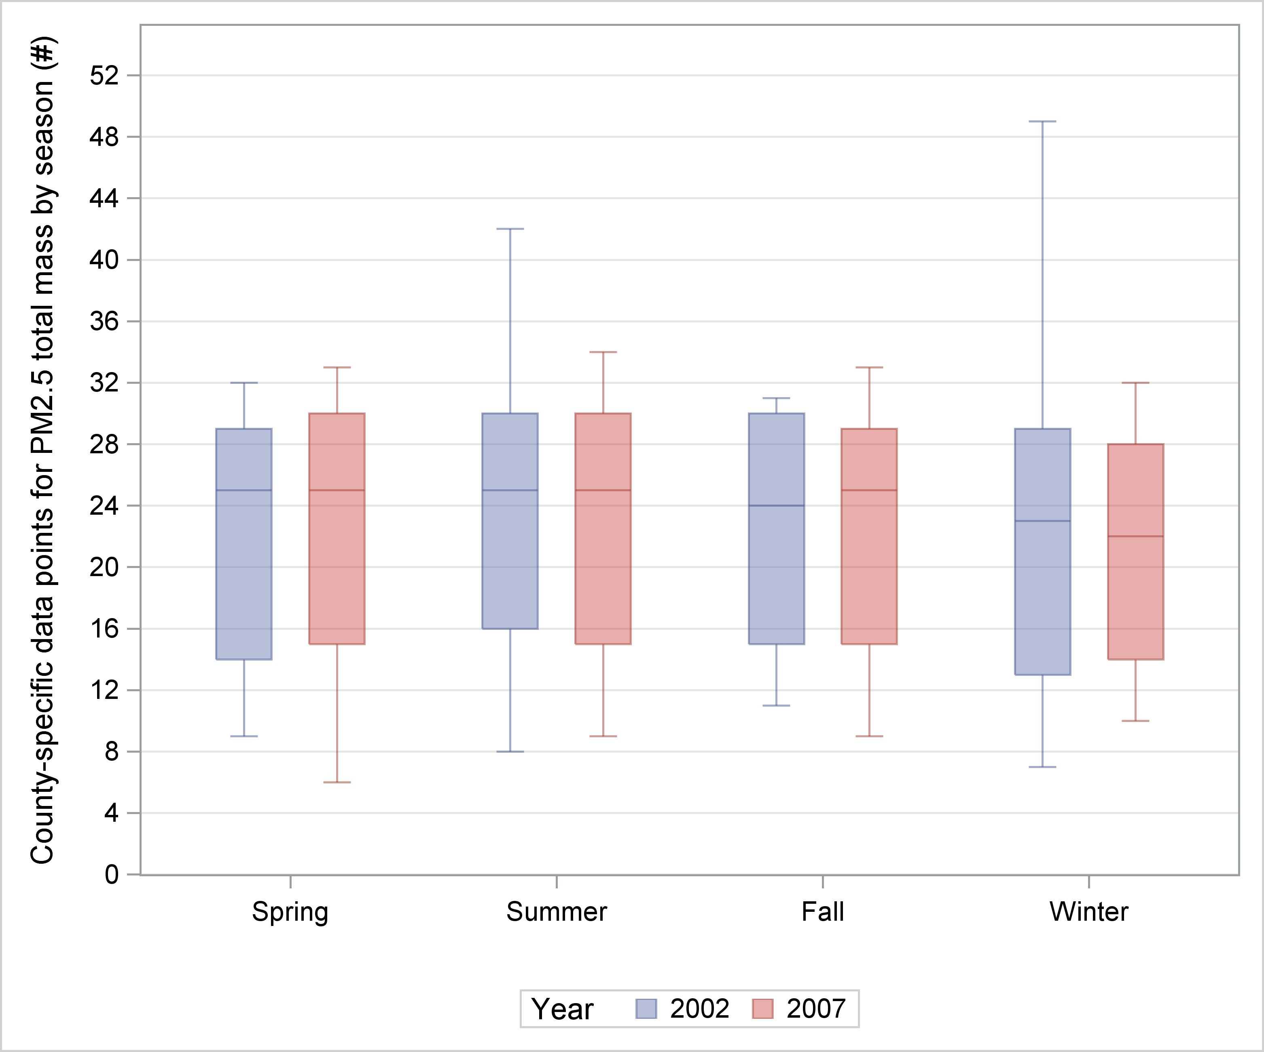

Figure S2. Associations between changes in PM_{2.5} total mass and its seven components (µg/m³, between 2002 and 2007) and changes in life expectancy (years, between 2007 and 2002), across 95 counties. The sold line represents the linear regression of changes in life expectancy controlling for changes in PM_{2.5} total mass and its seven components.

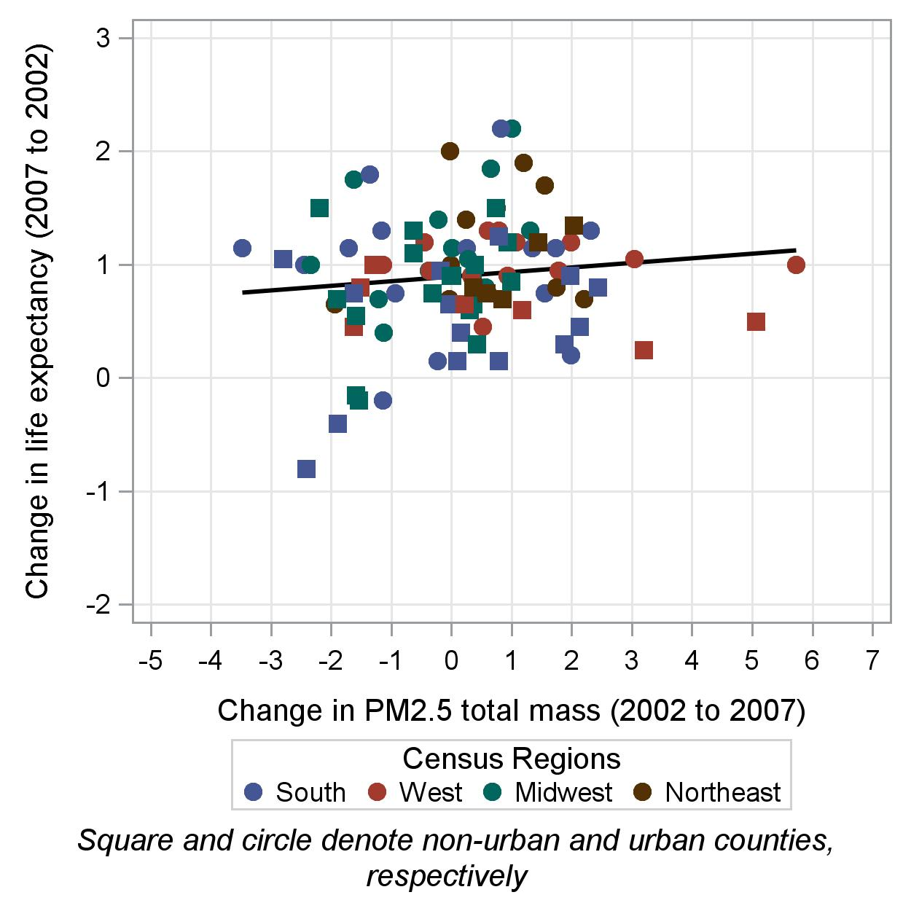 | 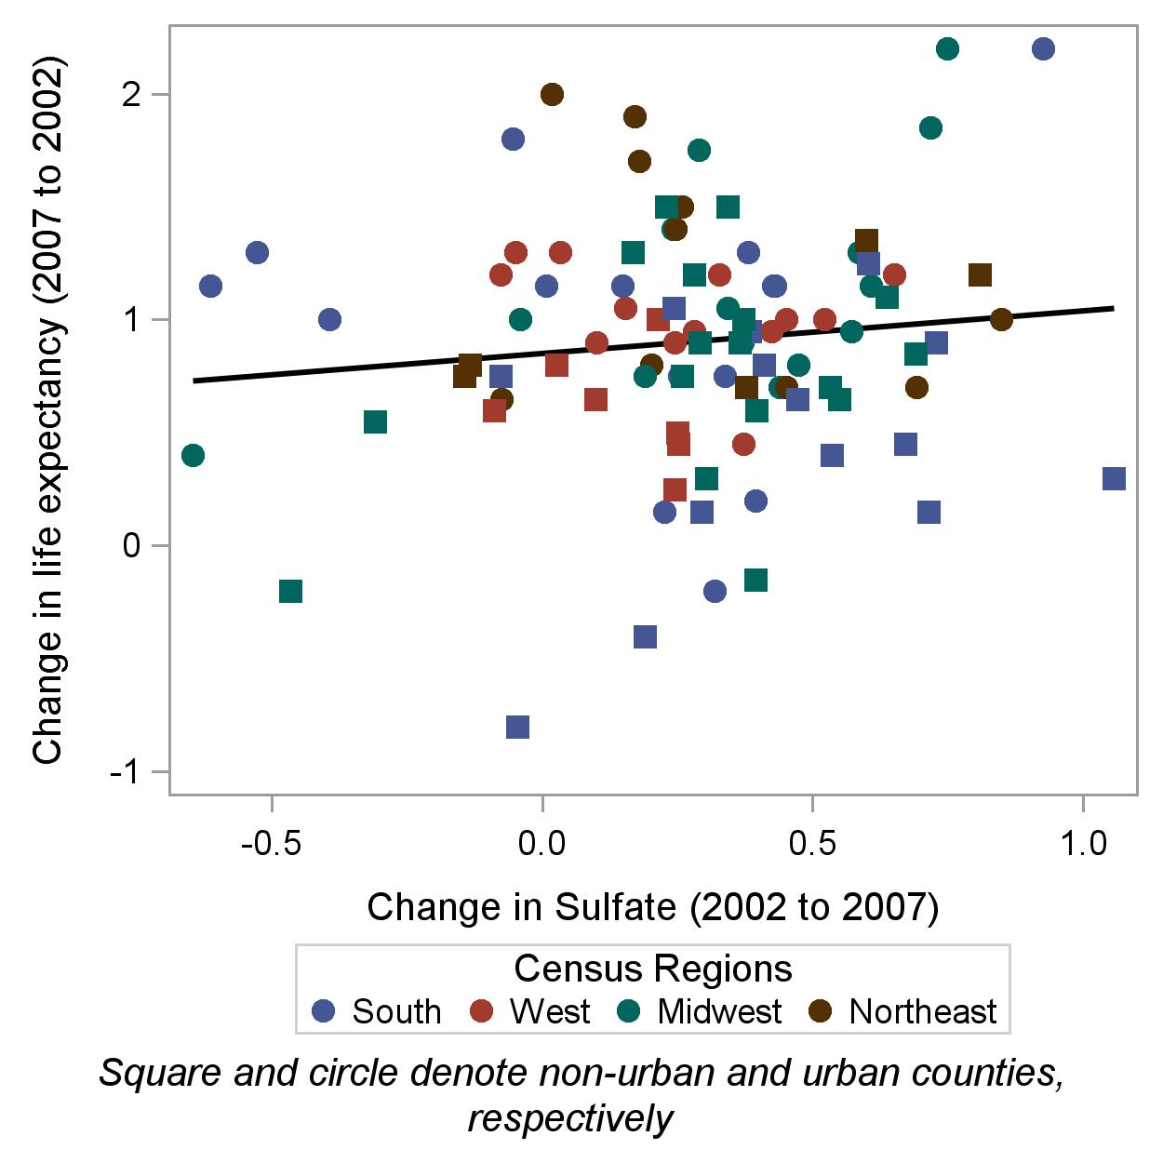
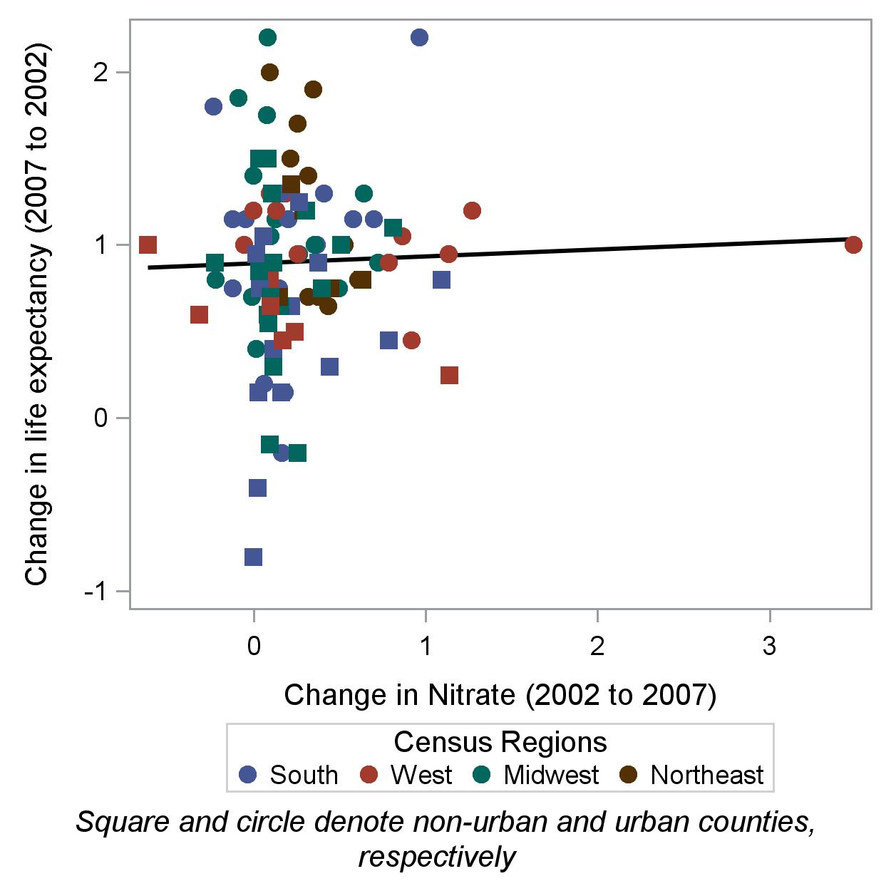 | 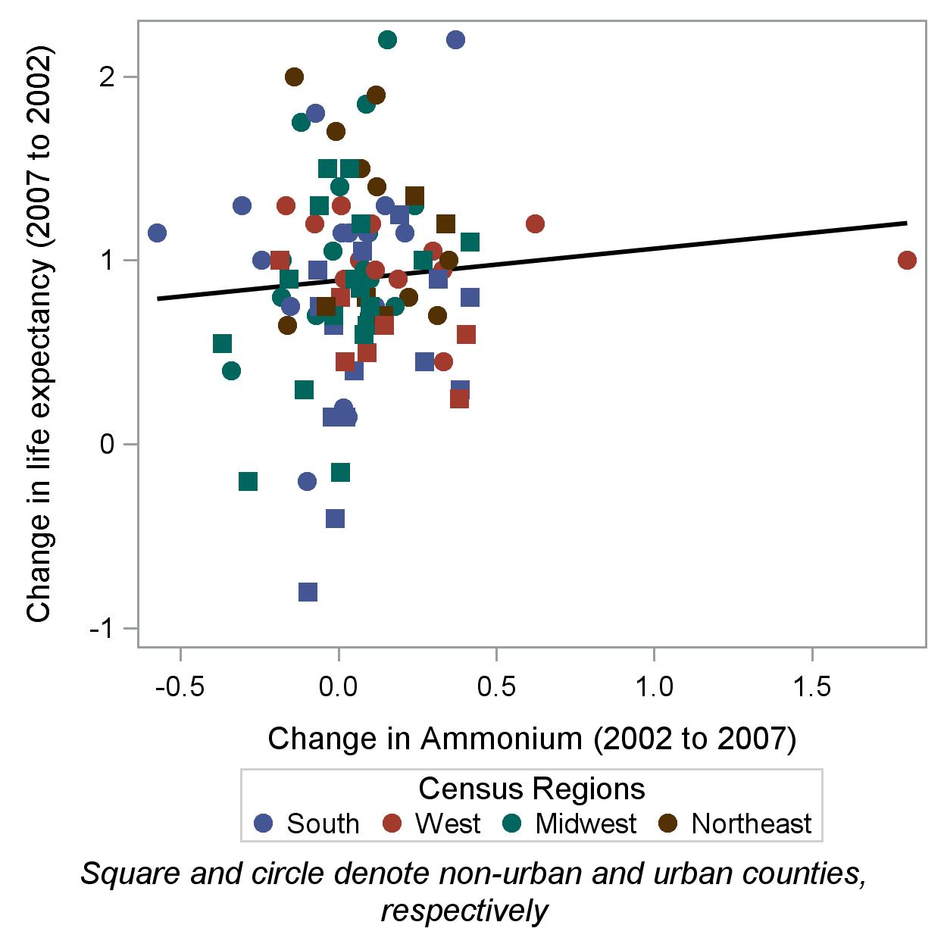

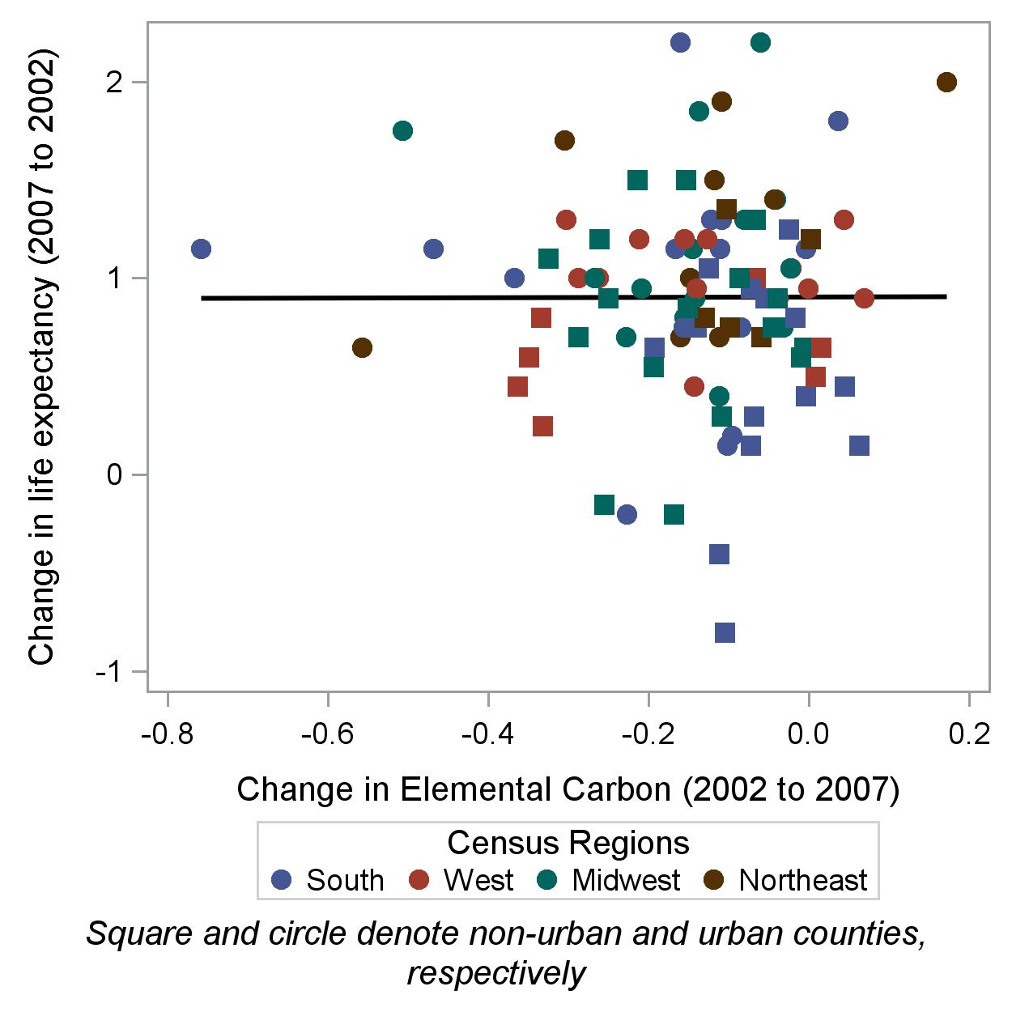 | 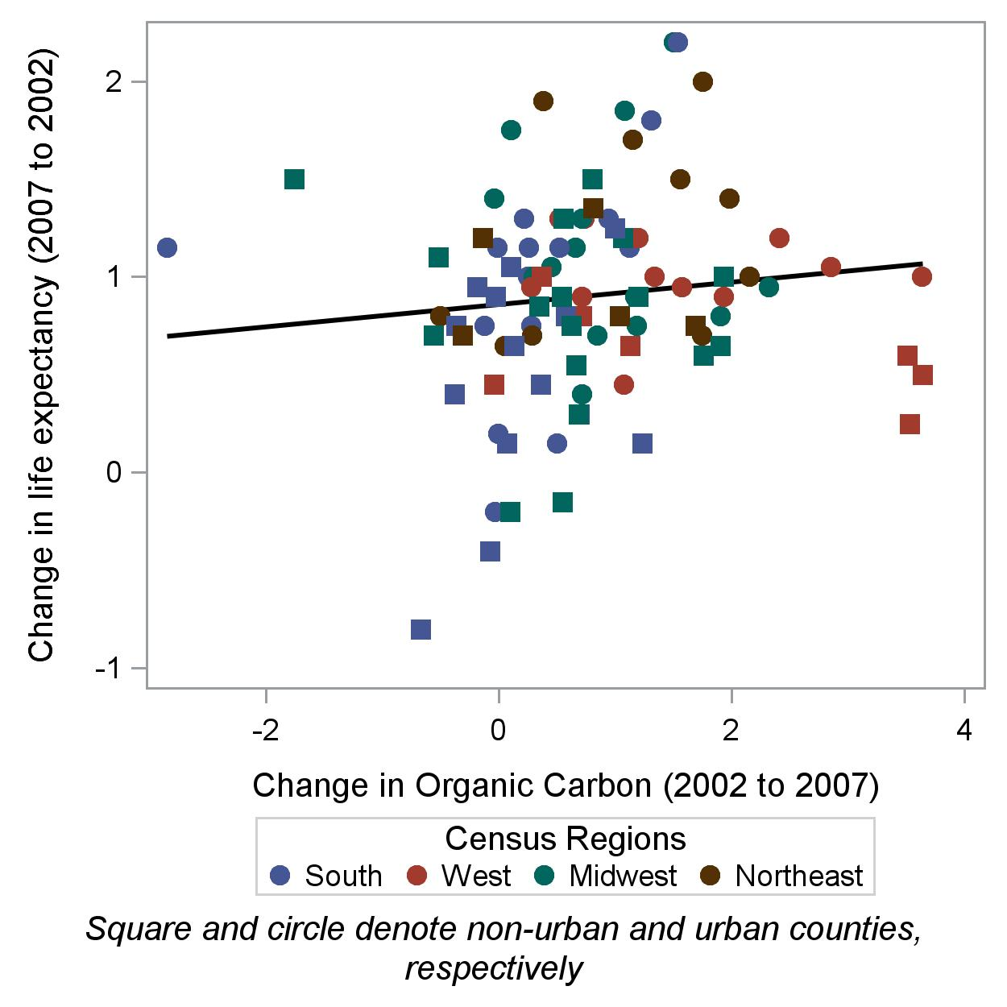
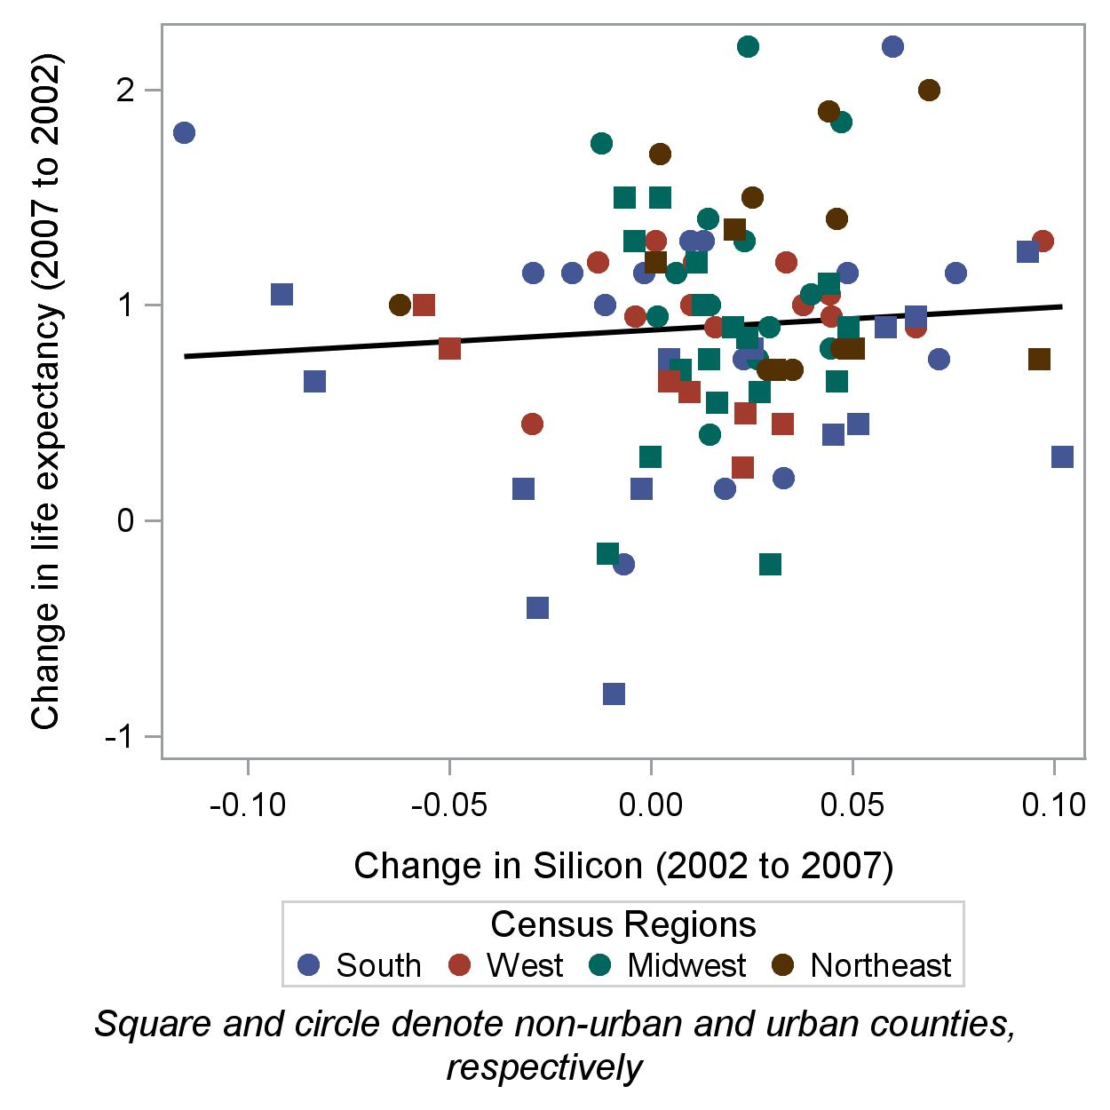 | 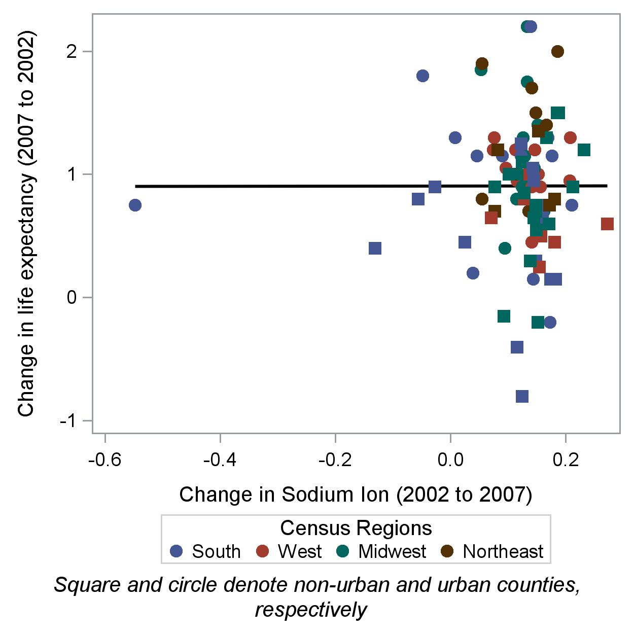

Figure S3A. Sensitivity analysis with 87 counties that had current smoking rates obtained from Center for Disease Control’s Behavioral Risk Factor Surveillance System. Point estimates and 95% confidence intervals of the change in life expectancy (years) associated with an inter-quartile range (IQR) reduction in each of the seven chemical components of PM_{2.5} and the PM_{2.5} total mass, by all available counties (left panel), non-urban counties (middle panel), and urban counties (right panel), 2002 and 2007. These estimates were obtained under an “unadjusted single pollutant model” that includes a single exposure predictor of the change in PM_{2.5} total mass or the change in one of the seven components.

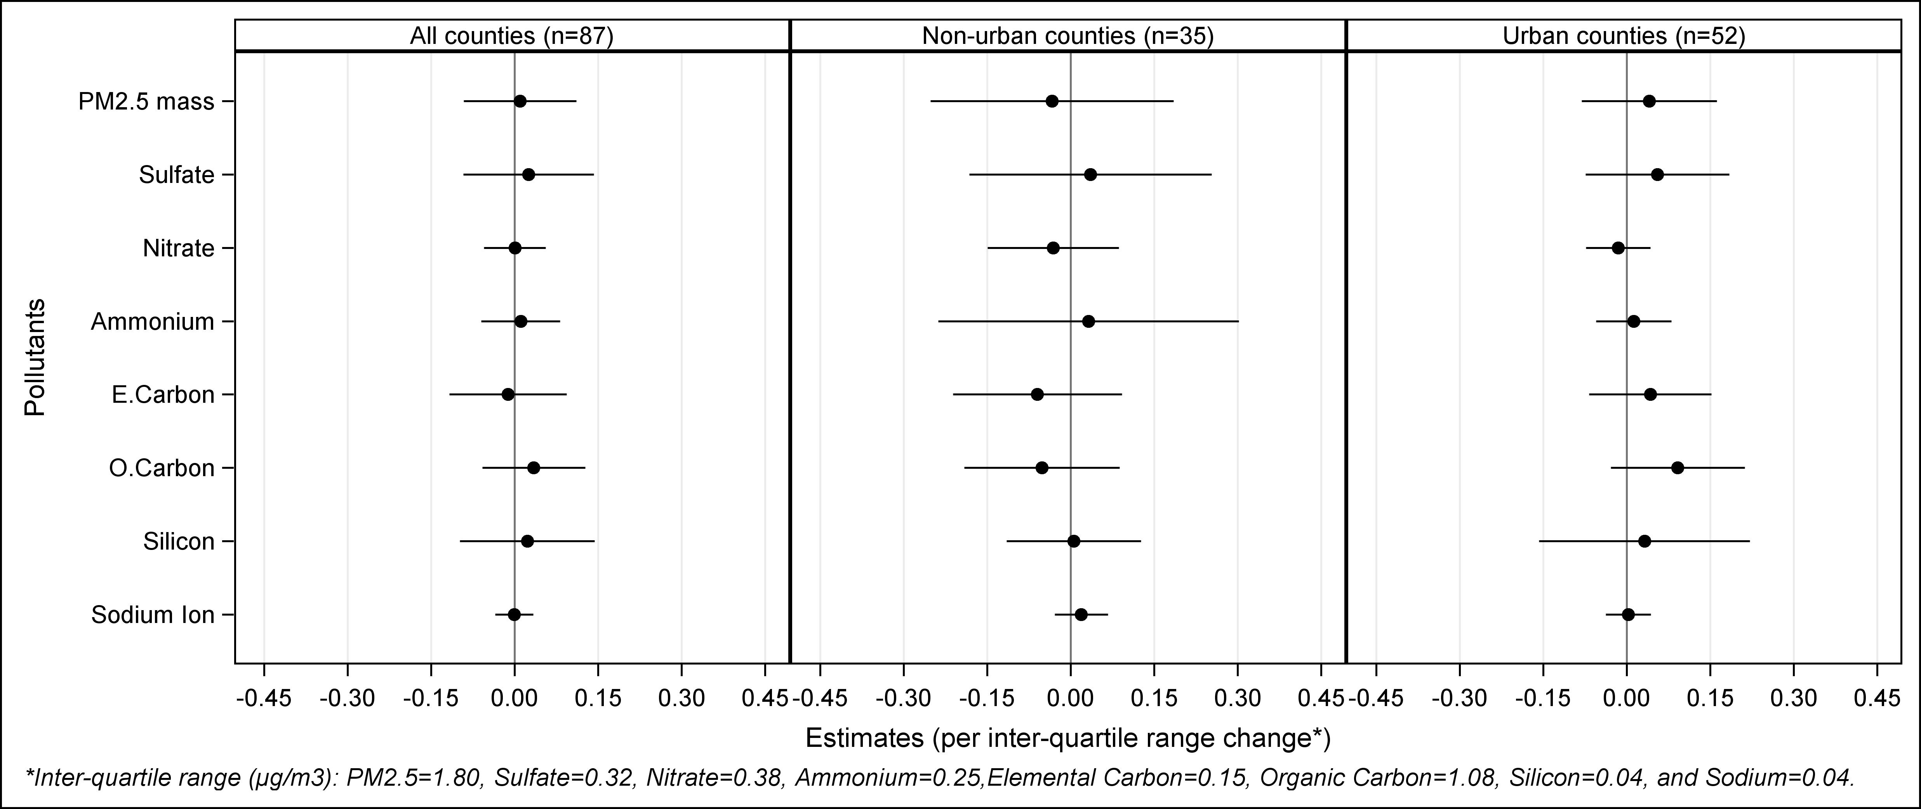
Figure S3B. Sensitivity analysis with 87 counties that had the change in current smoking rates obtained from Center for Disease Control (CDC)’s Behavioral Risk Factor Surveillance System (BRFSS). Point estimates and 95% confidence intervals of the change in life expectancy (years) associated with an inter-quartile range (IQR) reduction in each of the seven chemical components of PM_{2.5} and the PM_{2.5} total mass, by all available counties (left panel), non-urban counties (middle panel), and urban counties (right panel), 2002 and 2007. These estimates were obtained under an adjusted single pollutant model that adjusts for the changes in demographics, socioeconomic, population variables, smoking surrogates (lung cancer, and chronic obstructive pulmonary disease), and current smoking rate based on CDC’s BRFSS data.

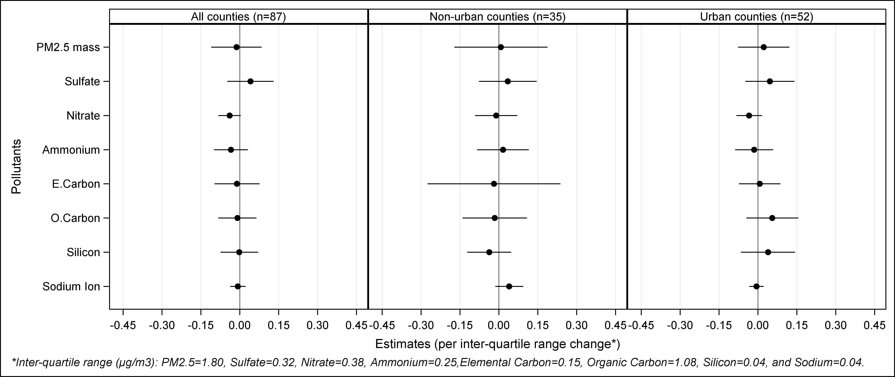
Figure S3C. Sensitivity analysis with 87 counties that had the change in current smoking rates obtained from Center for Disease Control (CDC)’s Behavioral Risk Factor Surveillance System (BRFSS). Point estimates and 95% confidence intervals of the change in life expectancy (years) associated with an inter-quartile range (IQR) reduction in each of the seven chemical components of PM_{2.5} and the PM_{2.5} total mass, by all available counties (left panel), non-urban counties (middle panel), and urban counties (right panel), 2002 and 2007. These estimates were obtained under an adjusted multiple pollutant model that adjusts for the changes in demographics, socioeconomic, population variables, smoking surrogates (lung cancer, and chronic obstructive pulmonary disease), current smoking rate based on CDC’s BRFSS data as well as all seven pollutants.



