**Supplemental Material**

eTable 1. Restriction to areas less than 400 km2.

eTable 2. Restriction to mothers who did not move or build a home extension.

eTable 3. Mutually adjusted for air pollution exposure before pregnancy and during pregnancy at age 2.5 years.

eTable 4. Mutually adjusted for air pollution exposure before pregnancy and during pregnancy at age 5.5 years.

eTable 5. Selected adjusted ORs from simple logistic regression model analyses without or with standardized IPW.

eFigure 1. Air pollution concentrations in Japan, by both municipality and number of exposure windows (April 2000 to December 2000 for newborns born in January 2001 and October 2000 to June 2001 for newborns born in July 2001): a) Suspended PM, b) NO2, and c) SO2. NO2: nitrogen dioxide; PM: particulate matter

; SO2: sulfur dioxide

|  |  |  |  |  |  |  |  |  |  |
| --- | --- | --- | --- | --- | --- | --- | --- | --- | --- |
| eTable 1. Restriction to areas less than 400 km2. | | | | | | | | | |
|  |  |  | Cases with behavioral delays |  | Adjusted ORs (95%CIs) per an interquartile range increaseb | | | | |
|  |  |  | n*case* / Total na |  | Suspended PMc |  | NO2 |  | SO2 |
| Behavioral development at age 2.5 | |  |  |  |  |  |  |  |  |
|  | Unable to walk |  | 84 / 28930 |  | 0.99 (0.68, 1.44) |  | 1.40 (0.81, 2.39) |  | 1.05 (0.79, 1.40) |
|  | Unable to run |  | 163 / 28927 |  | 1.04 (0.79, 1.37) |  | 1.49 (1.00, 2.24) |  | 1.15 (0.93, 1.42) |
|  | Unable to climb stairs |  | 550 / 28906 |  | 1.03 (0.89, 1.20) |  | 1.09 (0.87, 1.36) |  | 1.07 (0.95, 1.20) |
|  | Unable to say meaningful words |  | 188 / 28921 |  | 1.06 (0.82, 1.38) |  | 1.32 (0.91, 1.91) |  | 1.17 (0.96, 1.43) |
|  | Unable to compose a two-phrase sentence |  | 1185 / 28907 |  | 1.08 (0.98, 1.20) |  | 1.24 (1.07, 1.44) |  | 1.07 (0.98, 1.16) |
|  | Unable to say his or her own name |  | 3372 / 28869 |  | 1.06 (0.99, 1.13) |  | 1.14 (1.03, 1.25) |  | 1.06 (1.01, 1.11) |
|  | Unable to use a spoon to eat |  | 569 / 28914 |  | 0.94 (0.81, 1.09) |  | 1.23 (0.99, 1.53) |  | 1.05 (0.93, 1.18) |
| Behavioral development at age 5.5 | |  |  |  |  |  |  |  |  |
|  | Unable to listen without fidgeting |  | 4513 / 25841 |  | 1.10 (1.03, 1.16) |  | 1.07 (0.98, 1.18) |  | 1.06 (1.01, 1.12) |
|  | Unable to focus on one task |  | 3334 / 25875 |  | 1.05 (0.98, 1.12) |  | 1.09 (0.99, 1.20) |  | 1.01 (0.96, 1.06) |
|  | Unable to remain patient |  | 6284 / 25754 |  | 1.03 (0.98, 1.08) |  | 0.95 (0.88, 1.02) |  | 1.01 (0.97, 1.06) |
|  | Unable to express emotions |  | 5998 / 25727 |  | 1.10 (1.04, 1.15) |  | 1.17 (1.08, 1.26) |  | 1.07 (1.03, 1.12) |
|  | Unable to act in group |  | 1610 / 25855 |  | 1.10 (1.00, 1.20) |  | 1.15 (1.01, 1.32) |  | 1.05 (0.98, 1.14) |
|  | Unable to keep promises |  | 4917 / 25627 |  | 1.07 (1.01, 1.13) |  | 1.00 (0.93, 1.09) |  | 1.01 (0.96, 1.05) |
| CI: confidence interval; NO2: nitrogen dioxide; OR: odds ratio; PM: particulate matter; SO2: sulphur dioxide | | | | | | | | | |
| a Among 31,896 children to whom suspended PM exposure could be assigned. Total n represents total number of children whose developments were answered by questionnaire at age 2.5 and 5.5 years. | | | | | | | | | |
|
| b Adjusted for individual characteristics (sex, birth month, maternal age at delivery, parity, maternal smoking status, maternal educational attainment, and paternal income) and municipality-level variables (residential area, per capita tax income, and density). Interquartile ranges are 11.0 μg/m3 for suspended PM, 10.9 ppb for NO2, and 2.3 ppb for SO2. | | | | | | | | | |
|
|
| c Suspended PM accounts for PM with aerodynamic diameter less than 7 μm (PM7).   |  |  |  |  |  |  |  |  |  |  | | --- | --- | --- | --- | --- | --- | --- | --- | --- | --- | | eTable 2. Restriction to mothers who did not move or build a home extension | | | | | | | | | | |  |  |  | Cases with behavioral delays |  | Adjusted ORs per an interquartile range increase (95%CIs)b | | | | | |  |  |  | n*case* / Total na |  | Suspended PMc |  | NO2 |  | SO2 | | Behavioral development at age 2.5 | |  |  |  |  |  |  |  |  | |  | Unable to walk |  | 70 / 21585 |  | 0.91 (0.61, 1.37) |  | 1.03 (0.56, 1.89) |  | 0.99 (0.72, 1.38) | |  | Unable to run |  | 128 / 21583 |  | 0.96 (0.71, 1.31) |  | 1.26 (0.79, 2.00) |  | 1.12 (0.88, 1.44) | |  | Unable to climb stairs |  | 408 / 21569 |  | 1.02 (0.86, 1.21) |  | 0.99 (0.77, 1.28) |  | 1.04 (0.91, 1.20) | |  | Unable to say meaningful words |  | 139 / 21577 |  | 0.96 (0.71, 1.31) |  | 1.10 (0.69, 1.75) |  | 1.22 (0.95, 1.57) | |  | Unable to compose a two-phrase sentence |  | 911 / 21568 |  | 1.07 (0.95, 1.20) |  | 1.16 (0.98, 1.39) |  | 1.05 (0.96, 1.16) | |  | Unable to say his or her own name |  | 2515 / 21543 |  | 1.05 (0.98, 1.13) |  | 1.09 (0.98, 1.22) |  | 1.05 (0.99, 1.12) | |  | Unable to use a spoon to eat |  | 419 / 21575 |  | 0.97 (0.81, 1.15) |  | 1.26 (0.98, 1.64) |  | 1.08 (0.94, 1.24) | | Behavioral development at age 5.5 | |  |  |  |  |  |  |  |  | |  | Unable to listen without fidgeting |  | 3258 / 19403 |  | 1.09 (1.01, 1.17) |  | 1.07 (0.96, 1.20) |  | 1.06 (1.00, 1.13) | |  | Unable to focus on one task |  | 2464 / 19433 |  | 1.02 (0.95, 1.10) |  | 1.11 (0.99, 1.24) |  | 0.99 (0.93, 1.05) | |  | Unable to remain patient |  | 4782 / 19332 |  | 1.01 (0.95, 1.07) |  | 0.90 (0.83, 0.99) |  | 0.98 (0.93, 1.03) | |  | Unable to express emotions |  | 4373 / 19329 |  | 1.12 (1.06, 1.19) |  | 1.18 (1.08, 1.29) |  | 1.06 (1.01, 1.11) | |  | Unable to act in group |  | 1190 / 19420 |  | 1.06 (0.96, 1.18) |  | 1.14 (0.98, 1.33) |  | 1.08 (0.99, 1.17) | |  | Unable to keep promises |  | 3626 / 19252 |  | 1.06 (1.00, 1.13) |  | 0.98 (0.89, 1.08) |  | 0.99 (0.94, 1.04) | | CI: confidence interval; NO2: nitrogen dioxide; OR: odds ratio; PM: particulate matter; SO2: sulphur dioxide | | | | | | | | | | | b Among 23,596 children to whom suspended PM exposure could be assigned. Total n represents total number of children whose developments were answered by questionnaire at age 2.5 and 5.5 years. | | | | | | | | | | | | a Adjusted for individual characteristics (sex, birth month, maternal age at delivery, parity, maternal smoking status, maternal educational attainment, and paternal income) and municipality-level variables (residential area, per capita tax income, and density). Interquartile ranges are 11.0 μg/m3 for suspended PM, 10.9 ppb for NO2, and 2.3 ppb for SO2. | | | | | | | | | | | | | c Suspended PM accounts for PM with aerodynamic diameter less than 7 μm (PM7). | | | | | | | | | | | | | | | | | | | |

|  |  |  |  |  |  |  |  |  |  |  |  |
| --- | --- | --- | --- | --- | --- | --- | --- | --- | --- | --- | --- |
| eTable 3. Mutually adjusted for air pollution exposure before pregnancy and during pregnancy at age 2.5 years. | | | | | | | | | | | |
|  |  | Cases with behavioral problem |  | Adjusted ORs per an interquartile range increase (95%CIs)b | | | | | | | |
|  |  |  | Suspended PMc | |  | NO2 | |  | SO2 | |
|  |  | n*case* / Total na |  | Before pregnancyd | During pregnancy |  | Before pregnancyd | During pregnancy |  | Before pregnancyd | During pregnancy |
| Unable to walk |  | 90 / 30588 |  | 0.89 (0.44, 1.82) | 1.13 (0.58, 2.23) |  | 1.14 (0.30, 4.36) | 1.19 (0.31, 4.54) |  | 0.90 (0.51, 1.58) | 1.16 (0.66, 2.03) |
| Unable to run |  | 172 / 30585 |  | 1.07 (0.64, 1.78) | 1.03 (0.63, 1.67) |  | 1.17 (0.43, 3.22) | 1.28 (0.47, 3.51) |  | 0.98 (0.64, 1.48) | 1.19 (0.78, 1.80) |
| Unable to climb stairs |  | 583 / 30564 |  | 1.18 (0.89, 1.57) | 0.93 (0.71, 1.22) |  | 1.26 (0.71, 2.24) | 0.89 (0.50, 1.58) |  | 1.04 (0.82, 1.31) | 1.05 (0.83, 1.33) |
| Unable to say meaningful words |  | 197 / 30579 |  | 1.23 (0.79, 1.92) | 0.94 (0.61, 1.46) |  | 0.86 (0.33, 2.24) | 1.50 (0.58, 3.87) |  | 1.04 (0.70, 1.53) | 1.15 (0.78, 1.69) |
| Unable to compose a two-phrase sentence |  | 1260 / 30564 |  | 1.01 (0.83, 1.22) | 1.08 (0.90, 1.29) |  | 1.18 (0.80, 1.73) | 1.08 (0.73, 1.58) |  | 0.86 (0.73, 1.02) | 1.23 (1.04, 1.44) |
| Unable to say his or her own name |  | 3552 / 30526 |  | 0.98 (0.87, 1.10) | 1.08 (0.96, 1.21) |  | 1.38 (1.08, 1.77) | 0.84 (0.66, 1.07) |  | 0.92 (0.83, 1.02) | 1.13 (1.02, 1.26) |
| Unable to use a spoon to eat |  | 598 / 30571 |  | 1.06 (0.81, 1.39) | 0.93 (0.71, 1.20) |  | 1.37 (0.78, 2.40) | 0.92 (0.53, 1.62) |  | 1.02 (0.81, 1.29) | 1.05 (0.83, 1.32) |
| CI: confidence interval; NO2: nitrogen dioxide; OR: odds ratio; PM: particulate matter; SO2: sulphur dioxide | | | | | | | | | | | |
| a Among 33,730 children to whom suspended PM exposure could be assigned. Total n represents total number of children whose developments were answered by questionnaire at age 2.5 years. | | | | | | | | | | | |
|
| bAdjusted for individual characteristics (sex, birth month, maternal age at delivery, parity, maternal smoking status, maternal educational attainment, and paternal income) and municipality-level variables (residential area, per capita tax income, and density). Interquartile ranges are 10.7 μg/m3 for suspended PM before pregnancy, 10.2 μg/m3 for suspended PM during pregnancy, 10.9 ppb for NO2 before pregnancy,10.9 ppb for NO2 during pregnancy, 2.0 ppb for SO2 before pregnancy, and 2.3 ppb for SO2 during pregnancy. | | | | | | | | | | | |
|
|
| c Suspended PM accounts for PM with aerodynamic diameter less than 7 μm (PM7).  d As air pollution exposure before pregnancy, we used air pollution between July 1999 and March 2000 for participants born in January 2001 and between January 2000 and September 2000 for participants born in July 2001. | | | | | | | | | | | |

|  |  |  |  |  |  |  |  |  |  |  |  |
| --- | --- | --- | --- | --- | --- | --- | --- | --- | --- | --- | --- |
| eTable 4. Mutually adjusted for air pollution exposure before pregnancy and during pregnancy at age 5.5 years. | | | | | | | | | | | |
|  |  | Cases with behavioral problem |  | Adjusted ORs per an interquartile range increase (95%CIs)b | | | | | | | |
|  |  |  | Suspended PMc | |  | NO2 | |  | SO2 | |
|  |  | n*case* / Total na |  | Before pregnancyd | During pregnancy |  | Before pregnancyd | During pregnancy |  | Before pregnancyd | During pregnancy |
| Unable to listen without fidgeting |  | 4745 / 27343 |  | 1.00 (0.89, 1.12) | 1.11 (0.99, 1.23) |  | 1.00 (0.80, 1.26) | 1.08 (0.86, 1.35) |  | 1.07 (0.97, 1.17) | 1.01 (0.92, 1.11) |
| Unable to focus on one task |  | 3506 / 27383 |  | 0.94 (0.84, 1.06) | 1.12 (1.00, 1.25) |  | 0.86 (0.67, 1.09) | 1.28 (1.01, 1.63) |  | 0.99 (0.89, 1.09) | 1.03 (0.93, 1.13) |
| Unable to remain patient |  | 6646 / 27254 |  | 0.99 (0.90, 1.09) | 1.06 (0.97, 1.16) |  | 0.91 (0.75, 1.10) | 1.05 (0.87, 1.27) |  | 1.01 (0.93, 1.09) | 1.01 (0.93, 1.09) |
| Unable to express emotions |  | 6291 / 27226 |  | 0.94 (0.86, 1.04) | 1.16 (1.06, 1.27) |  | 0.89 (0.74, 1.08) | 1.31 (1.08, 1.59) |  | 0.96 (0.89, 1.04) | 1.11 (1.02, 1.20) |
| Unable to act in group |  | 1714 / 27356 |  | 0.95 (0.81, 1.12) | 1.12 (0.96, 1.31) |  | 1.03 (0.73, 1.45) | 1.11 (0.79, 1.56) |  | 0.94 (0.81, 1.09) | 1.11 (0.96, 1.28) |
| Unable to keep promises |  | 5191 / 27119 |  | 1.10 (0.99, 1.22) | 1.01 (0.92, 1.11) |  | 1.17 (0.95, 1.44) | 0.89 (0.72, 1.09) |  | 1.01 (0.93, 1.10) | 1.00 (0.92, 1.10) |
| CI: confidence interval; NO2: nitrogen dioxide; OR: odds ratio; PM: particulate matter; SO2: sulphur dioxide | | | | | | | | | | | |
| a Among 33,730 children to whom suspended PM exposure could be assigned. Total n represents total number of children whose developments were answered by questionnaire at age 5.5 years. | | | | | | | | | | | |
|
| b Adjusted for individual characteristics (sex, birth month, maternal age at delivery, parity, maternal smoking status, maternal educational attainment, and paternal income) and municipality-level variables (residential area, per capita tax income, and density). Interquartile ranges are 10.7 μg/m3 for suspended PM before pregnancy, 10.2 μg/m3 for suspended PM during pregnancy, 10.9 ppb for NO2 before pregnancy,10.9 ppb for NO2 during pregnancy, 2.0 ppb for SO2 before pregnancy, and 2.3 ppb for SO2 during pregnancy. | | | | | | | | | | | |
|
|
| c Suspended PM accounts for PM with aerodynamic diameter less than 7 μm (PM7).  d As air pollution exposure before pregnancy, we used air pollution between July 1999 and March 2000 for participants born in January 2001 and between January 2000 and September 2000 for participants born in July 2001. | | | | | | | | | | | |

|  |  |  |  |  |
| --- | --- | --- | --- | --- |
| eTable 5. Selected adjusted ORs from simple logistic regression model analyses without or with standardized IPWa. | | | | |
|
|  |  |  | Adjusted ORs per an interquartile range increase (95%CIs)c | |
|  |  |  |
|  |  |  | Without IPW | With IPW |
| At age 2.5 for NO2 | |  |  |  |
|  | Unable to compose a two-phrase sentence |  | 1.24 (1.07, 1.43) | 1.24 (1.07, 1.43) |
|  | Unable to say his or her own name |  | 1.14 (1.04, 1.25) | 1.14 (1.04, 1.25) |
|  | Unable to use a spoon to eat |  | 1.24 (1.00, 1.53) | 1.24 (1.00, 1.54) |
| At age 5.5 for Suspended PMb | |  |  |  |
|  | Unable to listen without fidgeting |  | 1.10 (1.04, 1.16) | 1.10 (1.04, 1.16) |
|  | Unable to focus on one task |  | 1.06 (1.00, 1.13) | 1.07 (1.01, 1.14) |
|  | Unable to express emotions |  | 1.10 (1.05, 1.16) | 1.11 (1.05, 1.16) |
|  | Unable to keep promises |  | 1.08 (1.02, 1.14) | 1.08 (1.03, 1.14) |
| CI: confidence interval; IPW: inverse probability weight; NO2: nitrogen dioxide; OR: odds ratio; PM: particulate matter | | | | |
|
| a We could not use IPW in our multilevel logistic regression model due to the characteristic of the software program. We thus provide results from simple logistic regression model analyses. | | | | |
|
| b Suspended PM accounts for PM with aerodynamic diameter less than 7 μm (PM7). | | | | |
| c Adjusted for individual characteristics (sex, birth month, maternal age at delivery, parity, maternal smoking status, maternal educational attainment, and paternal income) and municipality-level variables (residential area, per capita tax income, and density). Interquartile ranges are 10.7 μg/m3 for suspended PM and 10.9 ppb for NO2. | | | | |
|
|
|

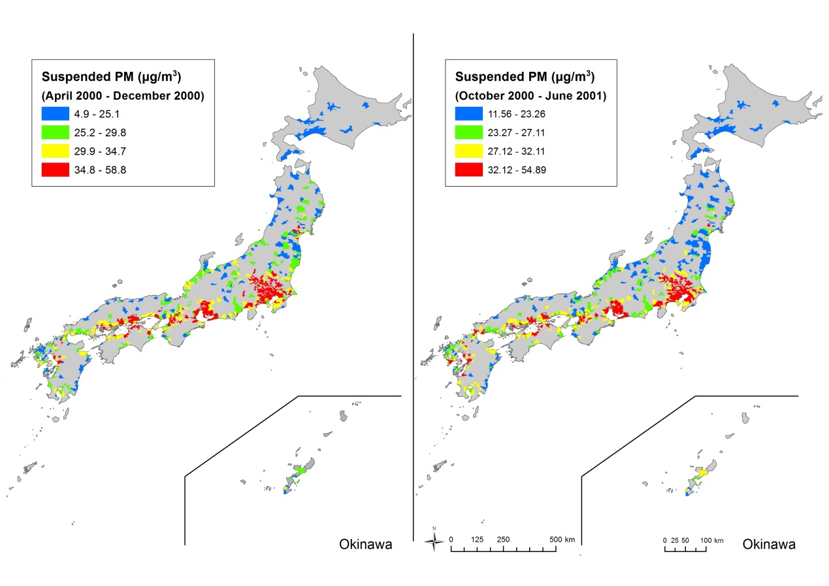

eFigure 1a. Suspended PM

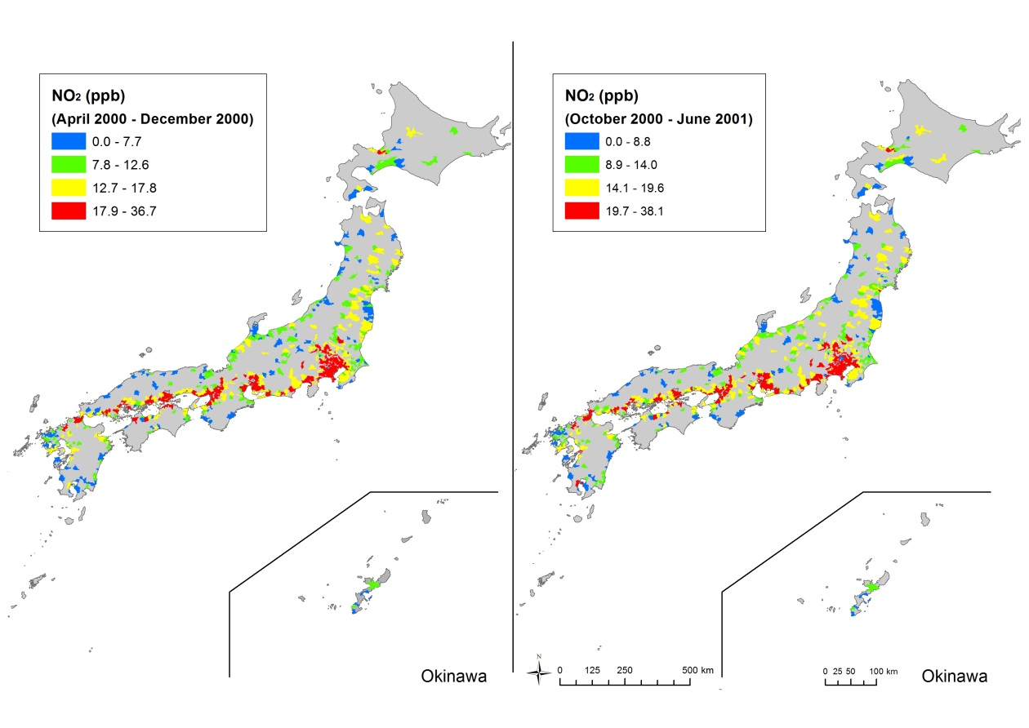 eFigure 1b. NO2

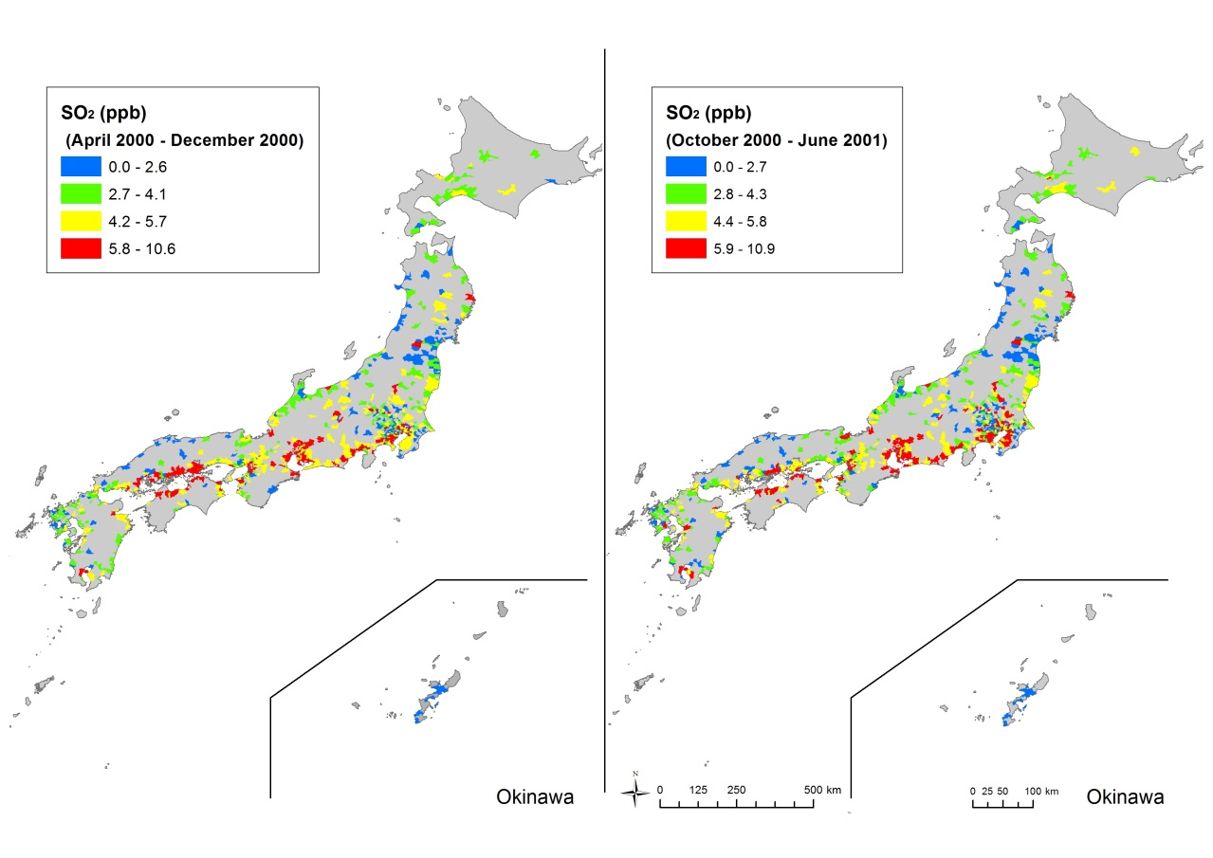

eFigure 1c. SO2